A BAYESIAN APPROACH TO CREDIBILITY THEORY ANALYSIS USING A BALANCED RANDOM EFFECTS MODEL

by

Rouché Zaaiman

Submitted in fulfillment
of the requirements
for one module of
the degree
of

Honours

in

MATHEMATICAL STATISTICS

in the

Department of Mathematical Statistics, Faculty of Science,

Nelson Mandela Metropolitan University

Supervisor: Johan Hugo

January 2010

INDEX

Chapter 1: Introduction ……………………………………………....... 1

  - History of Rev. Thomas Bayes ………………………..…………….. 1
  - Two approaches to statistical inference ……………………..……….. 1
  - What is credibility theory? ………………...…………………………. 2
  - Usefulness of Bayesian analysis for actuaries ……..………………… 2
  - The purpose of this project ……………………………………..……. 3

Chapter 2: Research done in the Bayesian field ………………... ……. 4

Chapter 3: Theory used in example ……………...…………………….. 7

3.1 Prior distribution ………………………..………………………........ 7
3.2 Rao-Blackwell theorem …………..………………………………….. 7
3.3 Markov Chain Monte Carlo ……..…………………………………... 8
3.4 Tolerance intervals ……………………..……………………………. 8
3.5 Credibility intervals ………………………..………………………… 9
3.6 Models and distributions used in the example ……..………………... 9

Chapter 4: Example on predicting future claims …………..………... 11

4.1 Histograms of the two variances ………..………………………….. 11
4.2 Histogram of the mean ……………………………..………………. 13
4.3 Histograms of the Unconditional Posterior Densities of the Row
Effects of the nine companies ………………………………..……. 14
  - Smooth curved unconditional predictive densities of the nine
companies ……………………………………………….………….. 19

Chapter 5: Conclusion ……………………………..………………….. 30

References …………..………………………………………………….. 31

Appendix ………………..…………………………………………….... 33

Chapter 1: Introduction

  - History of Rev. Thomas Bayes

Rev. Thomas Bayes (1702 – 1761), was born in London. He served as a
nonconformist minister in Turnbridge Wells which is about 35 miles southeast of London. He was elected as a fellow of the Royal Society in 1742, but this membership was a mystery to many since his major work was only published in 1764, which is three years after his death. However, a few years ago letters have been discovered that indicated that Bayes have been corresponding privately with many of the intellectuals of that area. Bayes’ work was showcased by Richard Price, his fellow clergyman, and championed and extended by the French astronomer, probabilist and mathematician Piere Simon Laplace (Herzog, 2008, p40).

All mathematicians are familiar with the Laplace transform in functional analysis. In an essay on probabilities, Laplace described a mathematical framework to do statistical inference, which extended Bayes’ work and made up the basis of statistical inference (Herzog, 2008, p40).

1.2 Two approaches to statistical inference

There are two approaches to statistical inference. Sampling theory, this is known as the frequentist approach and the Bayesian approach (Herzog, 2008, p40). The frequentist approach which is the most popular approach and the most abundantly available in statistical text consists of confidence intervals and hypothesis testing. Bayesian statistics is based on Bayes’ theorem and much less statistical text is available on this approach (Klugman, 1992, p.1). Recent and prior information are used to construct the probability distributions of the statistical model or parameters which is the objective. The Bayesian approach is supported by subjective probabilities and makes use of a theorem that Bayes developed. The theorem says that if A and B are events and P(B) > 0, then P(A/B) = P(B/A) × P(A) / P(B). Bayesian statistical inference mainly uses, besides this theorem, predictive distributions, posterior distributions and (posterior) odds ratio (Herzog, 2008, p40).
1.3 What is credibility theory?

Credibility theory is a branch of actuarial statistics (Wikipedia, Credibility Theory). It is about weighted averages (Venter, p.623). Credibility theory is applied by making future predictions for a subset using past experience / prior information of the population or the specific subset (Behan, 2009, p.1). The mathematical problem is thus to find a way to combine these experiences, and credibility theory has a solution to this problem (Wikipedia, Credibility Theory). The formulas in credibility theory are used to predict a future event or costs when data is random and lacks statistical reliability. More specifically they use it when there was a large error in the expected losses previously, to estimate expected losses (Boor, 1996, p.1,2), (Mahler and Dean, 2005, p.485).

Thus for actuaries it is important to be familiar with credibility theory to be able to calculate premiums for a group of insureds. The goal is to gather data to construct an experience rating system to be able to predict the next years’ premium, where the subjective and collective experiences are taken into account (Wikipedia, Credibility Theory).

The basic linear formula to calculate credibility weighted estimates is given by: Estimate = z × [observation] + (1 – z) × [other information] 0 ≤ z ≤ 1 where z is the credibility assigned to the observation (Mahler and Dean, 2005, p.485).

1.4 Usefulness of Bayesian analysis for actuaries

In the book “Bayesian Statistics in Actuarial Science: with emphasis on Credibility”, Stuart A. Klugman (1992) shows that in actuarial science there is several problems that is suited to use Bayesian analysis on. Actuaries knew this for a long time, but because they did not have the comfort of technology that we have these days and because there was not appropriate algorithms available, they used many approximations (Klugman, 1992, p.xi).

Actuaries have two great advantages using the Bayesian approach: The method they use is independent of the model and interval estimates are just as easy to obtain as point estimates. The basic credibility problem has the same background as the random effects model from the analysis of the variance (Klugman, 1992, p.xi).

1.5 The purpose of this project

In this project, the example that I will be explaining uses model-based predictions to calculate future claims, where all the computations were done in MATLAB. Firstly I have discussed the work that other students have done before, and in the following chapter theory that I have used in my example have been discussed, followed by the example in the next chapter. The project will then end off with a conclusion. The main purpose is to show that the methods can be used.

(Note: In chapter 4 the words company and fleet have been used, which has the same meaning. In the graphs the word ‘fleet’ has been used and in the discussion the word ‘company’. Also note that on the website of e-Handbook of Statistical Methods it is requested that the book will be referenced in the following way:
NIST/SEMATECH, e-Handbook of Statistical Methods, http://www.itl.nist.gov/div898/handbook/prc/section2/prc263.htm)

Chapter 2: Research done in the Bayesian field

In this chapter a few summaries is given about the work that other students have done in credibility theory where the emphasis is more on the use of Bayesian methods.

In “Foundations of casualty actuarial Science”, Matthew Rodermund (1990) wrote, “It is the concept of credibility that has been the casualty actuaries’ most important contribution to actuarial science.” (Rodermund, 1990). In the article by Thomas Herzog (2008), he took this statement further by saying that the best approach to credibility theory is by using the theorem that Rev. Thomas Bayes developed. He stated that Rev. Thomas Bayes’ work has an enormous effect on modern actuarial and statistical analysis and especially credibility theory (Herzog, 2008, p.40).

The credibility formula, given by P = z*x + (1-z)*μ, have been shown to be the best linearized approximation for the exact Bayesian forecast by Bühlman in 1967, where x – average claim from risk
μ - estimate of premium basis on collateral data
z – credibility factor
P – calculated premium
Bühlmans’ result for the credibility factor is given by

z = V_{θ} E(ε / θ) / V(1 / n * ∑ε_{t})

L.D’Hooge and M.J. Goovaerts (1975) in their paper used an appropriate Bayesian inference technique to estimate the credibility factor. Many other and different techniques have been used before to estimate the same result. It was their aim to show that the credibility factor can also be obtained using Bayesian methods for estimating parameters, under certain general conditions (‘Hooge and Goovaerts, 1975, p.164).

In “Bayes and Empirical Bayes Estimation for the Chain Ladder Model”, R.J. Verralls’ (1990) main focus was to forecast outstanding claims by making use of the chain ladder model. This method is dependent on the fact that the chain ladder method is using a linear model. This linear model is from the two-way analysis of variance and it is the main focus in this paper (Verrall, 1990, p.217).

The paper “Some Bayesian Credibility Premiums Obtained by using Posterior Regret Г-Minimax Methodology”, by E Gómez-Déniz (2009), he used a method based on the posterior regret Г-Minimax principle to derive a new credibility formula in an uncomplicated way. He used simple distributions to do this (Gómez-Déniz, 2009, p.223).

In the book “Bayesian Statistics in Actuarial Science: With Emphasis on Credibility”, Stuart A. Klugman (1992) shows that two important actuarial problems can be successfully solved using the Bayesian approach. The one is the general problem of model-based predictions, which is the type of example that I will be discussing in chapter 4. The other is under the general name of credibility. The problem here is to determine how much emphasis should be placed on actual experience and how much on the overall average for all the insureds. When insurance premiums is set up, the best result is found when the premium is somewhere between the actual experience of the insureds and the overall average for all the insureds (Klugman, 1992, p.1).

Ragnar Norberg (2004) in his article “Credibility Theory”, goes back to the origin of actuarial credibility, describes its history and how it developed, discusses its main issues and results and takes a look into previous related work in statistical science (Norberg, 2004, p.1).

In “Practical ‘Modern’ Bayesian Statistics in Actuarial Science”, Fernada Pereira (1999) was aiming to convince actuaries that Bayesian statistics could come in handy when solving problems in practice. There were two characteristics of Bayesian modeling which was not yet fully researched by practitioner actuaries; the first was the gathering of subjective information and the second the wider range of models that were available in Bayesian statistics. In this paper Pereira looked at many published papers based on Bayesian theory with insurance applications (Pereira, 1999, p.161).

Klaus D. Schmidt (1980) in his article “Convergence of Bayes and Credibility Premiums”, said that it is known that Bayes and credibility premiums are asymptotically optimal in terms of losses if the annual claim amount of a risk is conditionally independent and identically distributed with respect to a risk parameter. In his paper he shows that Bayes and credibility premiums converge to the individual premium (Schmidt, 1980, p167).

In “Empirical Bayesian Credibility for Workers’ Compensation Classification Ratemaking”, Glenn Meyers (1984) has demonstrated that the Bayesian empirical credibility formula used to determine class relatives for workers’ compensation insurance was more accurate than the present method of ratemaking. This methodology has been taken from the paper “Credibility for Loss Ratios” by Bhülman and Straub (1972) and modified by the ISO Credibility Subcommittee (Meyers, 1984, p.96,112).

The significance level of these tests was considered important enough to recommend use by individual companies in a competitive environment but the author does not recommend industry wide use in a highly – regulated non competitive environment (Meyers, 1984, p.112).

Chapter 3: Theory used in example

This chapter briefly discusses the methods and theory that will be used in the example in the next chapter.

3.1 Prior distribution

In Bayesian statistical inference, the prior probability distribution, also called the prior, is the probability distribution that symbolizes the prior knowledge about a population; this is before any observations have been captured. In the prior that I have, not much information is available; therefore it is called non-informative prior (Wikipedia, Prior Probabilities).

3.2 Rao-Blackwell theorem

If we have any unbiased estimator of a parameter and a sufficient statistic exists for this estimator, then the Rao-Blackwell theorem presents a method to improve the performance of this unbiased estimator i.e. it will reduce its variance (aiaccess, Rao-Blackwell Theorem). This is called Rao-Blackwellization. C.R. Rao and D. Blackwell discovered this idea independently and presented it in their papers in 1945 and 1947 respectively (scolarpedia, Rao-Blackwell Theorem).

This method is on a large scale used to make estimates from sample survey data. When an estimate that is dependent on the order in which observations occur, is made, the Rao-Blackwellized estimator can be obtained by averaging the estimator over all the possible outcomes. It will thus result in an improved estimator (scolarpedia, Rao-Blackwell Theorem).

Applications of Rao-Blackwellization can be found in engineering literature of switching dynamic systems where it is combined with Markov Chain Monte Carlo (MCMC) methods which will be the next point of discussion (scolarpedia, Rao-Blackwell Theorem).

3.3 Markov Chain Monte Carlo

The Markov Chain Monte Carlo method is a specific sort of algorithms that can be used for sampling from probability distributions. This is based on establishing a Markov chain that results in a stationary distribution which will be this specific / desired distribution. MCMC approximates the target distribution, since there will always be some residual. After a large number of steps the chain is used as a sample from the desired distribution. Take note that the more steps there is, the better the quality of the sample. If the stationary distribution is reached quickly, the chain is described as good. Algorithms that are more advanced such as coupling from the past, can give exact samples, but extra computation and unbounded running time will be needed (Wikipedia, Markov Chain Monte Carlo).

Applications of these algorithms are most frequently used in calculating multidimensional integrals. When a Markov chain is constructed, it is done in such a way that the integrand will be the stationary distribution. Multidimensional integrals appear often in the following fields: Bayesian statistics, computational physics, computational biology and computational linguistics. The Markov Chain Monte Carlo method is thus used on a regular basis in these fields (Wikipedia, Markov Chain Monte Carlo).

3.4 Tolerance intervals

A tolerance interval is a statistical interval that includes a specified proportion of a population, with some confidence. The bounds of tolerance intervals are limits that represent specific proportions of the population (Wikipedia, Tolerance interval). These bound are called tolerance limits. Three types of tolerance intervals are discussed that is frequently used:
- The (α , δ) tolerance interval, where α is the proportion of the population that is included in the interval and & is the confidence of the interval. 0 < α < 1, 0 < δ < 1 and often the values assigned to them is 0.90, 0.95 or 0.99.

- The α-expectation tolerance interval, where α is the expected proportion that will be covered. Again 0 < α < 1 and usually has a value like 0.90, 0.95 or 0.99 assigned to them. With the α-expectation tolerance intervals one or more future values is predicted.

- The fixed-in-advance tolerance interval, which is constant intervals and proportions of process measurements, is estimated. The content of bounds that have been determined before is considered when using these types of intervals.

These three types of intervals can all have the following forms: a lower limit (LL , ∞), upper limit (-∞ , UL), or a two-sided limit (L , UL) (Van der Merwe and Hugo, 2007, p.599).

3.5 Credibility intervals

A credibility interval is a Bayesian expectation tolerance interval. The credibility limits is the Bayesian expectation tolerance limits (Van der Merwe and Hugo, 2007, p.604).

3.6 Models and distributions used in the example

The random effects model is given by

y_{ij} = θ + r_{i} + ε_{ij}

where i = 1,2,…..,I, j = 1,2, ……,J, θ is the mean, r_{i} the row effect and ε_{ij} the error.
Also, ε_{ij} ~ N(0 , σ₁²) and r_{i} ~ N(0 , σ₂²).

The non-informative Jeffreys prior is given by

P(θ , σ₁² , σ₂²) ∞ 1 / σ₁²(σ₁² + J σ₂²)

and the Joint Posterior distribution is given by

P(σ₁², σ₂² / y) ∞ exp{-½[υ₂m₂ / (σ₁² + Jσ₂²) + υ₁m₁ / σ₁²]} / ((σ₁²)^{½(υ1 + 2)} ×
(σ₁² + Jσ₂²)^{½(υ2 + 2)})

where σ₁², σ₂² > 0 i.e. the Joint Posterior distribution is the product of the likelihood function and the prior distribution.

Also, θ / σ₁², σ₂², y ~ N(y.. , [ σ₁² + Jσ₂²] / IJ) and
r_{i} / σ₁², σ₂², y ~ N([Jσ₂² / (σ₁² + Jσ₂²)][y_{i}. – y..] , [σ₂² / (σ₁² + Jσ₂²)]
[σ₁² + Jσ₂² / I])

Some other formulas that I will be using are given below:
υ₁ = I(J – 1)
υ₂ = I – 1
υ₁m₁ =∑∑ (y_{ij} - y_{i}.)², the observed value for SS_{E}
υ₂m₂ = J∑( y_{i}.- y..)², the observed value for SS_{R}

In the next chapter I will be showing the steps used to calculate predictive densities of future observations for each company in order to predict a future observation, which is also the desired goal. This calculation takes into account that the variance components follow a normal distribution,

E(y_{i} / σ₁², σ₂², y) = Jσ₂² * y_{i}. / (σ₁² + Jσ₂²) + σ₁² * y.. / (σ₁² + Jσ₂²)

and

V(y_{i} / σ₁², σ₂², y) = σ₁² + σ₁² / (σ₁² + Jσ₂²) * (σ₂² + σ₁² / IJ).

Chapter 4: Example on predicting future claims

The following example will now be discussed as an example of how Bayesian statistics can be used to predict future claims. Data of the average claims for nine companies over ten years are given in the table below.

i^{th} Company | 1 | 2 | 3 | 4 | 5 | 6 | 7 | 8 | 9 | 10
1 | 540 | 514 | 576 | 483 | 481 | 493 | 438 | 588 | 541 | 441
2 | 99 | 103 | 163 | 126 | 0 | 219 | 370 | 273 | 155 | 275
3 | 0 | 400 | 1042 | 313 | 0 | 833 | 0 | 0 | 0 | 0
4 | 275 | 278 | 430 | 196 | 667 | 185 | 517 | 204 | 323 | 968
5 | 543 | 984 | 727 | 562 | 722 | 610 | 794 | 299 | 580 | 488
6 | 0 | 0 | 0 | 645 | 833 | 0 | 0 | 769 | 0 | 0
7 | 333 | 404 | 400 | 361 | 588 | 349 | 435 | 476 | 635 | 556
8 | 494 | 133 | 735 | 519 | 1000 | 641 | 339 | 513 | 227 | 244
9 | 1667 | 313 | 556 | 769 | 1818 | 0 | 1429 | 0 | 0 | 0

My goal is to predict what the average claim for the eleventh year for each of the nine companies will be.

Before I explain the steps and procedures to reach this goal, I first give the values of some variables that will be needed in the calculations:

I = 9, J = 10, υ₁ = 81, υ₂ = 8, y₁ = 509.5, y₂ = 178.3, y₃ = 258.8, y₄ = 404.3,
y₅ = 630.9, y₆ = 224.7, y₇ = 453.7, y₈ = 484.5, y₉ = 655.2, y = 422.2111111,
υ₁m₁ = 9 135 523.5, υ₂m₂ = 2 358 529.489

4.1 Histograms of the two variances

In Figure 1 and 2 the Histogram of the Unconditional Posterior Density within Group Variation and the Histogram of the Unconditional Posterior Density of the Between Group Variation are displayed. Given with them are their 95% Bayesian expectation tolerance intervals and their medians.
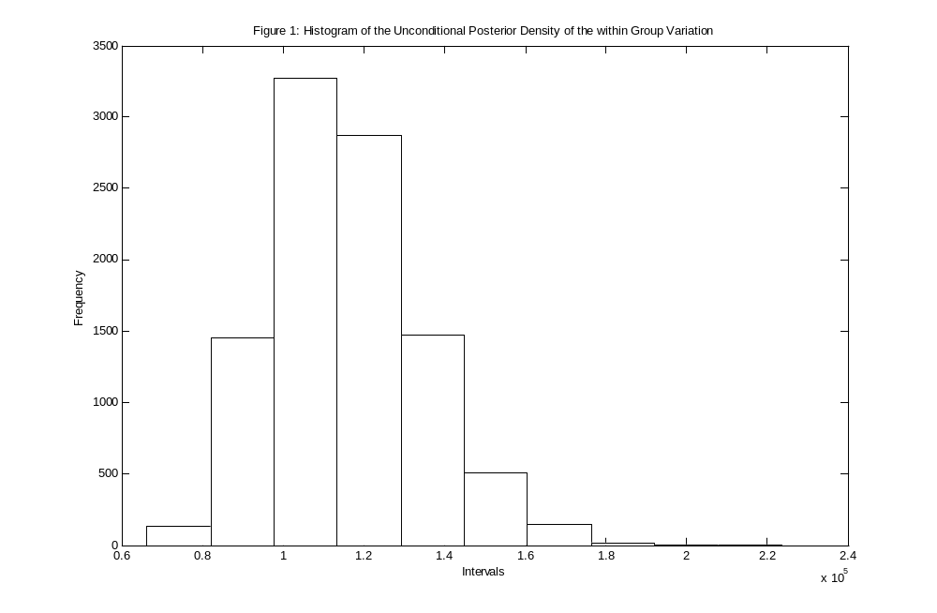
Credibility interval: [8.4617 × 10⁴ , 1.5541 × 10⁵], Median: 1.1349 × 10⁵

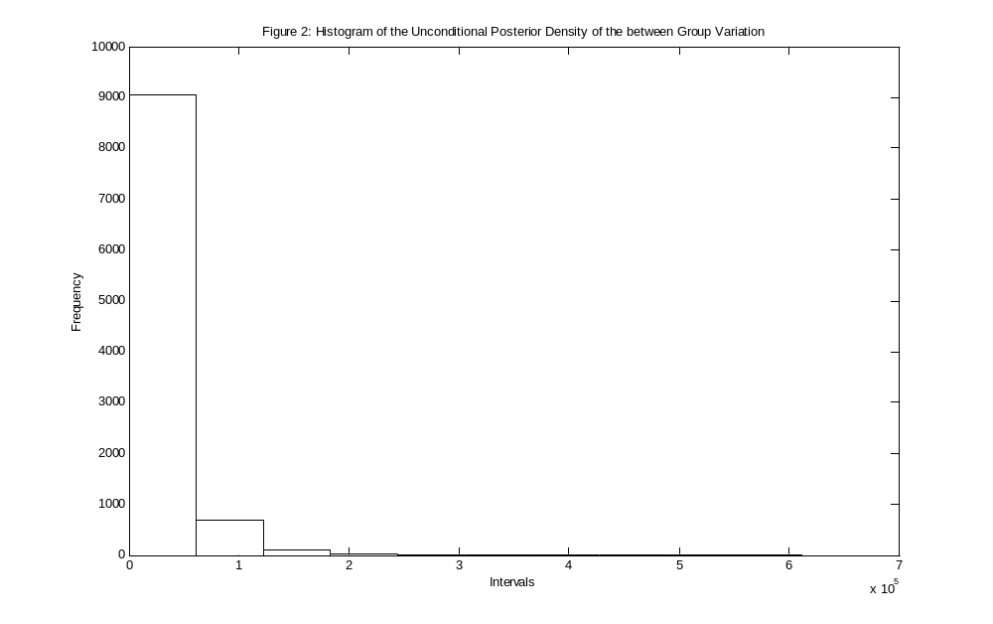
Credibility interval: [2.6832 × 10³ , 9.9004 × 10⁴], Median: 2.0926 × 10⁴
The Bayesian simulation method to obtain Figure 1 and 2 was conducted using the following steps:

- Simulate τ from a χ²υ₂ by taking υ1 standard normal numbers, squaring them and adding them together.
- To obtain one of the σ₁²’s, divide υ₁m₁ = 9 135 523.5 by the above sum.
- Simulate δ from a χ²υ₂ by taking υ₂ standard normal numbers, squaring them and adding them together.
- Substitute υ₂m₂ = 2 358 529.489, J = 10, the first δ and σ₁² into
σ₂² = (υ₂m₂ / δ - σ₁²) / J to obtain the first σ₂².
- This process is done 10 000 times to generate 10 000 values for σ₁²
and 10 000 values for σ₂².
- Drop out all the pairs where σ₂² < 0.
- Plot the sets of σ₁² and σ₂² values to obtain Figure 1 and 2 respectively.

4.2 Histogram of the mean

In Figure 3 the Histogram of the Unconditional Posterior Density of the Mean is displayed. Given with it are the 95% Bayesian expectation tolerance interval and the mean.
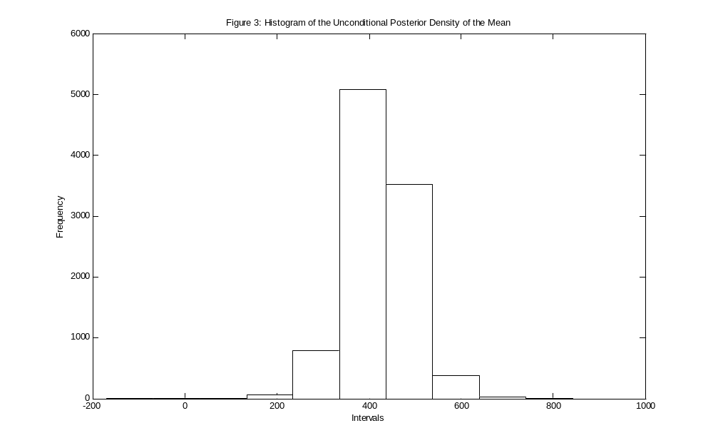
95 % Equal tails credibility interval: [287.8056 , 553.8576], Mean: 421.8275

The Bayesian simulation method to obtain Figure 3 was conducted using the following steps:

- Substitute each pair (σ₁², σ₂² ) into θ / σ₁², σ₂², y ~ N(y.. , [ σ₁² + Jσ₂²] / IJ) from chapter 3 and thus the same number of θ’s will be obtained as the number of σ₁²’s and σ₂²’s.
- Plot these values using the histogram option.

4.3 Histograms of the Unconditional Posterior Densities of the Row Effects
of the nine companies

In Figure 4 – 12 the Histograms of the Unconditional Posterior Densities of the Row Effects of Company 1 – 9 are displayed. Given with each of them are their 95% Bayesian expectation tolerance interval and their mean.

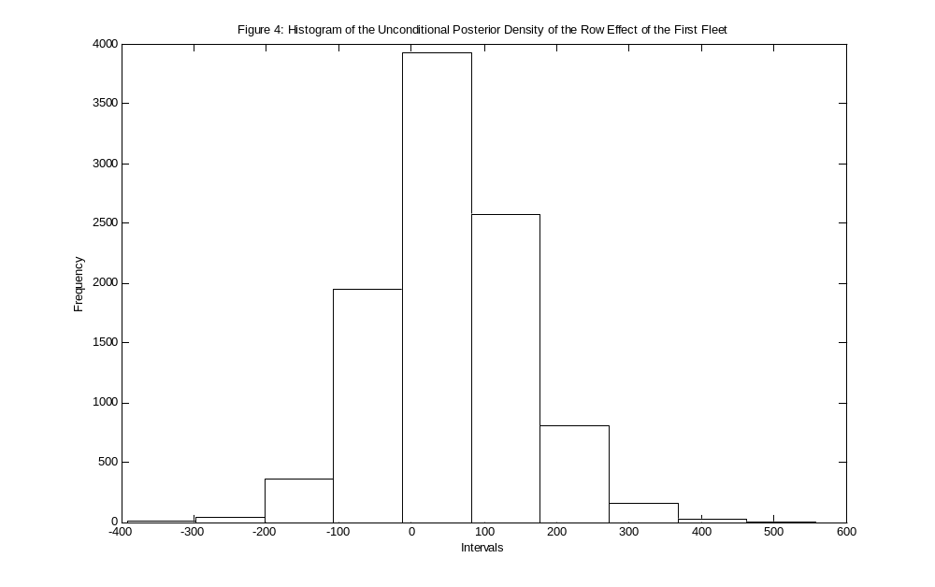
95 % Equal tails credibility interval: [-129.2507 , 257.2350], Mean: 54.4057

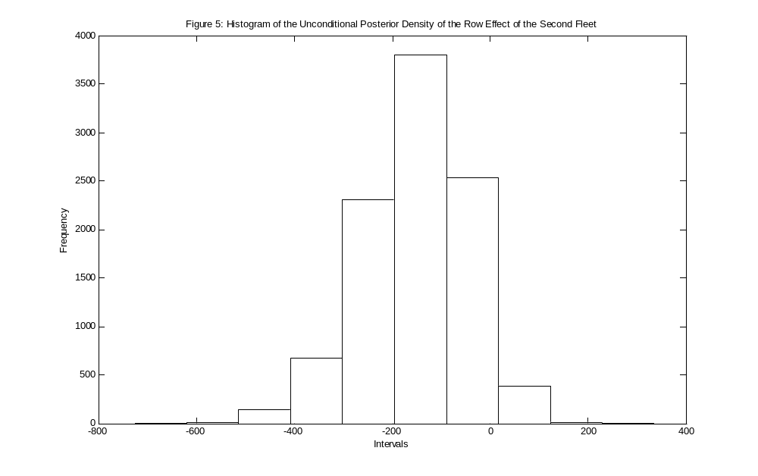
95 % Equal tails credibility interval: [-376.6378 , 37.0484], Mean: -150.1202
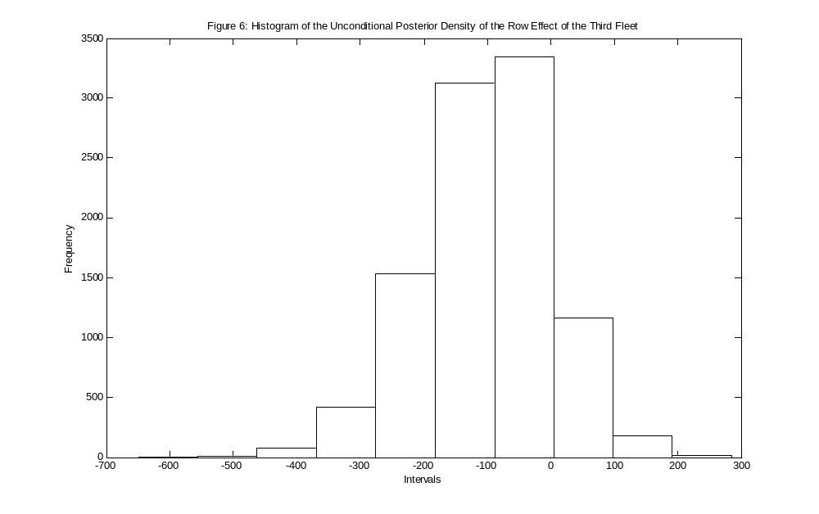
95 % Equal tails credibility interval: [-316.0705 , 84.1258], Mean: -101.2561

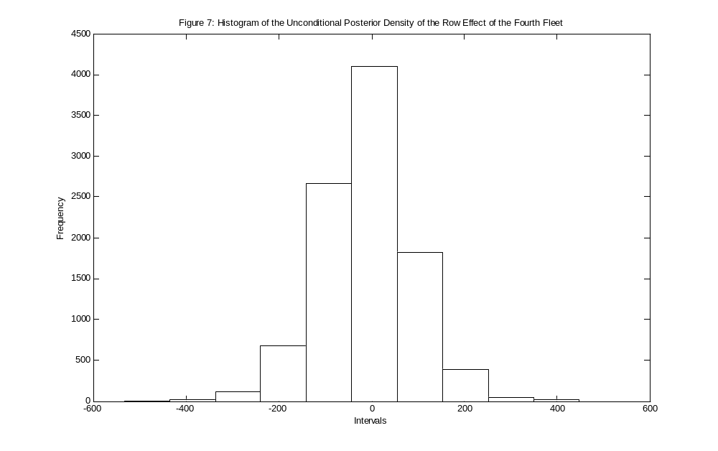
95 % Equal tails credibility interval: [-202.4550 , 181.3401], Mean: -10.5475
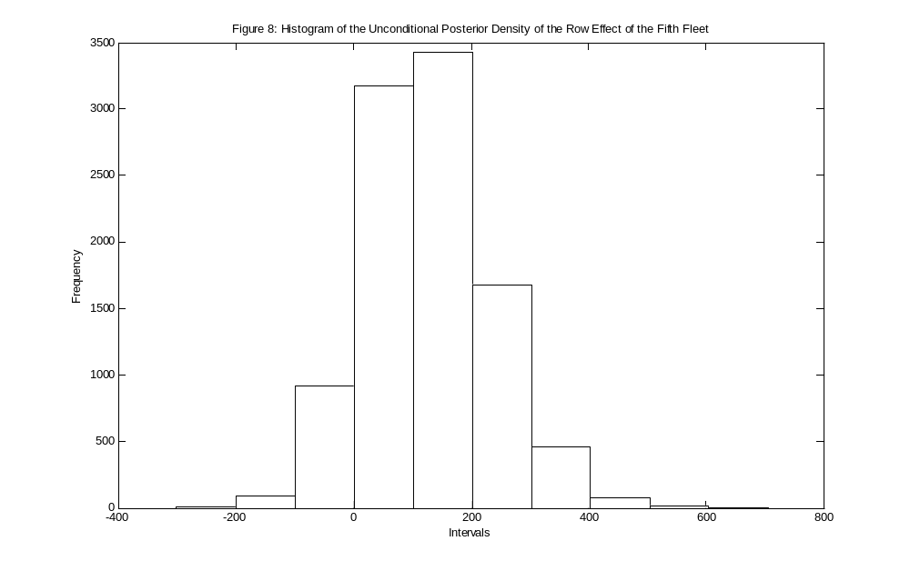
95 % Equal tails credibility interval: [-55.3566 , 350.1725], Mean: 130.0652

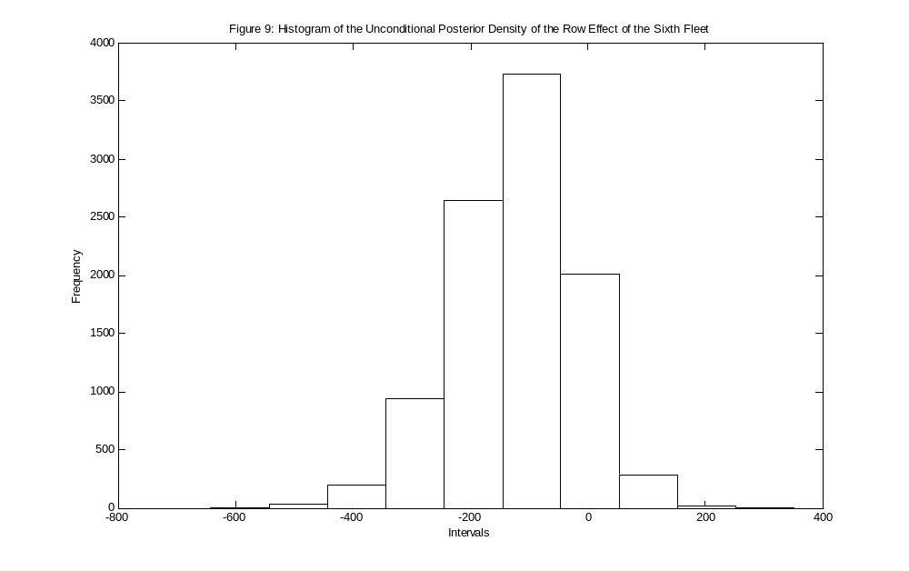
95 % Equal tails credibility interval: [-345.378 , 65.6778], Mean: -122.7428
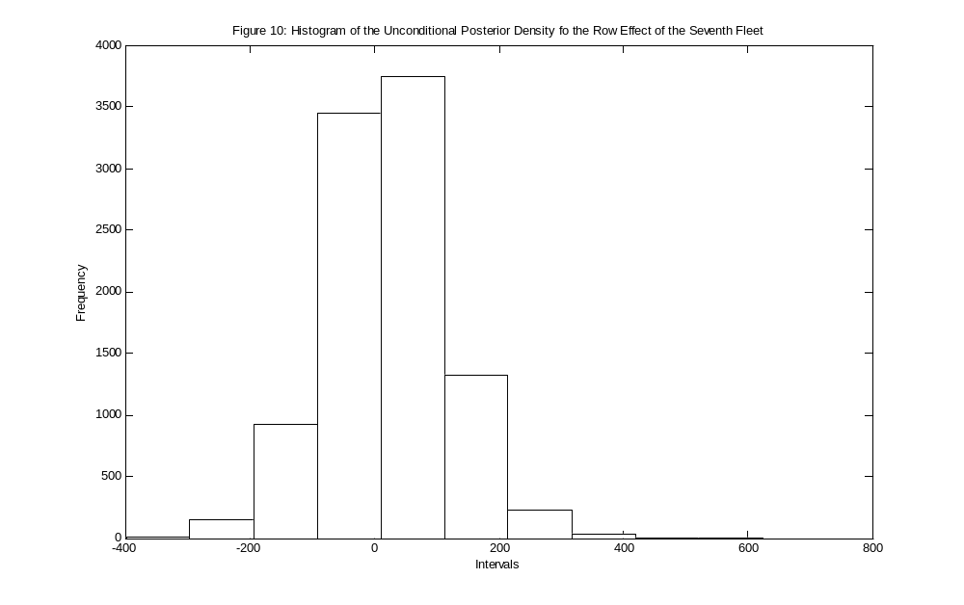
95 % Equal tails credibility interval: [-167.0938 , 220.5707], Mean: 20.8958
1
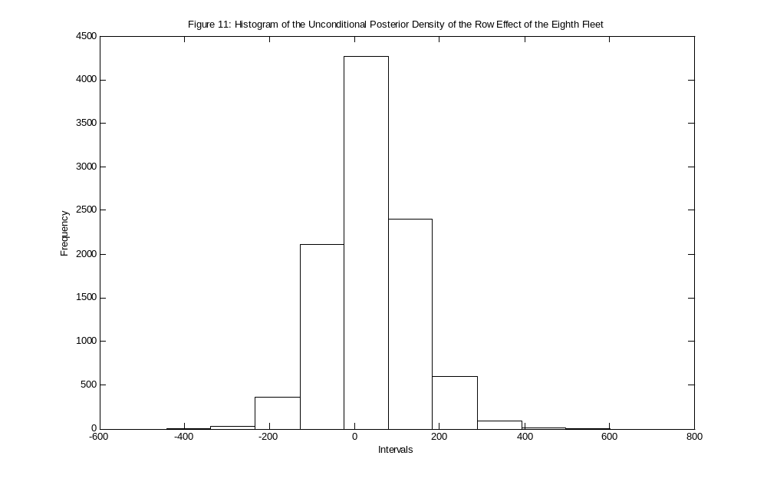
95 % Equal tails credibility interval: [-151.4618 , 242.6580], Mean: 38.5990
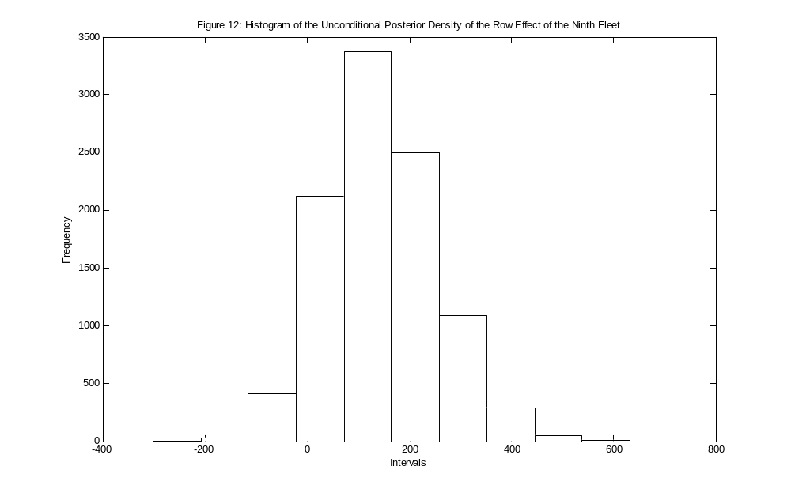
95 % Equal tails credibility interval: [-44.9879 , 370.9693], Mean: 144.5693

The Bayesian simulation method to obtain Figures 4 - 12 was conducted using the following steps:

- Substitute each pair of (σ₁² , σ₂²) into r_{i} / σ₁², σ₂², y ~
N([Jσ₂² / (σ₁² + Jσ₂²)][y_{i}. – y..],[σ₂² / (σ₁² + Jσ₂²)] [σ₁² + Jσ₂² / I]) to
obtain each of the nine row effects.
- Plot each of these sets of values using the histogram option.

4.4 Smooth curved unconditional predictive densities of the nine companies

In Figures 13 – 21 the smooth curved unconditional predictive densities of the nine companies are displayed. Given with each of them are their 95% Bayesian expectation tolerance interval and their mean. This is also the result that is needed to predict the expected claim amount for each company for the next year.

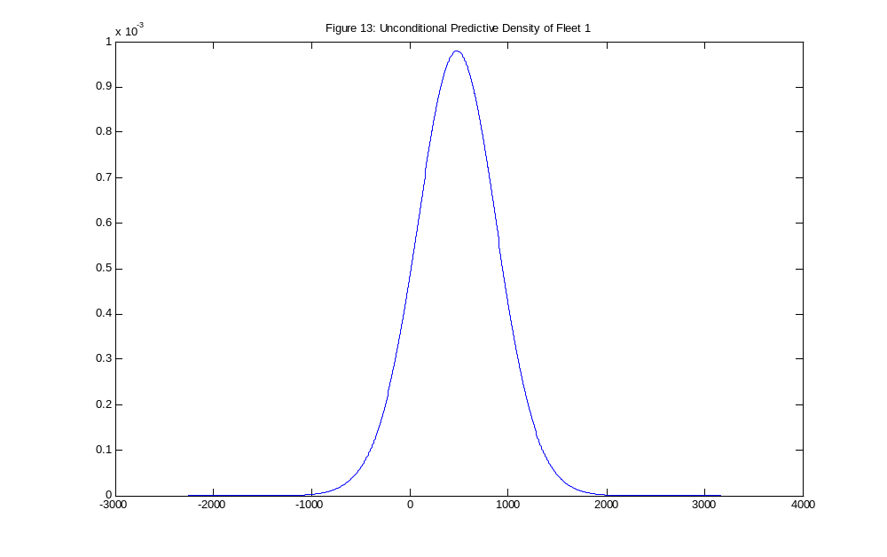
95% α-expectation tolerance interval: [-352.4067 , 1.2832 × 10³], Mean: 480.4443

95% of the expected claims for the eleventh year of company 1 will fall within the above interval and the expected mean claim is 480.4443.
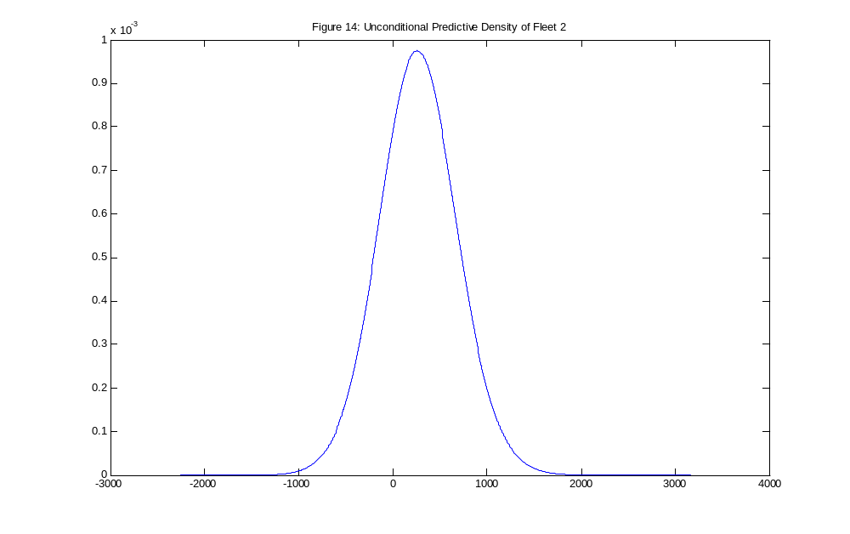
95% α-expectation tolerance interval: [-541.3337 , 1.1087 × 10³], Mean: 276.9945

95% of the expected claims for the eleventh year of company 2 will fall within the above interval and the expected mean claim is 276.9945.
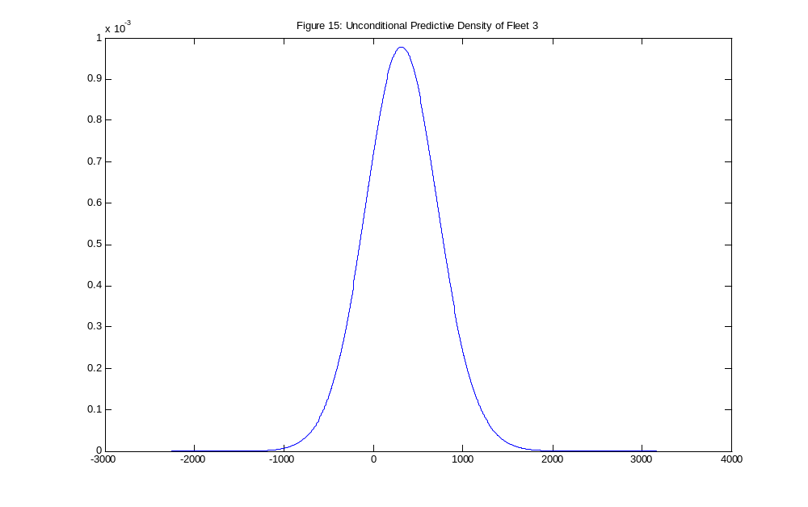
95% α-expectation tolerance interval: [-505.8256 , 1.1377 × 10³], Mean: 319.9075

95% of the expected claims for the eleventh year of company 3 will fall within the above interval and the expected mean claim is 319.9075.
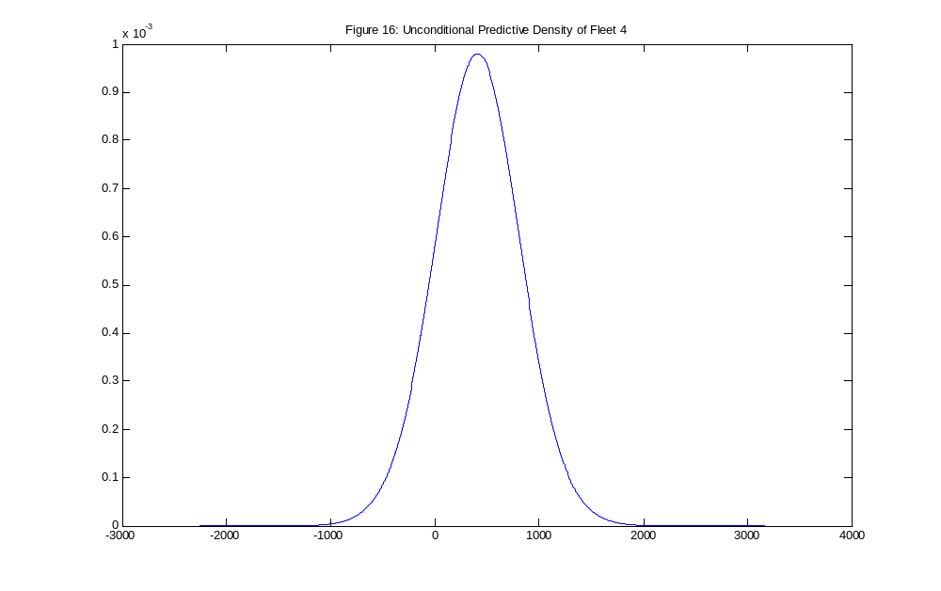
95% α-expectation tolerance interval: [-400.1090 , 1.2166 × 10³], Mean: 412.5281

95% of the expected claims for the eleventh year of company 4 will fall within the above interval and the expected mean claim is 412.5281.

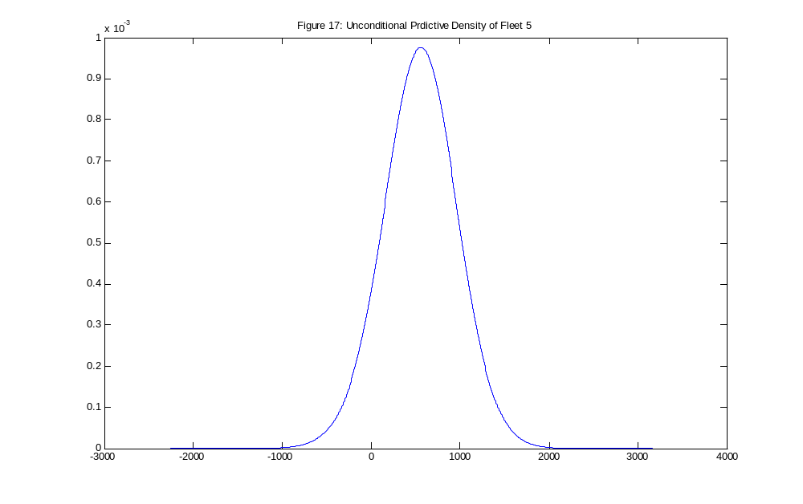
95% α-expectation tolerance interval: [-255.7364 , 1.3625 × 10³], Mean: 552.0538

95% of the expected claims for the eleventh year of company 5 will fall within the above interval and the expected mean claim is 552.0538.

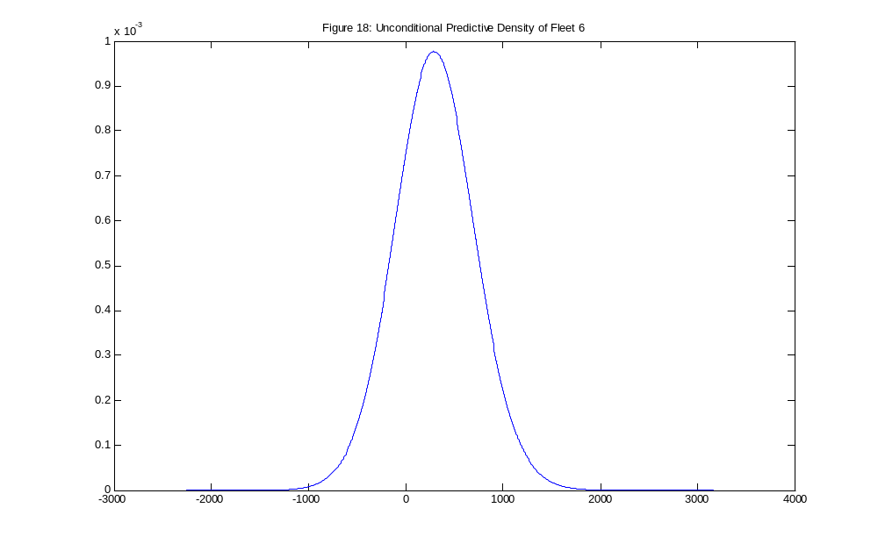
95% α-expectation tolerance interval: [-518.0963 , 1.1387 × 10³], Mean: 300.6511

95% of the expected claims for the eleventh year of company 6 will fall within the above interval and the expected mean claim is 300.6511.

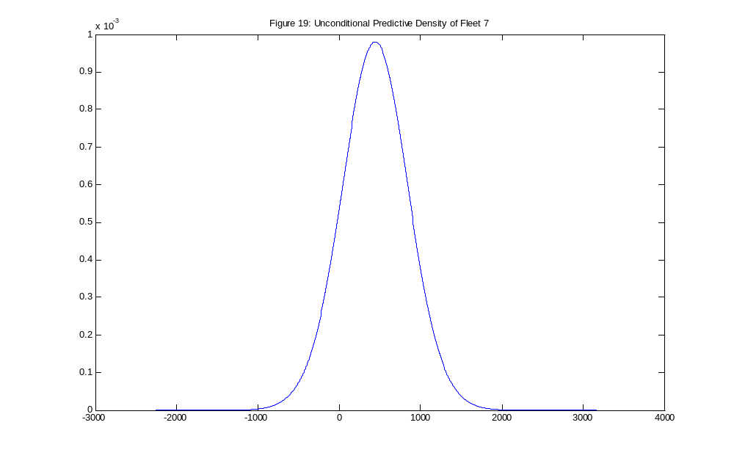
95% α-expectation tolerance interval: [-386.8171 , 1.2399 × 10³], Mean: 434.9274

95% of the expected claims for the eleventh year of company 7 will fall within the above interval and the expected mean claim is 434.9274.

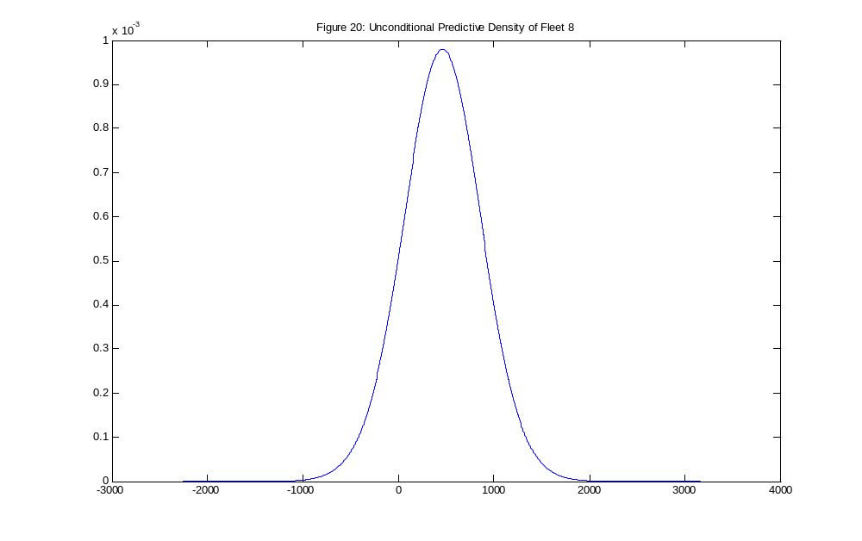
95% α-expectation tolerance interval: [-367.8210 , 1.2846 × 10³], Mean: 463.2367

95% of the expected claims for the eleventh year of company 8 will fall within the above interval and the expected mean claim is 463.2367.

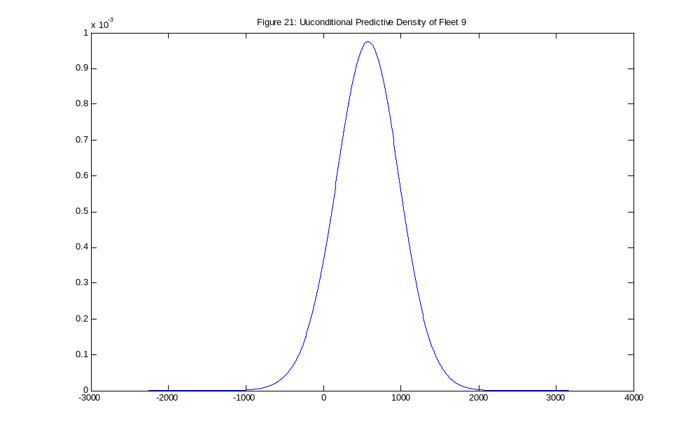
95% α-expectation tolerance interval: [-271.4431 , 1.3694 × 10³], Mean: 564.3510

95% of the expected claims for the eleventh year of company 9 will fall within the above interval and the expected mean claim is 564.3510.

The Bayesian simulation method to obtain Figures 13 - 21 was conducted using the following steps:

- Using the formulas E(y_{i} / σ₁², σ₂², y) and V(y_{i} / σ₁², σ₂², y) from chapter 3, determine E(y_{i} / σ₁², σ₂², y) and V(y_{i} / σ₁², σ₂², y) and obtain a Normal distribution by substituting these components into a Normal density function, for each pair of variances (σ₁² , σ₂²). Thus, if there is 10 000 pairs of variances (σ₁² , σ₂²), there is 10 000 Normal distributions.
- Take the average of these Normal distributions, which will result in the unconditional predictive density for the i^{th} company. i = 1,2,…,9
- To obtain the 95% Bayesian expectation tolerance interval, i.e. the α-expectation tolerance interval of the i^{th} company, where α = 0.05, set the lower limit equal to the 2.5th percentile which is the 247th value, and the upper limit equal to the 97.5th percentile which is the 9 613th value, where the values is in ascending order.

The idea of step-by-step explanations of all the calculations followed was found in “Bayesian tolerance intervals for the balanced two-factor nested random effects model” by Abrie J. Van der Merwe and Johan Hugo (2007).

Chapter 5: Conclusion

From the articles that I wrote about and my own example, it was proven that the Bayesian method can successfully be applied to many problems in practice. It is also evident that many statisticians and actuaries prefer the Bayesian methods above the frequentist approach.

Since high computational power is available today, much more accurate results can be generated than in the earlier years when computers were not available and in the later years not as highly developed. Also appropriate algorithms do exist to make accurate computations.

REFERENCES

Behan, D.F. (June 2009). “Statistical Credibility Theory”, http://www.behan.ws/Credibility_Presentation.pdf, p.1

Boor, A.J. (1996). “The Complement of Credibility”, Proceedings of the Casualty Actuarial Society, Volume 83, p.1,2

D‘Hooge, L., Goovaerts, M.J. (1975). “Bayesian Inference in Credibility Theory”, International Journal for Actuarial studies in Non-Life Insurance and Risk theory, Volume 8, nr.2, p.164

Gómez-Déniz, E. (2009), “Some Bayesian Credibility Premiums Obtained by using Posterior Regret Г-Minimax Methodology”, Bayesian Analysis, Volume 4, nr.2, p.223

Herzog, T. (January 2008). “The Rev. Thomas Bayes and credibility Theory”, Contingencies, p.40

http://www.aiaccess.net/English/Glossaries/GlosMod/e_gm_rao_blackwell.htm

http://www.scholarpedia.org/article/Rao-Blackwell_theorem

http://en.wikipedia.org/wiki/Credibility_theory

http://en.wikipedia.org/wiki/Markov_chain_Monte_Carlo

http://en.wikipedia.org/wiki/Prior_probability

http://en.wikipedia.org/wiki/Tolerance_interval

Klugman, S.A. (1992). “Bayesian Statistics in actuarial Science with Emphasis on Credibility”, Kluwer Academic Publishers, Boston, p.xi,1

Mahler, H.C., Dean, C.G. (2005). "Chapter 8: Credibility", http://www.casact.org/admissions/syllabus/ch8.pdf, p.485

Meyers, G. (1984). “Empirical Bayesian Credibility for Workers’ Compensation Classification Ratemaking”, Proceedings of the Casualty Actuarial Society, Volume 71, p.96,112

NIST/SEMATECH, e-Handbook of Statistical Methods, http://www.itl.nist.gov/div898/handbook/prc/section2/prc263.htm

Norberg, R. (2004). “Credibility theory”, http://stats.lse.ac.uk/norberg/links/papers/CRED-eas.pdf, p.1

Pereira, F. (1999). “Practical "Modern" Bayesian Statistics in Actuarial Science”, http://www.actuaries.org.uk/__data/assets/pdf_file/0003/26607/0159-0199.pdf, p.161

Roddermund, M., (1990). “Foundations of Actuarial Science”, New York: Casualty Actuarial Society, Introduction

Schmidt, K.D. (1980). “Convergence of Bayes and Credibility Premiums”, Astin Bulletin, Volume 20, nr.2, pp. 167

Van der Merwe, A.J., Hugo J. (2007). “Bayesian tolerance intervals for the balanced two-factor nested random effects model”, Test, Volume 16, p.599,604

Venter, G.G. “Credibility Theory for Dummies”, http://www.casact.org/pubs/forum/03wforum/03wf621.pdf, p.623

Verrall, R.J. (1990). “Bayes and Empirical Bayes Estimation for the Chain Ladder Model”, ASTIN Bulletin, Volume 20, nr.2, p.217

APPENDIX

The main programs written in MATLAB is as follow:

clear
clc

load H:\results1
randn ('seed', sum (100*clock));
J = 10;
I = 9;
expct = [];
varian = [];
f = [];
x = (456.79 - 6*451.2945): 0.001 :(456.79 + 6*451.2945);
d = [zeros (1, (max (size (x))))];
chance9 = [];
k = 0;
for i = 1:max (size (sig1))
i
s1 = sig1 (i);
s2 = sig2 (i);
expct = ((J*s2) / (s1 + J*s2))*655.2 + (s1/(s1 + \ J*s2))*422.2111111;
varian = s1 + (s1/(s1 + J*s2))*(s2 + (s1/I*J));
f1 = (exp (-0.5*((x - expct).^2) / varian))/(sqrt (2*pi)*sqrt \ (varian));
chance1 = randn (1,1)*sqrt (varian) + expct;
d = [d + f1];
chance9 = [chance9 chance1];
% f = [f f1];
k = k + 1;

% plot (x,f1);
% hold on
end;

e = d'/k;
plot (x,e)

save h:\r esult10 x e chance9

clc
clear

randn ('seed', sum (100*clock));

rmean = [ 509.5 178.3 258.8 404.3 630.9 224.7 453.7 484.5 655.2 ];
ymean = 422.2111111;
nu1 = 81;
nu2 = 8;
nu1m1 = 9135523.5;
nu2m2 = 2358529.489;
I = 9;
J = 10;
ra = [];
sig1 = [];
sig2 = [];
theta = [];

for j = 1:10000
j
y = randn (nu1,1);
y1 = y.^2;
y2 = sum (y1);
sig1a = nu1m1/y2;

x = randn (nu2,1);
x1 = x.^2;
x2=sum (x1);
sig2a = ((nu2m2/x2) - sig1a) / J;

p = randn (1,1);
theta1 = p*sqrt ((sig1a + J*sig2a)/(I*J)) + ymean;

r1=[];
for jj = 1:9
middle = rmean (jj) - ymean;
k = randn (1,1);
r11 = k*(sqrt ((sig2a/(sig1a +J*sig2a))*(sig1a + J*sig2a/I))) + \ ((J*sig2a/(sig1a +J*sig2a))*middle);
r1 = [r1 r11];
end;

if sig2a > 0
sig1 = [sig1 sig1a];
sig2 = [sig2 sig2a];
theta = [theta theta1];
ra = [ra;r1];
r=ra';
end;

end;

save h:\results1 sig1 sig2 theta r

figure (1)
hist (sig1)

figure (2)
hist (sig2)

figure (3)
hist (theta)

figure (4)
A=r (1,:);
hist (A)

clc
clear

load H:\results1
load H:\results2

chance1 = sort (chance9);
ptchance = mean (chance9)
LLchance = chance1 (247)
ULchance = chance1 (9613)

s1 = sort (sig1);
pt1 = median (s1)
LL1 = s1 (247)
UL1 = s1 (9613)

s2 = sort (sig2);
pt2 = median (s2)
LL2 = s2 (247)
UL = s2 (9613)

pta = mean (theta)
t = sort (theta);
LLa = t (247)
ULa = t (9613)

r1 = r (1,:);
r11 = sort (r1);
ptr1 = mean (r1)
LLr1 = r11 (247)
ULr1 = r11 (9613)

r2 = r (2,:);
r22 = sort (r2);
ptr2 = mean (r2)
LLr2 = r22 (247)
ULr2 = r22 (9613)

r3 = r (3,:);
r33 = sort (r3);
ptr3 = mean (r3)
LLr3 = r33 (247)
ULr3 = r33 (9613)

r4 = r (4,:);
r44 = sort (r4);
ptr4 = mean (r4)
LLr4 = r44 (247)
ULr4 = r44 (9613)

r5 = r (5,:);
r55 = sort (r5);
ptr5 = mean (r5)
LLr5 = r55 (247)
ULr5 = r55 (9613)

r6 = r (6,:);
r66 = sort (r6);
ptr6 = mean (r6)
LLr6 = r66 (247)
ULr6 = r66 (9613)

r7 = r (7,:);
r77 = sort (r7);
ptr7 = mean (r7)
LLr7 = r77 (247)
ULr7 = r77 (9613)

r8 = r (8,:);
r88 = sort (r8);
ptr8 = mean (r8)
LLr8 = r88 (247)
ULr8 = r88 (9613)

r9 = r (9,:);
r99 = sort (r9);
ptr9 = mean (r9)
LLr9 = r99 (247)
ULr9 = r99 (9613)

