

**Qatar University  
 College of Engineering  
 Computer Science and Engineering**

**CMPS350 Web development fundamentals  
 Spring 2024**

**Student #1 Name: Roudha Alkhalaf Student #1 QUID: 202002203**

**Student #2 Name: nouf Alkaabi Student #2 QUID: 202002196**

**Student #3 Name:Haya Alsubaey Student #3 QUID: 202002417**

**Section: L51**

**Date: 30March 2024**

**Website Description:** "The Closet" website is an e-commerce platform specializing in clothing for men, women, and children. We offer a different selection of stylish apparel, including trendy streetwear, elegant formal wear, and casual essentials. Our inventory features a variety of brands, styles, and sizes to cater to different fashion tastes and preferences. Whether users are looking for everyday outfits, special occasion attire, or statement pieces, "The Closet" aims to provide a seamless shopping experience with a focus on quality, affordability, and customer satisfaction.

**App Functionality:** "The Closet" app offers a user-friendly interface for buying and selling clothes. Key features include:

1. User Authentication Users can securely register and log in to their accounts to access the platform's features.
2. Browse and Search: Users can explore a wide range of clothing items, including tops, bottoms, dresses, outerwear, and accessories. They can browse by category or use the search feature to find specific items.
3. Purchase: Logged-in users can add items to their cart and proceed to checkout to complete their purchases. The app ensures secure transactions and provides order confirmation details.
4. Seller Dashboard: Sellers have access to a dashboard where they can manage their inventory, upload new items, update product details, and track sales.
5. Personalization: The app offers personalized recommendations based on user preferences and browsing history, enhancing the shopping experience.

**Githun link:** <https://github.com/Roudha-ra2002203/project.git>

**Application Design diagram (UI)**

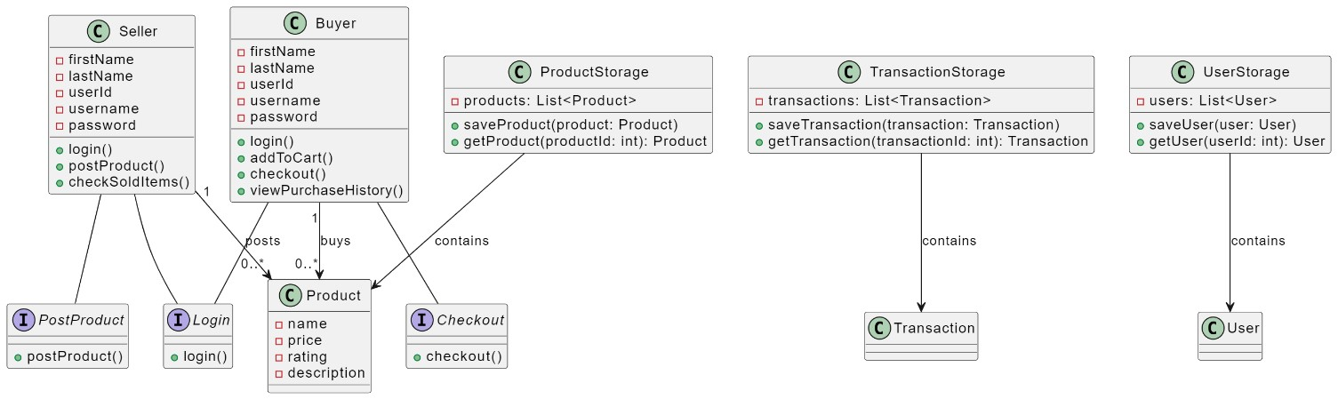

**Use case Testing**

# Use Case 1: Login

* It allows users to login to use the app using their username and password.

Login should be verified using the users data in users.json.

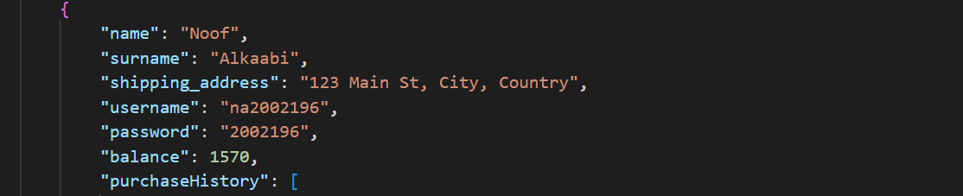

* A sample list of users will be provided in users. json. To keep the app simple, there is no need for the users to register to create an account to use the app.
* There are 3 users to login to the app (noof /haya/roudha).

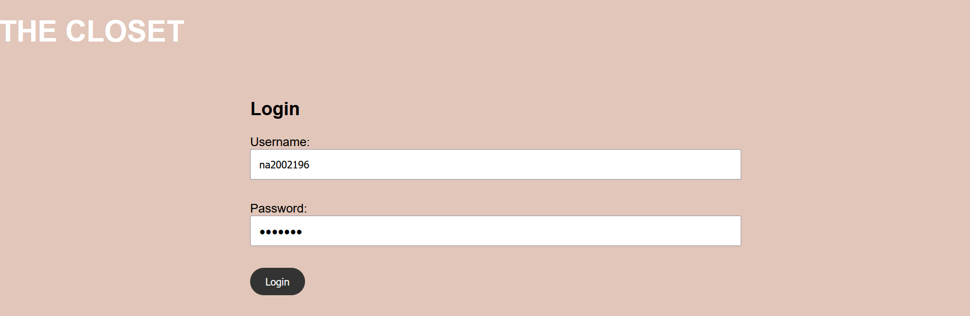

* Once a user is logged in, they will be directed to the main page of the app.

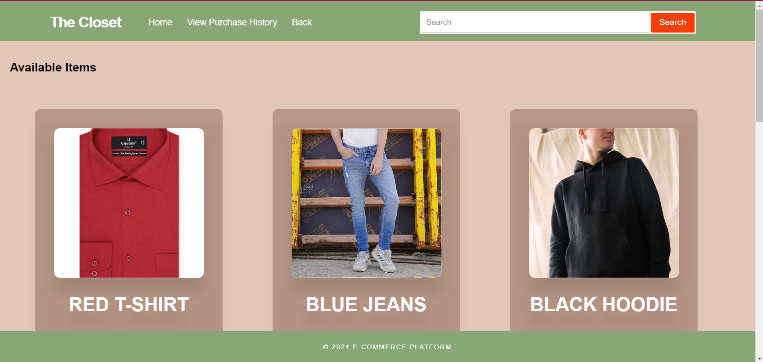

* An error message appear when the username is not the users. json.

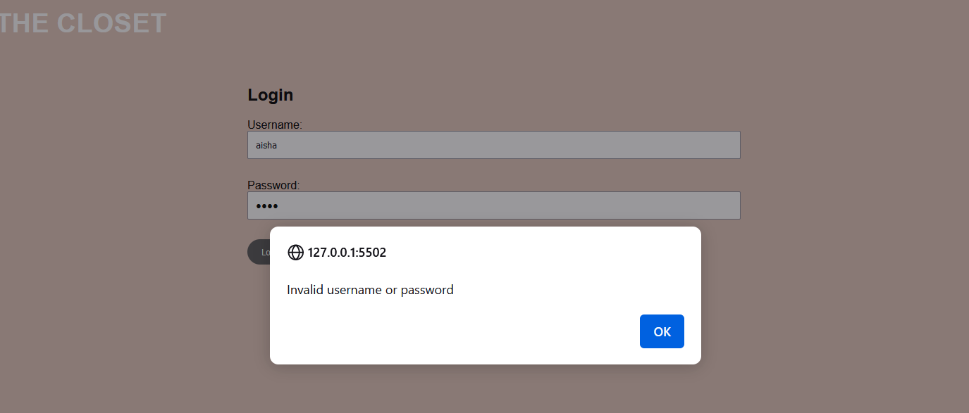

# Use Case 2: Search for available items.

* In the main page, user should be able to search available items. Once the search button is clicked, it will show only the suitable ones.
* To keep the application simple, you can create and use a json file for items.

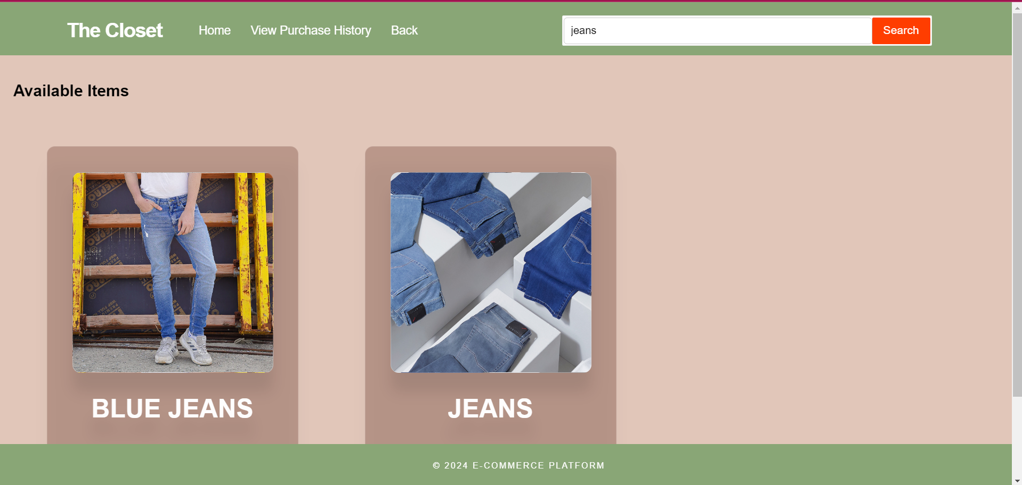

# Use Case 3: Purchase an item.

* A user can purchase an item. When the buy now button is clicked, it should direct the user to a new page to checkout.

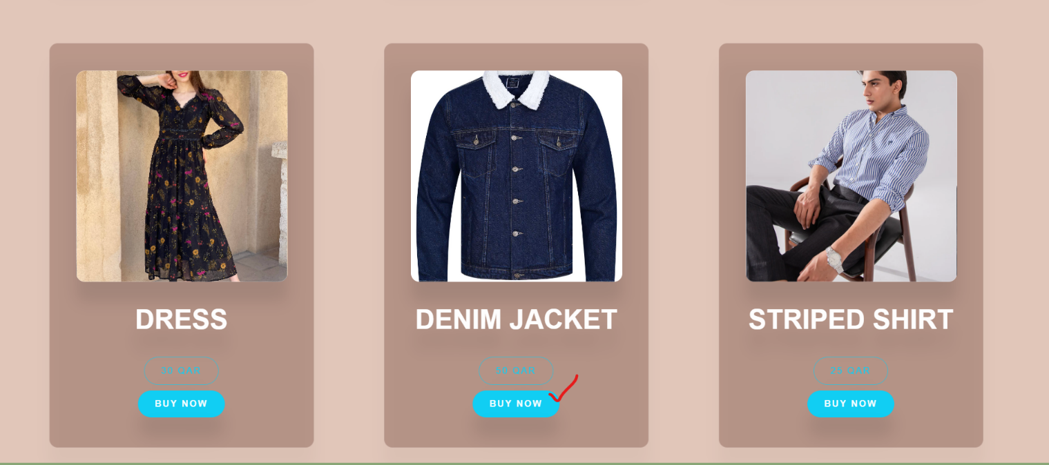

* purchase/sale histories are updated if purchase is successful.

# Use Case 4: View the purchase history.

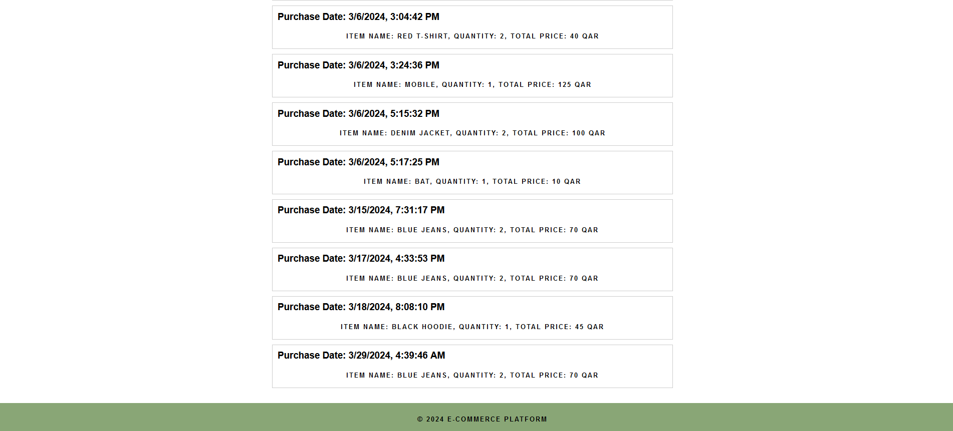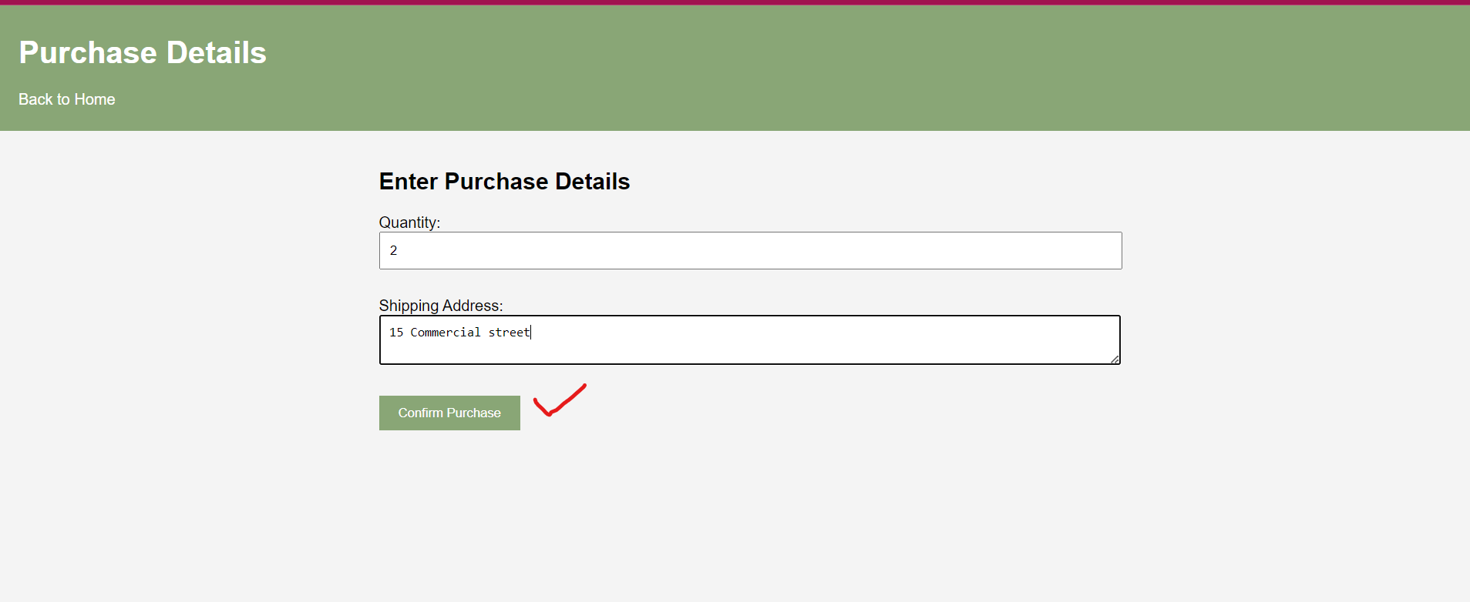• Customers should be able to see the list of purchased items.

# Use Case 5: View available items on sale and sale history.

* A seller should be able to see the list of items s/he is currently selling and the items that have already been sold.

* She should be able to click the item and see its details that how many items available. In the sale history section, how many items are sold, who bought it (username)

# Use Case 6: Upload an item to be sold.

* A seller can upload new items to be sold. The seller should define its price, available quantity, image and other details.

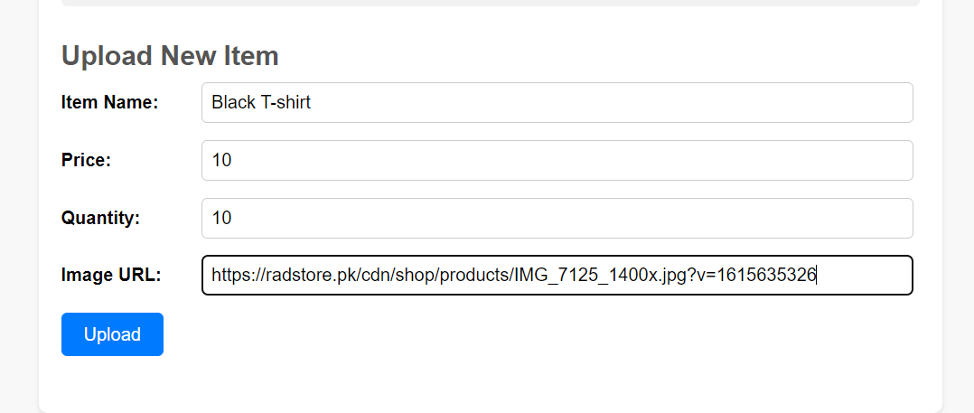

* The item should start appearing in the search and its quantity should be updated.

