**Software Requirements Specification**

**Version 1.0**

**<<Annotated Version>>**

**May 19, 2021**

**Hotel Management System**

* **ziad karam**
* **Roudi layoun**
* **Rawad Deeb**

**-Carol Elias**

<<Any comments inside double brackets such as these are not part of this SRS but are comments upon this SRS example to help the reader understand the point being made>>.

Refer to the SRS Template for details on the purpose and rules for each section of this document.

# Table of Contents

Table of Contents i

List of Figures ii

1.0. Introduction 1

1.1. Purpose 1

1.2. Scope of Project 1

1.3. Glossary 2

1.4. References 2

1.5. Overview of Document 2

2.0. Overall Description 4

2.1 System Environment 4

2.2 Functional Requirements Specification 5

2.2.1 Reader Use Case 5

Use case: Search Article 5

2.2.2 Author Use Case 6

Use case: Submit Article 6

2.2.3 Reviewer Use Case 7

Use case: Submit Review 7

2.2.4 Editor Use Cases 8

Use case: Update Author 8

Use case: Update Reviewer 9

Use case: Update Article 9

Use case: Receive Article 10

Use case: Assign Reviewer 11

Use case: Receive Review 11

Use case: Check Status 12

Use case: Send Response 12

Use case: Send Copyright 13

Use case: Remove Article 14

Use case: Publish Article 14

2.3 User Characteristics 15

2.4 Non-Functional Requirements 15

3.0. Requirements Specification 17

3.1 External Interface Requirements 17

3.2 Functional Requirements 17

3.2.1 Search Article 17

3.2.2 Communicate 18

3.2.3 Add Author 18

3.2.4 Add Reviewer 19

3.2.5 Update Person 19

3.2.6 Update Article Status 20

3.2.7 Enter Communication 20

3.2.8 Assign Reviewer 21

3.2.9 Check Status 21

3.2.10 Send Communication 22

3.2.11 Publish Article 22

3.2.12 Remove Article 23

3.3 Detailed Non-Functional Requirements 23

3.3.1 Logical Structure of the Data 23

3.3.2 Security 25

Index 26

# List of Figures

Figure 1 - System Environment 4

Figure 2 - Article Submission Process 6

Figure 3 - Editor Use Cases 8

Figure 4 - Logical Structure of the Article Manager Data 23

# Introduction

The Hotel Management System is a tool for booking the rooms of Hotel through online process by the Customer. It provides the proper management tools and ease of access to the Customer Information. ..

## 1.1. Purpose

The Software Requirements Speciﬁcation (SRS) will provide a detailed description of the requirements for the Hotel Management System (HMS). This SRS will allow for a complete understanding of what is to be expected from the newly introduced system which is to be constructed. The clear understanding of the system and its' functionality will allow for the correct software to be developed for the end user and will be used for the development of the future stages of the project. This SRS will provide the foundation for the project. From this SRS, the Hotel Management System can be designed, constructed, and ﬁnally tested. This SRS will be used by the system development team which is constructing the HMS and the hotel end users. The Project team will use the SRS to fully understand the expectations of this HMS to construct the appropriate software. The hotel end users will be able to use this SRS as a "test" to see if the constructing team will be constructing the system to their expectations. If it is not to their expectations the end users can specify how it is not to their liking and the team will change the SRS to ﬁt the end users' needs.

## 1.2. Scope of Project

The introducing software, Hotel Management System which is going to be implemented for Hotel Dayal will automate the major operations of the hotel. The Reservation System is to keep track in room and hall reservation and check availability. The Room Management System is for manage all room types room services. The Inventory Control System will keep track in all inventories of the hotel and guest details will handled by guest management. Administration department will monitor the all. There is three End Users for HMS. The End Users Are Owner, Manager and Receptionist. Owner can access to all system functionalities without any restrictions. Manager can access to all system functionalities with limited restrictions. Receptionist can only access to the Reservation management section. To keep restrictions for each End User levels HMS can create different Login functions. The objectives of the automated Hotel Management System is to simplify the day to day processes of the hotel. The system will be able to handle many services to take care of all customers in a quick manner. As a solution to the large amount of ﬁle handling happening at the hotel, this software will be used to overcome those drawbacks. Safety, easiness of using and most importantly the efﬁciency of information retrieval are some beneﬁts the development team going to present with this system. The system should be user appropriate, easy to use, provide easy recovery of

appropriate, easy to use, provide easy recovery of errors and have an overall end user high subjective satisfaction.

## 1.3. Glossary

|  |  |
| --- | --- |
| **Term** | **Definition** |
| SRS | Software Requirements Speciﬁcation ..  . |
| HMS | Hotel Management System .. |
| USR | Reviewer or Author |
| Editor | Person who receives articles, sends articles for review, and makes final judgments for publications. |
| Field | A cell within a form. |
| **End users** | The people who will be actually using the system SQL Structural Query Language .. |
| Member | A member of the Historical Society listed in the HS database. |
| Reader | Anyone visiting the site to read articles. |
| Review | A written recommendation about the appropriateness of an article for publication; may include suggestions for improvement. |
| Reviewer | A person that examines an article and has the ability to recommend approval of the article for publication or to request that changes be made in the article. |
| Software Requirements Specification | A document that completely describes all of the functions of a proposed system and the constraints under which it must operate. For example, this document. |
| Stakeholder | Any person with an interest in the project who is not a developer. |
| User | Reviewer or Author. |

## 1.4. References

IEEE. *IEEE Std 830-1998 IEEE Recommended Practice for Software Requirements Specifications.* IEEE Computer Society, 1998.

## 1.5. Overview of Document

. This SRS is organized into two parts the ﬁrst is the overall description and the second section is the speciﬁc requirement. The overall description will describe the requirement of Hotel Management System. The speciﬁc requirement section describes the detail of the system.

# 2.0. Overall Description

## 2.1 System Environment

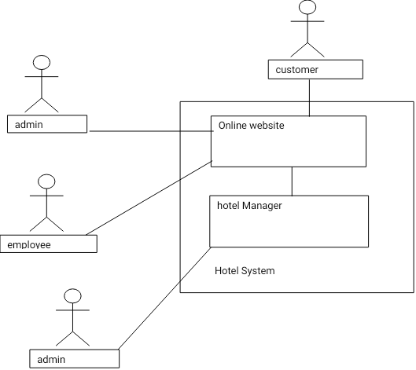

**Figure 1 - System Environment**

***2.1 Flow chart***

The booking System has three active actors and one cooperating system. The customer, admin, or hotel admin accesses the online booking through the Internet. Any admin communication with the system is through control panel. The customer accesses the entire system directly.

***2.2 Functional Requirements Specification***

This section outlines the use cases for each of the active readers separately. The reader, the author and the reviewer have only one use case apiece while the editor is main actor in this system.

2.2.1: admin Use Case

In case of multiple admin, this term refers to the *principal admin*, with whom all communication is made.

Use case: admin use case

**Diagram:**

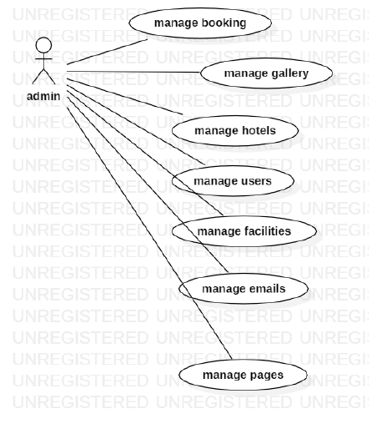

**Brief Description**

The admin confirms the booking.

**Initial Step-By-Step Description**

Before this use case can be initiated, the admin has already connected to the Online Booking System.

1. The admin chooses the *reservation to confirm it*.

2. The admin click on confirm the email will send to customer that your room confirmed.

3. The System generates and sends an email acknowledgement.

Xref: section 3.2.1, admin hotel

2.2.2: Use case: **Customer**

Diagram:

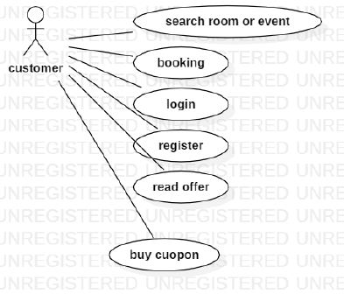

**Brief Description**

The customer accesses the Online Booking Website, searches for an room and reserve it.

**Initial Step-By-Step Description**

Before this use case can be initiated, the customer has already accessed the Online booking system.

8. The customer chooses to search by price, location, or keyword.

9. The system displays the choices to the Customer.

10. The customer selects the room or event desired.

11. The system presents the details of the order to the customer.

**Xref:** section 3.2.2, add customer;

### 2.2.3 Employee Use Case

**Diagram:** 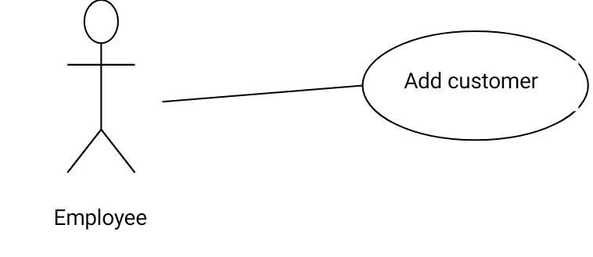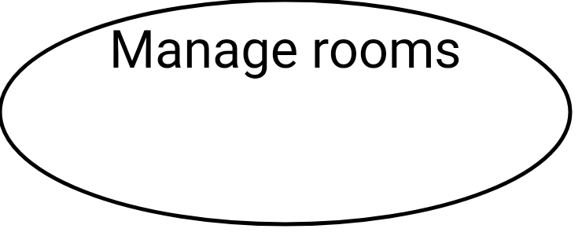

**Brief Description**

The confirms the booking. .

**Initial Step-By-Step Description**

Before this use case can be initiated, the Employee has already connected to the Online hotel Website.

1. The Employee chooses the *Email Editor* button.
2. The System uses the *sendto* HTML tag to bring up the user’s email system.
3. The Employee fills in the Subject line and attaches the file as directed and emails it.
4. The System generates and sends an email acknowledgement.

**Xref:** Section 3.2.3, Employee

2.2.4: administrative admin use case

**Diagram:**

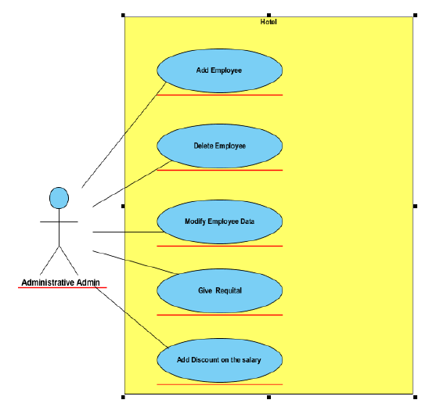

**Brief Description**

# Services provided to hotel managers: Administrative admin.

**Initial Step-By-Step Description**

# His mission is to manage the personnel affairs of the hotel, In addition to the hotel’s financial affairs department, he has the following responsibilities:

# 1- Add an employee to the working staff.

# 2- Dismissing an employee from his work.

# 3- Amending the employee's information when necessary.

# 4- Imposing penalties on an employee.

# 5- Granting a reward to an employee.

# 6- Calculating salaries of employees and disbursing them after taking into consideration (rebates) And employee rewards).

# 7- one account paid by the hotel to secure its requirements and pay taxes.

Xref: section 3.2.4 , adimistrative

2.2.5 : service admin use case

**Diagram:**

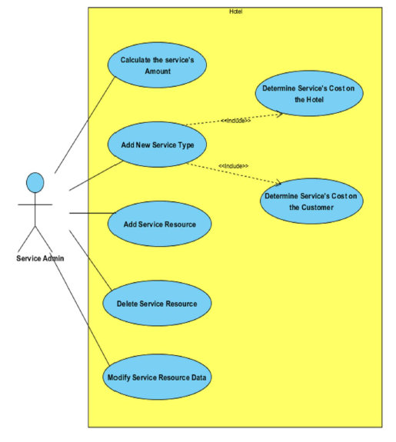

**Brief Description**

# Services provided to hotel managers : service admin

**Initial Step-By-Step Description :**

He is responsible for the services provided by the hotel and coordinating communication With the authorities that provide these services, and in detail, his mission will be:

# 1- Adding a new service at the hotel.

# 2- Calculating the available quantity of a service.

# 3- Add the service. Calculate the cost of the hotel towing

# 4- Determining the cost of the service that the customer incurs if he requests it.

# 5- Adding a new service agency to start dealing with it (company - factory - restaurant).

# 6 - Deleting a service agency the hotel was dealing with. G- Modifying the data of a service agency that the hotel deals with (location - phone numbers ..).

***Xref: section 3.2.5, service admin***

**2.3 User Characteristics :**

The customer is expected to be Internet literate and be able to use a search engine. The main screen of the Booking online system will have the search function and a link to “room details Information.”

The customer and admin hotel are expected to be Internet literate and to be able to use chat.

The admin is expected to be Windows literate and to be able to use button, pull-down menus, and similar tools.

The detailed look of these pages is discussed in section 3.2 below.

## 2.4 Non-Functional Requirements

1. The system must ensure that all the transferable data as for examples customers credit or debit card number, CVV Code, e-payment should be done in secured connection.

2. The system must be able to handle multiple transactions a time.

3. The system must provide customers 24*7 hours online booking service.

4. The system should support almost all the browsers (Internet Explorer, Safari, Chrome, and Firefox).

5. The system should be able to convert the price from R.S to USD.

6. System should send the newsletter about ongoing promotions or deal to registered customers.

7. Customers need to cancel the booking before 24 hrs. Otherwise their credit card will be charged for one day.

8. In promotion time the system will charge credit card promptly.

# 3.0 Requirements Specification

## 3.1 External Interface Requirements

The only link to an external system is the link to the Hotel Booking (HB) Database to verify the membership of a customer. The admin believes that a admin hotel has to confirm the booking. The HB Database fields of interest to the Hotel Booking System are member’s name, membership (ID) number, and email address (an optional field for the HB Database).

## 3.2 Functional Requirements

The Logical Structure of the Data is contained in Section 3.3.1.

### 3.2.1 Search room

|  |  |
| --- | --- |
| **Use Case Name** | Search room |
| **Xref** | Section 2.2.1, search room  SDD, Section 7.1 |
| **Trigger** | The customer assesses the Online hotel booking Website |
| **Precondition** | The Web is displayed with grids for searching |
| **Basic Path** | 1. The customer chooses how to search the Web site. The choices are by price, by Category, by location, and by Keyword.  2.If the search is by Keyword, the system creates and presents an alphabetical list of all Keyword in the database. In the case of a hotel with multiple rooms, each is contained in the list.  3. The customer selects a room.  4. The system creates and presents a list of all room by that location in the database.  5. The customer selects a room.  6. The system displays the details for the room.  7. The customer selects to book the room or to return to the room list or to the previous list. |
| **Alternative Paths** | In step 2, if the customer selects to search by category, the system creates and presents a list of all categories in the database.  3. The customer selects a category.  4. The system creates and presents a list of all rooms in that category in the database. Return to step 5.  In step 2, if the customer selects to search by keyword, the system presents a dialog box to enter the keyword or phrase.  3. The customer enters a keyword.  4. The system searches the details of rooms with that keyword and creates and presents a list of all such rooms in the database. Return to step 5. |
| **Postcondition** | The selected room is reserved. |
| **Exception Paths** | The customer may abandon the search at any time. |
| **Other** | The categories list is generated admin. |

**3.2.2: customer management:**

|  |  |
| --- | --- |
| **Use Case Name** | customer management |
| **XRef** | Section 2.2.4, customer management  SDD, Section 7.12 |
| **Trigger** | His mission is to manage the personnel affairs of the hotel |
| **Precondition** | The Web is displayed with grids for searching |
| **Basic Path** | 1-login to website.2-reservation room.3-de-reservation. 4- display your bill.  5- display services in hotel. |
| **Alternative Paths** | None. |
| **Postcondition** | one account paid by the hotel to secure its requirements and pay taxes |
| **Exception Paths** | The manager may abandon the operation at any time. |
| **Other** | The categories list is generated admin. |

**3.2.3: Employee manager:**

|  |  |
| --- | --- |
| **Use Case Name** | Employee manager |
| **XRef** | Section 2.2.4, Employee manager  SDD, Section 7.12 |
| **Trigger** | His mission is to manage the personnel affairs of the hotel |
| **Precondition** | The Web is displayed with grids for searching |
| **Basic Path** | 1-create reservation.2- de-reservation3- update on reservation information.4- Room management. 5- calculate customers bill. |
| **Alternative Paths** | None. |
| **Postcondition** | one account paid by the hotel to secure its requirements and pay taxes |
| **Exception Paths** | The manager may abandon the operation at any time. |
| **Other** | The categories list is generated admin. |

### 3.2.4: service admin:

|  |  |
| --- | --- |
| **Use Case Name** | Service admin |
| **XRef** | Section 2.2.4, administrative  SDD, Section 7.11 |
| **Trigger** | He is responsible for the services provided by the hotel and coordinating communication With the authorities that provide these services |
| **Precondition** | The Web is displayed with grids for searching |
| **Basic Path** | 1-Adding a new service at the hotel.2- Calculating the available quantity of a service.3- Add the service. Calculate the cost of the hotel towing4- Determining the cost of the service that the customer incurs if he requests it.5- Adding a new service agency to start dealing with it (company - factory - restaurant). |
| **Alternative Paths** | None. |
| **Postcondition** | Modifying the data of a service agency that the hotel deals with (location - phone numbers |
| **Exception Paths** | The manager may abandon the operation at any time. |
| **Other** | The categories list is generated admin. |

3.2.5: administrative admin:

|  |  |
| --- | --- |
| **Use Case Name** | administrative admin: |
| **XRef** | Section 2.2.4, administrative maneger  SDD, Section 7.12 |
| **Trigger** | His mission is to manage the personnel affairs of the hotel |
| **Precondition** | The Web is displayed with grids for searching |
| **Basic Path** | 1-Add an employee to the working staff.2- Dismissing an employee from his work.3- Amending the employee's information when necessary.4- Imposing penalties on an employee. 5- Granting a reward to an employee |
| **Alternative Paths** | None. |
| **Postcondition** | one account paid by the hotel to secure its requirements and pay taxes |
| **Exception Paths** | The manager may abandon the operation at any time. |
| **Other** | The categories list is generated admin. |

## 3.3 Detailed Non-Functional Requirements

### 3.3.1 Logical Structure of the Data

The logical structure of the data to be stored in the internal hotel Manager database is given below.

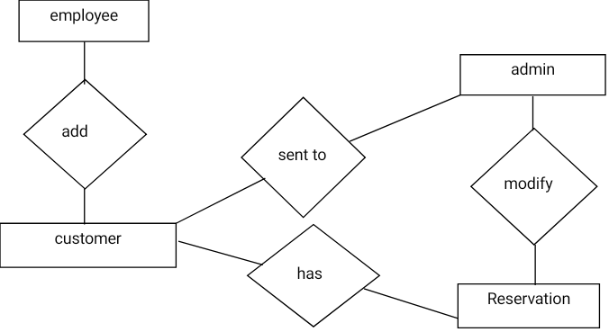

**Figure 4 - Logical Structure of the hotel Manager Data**

The data descriptions of each of these data entities is as follows:

**employee Data Entity**

|  |  |  |  |
| --- | --- | --- | --- |
| **Data Item** | **Type** | **Description** | **Comment** |
| Name | Text | Name of principle employee |  |
| Email Address | Text | Internet address |  |

**admin Data Entity**

|  |  |  |  |
| --- | --- | --- | --- |
| **Data Item** | **Type** | **Description** | **Comment** |
| Name | Text | Name of principle admin |  |
| ID | Integer | ID number of Historical Society member | Used as key in Historical Society Database |
| Email Address | Text | Internet address |  |
| password | Integer |  |  |

**bill Entity**

|  |  |  |  |
| --- | --- | --- | --- |
| **Data Item** | **Type** | **Description** | **Comment** |
| id | integer |  |  |
| Service name | string | Name of service |  |
| Service-cost | integer |  |  |

**Reservation Entity**

|  |  |  |  |
| --- | --- | --- | --- |
| **Data Item** | **Type** | **Description** | **Comment** |
| cid | integer | nun of customer |  |
| Room-id | integer |  |  |
| period | integer | Period for end reservation online |  |
| member | integer | num of person whose come to stay in hotel |  |

**service Entity**

|  |  |  |  |
| --- | --- | --- | --- |
| **Data Item** | **Type** | **Description** | **Comment** |
| Name | Text | Name of service |  |
| source | Text |  |  |

### 3.3.2 Security

The server on which the Online hotel resides will have its own security to prevent unauthorized *login*/sign-out access. There is no restriction on *read* access. The use of email by an Employee or Admin is on the client systems and thus is external to the system.

The PC on which the hotel Manager resides will have its own security. Only the Customer will have physical access to the machine and the program on it.

Index

Abstract, 6, 17, 27

add, 9, 11, 19, 20, 21

Add, 8, 9, 19

Article, 1, 5, 6, 7, 8, 9, 10, 11, 12, 13, 14, 15, 16, 17, 18, 19, 20, 21, 22, 23, 24, 25, 26, 27, 28

Article Manager, 5, 8, 9, 10, 11, 12, 13, 14, 15, 16, 19, 20, 21, 22, 23, 24, 25, 28

Author, 1, 4, 5, 6, 7, 8, 9, 13, 14, 16, 17, 19, 20, 22, 23, 25, 26, 27

Category, 5, 14, 17, 18, 20, 21, 23, 26, 27

Database, 2, 9, 11, 14, 15, 16, 17, 18, 19, 20, 21, 22, 24, 25, 26, 27

Editor, 1, 4, 5, 6, 7, 8, 9, 10, 11, 12, 13, 14, 15, 16, 17, 19, 20, 21, 22, 23, 24, 25, 28

Field, 17, 19, 20

Form, 1, 6, 9, 10, 11, 12, 14, 19, 20, 21, 23, 24, 27

Grid, 9, 11, 12, 19, 20, 21

Historical Society, 1, 5, 9, 11, 16, 17, 19, 20, 26

Online Journal, 4, 5, 6, 7, 15, 16, 17, 18, 24, 27, 28

Reader, 4, 5, 6, 16, 17, 18

Review, 1, 7, 11, 12, 18, 21, 23, 26, 27

Reviewer, 1, 4, 5, 6, 7, 9, 11, 16, 17, 19, 20, 21, 22, 23, 26, 27

Security, 27, 28

Status, 11, 12, 13, 14, 17, 21, 22, 23, 27

update, 9, 11, 20, 21

Update, 8, 9, 10, 11, 12, 13, 14, 15, 17, 19, 20, 21, 22

User, 7, 16, 18

Web Publishing System, 1, 4, 5, 17