

Assignment 02
Name: Mehedi Hasan Rowdro
Student id: 24101226
Section: 03
Course code: CSE320
Course title: Data Communication
Semester: Spring 25

Answer to the Question No. 01

Scenario 01:
Network Type: LAN (Local Area Network)
Reason: The 10 labs are in the same building (UB06) in a comparative small area, that’s why it is LAN.

Scenario 02:
Network Type: WAN (Wide Area Network)
Reason: As the PCs in BU01 and the PCs at Brac Center are in different networks and can communicate with each other, here the network type is WAN.

Scenario 03:
Network type: WAN (Wide Area Network)
Reason: Brac Center (in Gulshan) and Brac CDM (in Rajendrapur) are in distant places and the distance between this to places is most likely 45km. So, it’s a WAN network.

Scenario 04:
Network Type: MAN (Metropolitan Area Network)
Reason: As the fire stations are in the same city. so, the network type is MAN.

Answer to the Question No. 02

- Number 1 is Ring Topology
- Number 2 is Mesh Topology
- Number 3 is Star Topology
- Number 4 & 5 are Bus Topology

Answer to the Question No. 03

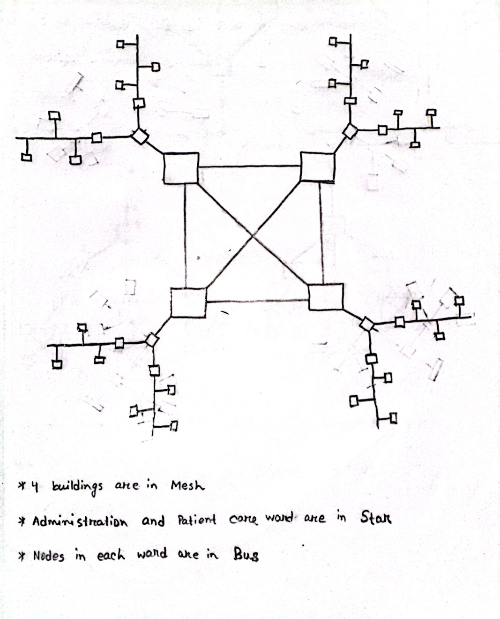
Answer to the Question No. 04

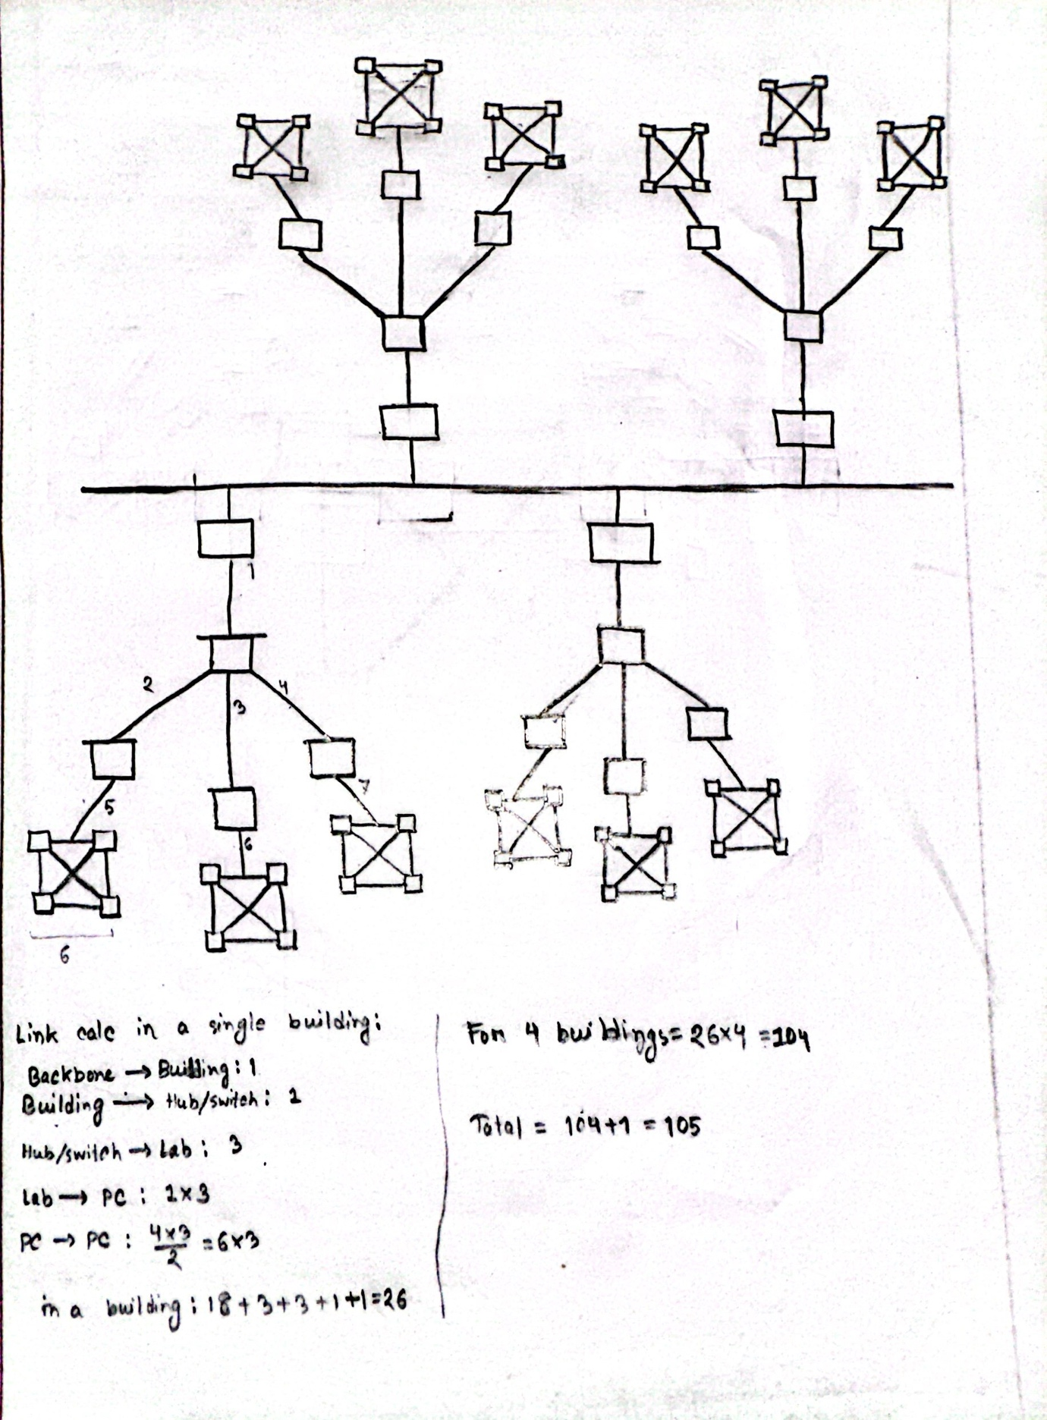
Answer to the Question No. 05

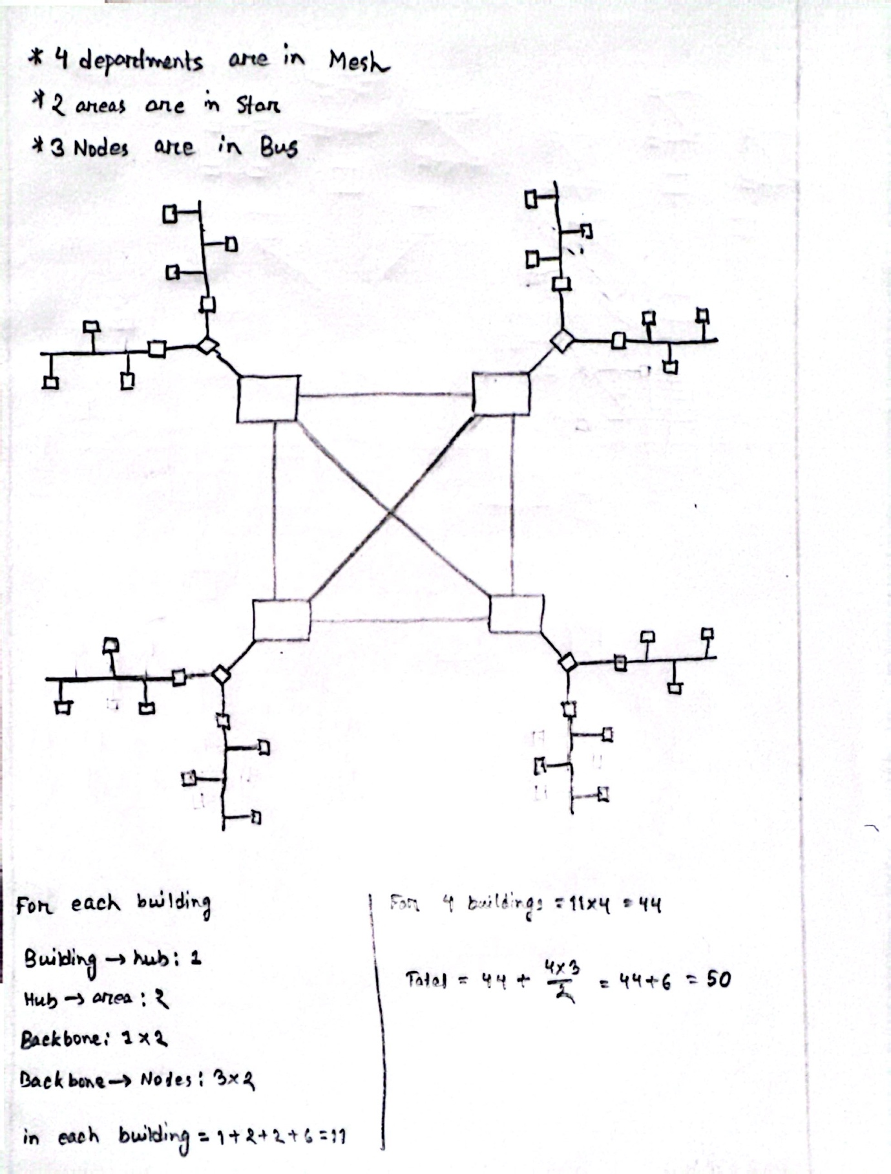
Answer to the Question No. 06

Network type | Full form | Coverage area | Example
PAN | Personal Area Network | Within few meters of radius around an individual. | Bluetooth, Airdrops.
LAN | Local Area Network | Within an office, building or campus. | Wi-fi, lab network.
MAN | Metropolitan Area Network | Within a city. | TV cable network.
WAN | Wide Area Network | Within countries, or even globally. | Internet.

Answer to the Question No. 07

- End-to-end device: Computer, Mobile phone.
- Intermediary device: Router, Hub.

Answer to the Question No. 08
Software is classified in two types.
- System Software: The built-in (mostly) software which manage the hardware are called System Software. This type of software works like a bridge between users and hardware. Example: Windows, MacOS, Linux.
- Application Software: Software which are used for specific types of tasks, for example productivity, entertainment, or communication, they are called the Application Software. Example: Microsoft word, Power point, Gmail.

Answer to the Question No. 09

Data Type | Standard/file extensions
Image | .jpg, .gif, .png
Audio | .mp3, .m4a, .wav
Video | .mp4, .mkv, .mov
Text | .txt, .docx, .pdf
Application | .apk, .dmg, .jar
Code | .py, .java, .c, .cpp, .html, .js
Spreadsheet | .xls, .xlsx
Presentation | .ppt, .pptx
Compressed file | .zip

Answer to the Question No. 10

The factors that determine the effectiveness of a network system are:
- Delivery
- Accuracy
- Timeliness
- Jitter

