

Assignment 04
Name: Mehedi Hasan Rowdro
Student id: 24101226
Section: 03
Course code: CSE320
Course title: Data Communication
Semester: Spring 25

Answer to the Question No. 01

  - Period(T): The time a signal takes to complete a full cycle.
Unit: S
Equation: T = 1 / f
  - Wavelength(λ): The distance a signal travels in one period.
Unit: m
Equation: λ = v / f
  - Frequency(f): The number of full cycles in one second.
Unit: Hz
Equation: f = 1 / T
  - Amplitude: The intensity of a signal.
Unit: V(for electrical signal)
  - Phase: The position or condition of wave particle in a specific time.
Unit: Degree, radian
  - Bandwidth(B): The difference between the highest and the lowest frequencies of a composite signal.
Unit: Hz, bps
Equation: B=f_{max} - f_{min}
  - Bit Rate: The number of bits sent per second.
Unit: bps
Equation: R=Number of bits / time
  - Bit Length: The distance one bit occupies in transmission medium.
Unit: m
Equation: Length=speed*time
  - Attenuation: The loss of energy in overcoming resistance of the medium.
Unit: dB
Equation: A=10log₂ (P_{in} / P_{out} )
1.10 Distortion: The change of shape or form of signal.
1.11 Noise: Mixing of extra signal other than the sender sent.
Unit: dB
1.12 Signal-to-noise ratio (SNR): The ratio of the signal power to the noise power.
Equation: SNR = (average signal power / average noise power)

1.13 Throughput: The actual measurement of how fast we can send data.
Unit: bps
1.14 Latency (Delay): The total time of the data completely reaching the destination.
Unit: S
Equation: Latency = propagation time + transmission time + queuing time + processing delay
1.15 Transmission time: The time between first bit’s leaving and last bit’s arriving.
Unit: S
Equation: Transmission time = (Message Size / Bandwidth)
1.16 Queueing time: The time needed for each intermediate or end device to hold the message before it can be processed.
Unit: S

1.17 Processing time: The time taken by a system (router, switch, etc.) to process a packet before forwarding it.
Unit: S

1.18 Propagation time: The time required for a bit to travel from the source to destination.
Unit: S
Equation: Propagation Time = (Distance / Propagation Speed)
1.19 Jitter: Different packets of data encountering different delays.
Unit: mS

1.20 Broadband transmission or modulation: Changing the digital signal to an analog signal for transmission.

Answer to the Question No. 02

Periodic vs Non-periodic

Periodic | Non-periodic
1. Follows a pattern within specific amount of time and complete cycle. | 1. Doesn’t follow any pattern.
2. Repeats that cycle in same amount of time. | 2. Doesn’t repeat any cycle.

Analog vs digital signals

Analog signals | digital signals
1. Is continuous. | 1. Is discrete.
2. Example: Sounds made by human. | 2. Data stored in computer in the form of 0s and 1s.

Answer to the Question No. 03
Sl | Statements | True/False
1. | Frequency and period are the inverse of each other. | True
2. | Frequency is the rate of change with respect to wavelength. | False
3. | If a signal does not change at all, its frequency is one. | False
4. | If a signal changes instantaneously, its frequency is infinite. | True
5. | Phase describes the position of the waveform relative to time 0. | True
6. | The wavelength is the distance a simple signal can travel in one period. | True
7. | A complete sine wave in the time domain can be represented by one single spike in the frequency domain. | True
8. | If the composite signal is non-periodic, the decomposition gives a combination of sine waves with discrete frequencies. | False
9. | A composite signal is made of many simple sine waves. | True
10. | A complete sine wave in the time domain can be represented by one single spike in the frequency domain. | True
11. | A sine wave with a phase of 90° starts at time 0 with a peak amplitude. The amplitude is increasing. | False
12. | A sine wave with a phase of 180° is shifted to the left by a ½ cycle. However, note that the signal does not really exist before time 0. | True
13. | Bit rate is the same as bits-per-second. | True
14. | A vertical line in the time domain means a frequency of infinity (sudden change in time); a horizontal line in the time domain means a frequency of zero (no change in time). | True
15. | A digital signal is a composite analog signal with an infinite bandwidth. | True
16. | If we need to send bits faster, we need as less bandwidth as possible. | False
17. | If the available channel is a bandpass channel, we can send the digital signal directly to the channel. | False
18. | When a signal, simple or composite, travels through a medium, it loses some of its energy in overcoming the resistance of the medium. | True
19. | Increasing the levels of a signal increases the reliability of the system. | False
20. | The Shannon capacity gives us the upper limit; the Nyquist formula tells us how many signal levels we need. | True

Answer to the Question No. 04

the two contexts of bandwidth that we use in Networking are
1. Bandwidth in Hertz
2. Bandwidth in Bits per Seconds

Answer to the Question No. 05
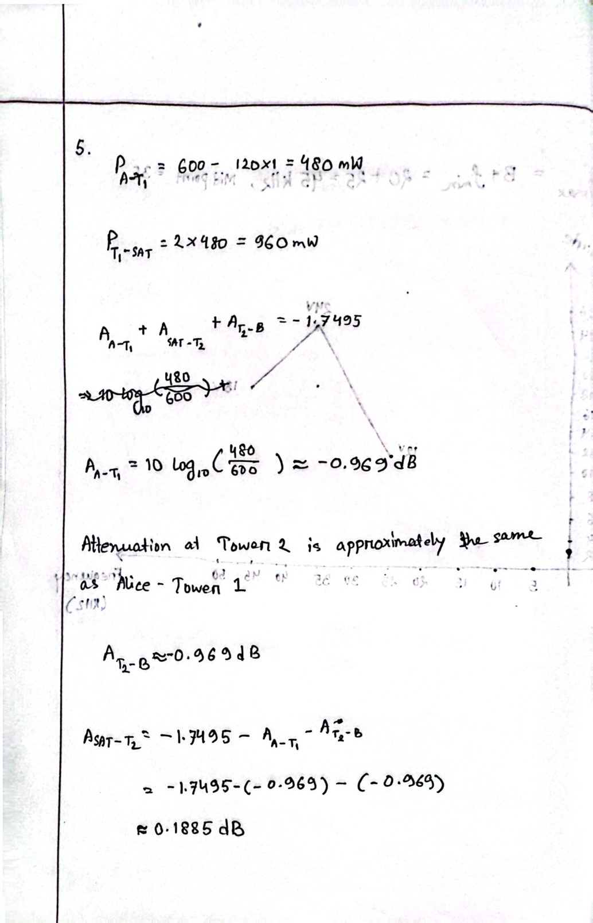

Answer to the Question No. 06
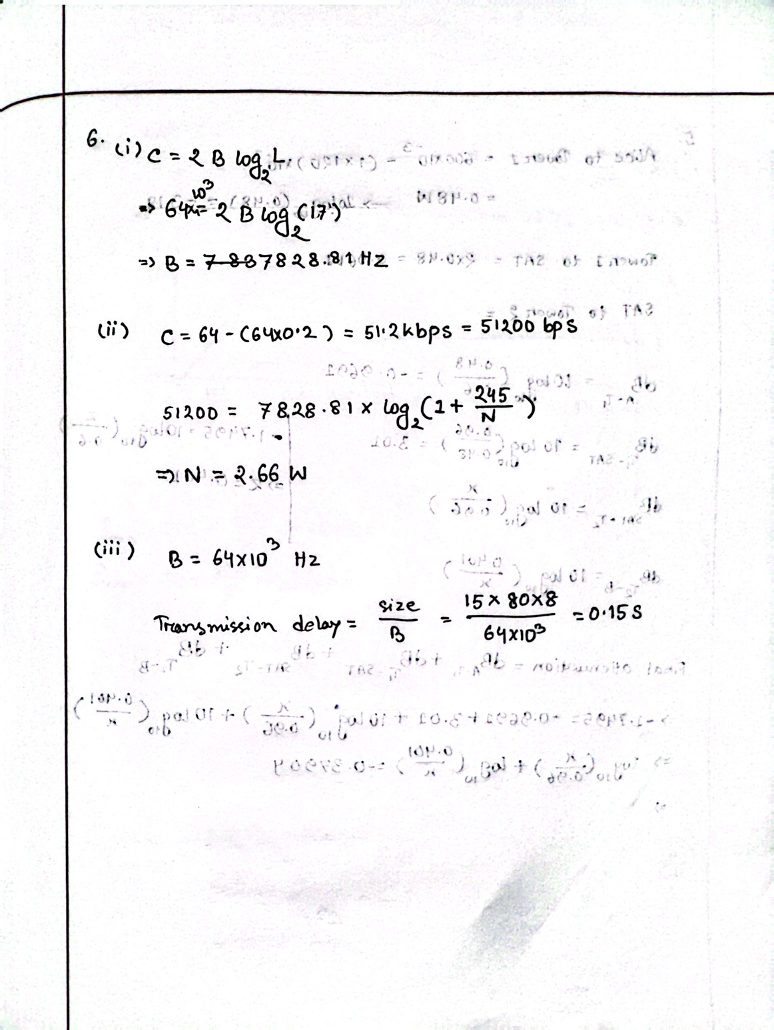

Answer to the Question No. 07
Baseband | Broadband
1. Baseband transmission means sending a digital signal over a channel without changing the digital signal to an analog signal. | 1. Broadband transmission or modulation means changing the digital signal to an analog signal for transmission.
2. Baseband transmission requires that we have a low-pass channel, a channel with  a bandwidth that starts from zero. | 2. Broadband transmission or modulation uses a bandpass channel with a bandwidth that does not start from zero.

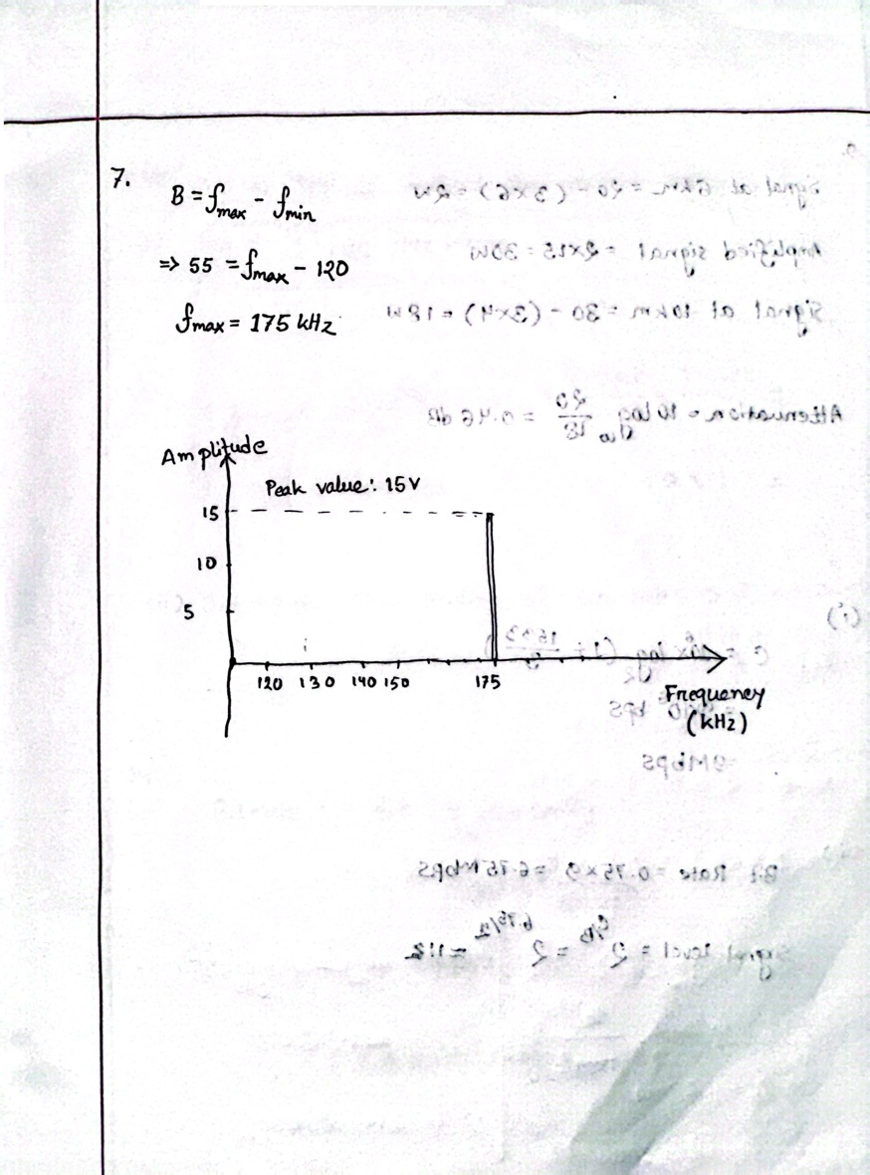
Answer to the Question No. 08
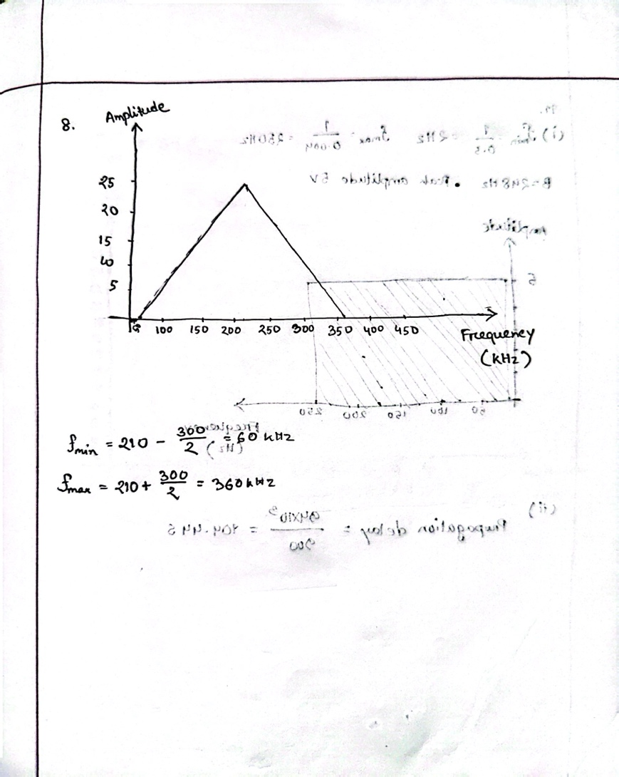
Answer to the Question No. 09
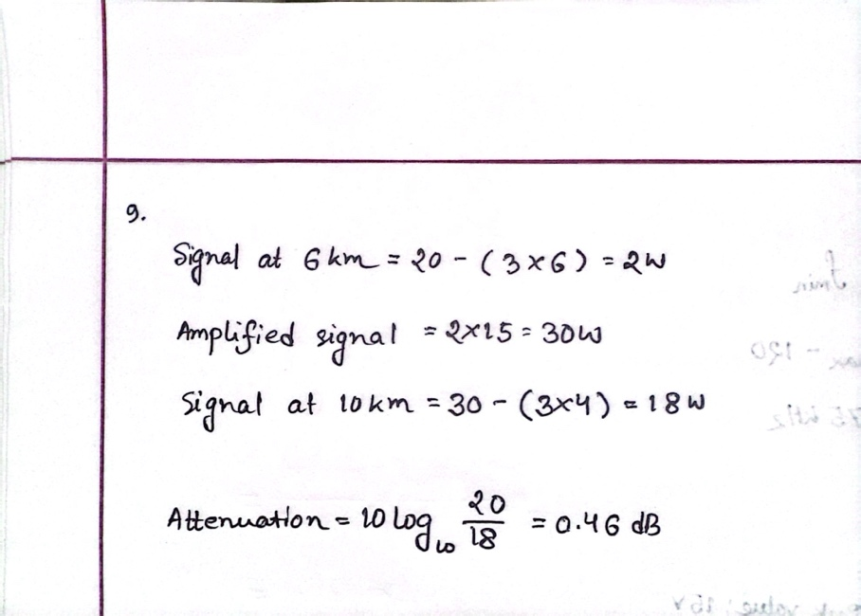
Answer to the Question No. 10
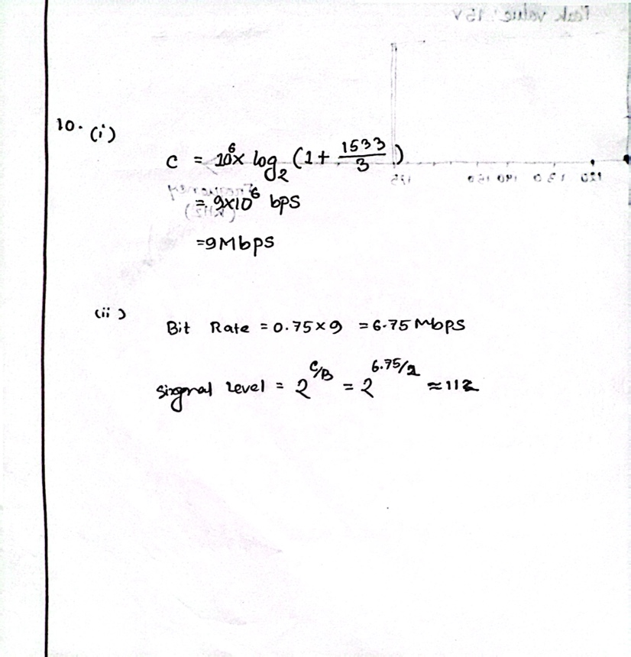
Answer to the Question No. 11
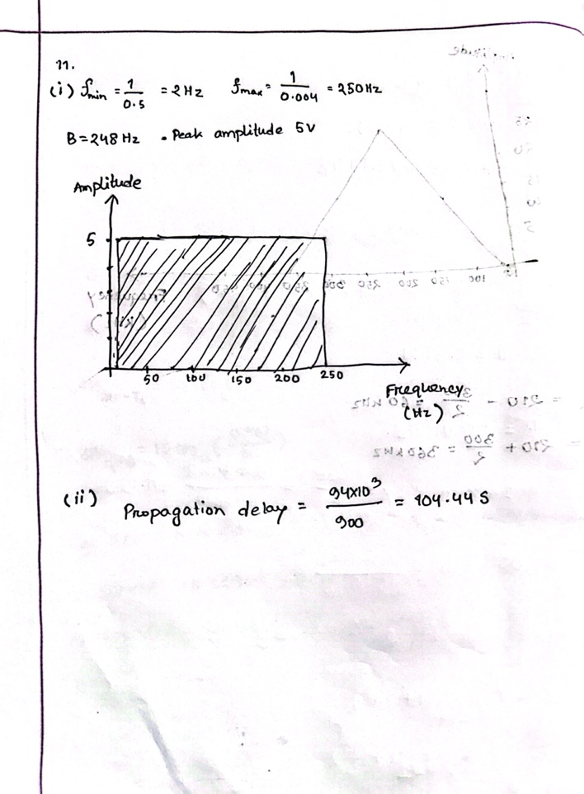
Answer to the Question No. 12
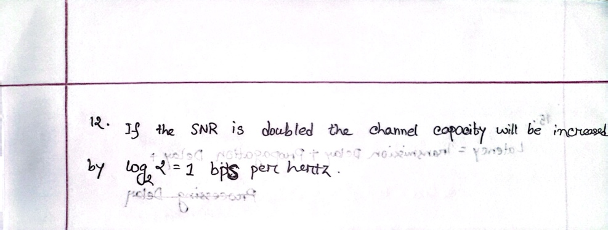
Answer to the Question No. 13
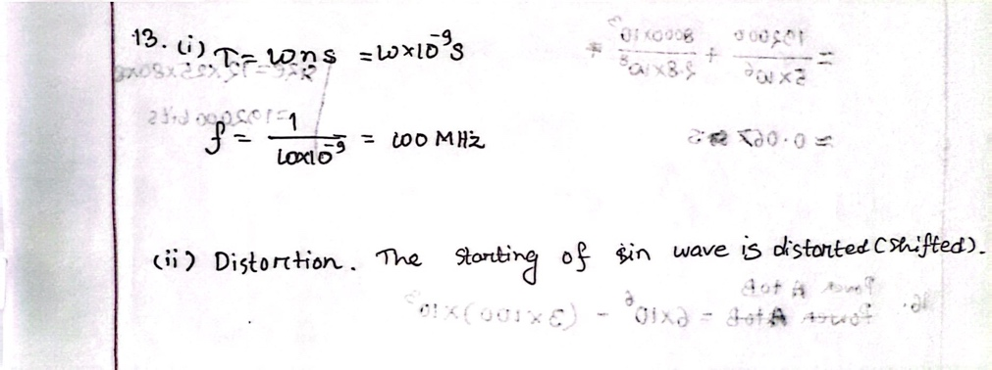
Answer to the Question No. 14
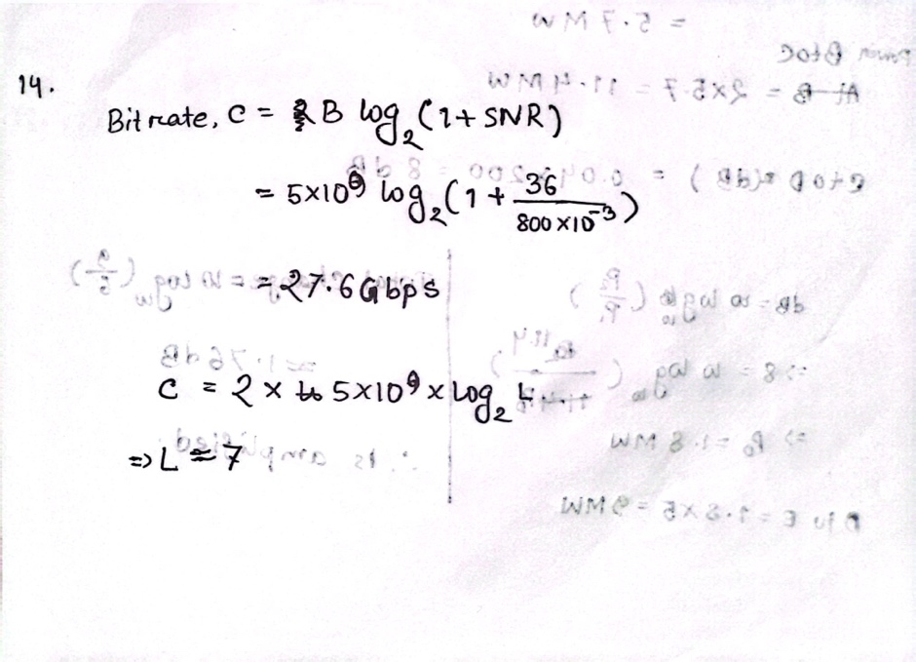

Answer to the Question No. 15
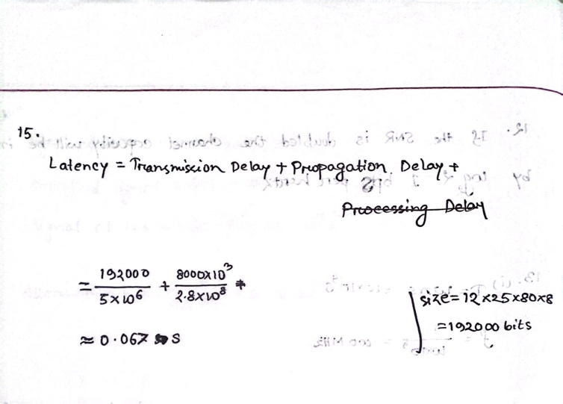
Answer to the Question No. 16
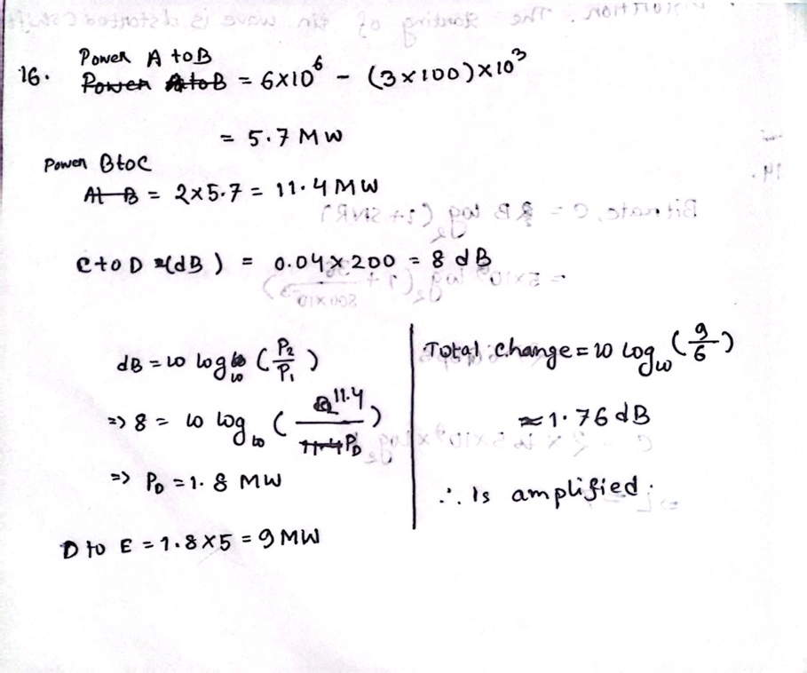

Answer to the Question No. 17
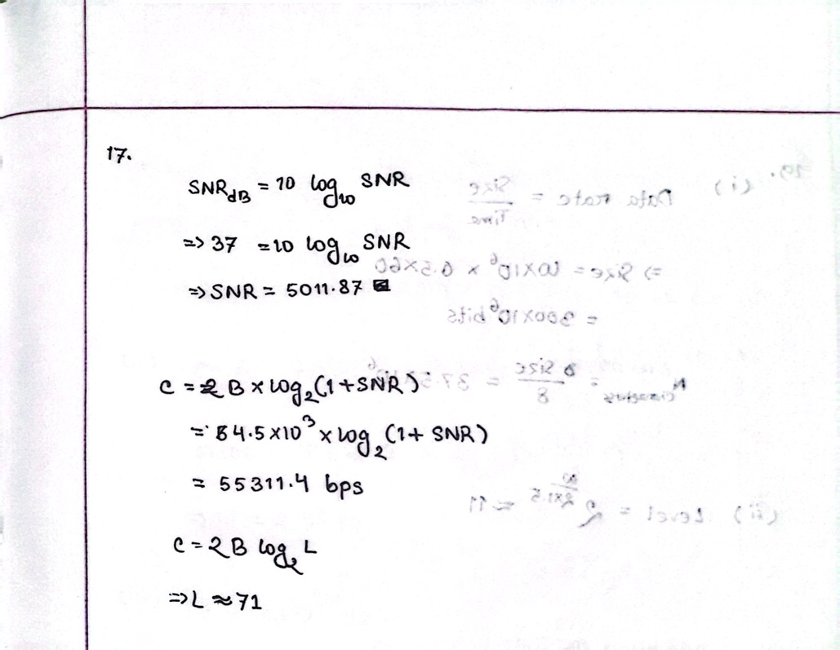
Answer to the Question No. 18
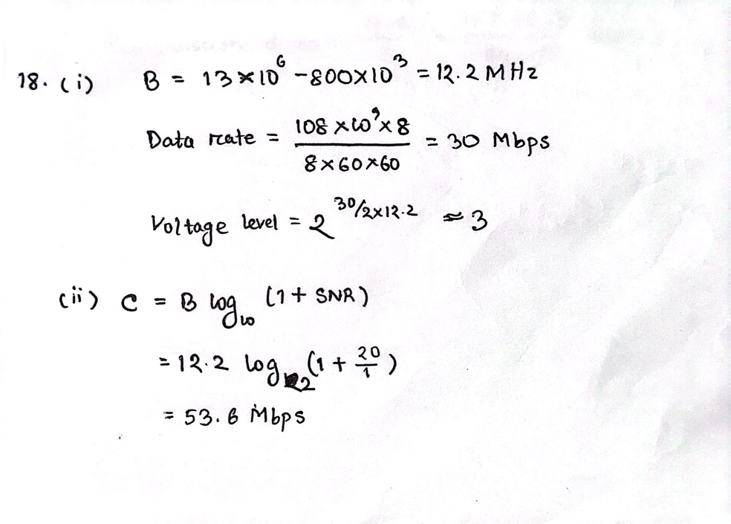

Answer to the Question No. 19
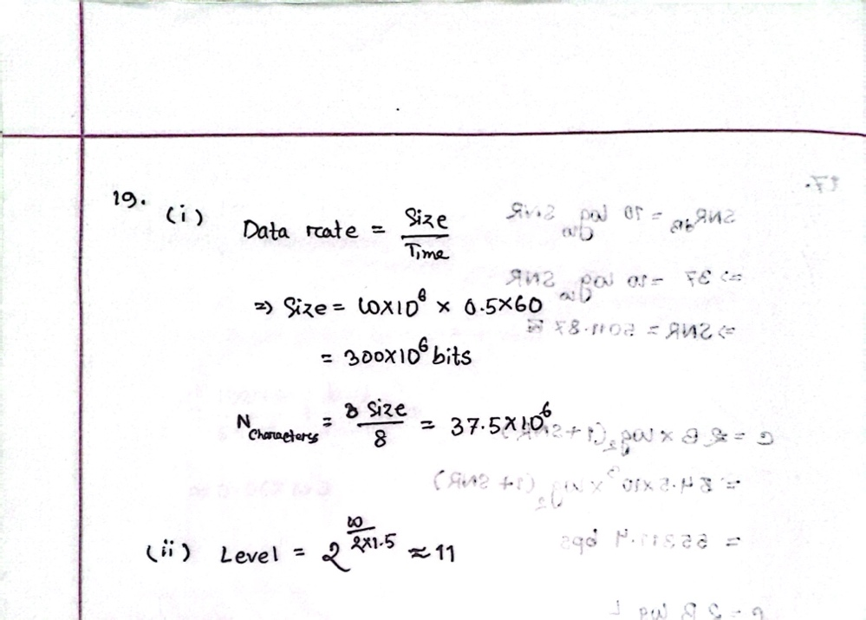
Answer to the Question No. 20

