

Assignment 05
Name: Mehedi Hasan Rowdro
Student id: 24101226
Section: 03
Course code: CSE320
Course title: Data Communication
Semester: Spring 25

Answer to the Question No. 01

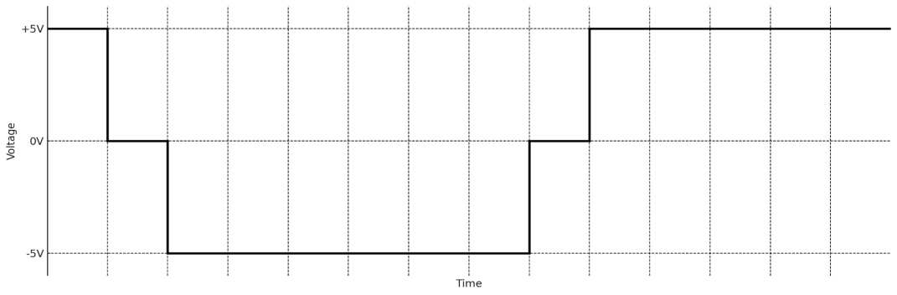
A. 11000000110000
B. As there is a long sequence of 0 in the data the signal suffers from baseline wondering and DC components issue.
C. Suitable technique such that the signal do not suffer for 4 consecutive zero is HDB3
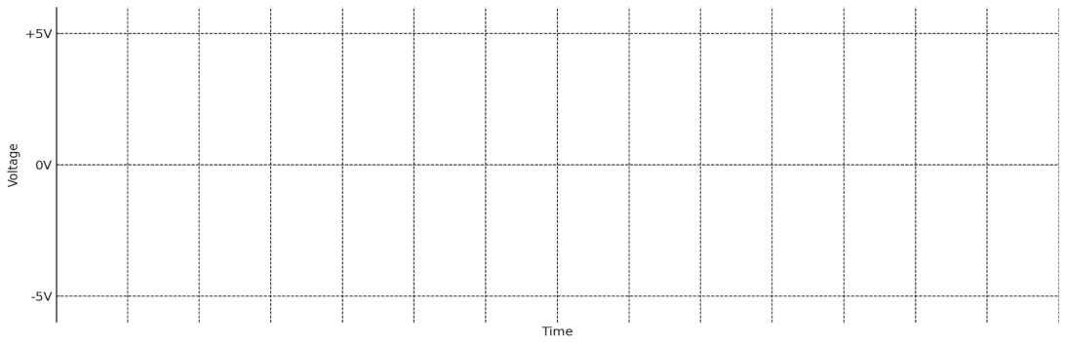

D. Data: 1001000001000011
Using HDB3

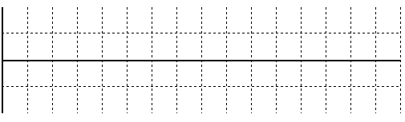

Answer to the Question No. 02

A.
Baseline Wondering: A long string of 0’s or 1’s can cause a drift in the baseline which called baseline wondering. It can make it difficult for receiver to decode correctly.

DC Components: When the voltage level in a digital signal is constant for a while, the spectrum creates very low frequencies, these frequencies around zero are called DC components.

B.
i. 0 0 1 0 0 0 0 0 0 0 0 0 1 0



ii. 1 0 1 0 0 0 0 1 0 0 0 0 1 0

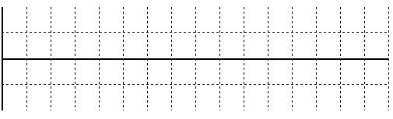

C.
Yes, it contains the Baseline Wondering problem.

1 0 1 0 0 0 0 1 0 0 0 0 1 0



HBD3 is used to solve this problem.

Answer to the Question No. 03

A.
(i) Redundant bit per block = (4-3) = 1
Percentage of Redundant bit = (Redundant bit / Total bit) * 100% = (1/4)*100% = 25%
(ii) 0100 1010 1111 0101

Original:

0100 Not in the table

1010 111
1111 101
0101 010

As 0100 is not present in the table for 1010 1111 0101 the original bit stream is 111 101 010

(iii) From the table we can see there will be maximum 2 0’s.

B.
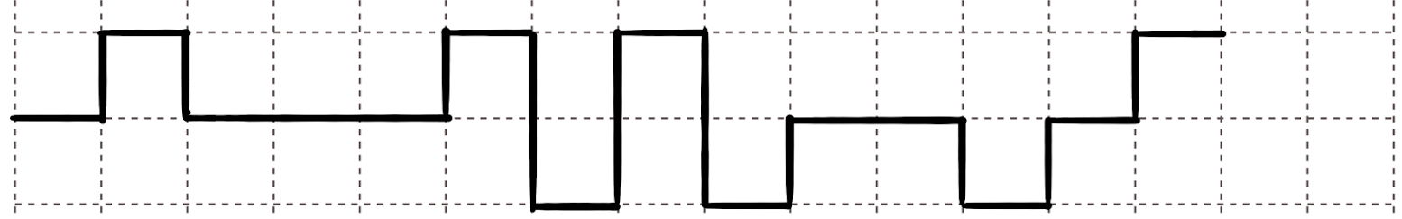
Bit sequence is: 01000111100101

Differential Manchester


Answer to the Question No. 04

A. 101 000 110 100 001
101 01011
000 10110
110 11101
100 01111
001 11011

Encoded bit stream is: 01011 10110 11101 01111 11011
B. The appropriate line code scheme is Manchester
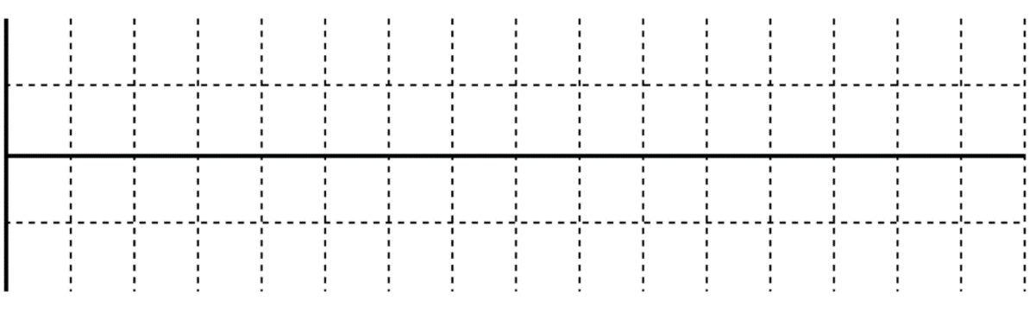

C. Manchester scheme is comparatively complex. To resolve long sequence of 0’s issue in given bit stream in A HBD3 can be used.
Given, 101 000 110 100 001
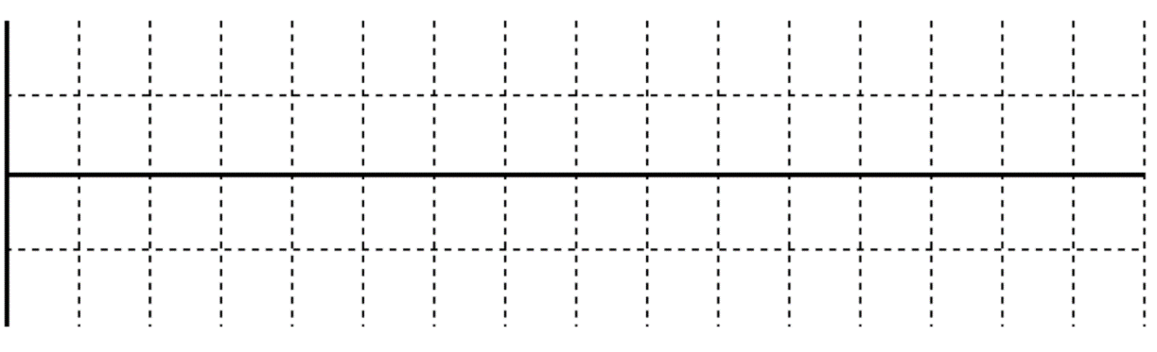
Answer to the Question No. 05

A. Data: 1 1 0 1 0 0 0 0 0 0 1 0 0 0
Using Bipolar AMI

Technique to prevent long sequence of 0, using HBD3
Data: 1 1 0 1 0 0 0 0 0 0 1 0 0 0

B. The characteristics of Bipolar AMI
1. Three volage level
2. Alternate pulsing
3. No DC components
4. No self-synchronization for 0

It addresses and solve the long strings of 1’s problem by alternating between positive and negative for 1.

D. In bipolar scheme 3 levels are used. These are: 1. Positive Voltage, 2. Zero Voltage, and 3. Negative Voltage.

Answer to the Question No. 06

B.
Manchester and Differential Manchester encoding schemes solve the problem of consecutive 0's and 1's by ensuring frequent transitions in the signal. These frequent transitions result in a higher bandwidth requirement which is twice than the NRZ because the signal changes state more often, introducing higher frequency components.

C.
i. After decoding we get: 0111101000
ii. Using Manchester, cause there’s no synchronizing problem in it.
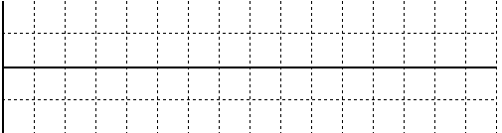

Answer to the Question No. 07

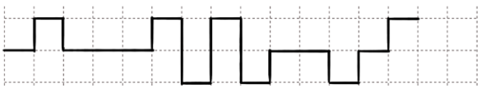

A. Decoding: 010000111000001
B. Using Differential Manchester
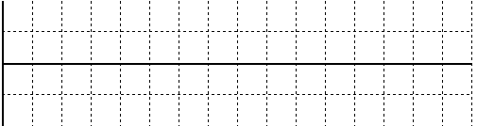
Answer to the Question No. 08

A. The synchronization problem occurs when the receiver loses track of the bit boundaries in a digital signal. This happens when the signal does not have enough transitions in the cases of long sequences of 0's or 1's. It makes difficulties for the receiver to determine where one bit ends and the next begins. NRZ-L can handle this issue neither for 0 nor 1. NRZ-I can handle for 1, however it fails for 0. But Manchester of Differential Manchester can handle for both by transition. It touches the Zero Voltage for both 0 and 1. That’s why the receiver can differentiate data and sync with the sender.

B. Baseline wandering is worse in NRZ-L because the signal can drift in both directions during long sequences of 0's or 1's, but in NRZ-I, the signal only drifts in one direction during long sequences of 0's.

C.
i. 0 1 1 0 1 0 0 0 0 0
ii. Using Manchester


Answer to the Question No. 09

A
Unipolar | Polar | Bipolar | Multitransition
1. Two levels. 0 and +ve. | 1. Two levels. 0 and +ve. | 1. Three levels. 0, +ve, and -ve. | 1. Multiple levels.
2. Has a DC component. | 2. No DC components. | 2. No DC components. | 2. May of may not have DC component.
3. Poor sync for long 0. | 3. Better sync than Unipolar. | 3. Better sync for long 1. | 3. Good sync due to frequent transition.

B

NRZ-L | NRZ-I
1. 0 = +ve, 1 = -ve | 1. 1 = Inversion, 0 = No inversion
2. Sync is poor for long 0 and 1. | 2. Sync better for long 1.

C
NZR | ZR
1. Singal is constant for a bit. | 1. Returns to zero in the middle.
2. Lower bandwidth. | 2. Higher bandwidth due to transition.
3. Sync is poor. | 3. Sync is better.
4. May have a DC component. | 4. No DC component.
5. Example: NZR-L, NZR-I | 5. Example: Man, DMan.

D
Line Coding | Block Coding
1. Encodes individual bits. | 1. Encodes a group/block of bits.
2. No redundancy. | 2. Redundancy due to error detection and correction.
3. May have sync issue. | 3. Better synchronization.
4. Lower bandwidth. | 4. Higher bandwidth due to added bits.
5. Example: NZR, Manchester, Bipolar AMI. | 5. Example: 4B/5B, 8B/10B.

E
B8ZS | HDB3
1. Works for 8 consecutive zero. | 1. Works for 4 consecutive zero.
2. Simpler. | 2. More complex.
3. Used in North America. | 3. Used in Europe and Japan.

F
Manchester | Differential Manchester
1. 0 = High to Low, 1 = Low to High. | 1. 0 = Inversion, 1 = No inversion.
2. Simpler. | 2. Slightly complex.

Answer to the Question No. 10

A.
S_{avg} = N_{avg} [for NZR-I]
S_{avg} = 10 Mbaud
Minimum bandwidth = S/2 = 10/2 = 5 MHz

B.
SNR_{dB}​ = 6.02 * n + 1.76
40 = 6.02 * n +1.76
n = 6.35 = 7 bits per sample

C.
Extra bits = 1kbps * (0.2/100) = 1000bps * (0.2/100) = 2 bps
For 1Mbps,
Extra bits = 1Mbps * (0.2/100) = 1000000bps * (0.2/100) = 2000 bps

D.
Scheme | Category | Costly? (Yes/No) | Has DC Component problem? (Yes/No) | Has synchronization problem? (Yes/No) | Has baseline wandering problem? (Yes/No) | Signal Rate/ Bandwidth
NRZ | Unipolar | No | Yes | Yes | Yes | N/2 Bd
NRZ-L | Polar | No | Yes | Yes | Yes | N/2 Bd
NRZ-I | Polar | No | Yes | Yes | Yes | N/2 Bd
Manchester | Bi-phase | Yes | No | No | No | N Bd
Differential Manchester | Bi-phase | Yes | No | No | No | N Bd
AMI | Bipolar | No | Yes | Yes | Yes | N/2 Bd
MLT-3 | Multitransitional | Yes | Yes | Yes | Yes | N/3 Bd

