Visited Website: http://www.educationboardresults.gov.bd/
Website IP: 103.230.107.233

My PC IP: 192.168.0.118
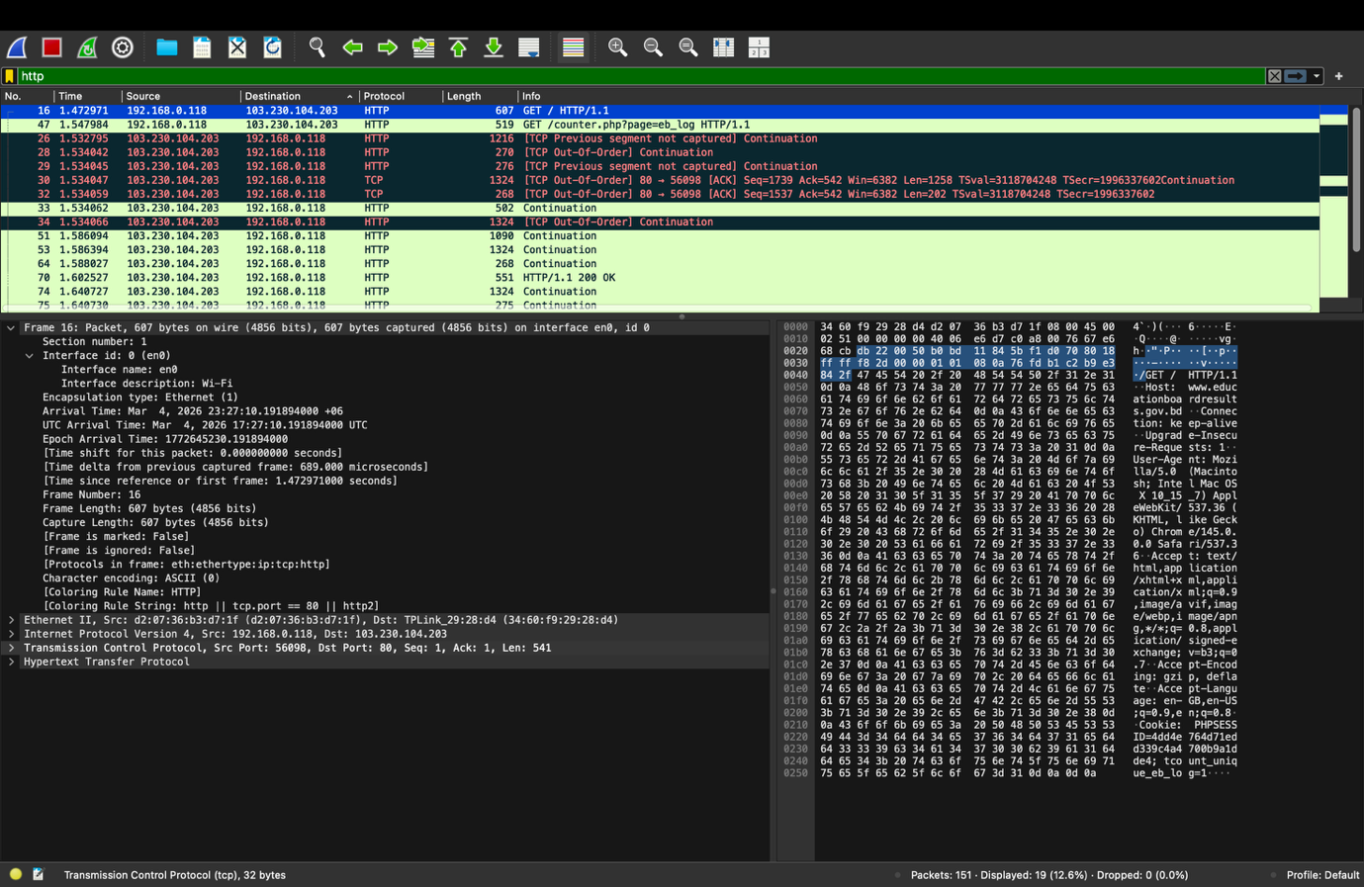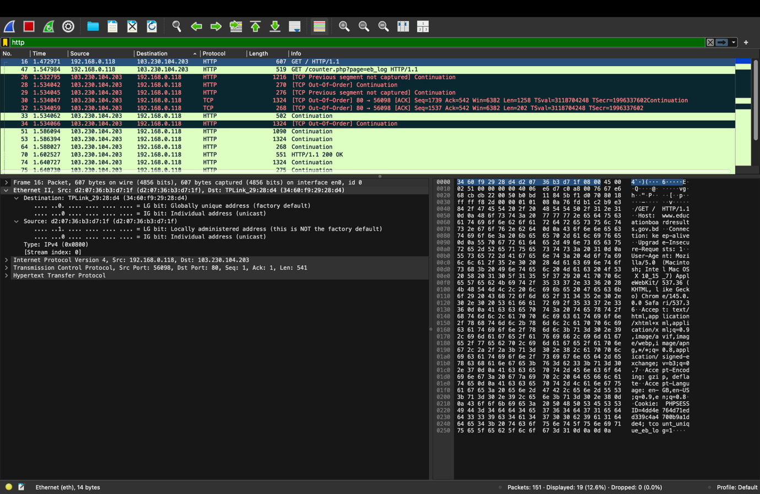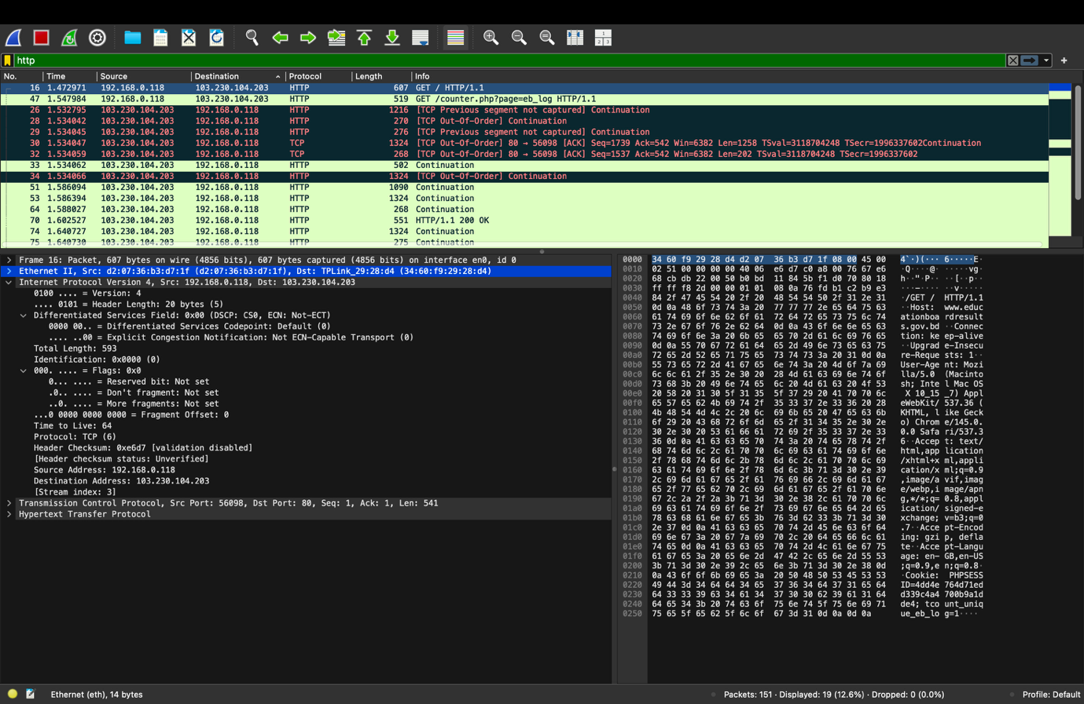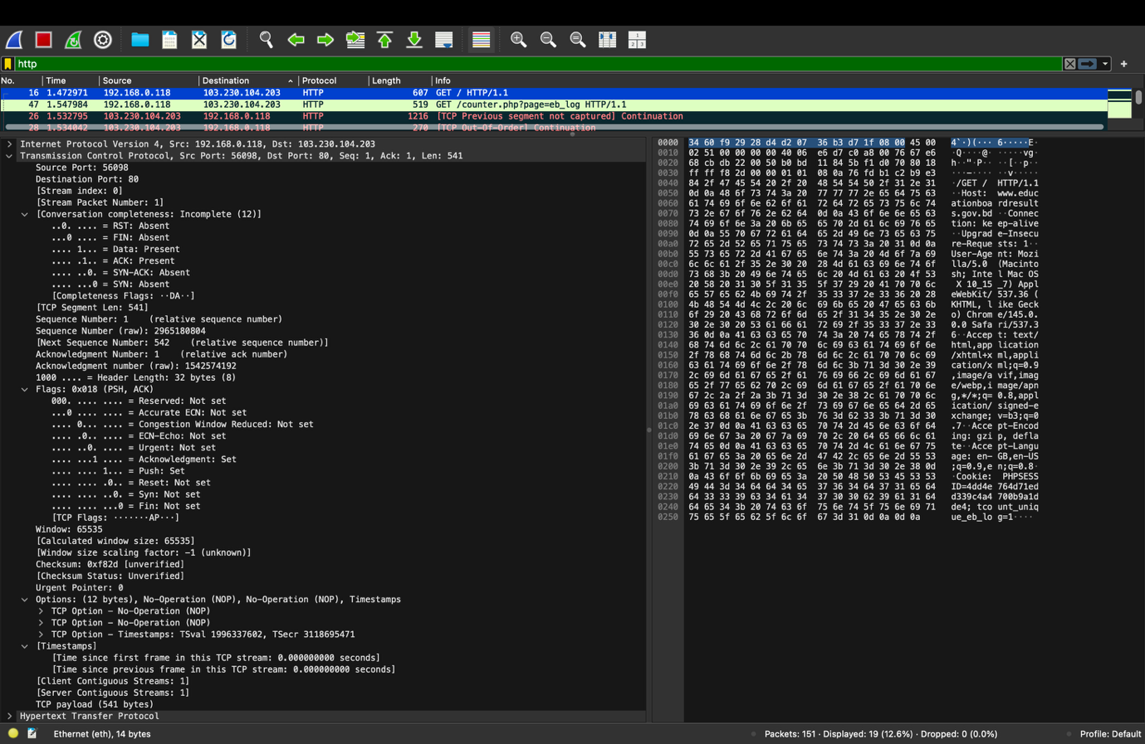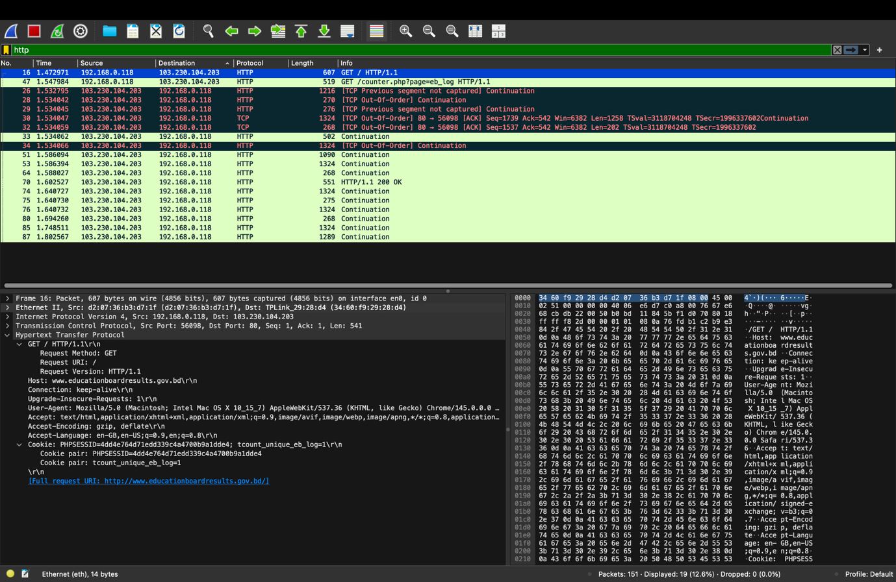
HTTP Request:

1. Frame:

Frame is PDU for Data Link Layer.

2. Ethernet II:

MAC (Media Access Control) address: 48 bit; Hexadecimal format; Used in Data Link Layer.

Source: d2:07:36:b3:d7:1f
Destination: 34:60:f9:29:28:d4

3. Internet Protocol:

Version: IPV4

IP Address: Used in Network Layer; 32 bit; PDU is Packet.

Source: 192.168.0.118
Destination: 103.230.104.203

4. TCP (Transmission Control Protocol): Transport Layer; PDU is segment; Uses Port address.

Source Port: 56098
Destination Port: 80

5. HTTP (Hypertext Transfer Protocol):

Request Line:
Get method to get information.
Url: /
Version: HTTP/1.1

Header Line:
Header field name: Value cr lf

Host is www.educationboardresults.gov.bd

Connection will be kept alive after one request, meaning persistent

Browser is Mozilla/5.0 (Macintosh; Intel Mac OS X 10_15_7) AppleWebKit/537.36 (KHTML, like Gecko) Chrome/145.0.0.0 Safari/537.36

Accept text/html,application/xhtml+xml,application/ xml;q=0.9,image/avif,image/webp,image/apng,*/ *;q=0.8,application/signed-exchange;v=b3;q=0.7

Accept encoding in gzip

Accept language en-GB,en-US;q=0.9,en;q=0.8

carriage return character: \r

line-feed character: \n

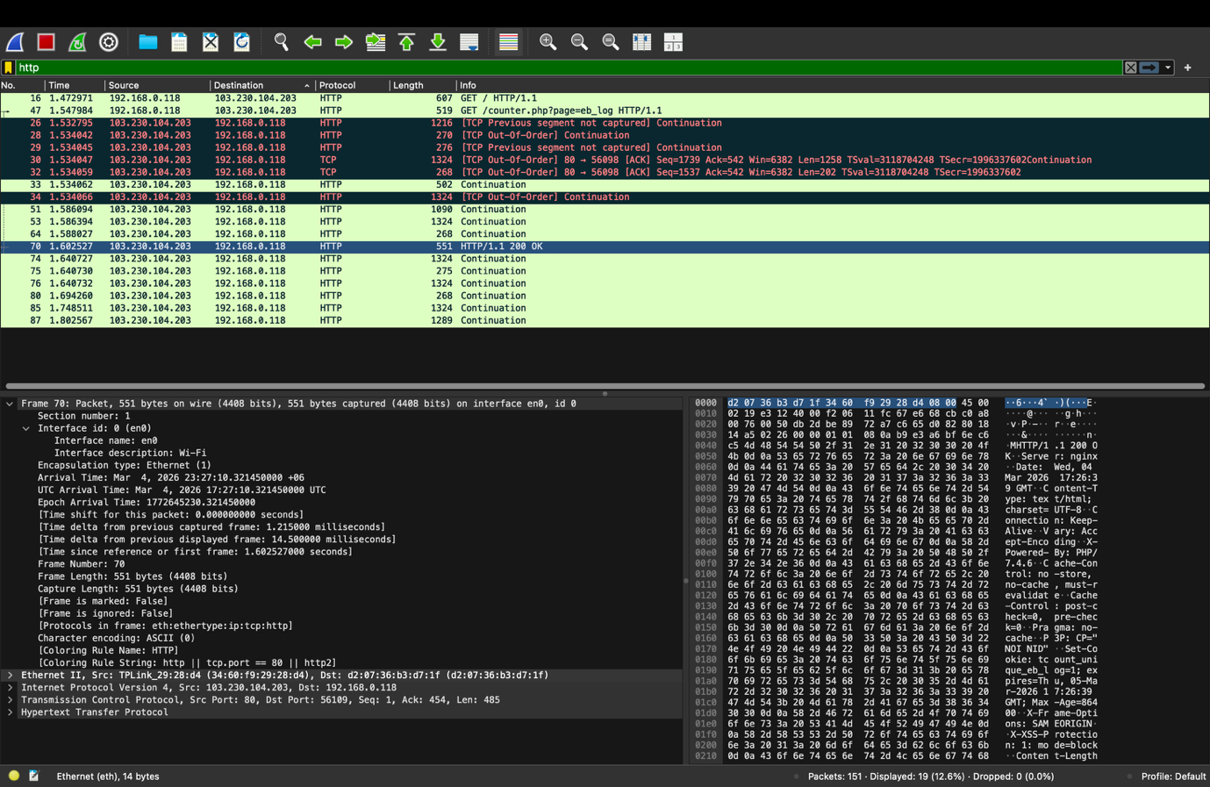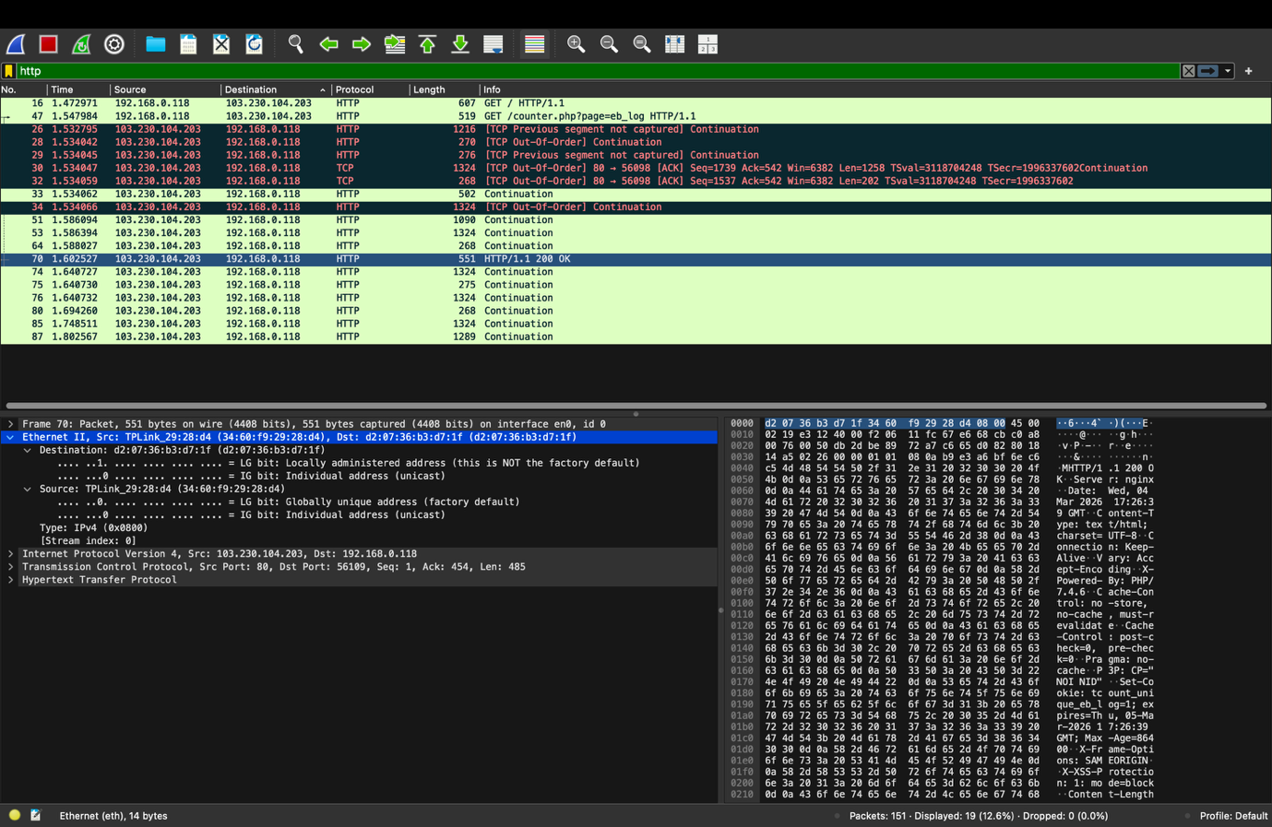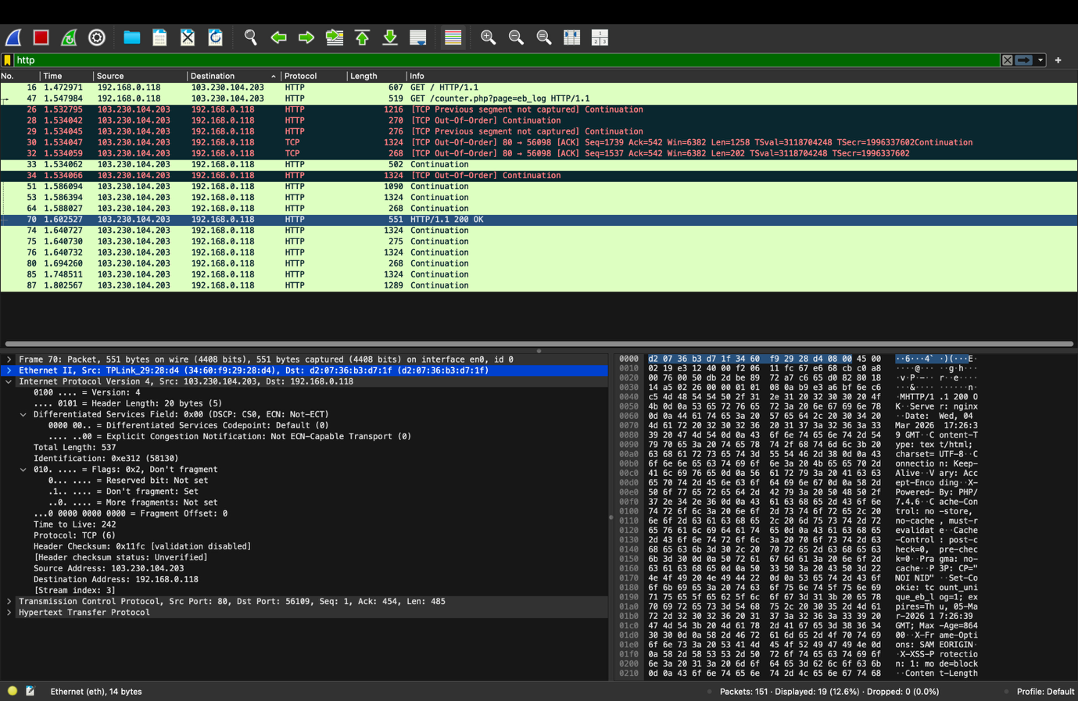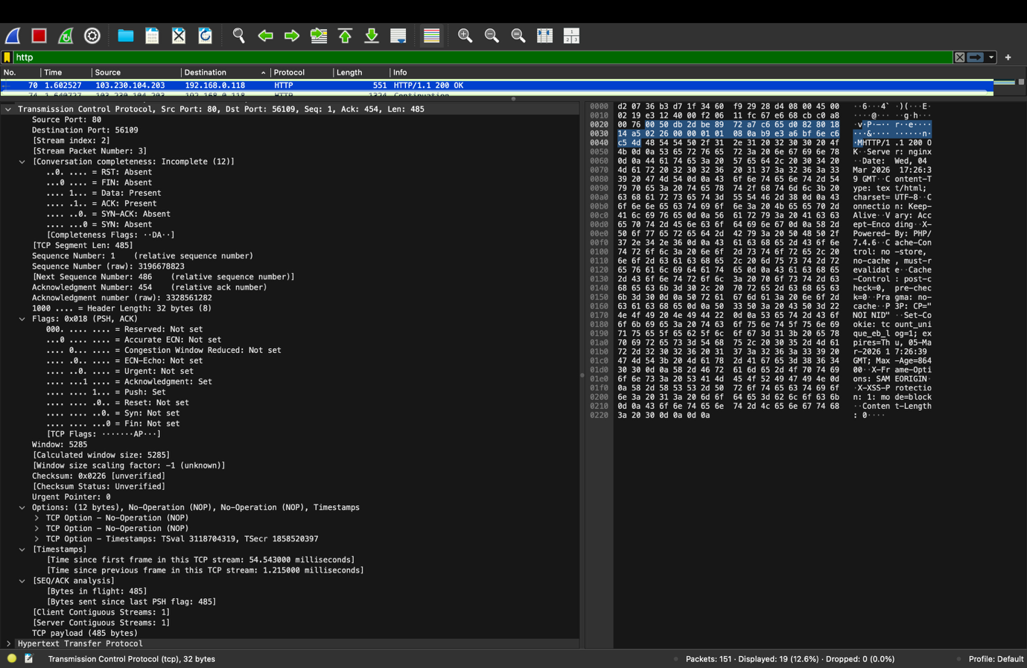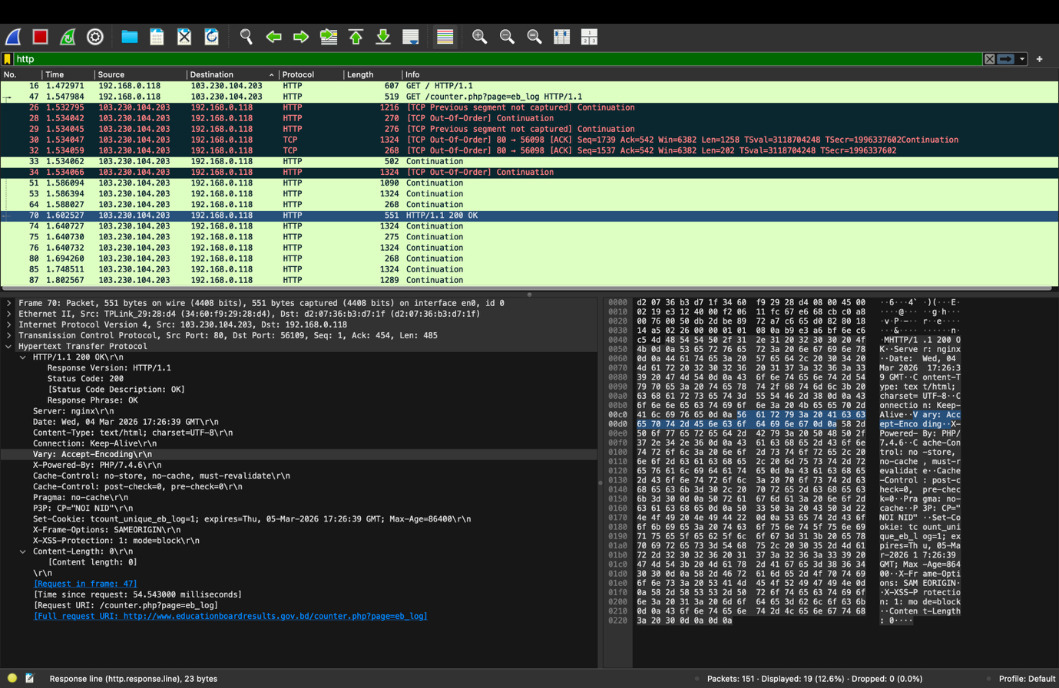
HTTP Response:

1. Frame:

Frame is PDU for Data Link Layer.

2. Ethernet II:

MAC (Media Access Control) address: 48 bit; Hexadecimal format; Used in Data Link Layer.

Source: 34:60:f9:29:28:d4
Destination: d2:07:36:b3:d7:1f

3. Internet Protocol:

Version: IPV4

IP Address: Used in Network Layer; 32 bit; PDU is Packet.

Source: 103.230.104.203
Destination: 192.168.0.118

4. TCP (Transmission Control Protocol): Transport Layer; PDU is segment; Uses Port address.

Source Port: 80
Destination Port: 56109

5. HTTP (Hypertext Transfer Protocol):

Status Line:
Version: HTTP/1.1
Status code: 200
Response phase: OK

Header Line:
Header field name: Value cr lf

Date: Wed, 04 Mar 2026 17:26:39 GMT\r\n

Content-Type: text/html; charset=UTF-8\r\n

Connection will be kept alive after one request, meaning persistent

carriage return character: \r

line-feed character: \n

