Blog
Tales of Harmony: The journey of “ALTERCATION”
13th March 24 | Mehedi Hasan Rowdro

Music holds a special place in the hearts of many, including myself. It is always a source of immense inspiration and passion for me. Today, I am excited to share the story of my band, ALTERCATION.

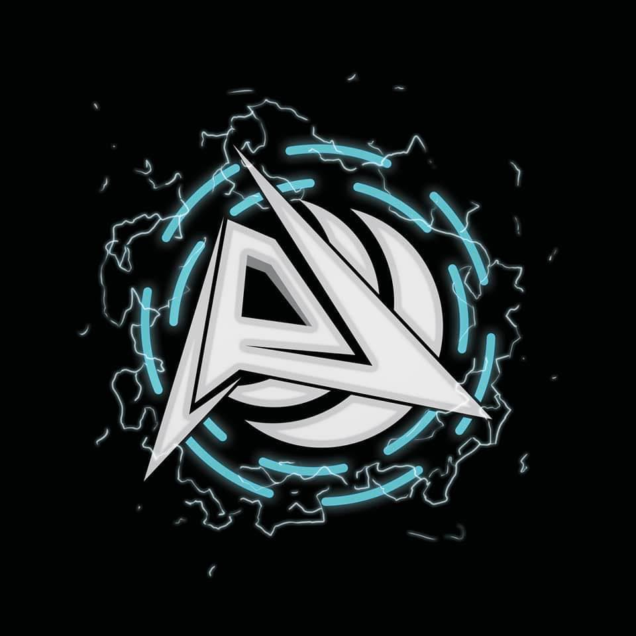

The logo of ALTERCATION

In the year of 2018, when I just got into 9th grade, a thougth of interest was developed in my mind, the interest of playing music, forming a band.As I was more into the guitar i started asking my mother to buy me a one, so that I can learn how to play it. After many many times of repeating my requests she was finally agreed to buy me my first guitar, an acoustic one. With this instrument my the journey was started toward my dream of forming a band of my own.

The initial steps toward this dream was not that easy. A band can not be formed while containing only one member, so, I had to find other members. While learning guitar from a tutor, I met Raj, a friend of mine who shared the same aspirations as me. Together me and Raj started to search for other members who shared our musical vision.

By the year 2020, after much struggle, we managed to gather a group of six to form our band, Altercation. Saad bhai joined as the vocalist, while Tamim bhai, Rahul and I took the guitar roles, Badhon took the responsibility of the drums and Raj took the bass guitar part. With this six members, we began our musical journey.

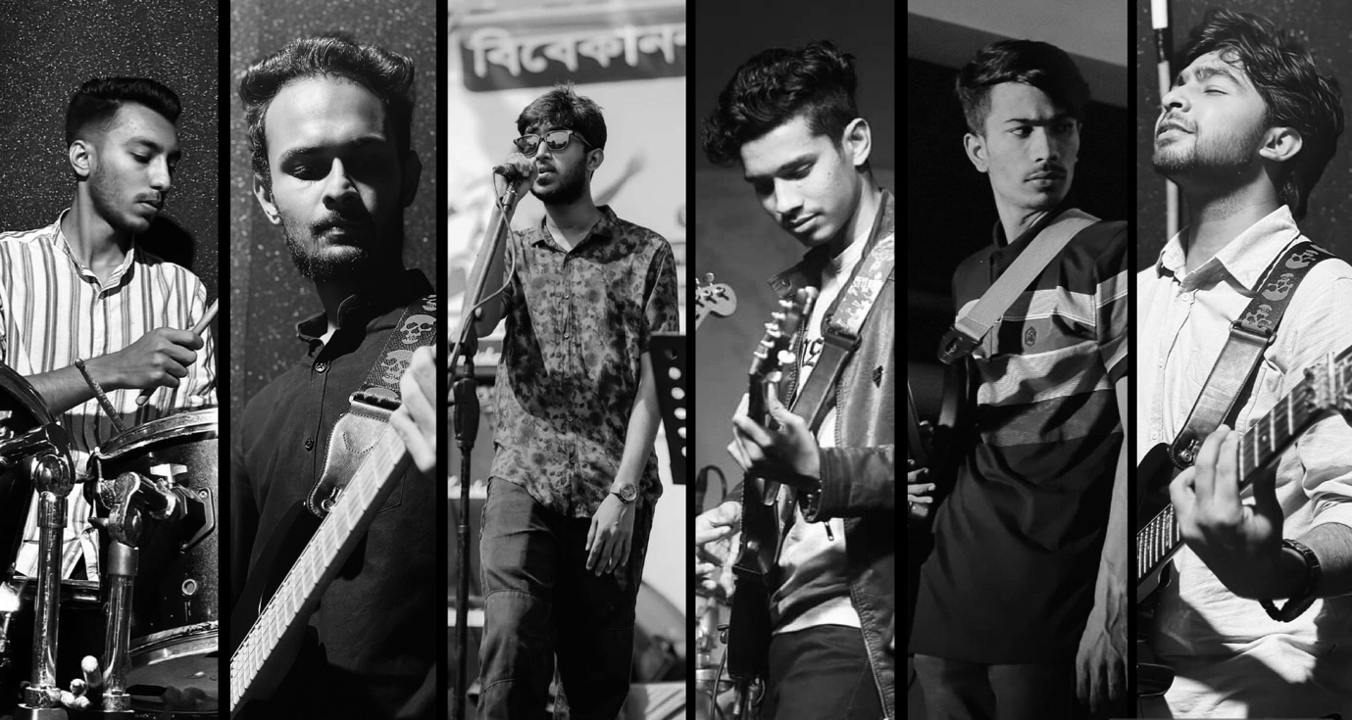

ALTERCATION band members

In the beginning, our rehearsals were really exciting as we tried and explored various musical genres and styles. We kept practicing over hours and hours and did experiments with different sounds. Despite out dedication, we faced a challenge. A challenge to name our band. After much thinking, we all were agreed on ALTERCATION, which symbolizes our motto to fight negativity through music.

The practicing room we had in the first place were not good at all, we had to change our practicing room we. After managing a new practice room we transformed that room into our sanctuary, decorated and designed it nicely. We also soundproofed this room of ours. We poured our hearts and souls into music here.
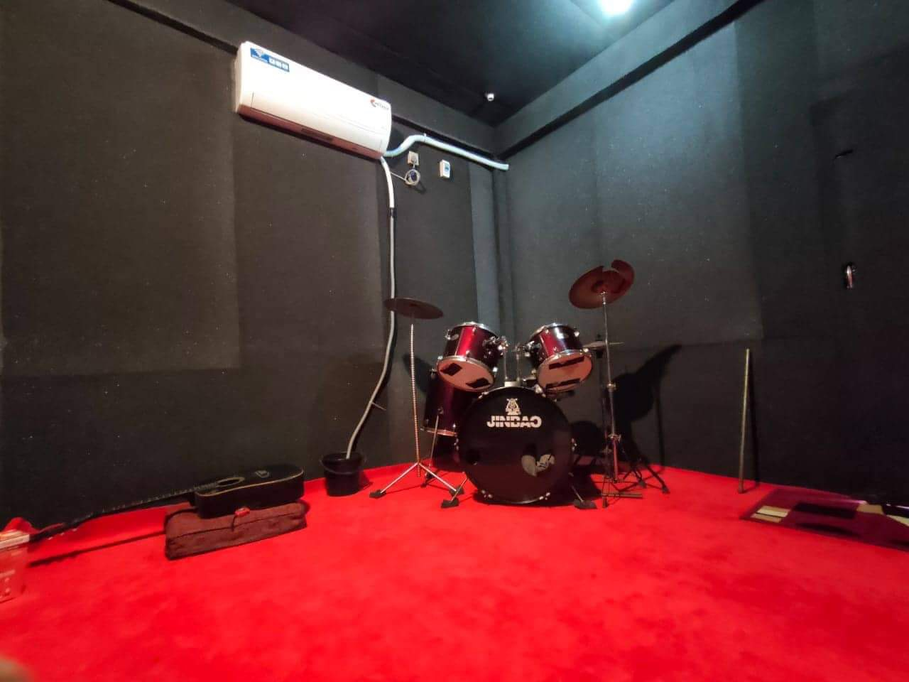

Our Practice room

Our efforts were soon showing results as we begam performing at local events in our town. We received praise and recognition from people around us and the community, with our every performances. However, our desire for music kept rising. We were not satisfied with only covering other’s song we started to compose our own music.

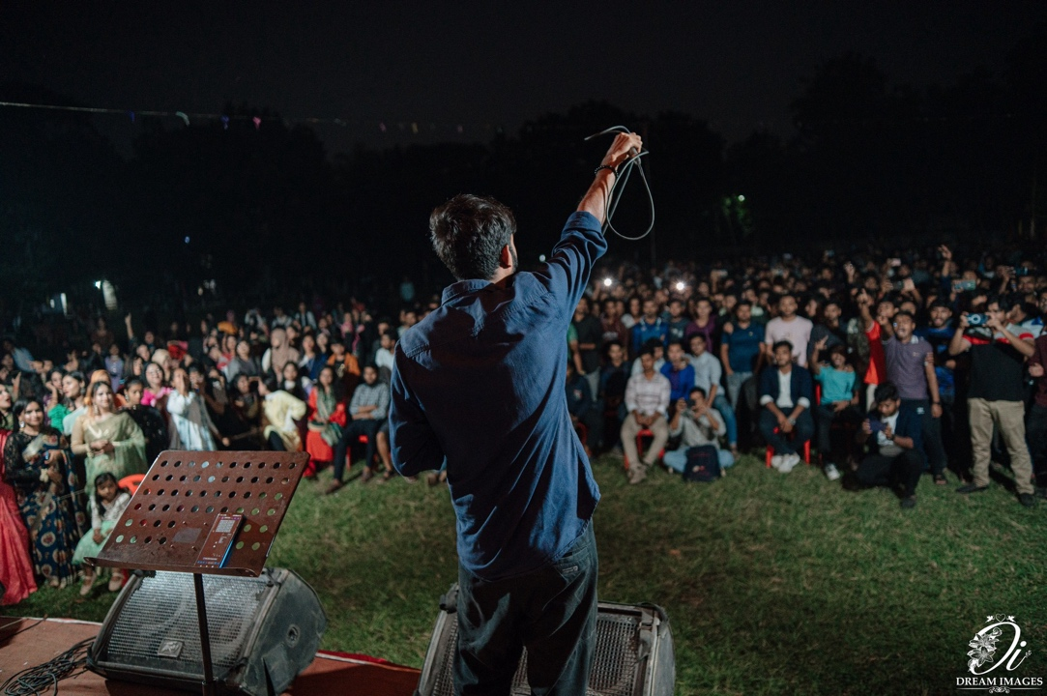

A glimps of one of our concerts

Despite of having numerous obstacles such as academic and personal responsibilities, we remained committed to our band. Gradually, our original compositions took shape. Today we dtand on the edge of releasing our first album an a reward to our dedication and passion for music.

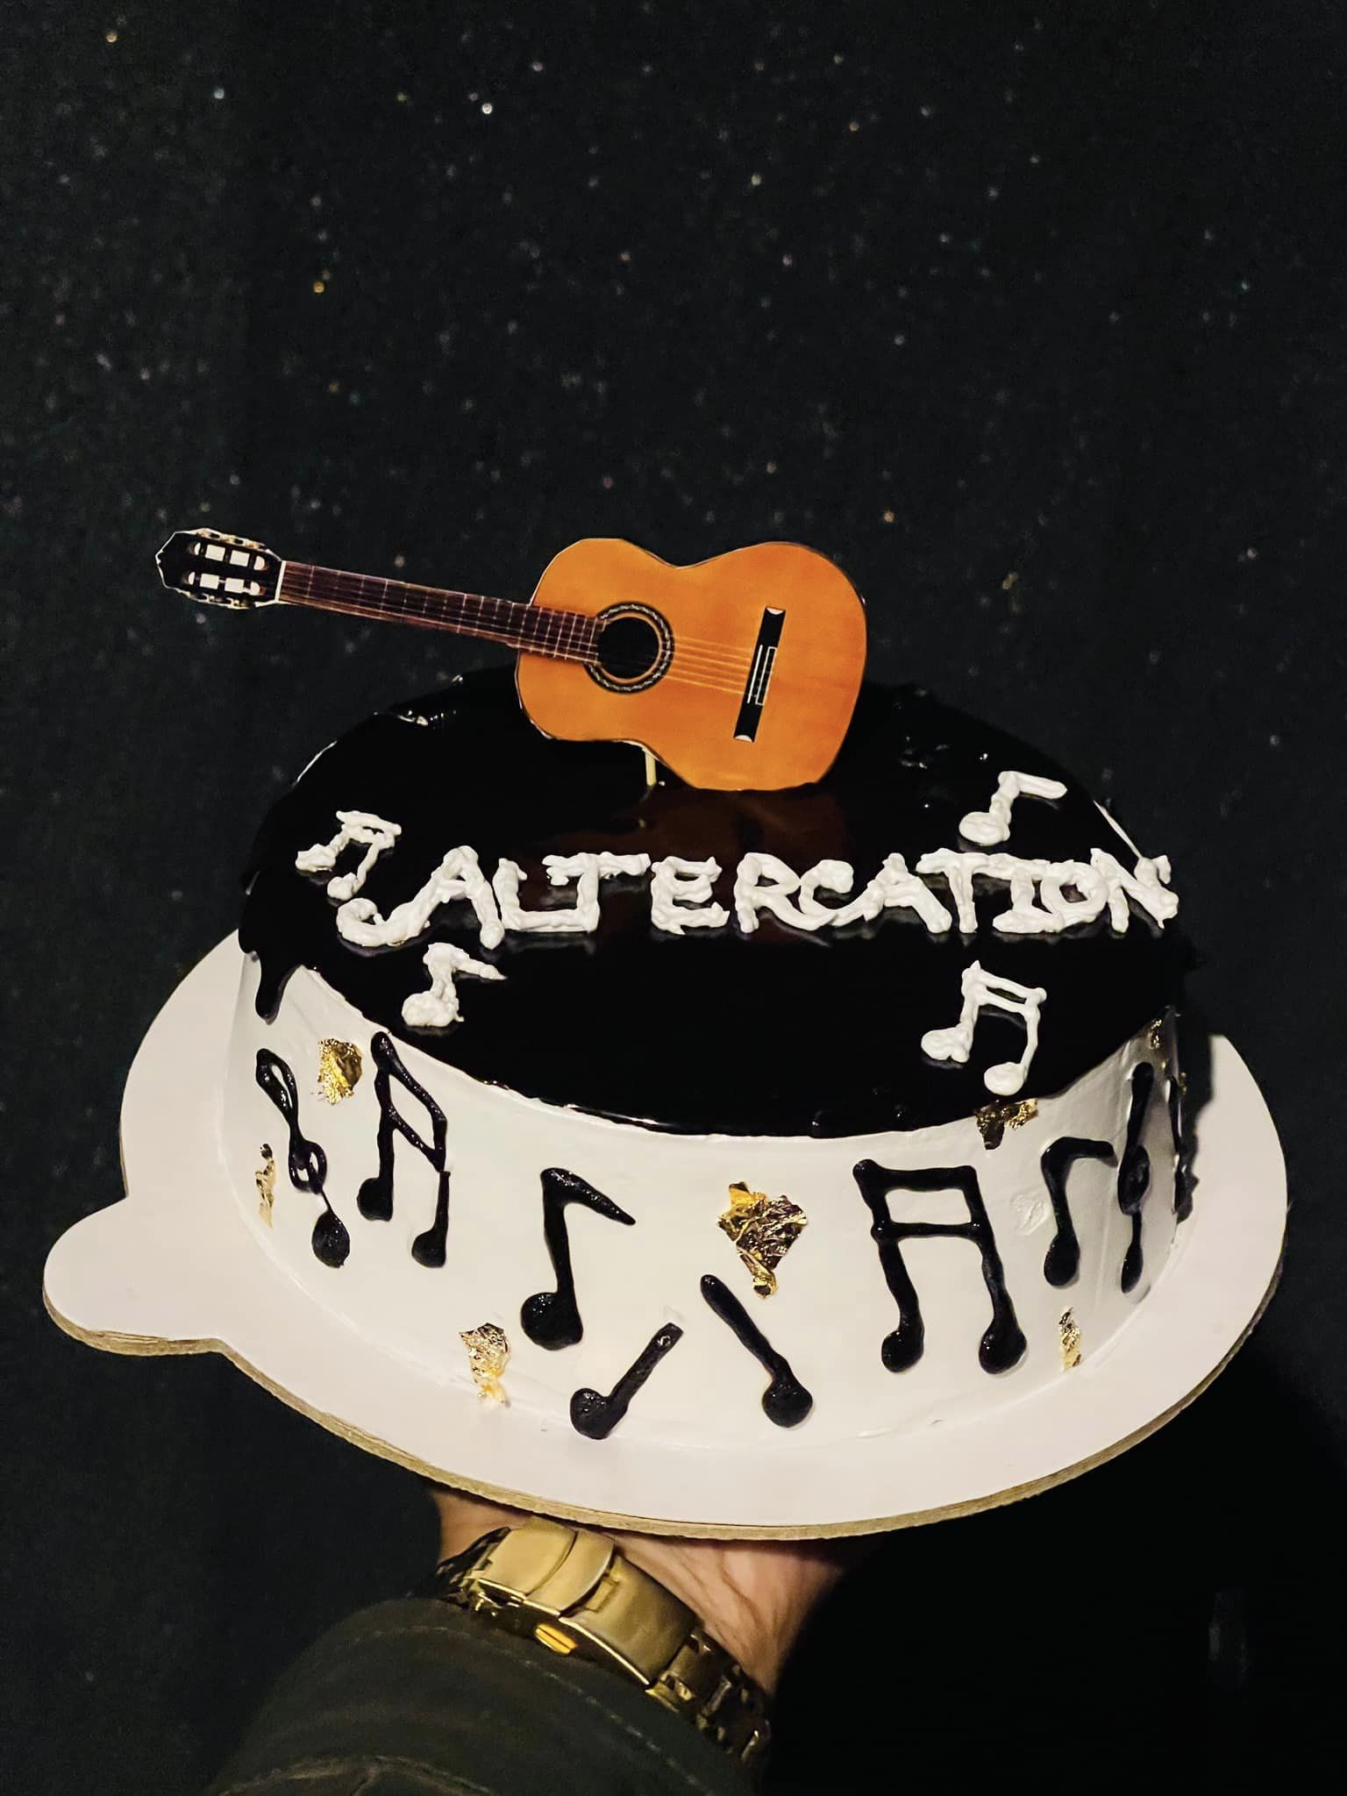

Celebrating the 1-year anniversary of the formation of our band

If we look back now, our journey with Altercation was filled with challenges and uncertainities. But we are really greatful for the experiences and opportunities that music has bought us. We always remained committed to our commitment of chasing our dream. With every note we play we move closer and closer in making a long lasting impact on music world.

In conclusion, the story reveals the back story of Altercation, about it’s formation and it’s journey of being where it is now. There were challenges we faced while we were on this journey. The journey is not going to over yet, we are going to face more challenges. Hopefully, wiith our dedications we are going to break all those barrier of challenges.

