Portfolio

Contents
- Classwork
- Journal
- Article Review
- Blog
- Data Log
- Assignment Drafts

Submitted by
Name: Mehedi Hasan Rowdro
ID: 24101226
Sec: 04
Semester: Spring 24\

Journal
Assignment

The Story of an Hour
By Kate Chopin

Pre-reading discussion:

Q: What is freedom to you? Give examples for your opinion.

Answer: To me freedom means the ability of making choices by one’s own and expressing own opinion freely. The examples of freedom are the right of choosing one’s profession, the right of practicing one's own religion freely, freedom of speech, etc.

Post-reading tasks:

1. Write the contextual meanings of the following words in one or two sentences.

a) wild abandonment: In the story, “wild abandonment” refers to Mrs. Mallard’s sudden thought of being left. After Mrs. Mallard getting informed of her husband’s death she felt immense grief and sorrow which numbed her feelings.

b) the joy that kills: The phrase “the joy that kills” means Mrs. Mallard’s overwhelming joy
that came from her newfound freedom was the very reason for her death. After seeing her husband not only alive but in well shape as well, her freedom was questioned. As she was a heart patient it was heavy for her to take these shocks one after another. And eventually, these shocks were what that killed her.

2. “There would be no one to live for during those coming years; she would live for herself” - Explain your understanding of Mrs. Mallard’s feelings expressed in this sentence.

Answer: Mrs. Mallard after getting to know about her husband’s death she was all by herself. She acknowledged that the years that were ahead of her will be her and hers only. There would be no one to dominate her, no one to tell her what to do and not to. Finally, she will have her freedom and will be able to live for herself only without thinking of others.

Classwork
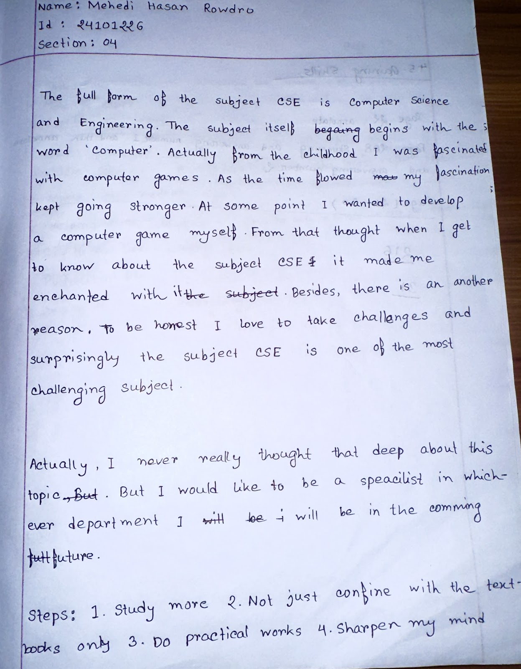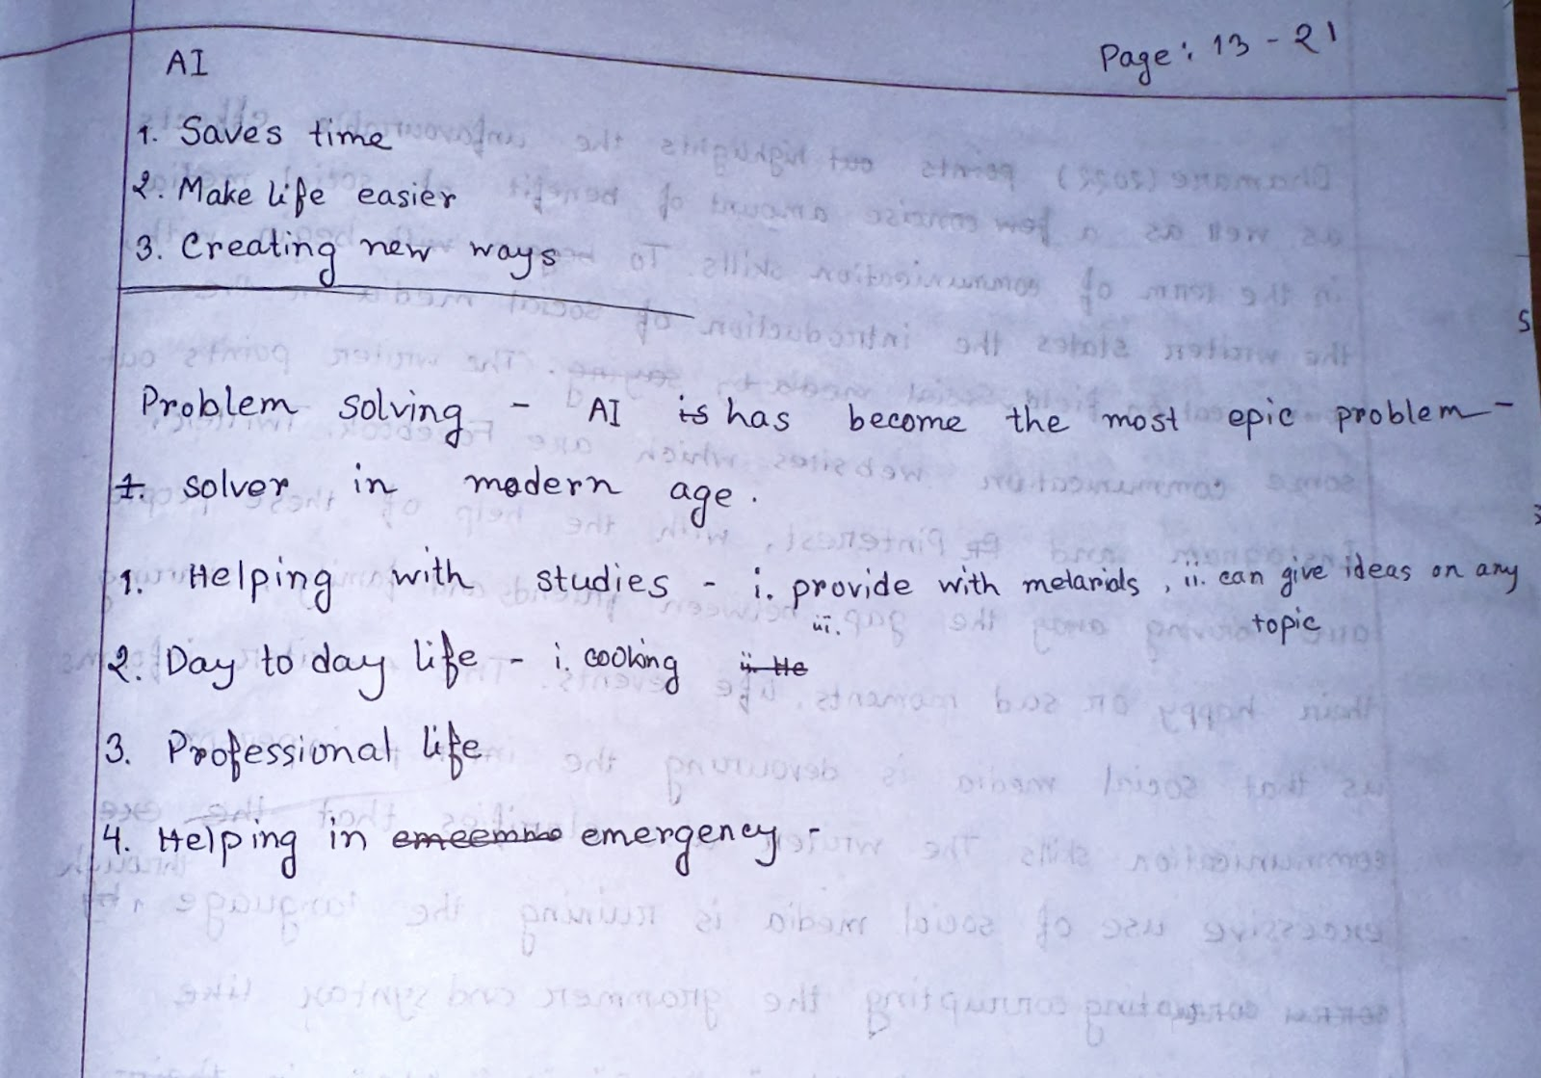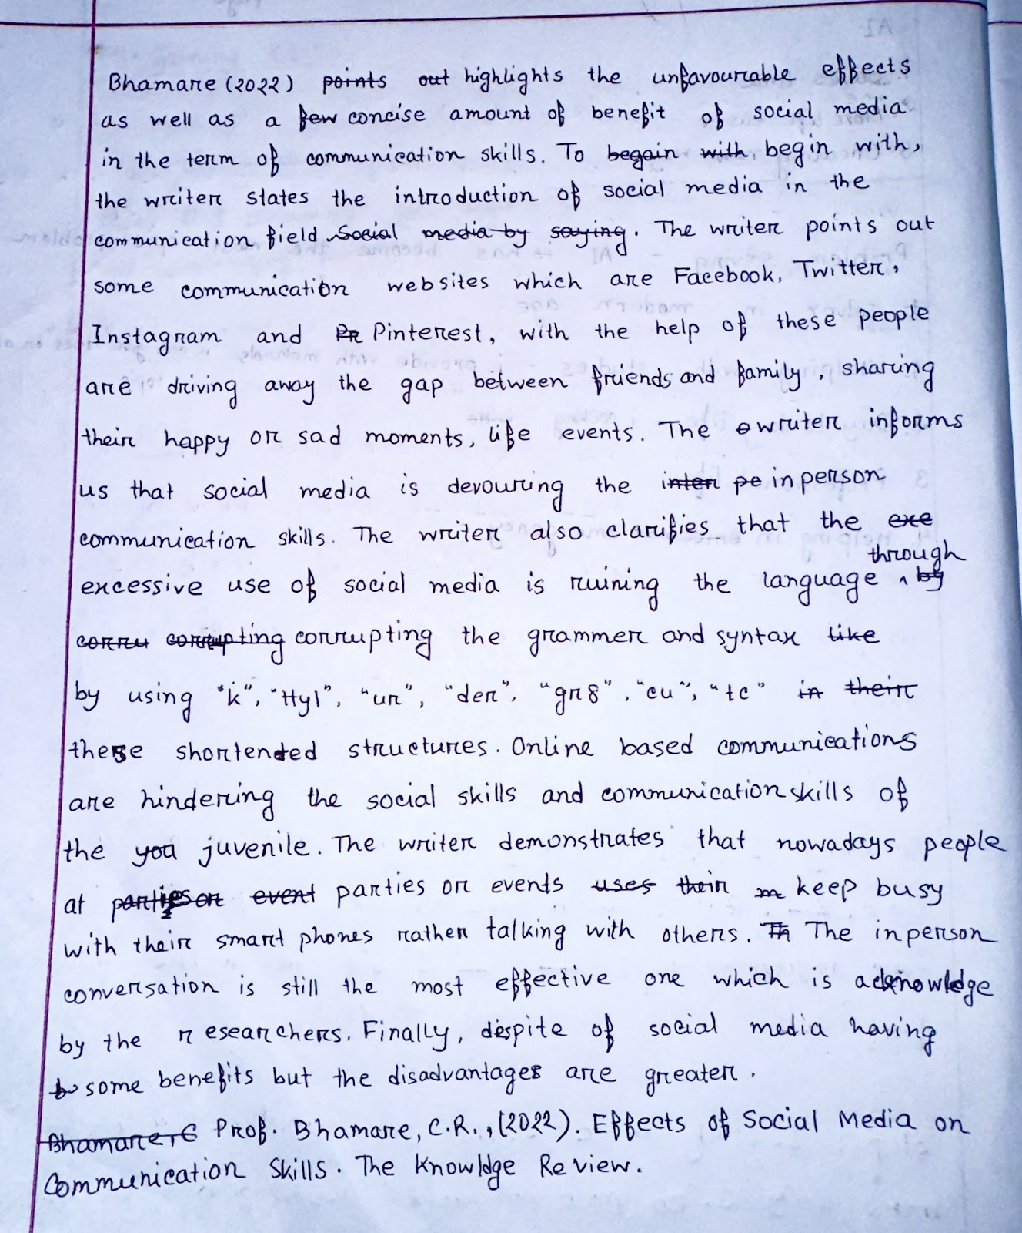
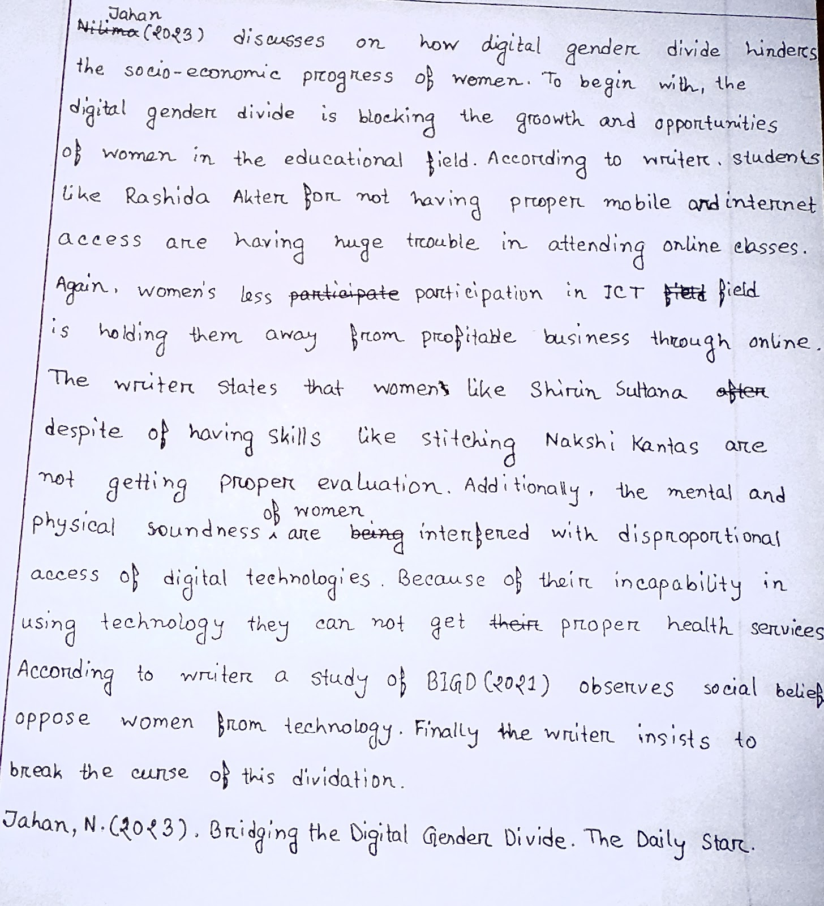

Paragraph
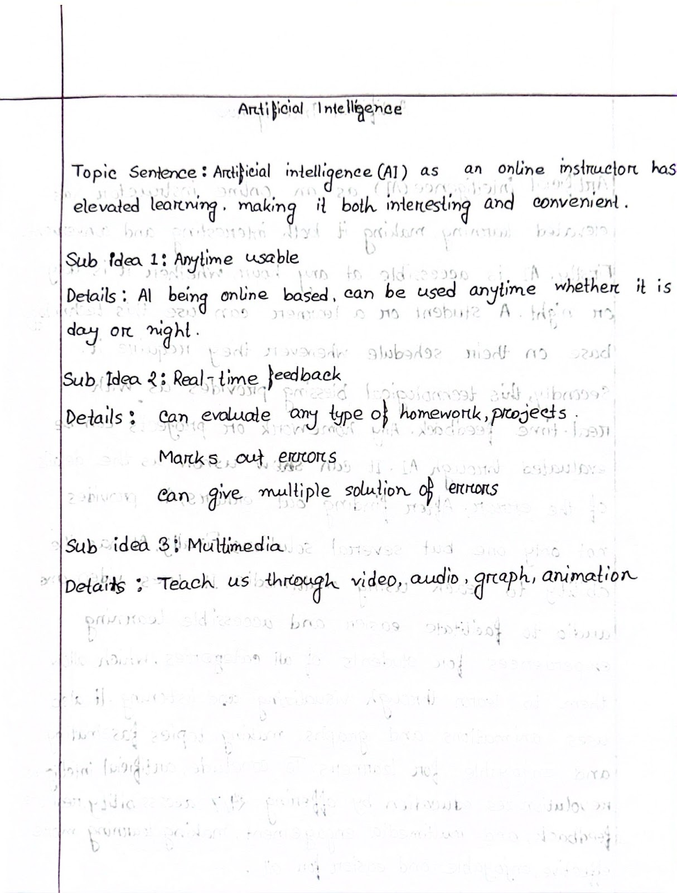
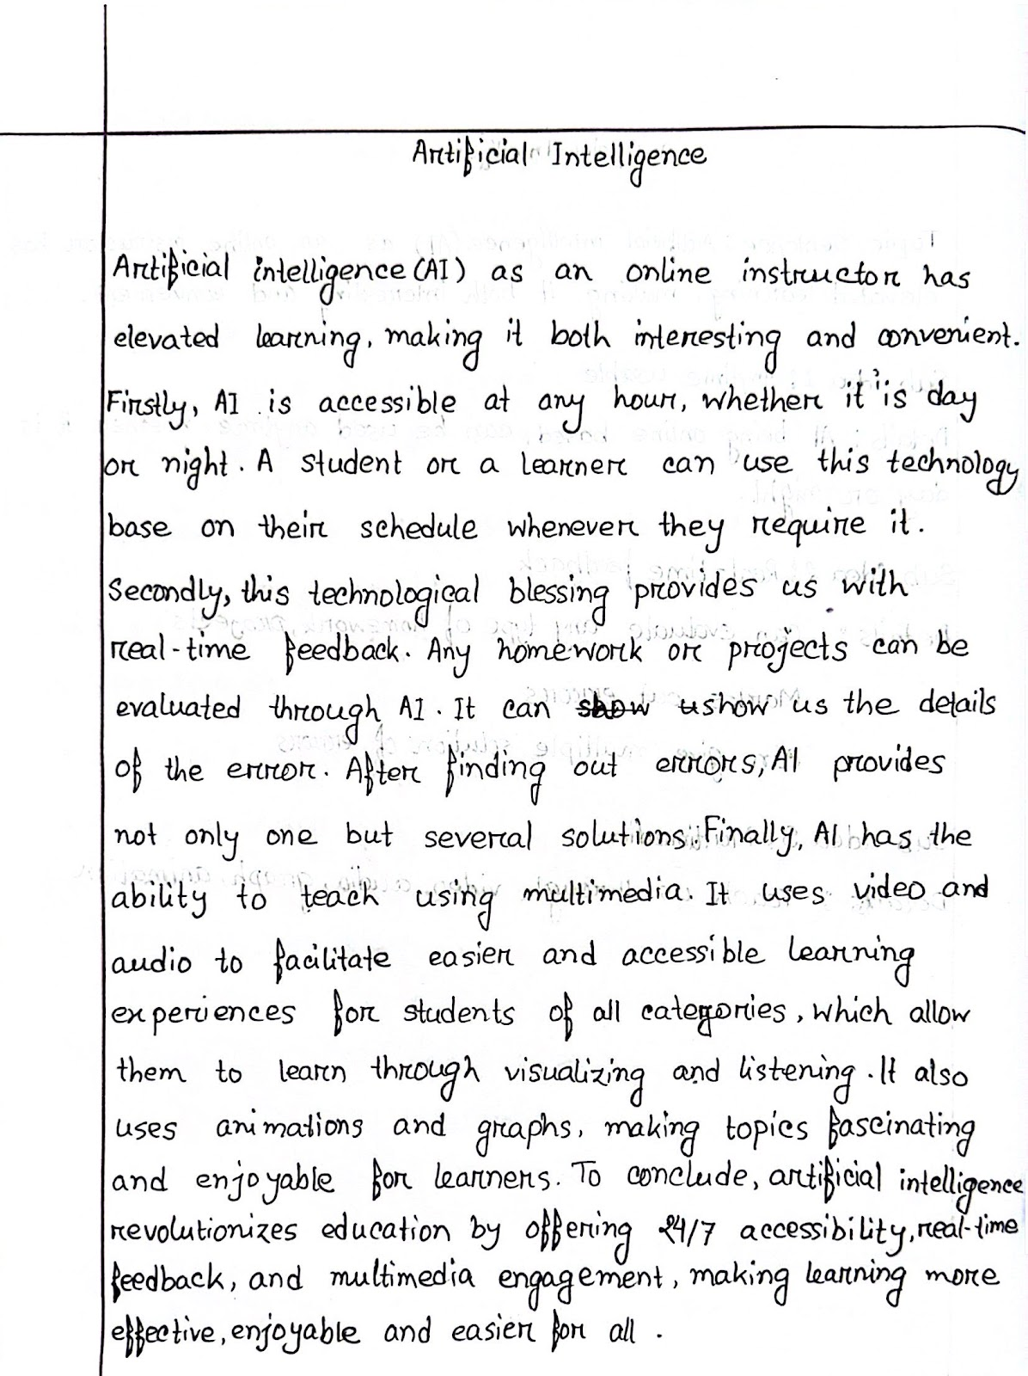

Artificial Intelligence

Artificial intelligence (AI) as an online instructor has elevated learning, making it both interesting and convenient. Firstly, AI is accessible at any hour, whether it is day or night. A student or a learner can use this technology based on their schedule whenever they require it. Secondly, this technological blessing provides us with real-time feedback. Any homework or projects can be evaluated through AI. It can show us the details of the error. After finding out errors, AI provides not only one but several solutions. Finally, AI has the ability to teach using multimedia. It uses video and audio to facilitate easier and accessible learning experiences for students of all categories, which allow them to learn through visualizing and listening. It also uses animations and graphs, making topics fascinating and enjoyable for learners. To conclude, artificial intelligence revolutionizes education by offering 24/7 accessibility, real-time feedback, and multimedia engagement, making learning more effective, enjoyable, and easier for all.

Opinion Paragraph
Draft 1
The carelessness of the mass people is causing deforestation in Bangladesh. I am strongly agreeing with this statement. Firstly, for one’s own benefit many people, factories, or companies are cutting down trees. For instance, on January 19, 2023, a tea estate burned down trees within all the living creature on those trees for expanding their tea garden (Amin, 2023). Additionally, there are many people in Bangladesh who do not even understand the advantages we get from trees. So, whenever they need to build their houses, furniture, or expand their agricultural land they do not even think twice before cutting down trees. Finally, to make the transportation system smoother for the excessive population, trees are being sacrificed. For example, the Road and Highway Department are planning to deforest the Ramgarh-Sitakunda Reserve Forest in Chattogram if they succeed in getting 174 acres of this forest to widen the road that passes through it (Amin, 2023). To conclude, these ignorances of mass people are deforesting Bangladesh.

Reference:
Amin, A. M. (2023). The ‘War on Tress’ is winning. The Daily Star.
http://rb.gy/uib1zu

Competent paragraph structure:
The student's paragraph demonstrates a competent structure with a clear topic sentence expressing their opinion, supporting sentences providing relevant evidence and explanation, and an effective concluding sentence that summarizes the paragraph.
Adequate development of ideas:
- All three reasons are adequately developed with relevant and specific evidence. For instance, the student mentions the burning of trees in a tea estate, the lack of awareness about the benefits of trees, and the sacrifice of trees for transportation infrastructure.
- The student adequately explains each reason, providing examples and explanations to support their claims.
Citation:
- In-text citation: The student correctly uses the author-date method to cite evidence from external sources. For example, "(Amin, 2023)" is placed appropriately after the information borrowed from the source.
- The reference at the end of the paragraph follows the basic format of APA 7th edition style, including the author's name, year of publication, article title, source, and URL.
Unity and Coherence:
- The supporting ideas and evidence align with the main idea expressed in the topic sentence, maintaining unity in the paragraph.
- The student demonstrates coherence through logical progression and transitions between ideas. However, to improve coherence further, consider replacing repetitive transitional words such as "Firstly," "Additionally," and "Finally" with more mature transitions like "Moreover," "Furthermore," and "Ultimately."
Grammatical Accuracy:
Sentence | Error Type | Description | Suggestion
For one’s own benefit many people, factories, or companies | Subject-Verb Agreement | Subject ("many people, factories, or companies") is plural, but the verb ("is") is singular. | Use the plural verb "are" instead: "are cutting down trees."
within all the living creature on those trees | Word Form | "Creature" should be "creatures" to match the plural noun "all" | Change "creature" to "creatures."
So, whenever they need to build their houses, furniture | Fragment | The phrase "So, whenever they need to build their houses, furniture" is a sentence fragment without a subject. | Connect it with the previous sentence or make it a complete sentence.
To make the transportation system smoother for the excessive population, trees are being sacrificed | Tense | "To make" is in the present tense, but the context suggests a past action. | Change "To make" to "In order to make" or "To have made" for past tense.
Overall, the student demonstrates a good understanding of paragraph structure, idea development, citation, and coherence. Addressing minor grammatical errors and refining transitional phrases would further enhance the clarity and effectiveness of the paragraph.

Corrected:
Draft 2

The carelessness of the mass people is causing deforestation in Bangladesh. I am strongly agreeing with this statement. Firstly, for one’s own benefit many people, factories, or companies are cutting down trees. For instance, on January 19, 2023, a tea estate burned down trees within all the living creatures on those trees for expanding their tea garden (Amin, 2023). Additionally, there are many people in Bangladesh who do not even understand the advantages we get from trees. So, whenever they need to build their houses, furniture, or expand their agricultural land, they do not even think twice before cutting down trees. Finally, in order to make the transportation system smoother for the excessive population, trees are being sacrificed. For example, the Road and Highway Department are planning to deforest the Ramgarh-Sitakunda Reserve Forest in Chattogram if they succeed in getting 174 acres of this forest to widen the road that passes through it (Amin, 2023). To conclude, these ignorances of mass people are deforesting Bangladesh.

Reference:
Amin, A. M. (2023). The ‘War on Tress’ is winning. The Daily Star.
http://rb.gy/uib1zu

Blog
Tales of Harmony: The journey of “ALTERCATION”
13th March 24 | Mehedi Hasan Rowdro

Music holds a special place in the hearts of many, including myself. It is always a source of immense inspiration and passion for me. Today, I am excited to share the story of my band, ALTERCATION.



The logo of ALTERCATION

In the year of 2018, when I just got into 9th grade, a thought of interest was developed in my mind, the interest of playing music, forming a band.As I was more into the guitar I started asking my mother to buy me a one, so that I can learn how to play it. After many many times of repeating my requests she finally agreed to buy me my first guitar, an acoustic one. With this instrument my journey started toward my dream of forming a band of my own.

The initial steps toward this dream were not that easy. A band can not be formed while containing only one member, so I had to find other members. While learning guitar from a tutor, I met Raj, a friend of mine who shared the same aspirations as me. Together me and Raj started to search for other members who shared our musical vision.

By the year 2020, after much struggle, we managed to gather a group of six to form our band, Altercation. Saad bhai joined as the vocalist, while Tamim bhai, Rahul and I took the guitar roles, Badhon took the responsibility of the drums and Raj took the bass guitar part. With these six members, we began our musical journey.



ALTERCATION band members

In the beginning, our rehearsals were really exciting as we tried and explored various musical genres and styles. We kept practicing over hours and hours and did experiments with different sounds. Despite our dedication, we faced a challenge. A challenge to name our band. After much thinking, we all agreed on ALTERCATION, which symbolizes our motto to fight negativity through music.

The practice room we had in the first place was not good at all, so we had to change our practice room. After managing a new practice room we transformed that room into our sanctuary, decorated and designed it nicely. We also soundproofed this room of ours. We poured our hearts and souls into music here.


Our Practice room

Our efforts were soon showing results as we began performing at local events in our town. We received praise and recognition from people around us and the community, with our every performance. However, our desire for music kept rising. We were not satisfied with only covering other’s songs, We started to compose our own music.



A glimps of one of our concerts

Despite having numerous obstacles such as academic and personal responsibilities, we remained committed to our band. Gradually, our original compositions took shape. Today we stand on the edge of releasing our first album an a reward to our dedication and passion for music.



Celebrating the 1-year anniversary of the formation of our band

If we look back now, our journey with Altercation was filled with challenges and uncertainties. But we are really grateful for the experiences and opportunities that music has bought us. We always remained committed to our commitment of chasing our dream. With every note we play we move closer and closer in making a long lasting impact on the music world.

In conclusion, the story reveals the backstory of Altercation, about its formation and its journey of being where it is now. There were challenges we faced while we were on this journey. The journey is not going to be over yet, we are going to face more challenges. Hopefully, with our dedications we are going to break all those barriers of challenges.

Assignment

Persuasive essay
Outline
Topic: Air Pollution is Devouring the environment of Dhaka City
Introduction

Grabber:
Connecting sentences (background information):

Thesis Statement: Air pollution is devouring Dhaka city’s environment, as it harms resident’s health, damages nature and impedes economic growth.
Reason 1 (Body Paragraph 1)

Topic sentence 1: To begin with, air pollution is interfering with the health of residents of Dhaka city.

Supporting idea 1: Dhaka residents are experiencing respiratory issues due to contamination of air.
Evidence: The Global Air Quality Database (2022) of the World Health Organization (WHO) shows that Dhaka consistently surpasses safe limits for PM2.5 (particulate matter). This particulate matter deeply penetrates the lungs, causing respiratory problems.

Supporting idea 2: Moreover, the number of fatalities and disabilities caused by air pollution is increasing.
Evidence: According to Siddiqui, Jakaria, Amin, Mahmud and Gozal (2020), study published in the European Respiratory Society Journal titled "Chronic air pollution and health burden in Dhaka city" states that air pollution alone holds for 17.6% of the risk of death and disability in Bangladesh.

Concluding sentence: Thus, air pollution is hampering the life of residents of Dhaka by endangering their health.
Reason 2 (Body Paragraph 2)

Topic sentence 2: Not only this pollution is hampering people’s health, it is also damaging the natural environment in Dhaka.

Supporting idea 1: Due to air contamination, trees and plants are unable to grow as they are supposed to.
Evidence: As per Hasan (2019), a research conducted by Dhaka University observed Debdaru, Mahogany, and Jackfruit trees across Dhaka city during different seasons (summer, rainy and winter) in 2017-18, which showed that tree sensitivity, measured by the Air Pollution Tolerance Index (APTI), was highest in summer (7.34) and the rainy season (8.10), which indicates low rate of survival for trees. This sensitivity increased further in winter (6.69), particularly affecting trees in over-polluted areas like Farmgate and Gulshan compared to less polluted zones, the residential areas and the Botanical Garden.

Supporting idea 2: Additionally, birds and small animals are also being endangered due to this pollution.
Evidence: Ahasan, Chowdhury, Azam, Parvin, Rahaman and Bhuyan (2010) points out that a research by Department of Livestock Services, Research Section, Dhaka Zoo says that smokes and dust from city traffic, nearby brick fields, industries and leaf burning cause anthracosis in Dhaka Zoo animals.

Concluding sentence: In this way, polluted air is affecting the environment of Dhaka city by impacting the elements of nature.
Reason 3 (Body Paragraph 3)

Topic sentence 3: Finally, contamination of air is negatively affecting Dhaka's economy.

Supporting idea 1: Residents have to count for extra money to treat air pollution-related diseases.
Evidence: According to a study by the Center for Policy Dialogue (CPD) (2023), in Dhaka city, people spend an average of 4,000 Tk annually on diagnosing and treating symptoms caused by air pollution. The figure is almost twice than the government's per-person health budget allocation of 2,228 Tk in that year.

Supporting idea 2: Furthermore, respiratory illnesses and other health problems caused by air pollution is leading to absenteeism from work and lower productivity among the residentes.
Evidence: According to Khatun, Saadat and Ashraf (2022), a survey done by The World Bank in 2018 indicates that due to air pollution and environmental degradation in urban areas, the annual loss of productivity was estimated to be USD 1.44 billion for Dhaka city, and approximately USD 6.52 billion, or 3.4 percent of GDP for Bangladesh in 2015.

Concluding sentence: In short, air pollution in Dhaka is hindering this city’s economy by reducing productivity and increasing healthcare cost and causing higher rates of absenteeism among its citizens.
Conclusion

Restatement of the Thesis: In conclusion, air pollution in Dhaka poses a grate threat to public health, natural environment and economic prosperity.

Suggestions/recommendation (2-3):
- Public awareness should be raised to encourage wearing masks whenever people go outside, to lessen their exposure to pollution.
- A motto should be adopted: 'For every tree cut down, three more trees will be planted,’ so that the ecological balance is ensured.
- The government should implement strict regulations on industrial emission, promote cleaner technologies such as electric vehicles and public transportations.

Clincher:

1st Draft

Air Pollution is Devouring the environment of Dhaka City

Imagine willingly taking poison, knowing it will eventually lead you towards your death. Will you believe, if I tell you that the air you breath to stay alive is a silent killer, which is slowly pushing you towards your death? For the residents of Dhaka city this scenario is a common one. Air around them is at its final stage of contamination. It is polluted in such a way that it cannot even be imagined. According to The Daily Star (April 8, 2024, Apr 10, 2024, Apr 12, 2024) Dhaka air respectively was holding the position as top 4th, 3rd and 5th in the list of contaminated air. From this it is clear that Dhaka air is holding the top position in terms of being the worst. Indeed, air pollution is devouring Dhaka city’s environment, as it harms resident’s health, damages nature and impedes economic growth.

To begin with, air pollution is interfering with the health of residents of Dhaka city. Firstly, Dhaka residents are experiencing respiratory issues due to contamination of air. The Global Air Quality Database (2022) of the World Health Organization (WHO) shows that Dhaka consistently surpasses safe limits for PM2.5 (particulate matter). This particulate matter deeply penetrates the lungs, causing respiratory problems. Additionally, the number of fatalities and disabilities caused by air pollution is increasing. According to Siddiqui, Jakaria, Amin, Mahmud and Gozal (2020), study published in the European Respiratory Society Journal titled "Chronic air pollution and health burden in Dhaka city" states that air pollution alone holds for 17.6% of the risk of death and disability in Bangladesh. Thus, air pollution is hampering the life of residents of Dhaka by endangering their health.

Not only this pollution is hampering people’s health, it is also damaging the natural environment in Dhaka. Due to air contamination, trees and plants are unable to grow as they are supposed to. As per Hasan (2019), a research conducted by Dhaka University observed Debdaru, Mahogany, and Jackfruit trees across Dhaka city during different seasons (summer, rainy and winter) in 2017-18, which showed that tree sensitivity, measured by the Air Pollution Tolerance Index (APTI), was highest in summer (7.34) and the rainy season (8.10), which indicates low rate of survival for trees. This sensitivity increased further in winter (6.69), particularly affecting trees in over-polluted areas like Farmgate and Gulshan compared to less polluted zones, the residential areas and the Botanical Garden. Additionally, birds and small animals are also being endangered due to this pollution. Ahasan, Chowdhury, Azam, Parvin, Rahaman and Bhuyan (2010) points out that a research by Department of Livestock Services, Research Section, Dhaka Zoo says that smokes and dust from city traffic, nearby brick fields, industries and leaf burning cause anthracosis in Dhaka Zoo animals. In this way, polluted air is affecting the environment of Dhaka city by impacting the elements of nature.

Finally, contamination of air is negatively affecting Dhaka's economy. The residents of this city have to count for extra money to treat air pollution-related diseases. According to a study by the Center for Policy Dialogue (CPD) (2023), in Dhaka city, people spend an average of 4,000 Tk annually on diagnosing and treating symptoms caused by air pollution. The figure is almost twice than the government's per-person health budget allocation of 2,228 Tk in that year. Furthermore, respiratory illnesses and other health problems caused by air pollution is leading to absenteeism from work and lower productivity among the residentes. According to Khatun, Saadat and Ashraf (2022), a survey done by The World Bank in 2018 indicates that due to air pollution and environmental degradation in urban areas, the annual loss of productivity was estimated to be USD 1.44 billion for Dhaka city, and approximately USD 6.52 billion, or 3.4 percent of GDP for Bangladesh in 2015. In short, air pollution in Dhaka is hindering this city’s economy by reducing productivity and increasing healthcare costs and causing higher rates of absenteeism among its citizens.

In conclusion, air pollution in Dhaka poses a great threat to public health, natural environment and economic prosperity. However, to reduce this threat, public awareness should be developed to use masks whenever people go outside to decrease the exposure to pollution. Also, a motto can be made titled, ”For every tree cut down, three more trees will be planted,” so that the ecological balance is ensured. Last but not least, the government should implement strict regulations on industrial emission, promote cleaner technologies such as electric vehicles and public transportations. By ensuring these actions, Dhaka can walk towards a healthier, more reliable future for its citizens and environment.

References:
The Daily Star (2024).
https://www.thedailystar.net/environment/pollution/air-pollution/news/dhakas-air-quality-4th-worst-the-world-morning-3584661
https://www.thedailystar.net/environment/pollution/air-pollution/news/dhakas-air-quality-3rd-worst-the-world-morning-3585896
https://www.thedailystar.net/environment/pollution/air-pollution/news/dhakas-air-quality-5th-worst-the-world-morning-3586496

World Health Organization (2022). The Global Air Quality Database.
https://www.who.int/data/gho/data/themes/air-pollution/who-air-quality-database/2022

Siddiqui, S. A, Jakaria, M., Amin, M. N., Mahmud, A. A., & Gozal, D. European Respiratory Society (2020). Chronic air pollution and health burden in Dhaka city.
https://www.qdcxjkg.com/content/56/2/2000689.full.pdf

Hasan, R. (2019). Air pollution kills Dhaka’s trees too. Prothom Alo English.
https://en.prothomalo.com/environment/Air-pollution-kills-Dhaka%E2%80%99s-trees-too

Ahasan, S. A., Chowdhury, E. H., Azam, S. U., Parvin, R., Rahaman, A. Z. & Bhuyan, A. R. (2010). Pulmonary anthracosis in Dhaka Zoo collections – a public health forecasting for city dwellers. Google Scholar.
http://threatenedtaxa.org/index.php/JoTT/article/view/563

The Business Standard, (2023). Center for Policy Dialogue (CPD).
https://www.tbsnews.net/bangladesh/dhaka-people-spend-tk4000-annually-air-pollution-linked-ailments-cpd-study-708410

Khatun, F., Saadat, S. Y., & Ashraf, K. (2022). BREATHING UNEASY: An Assessment of Air Pollution in Bangladesh. Centre for Policy Dialogue (CPD).
https://www.theigc.org/sites/default/files/2023-11/BREATHING-UNEASY-An-Assessment-of-Air-Pollution-in-Bangladesh.pdf

