

Assignment 01

Name: Mehedi Hasan Rowdro

Student id: 24101226

Section: 03

Course code: CSE320

Course title: Data Communication

Semester: Spring 25

Answer to the Question No. 1

The differences among simplex, half-duplex and full-duplex modes are:

|  |  |  |
| --- | --- | --- |
| **Simplex** | **Half-duplex** | **Full-duplex** |
| 1. In communication, if only one device can send and the other one can just receive, then it’s called a Simplex mode. | 1. In communication, if both devices can send and receive but one at a time, then it’s called a Half-duplex mode. | 1. In communication, if both devices can send and receive simultaneously, then it’s called a Full-duplex mode. |
| 1. The entire capacity is used by the sending device. | 1. The entire capacity of the channel is used by whichever device is transmitting data at a time. | 2. The capacity is divided between the two devices. |
| 1. Example: TV, Keyboard, Mouse, Monitor. | 1. Example: Walkie-talkie, Traditional CB (citizens band) radio. | 3. Example: Discord, Telephone calls. |

Answer to the Question No. 2

The elements of a network are:

1. Message: Shared data or information. Can be text, image, audio, video, number.
2. Sender: The device that sends data. Example: Computer, Mobile phone, Video camera.
3. Receiver: The device that receives data. Example: Computer, Mobile phone, Television.
4. Transmission medium: The path by which the data flows from sender to receiver. Example: Cable wire, Optical fiber, Radio wave.
5. Rules/Protocol: A set of rules that governs data flow for smoother communication.

Answer to the Question No. 3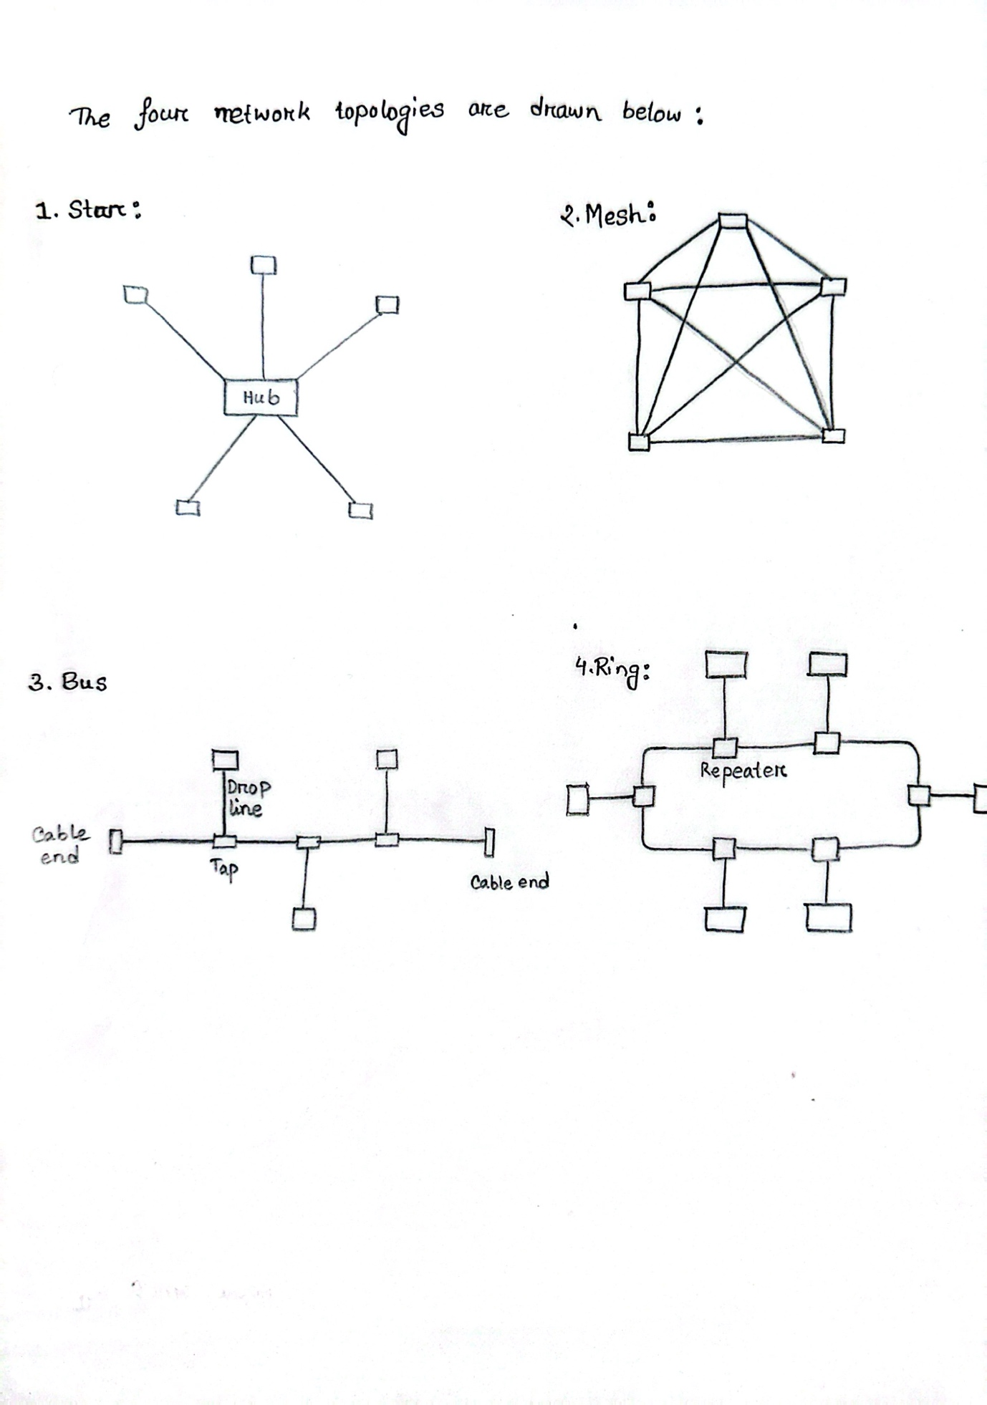

Answer to the Question No. 4

|  |  |  |  |  |
| --- | --- | --- | --- | --- |
| Topology | Structure | Pros | Cons | Example |
| Mesh | All the devices are interconnected. | Provides a tight security. | Costly and maintenance is critical. | CBI |
| Star | All the devices are connected through a central hub or switch. | Failure of one device doesn’t affect others, easy to expand. | If the central hub is damaged the entire system goes down. | Wi-fi |
| Bus | Devices are connected with a central cable (Backbone). | Low costing, easy to set up. | If backbone fails the whole system goes down, transmission is slower compared to others. | Small office |
| Ring | The devices are connected in circular loop. | Relatively easy to install and reconfigure. | Doesn’t provide that much of security. | Industrial network |

Answer to the Question No. 5

