

Assignment 02

Name: Mehedi Hasan Rowdro

Student id: 24101226

Section: 03

Course code: CSE320

Course title: Data Communication

Semester: Spring 25

**Answer to the Question No. 01**

Scenario 01:

Network Type: LAN (Local Area Network)

Reason: The 10 labs are in the same building (UB06) in a comparative small area, that’s why it is LAN.

Scenario 02:

Network Type: WAN (Wide Area Network)

Reason: As the PCs in BU01 and the PCs at Brac Center are in different networks and can communicate with each other, here the network type is WAN.

Scenario 03:

Network type: WAN (Wide Area Network)

Reason: Brac Center (in Gulshan) and Brac CDM (in Rajendrapur) are in distant places and the distance between this to places is most likely 45km. So, it’s a WAN network.

Scenario 04:

Network Type: MAN (Metropolitan Area Network)

Reason: As the fire stations are in the same city. so, the network type is MAN.

**Answer to the Question No. 02**

* Number 1 is **Ring Topology**
* Number 2 is **Mesh Topology**
* Number 3 is **Star Topology**
* Number 4 & 5 are **Bus Topology**

**Answer to the Question No. 03**

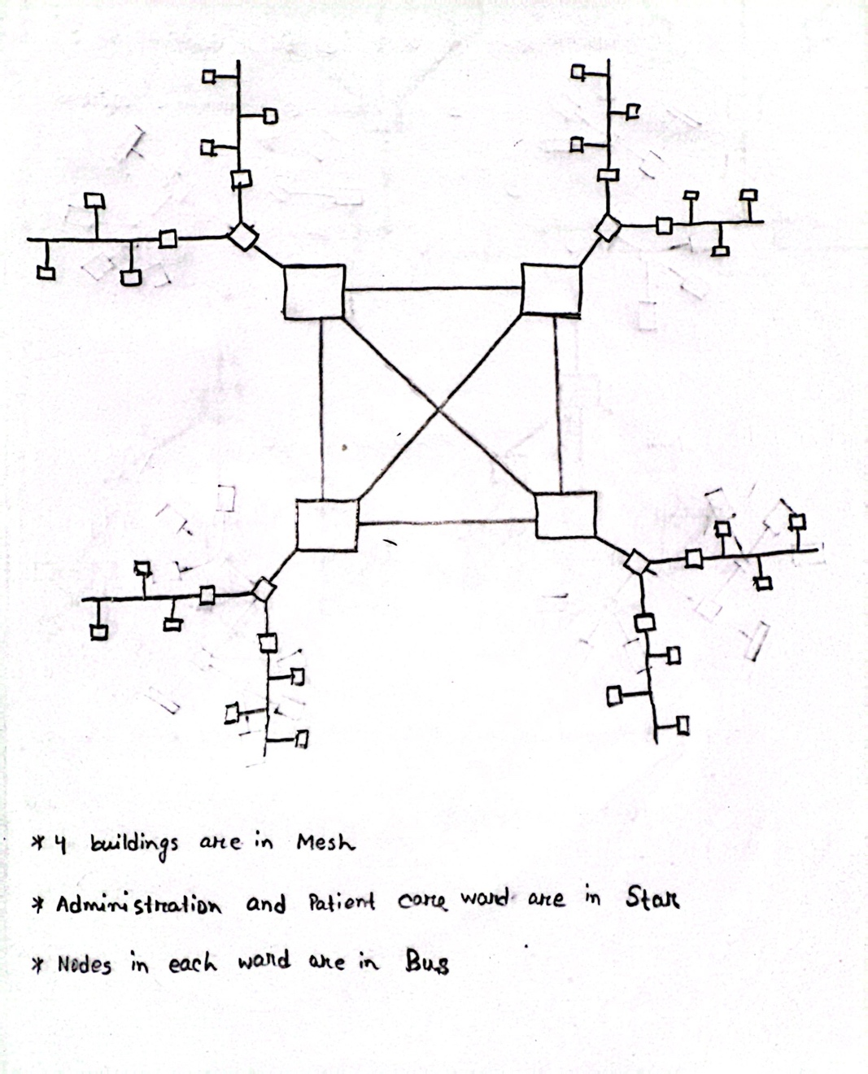

**Answer to the Question No. 04**

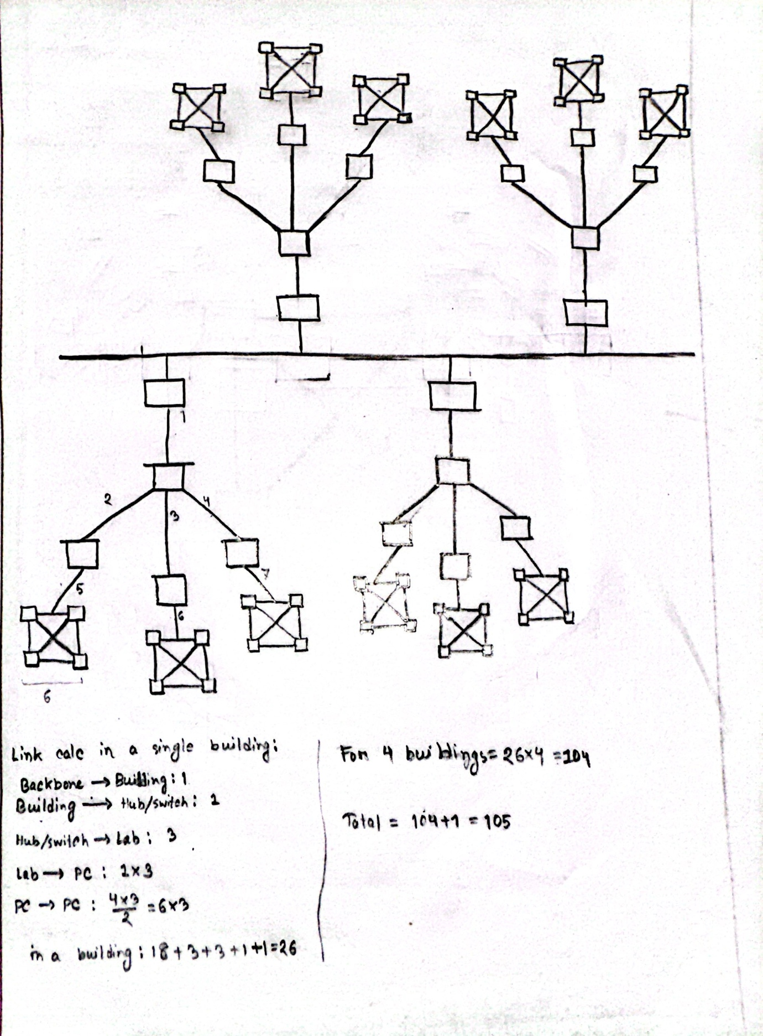

**Answer to the Question No. 05**

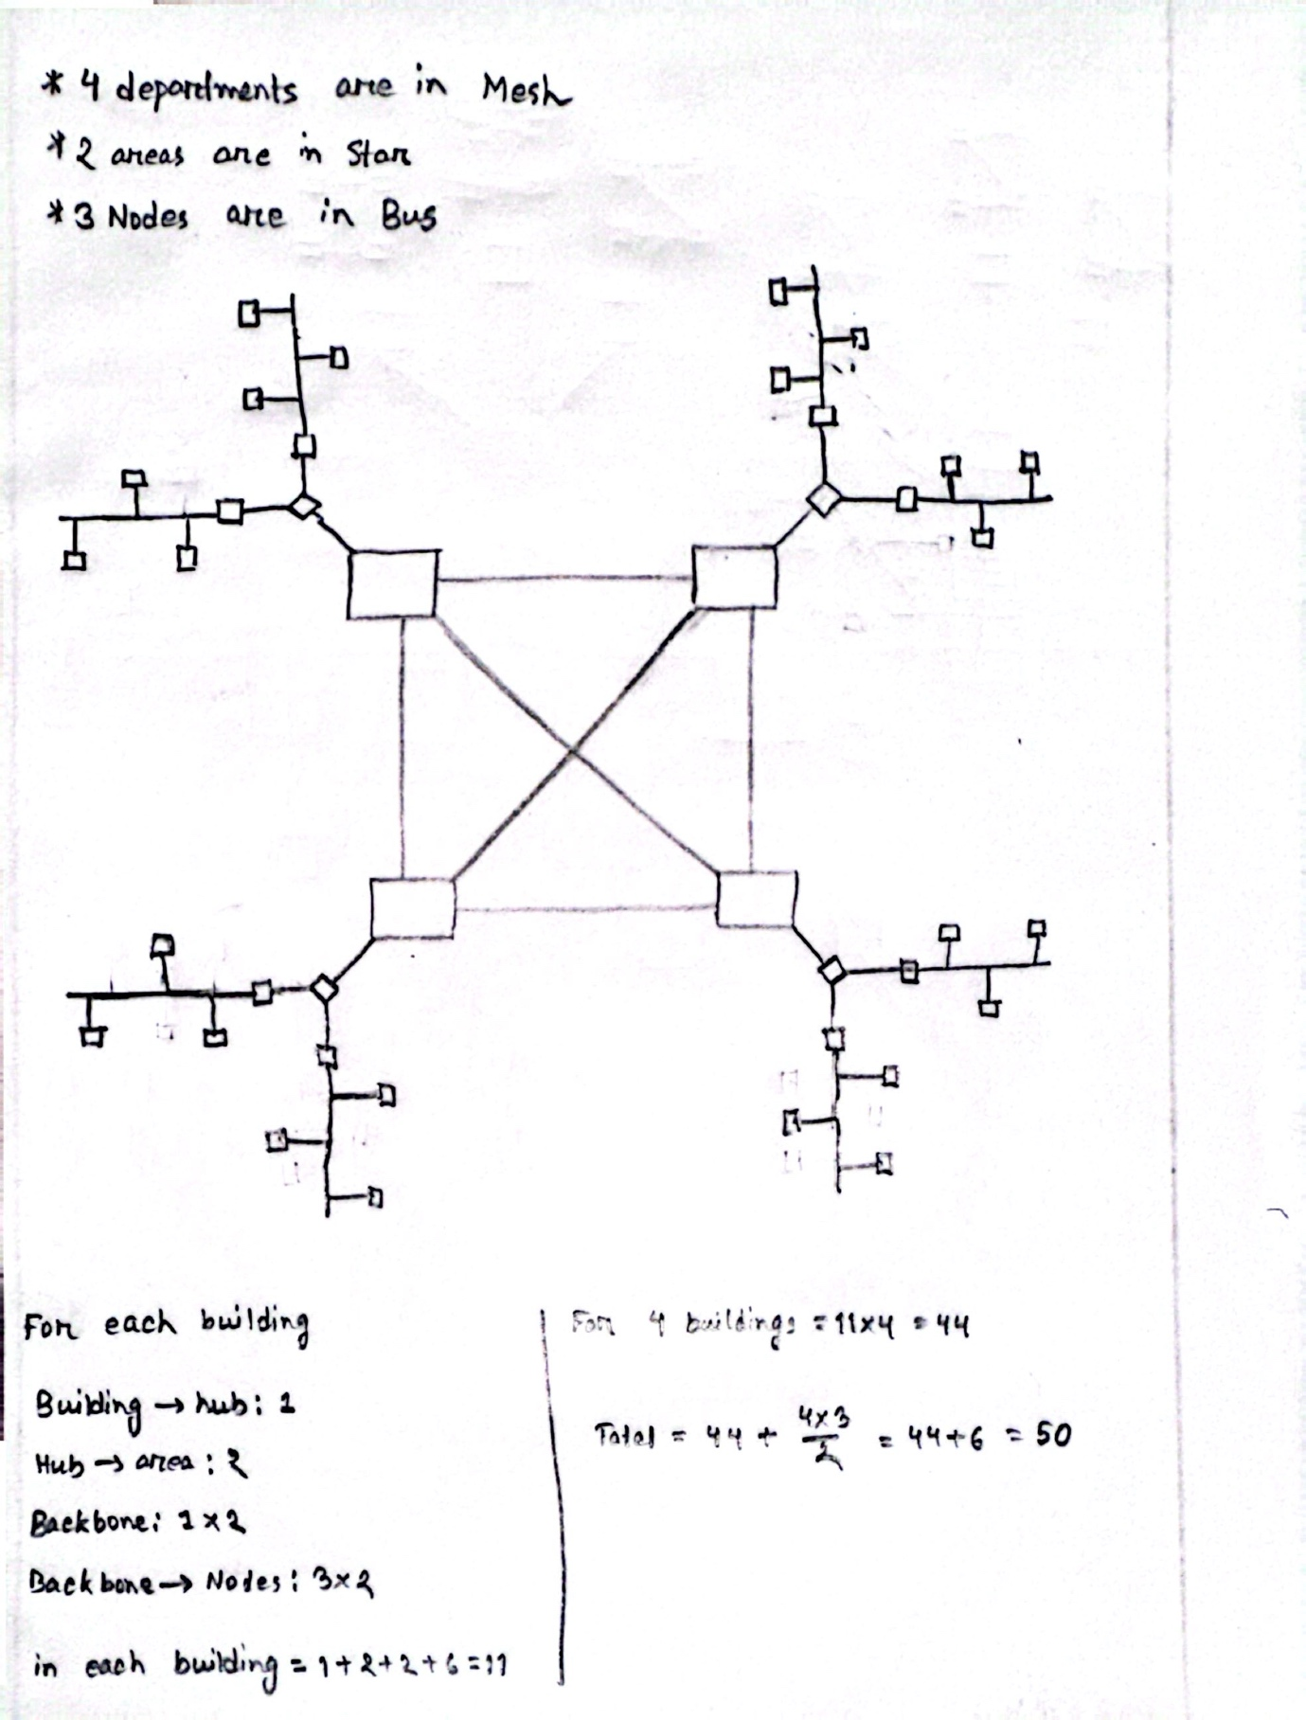

**Answer to the Question No. 06**

|  |  |  |  |
| --- | --- | --- | --- |
| **Network type** | **Full form** | **Coverage area** | **Example** |
| PAN | Personal Area Network | Within few meters of radius around an individual. | Bluetooth, Airdrops. |
| LAN | Local Area Network | Within an office, building or campus. | Wi-fi, lab network. |
| MAN | Metropolitan Area Network | Within a city. | TV cable network. |
| WAN | Wide Area Network | Within countries, or even globally. | Internet. |

**Answer to the Question No. 07**

* End-to-end device: Computer, Mobile phone.
* Intermediary device: Router, Hub.

**Answer to the Question No. 08**

Software is classified in two types.

* System Software: The built-in (mostly) software which manage the hardware are called System Software. This type of software works like a bridge between users and hardware. Example: Windows, MacOS, Linux.
* Application Software: Software which are used for specific types of tasks, for example productivity, entertainment, or communication, they are called the Application Software. Example: Microsoft word, Power point, Gmail.

**Answer to the Question No. 09**

|  |  |
| --- | --- |
| **Data Type** | **Standard/file extensions** |
| Image | .jpg, .gif, .png |
| Audio | .mp3, .m4a, .wav |
| Video | .mp4, .mkv, .mov |
| Text | .txt, .docx, .pdf |
| Application | .apk, .dmg, .jar |
| Code | .py, .java, .c, .cpp, .html, .js |
| Spreadsheet | .xls, .xlsx |
| Presentation | .ppt, .pptx |
| Compressed file | .zip |

**Answer to the Question No. 10**

The factors that determine the effectiveness of a network system are:

* Delivery
* Accuracy
* Timeliness
* Jitter