

Assignment 04

Name: Mehedi Hasan Rowdro

Student id: 24101226

Section: 03

Course code: CSE320

Course title: Data Communication

Semester: Spring 25

**Answer to the Question No. 01**

* 1. Period(T): The time a signal takes to complete a full cycle.

Unit: S

Equation: T = 1 / f

* 1. Wavelength(λ): The distance a signal travels in one period.

Unit: m

Equation: λ = v / f

* 1. Frequency(f): The number of full cycles in one second.

Unit: Hz

Equation: f = 1 / T

* 1. Amplitude: The intensity of a signal.

Unit: V(for electrical signal)

* 1. Phase: The position or condition of wave particle in a specific time.

Unit: Degree, radian

* 1. Bandwidth(B): The difference between the highest and the lowest frequencies of a composite signal.

Unit: Hz, bps

Equation: B=fmax - fmin

* 1. Bit Rate: The number of bits sent per second.

Unit: bps

Equation: R=Number of bits / time

* 1. Bit Length: The distance one bit occupies in transmission medium.

Unit: m

Equation: Length=speed*time

* 1. Attenuation: The loss of energy in overcoming resistance of the medium.

Unit: dB

Equation: A=10log2 (Pin / Pout )

1.10 Distortion: The change of shape or form of signal.

1.11 Noise: Mixing of extra signal other than the sender sent.

Unit: dB

1.12 Signal-to-noise ratio (SNR): The ratio of the signal power to the noise power.

Equation: SNR = (average signal power / average noise power)

1.13 Throughput: The actual measurement of how fast we can send data.

Unit: bps

1.14 Latency (Delay): The total time of the data completely reaching the destination.

Unit: S

Equation: Latency = propagation time + transmission time + queuing time + processing delay

1.15 Transmission time: The time between first bit’s leaving and last bit’s arriving.

Unit: S

Equation: Transmission time = (Message Size / Bandwidth)

1.16 Queueing time: The time needed for each intermediate or end device to hold the message before it can be processed.

Unit: S

1.17 Processing time: The time taken by a system (router, switch, etc.) to process a packet before forwarding it.

Unit: S

1.18 Propagation time: The time required for a bit to travel from the source to destination.

Unit: S

Equation: Propagation Time = (Distance / Propagation Speed)

1.19 Jitter: Different packets of data encountering different delays.

Unit: mS

1.20 Broadband transmission or modulation:Changing the digital signal to an analog signal for transmission.

**Answer to the Question No. 02**

Periodic vs Non-periodic

|  |  |
| --- | --- |
| Periodic | Non-periodic |
| 1. Follows a pattern within specific amount of time and complete cycle. | 1. Doesn’t follow any pattern. |
| 2. Repeats that cycle in same amount of time. | 2. Doesn’t repeat any cycle. |

Analog vs digital signals

|  |  |
| --- | --- |
| Analog signals | digital signals |
| 1. Is continuous. | 1. Is discrete. |
| 2. Example: Sounds made by human. | 2. Data stored in computer in the form of 0s and 1s. |

**Answer to the Question No. 03**

|  |  |  |
| --- | --- | --- |
| Sl | Statements | True/False |
| 1. | Frequency and period are the inverse of each other. | True |
| 2. | Frequency is the rate of change with respect to wavelength. | False |
| 3. | If a signal does not change at all, its frequency is one. | False |
| 4. | If a signal changes instantaneously, its frequency is infinite. | True |
| 5. | Phase describes the position of the waveform relative to time 0. | True |
| 6. | The wavelength is the distance a simple signal can travel in one period. | True |
| 7. | A complete sine wave in the time domain can be represented by one single spike in the frequency domain. | True |
| 8. | If the composite signal is non-periodic, the decomposition gives a combination of sine waves with discrete frequencies. | False |
| 9. | A composite signal is made of many simple sine waves. | True |
| 10. | A complete sine wave in the time domain can be represented by one single spike in the frequency domain. | True |
| 11. | A sine wave with a phase of 90° starts at time 0 with a peak amplitude. The amplitude is increasing. | False |
| 12. | A sine wave with a phase of 180° is shifted to the left by a ½ cycle. However, note that the signal does not really exist before time 0. | True |
| 13. | Bit rate is the same as bits-per-second. | True |
| 14. | A vertical line in the time domain means a frequency of infinity (sudden change in time); a horizontal line in the time domain means a frequency of zero (no change in time). | True |
| 15. | A digital signal is a composite analog signal with an infinite bandwidth. | True |
| 16. | If we need to send bits faster, we need as less bandwidth as possible. | False |
| 17. | If the available channel is a bandpass channel, we can send the digital signal directly to the channel. | False |
| 18. | When a signal, simple or composite, travels through a medium, it loses some of its energy in overcoming the resistance of the medium. | True |
| 19. | Increasing the levels of a signal increases the reliability of the system. | False |
| 20. | The Shannon capacity gives us the upper limit; the Nyquist formula tells us how many signal levels we need. | True |

**Answer to the Question No. 04**

the two contexts of bandwidth that we use in Networking are

1. Bandwidth in Hertz

2. Bandwidth in Bits per Seconds

**Answer to the Question No. 05**

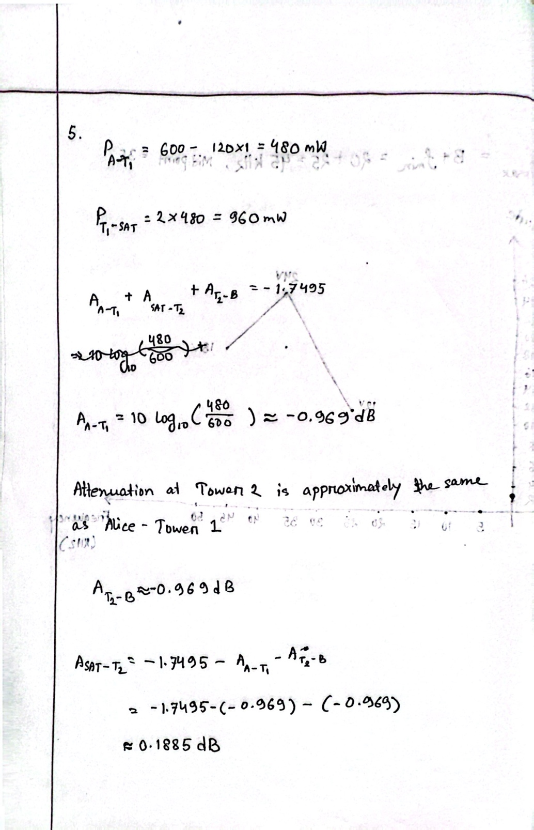

**Answer to the Question No. 06**

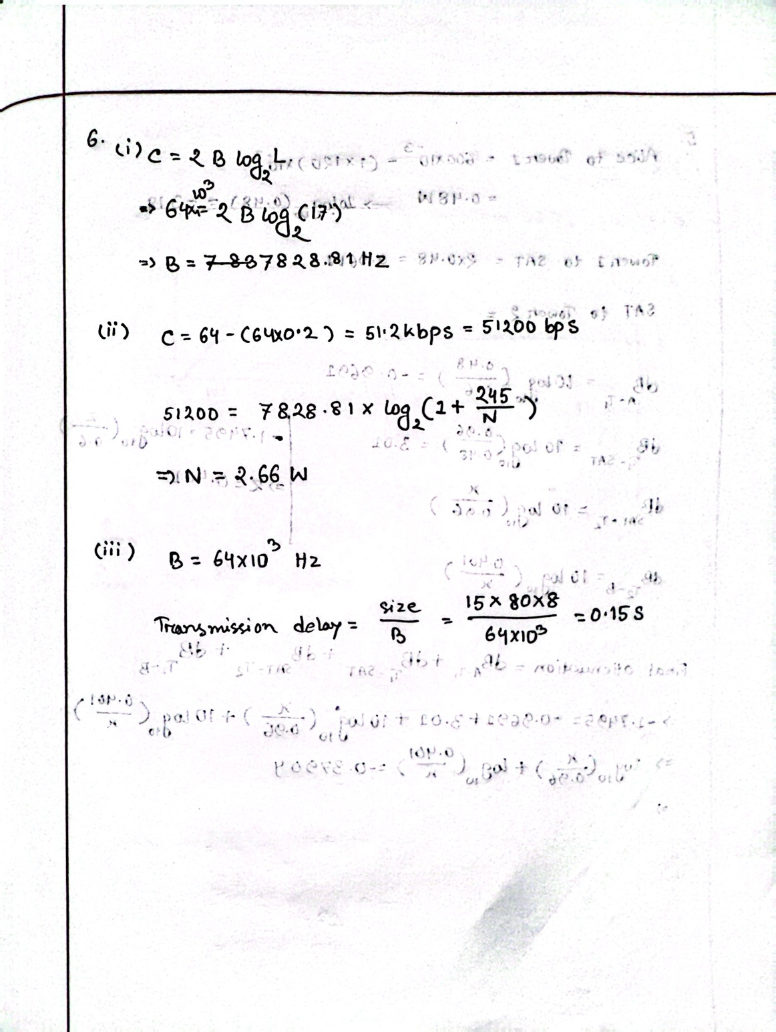

**Answer to the Question No. 07**

|  |  |
| --- | --- |
| Baseband | Broadband |
| 1. Baseband transmission means sending a digital signal over a channel without changing the digital signal to an analog signal. | 1. Broadband transmission or modulation means changing the digital signal to an analog signal for transmission. |
| 2. Baseband transmission requires that we have a low-pass channel, a channel with  a bandwidth that starts from zero*.* | 2. Broadband transmission or modulation uses a bandpass channel with a bandwidth that does not start from zero. |

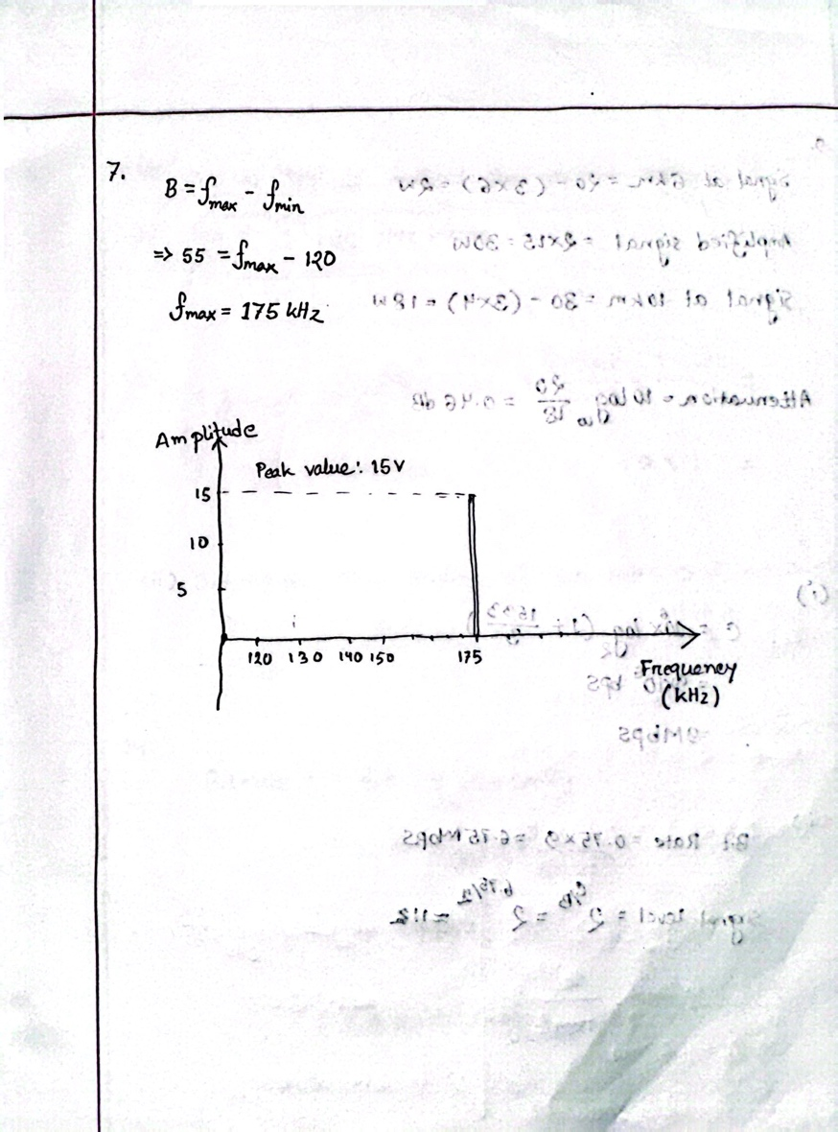

**Answer to the Question No. 08**

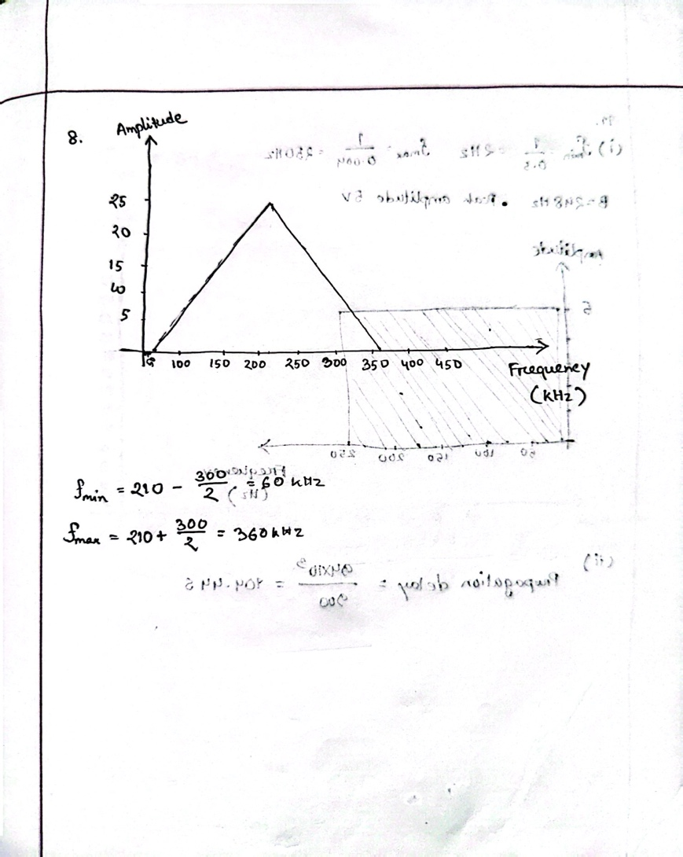

**Answer to the Question No. 09**

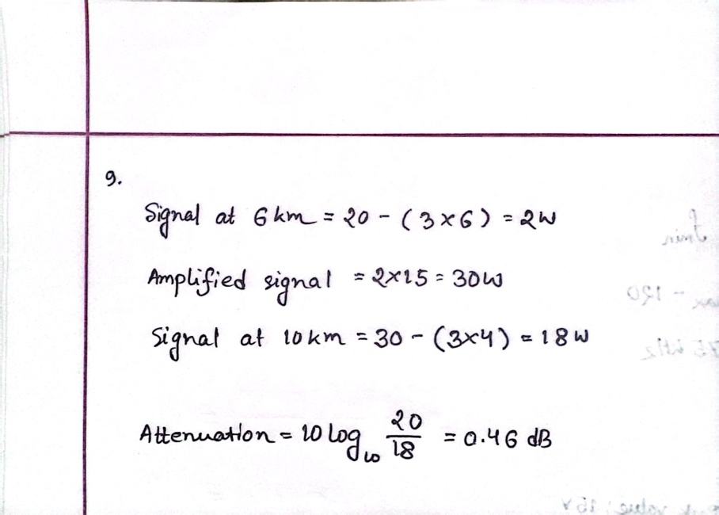

**Answer to the Question No. 10**

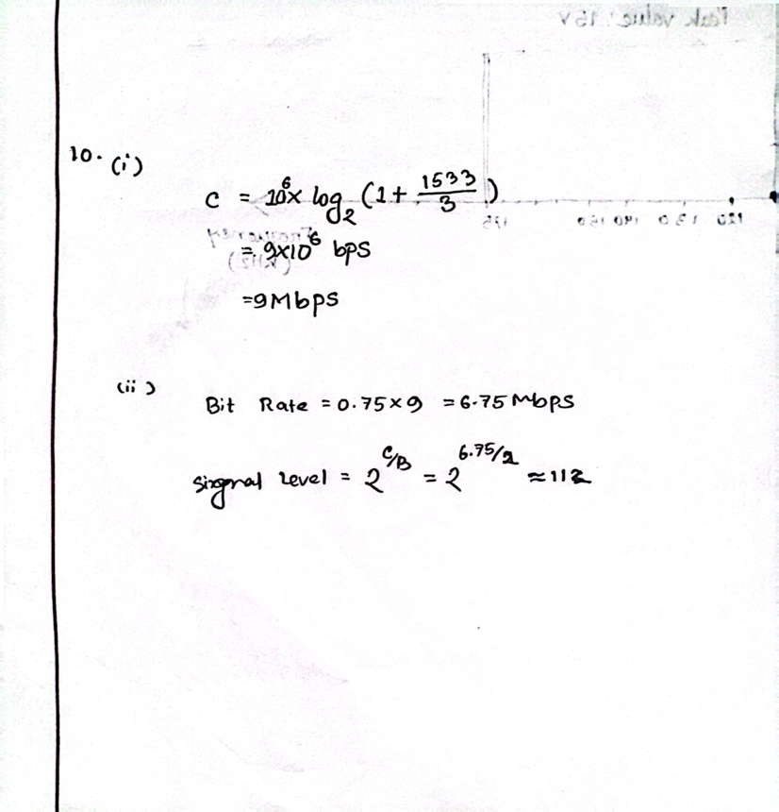

**Answer to the Question No. 11**

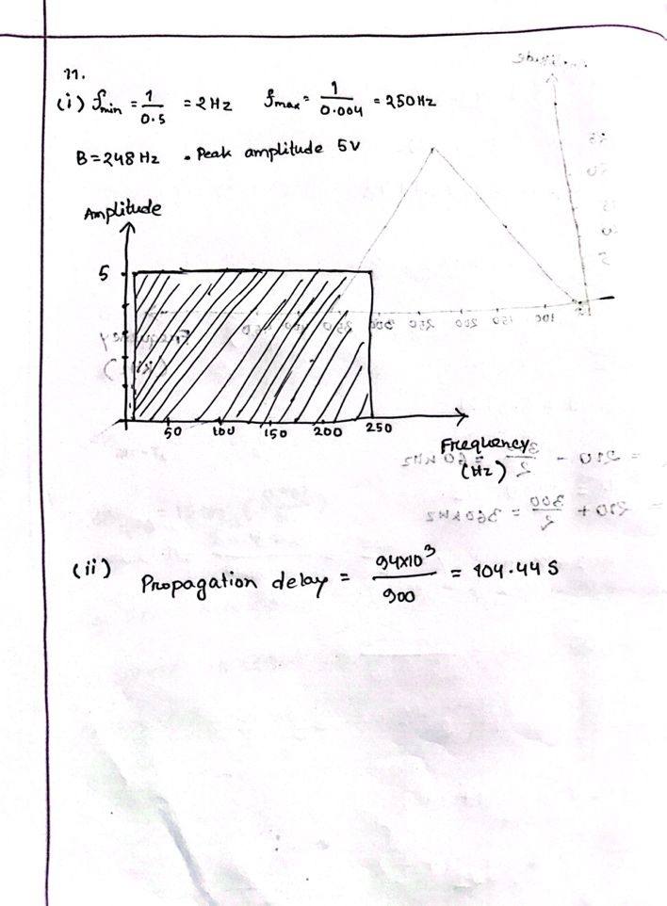

**Answer to the Question No. 12**

**Answer to the Question No. 13**

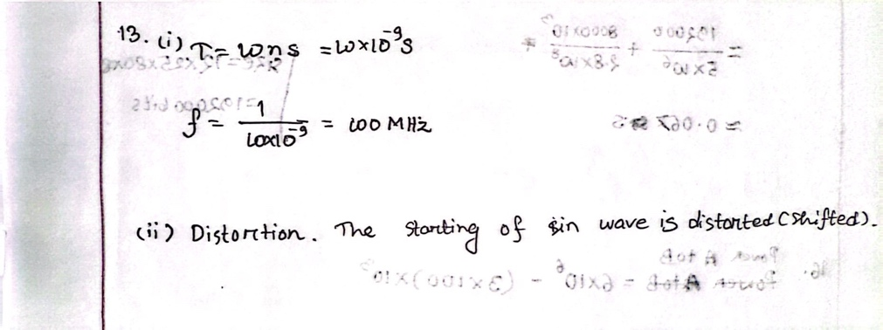

**Answer to the Question No. 14**

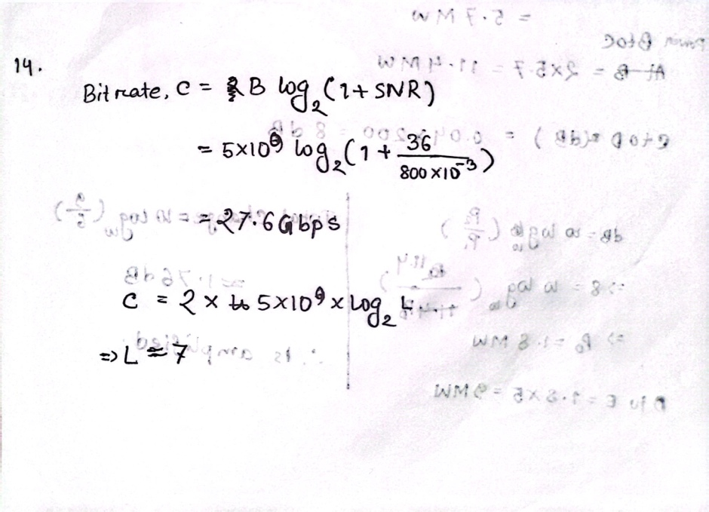

**Answer to the Question No. 15**

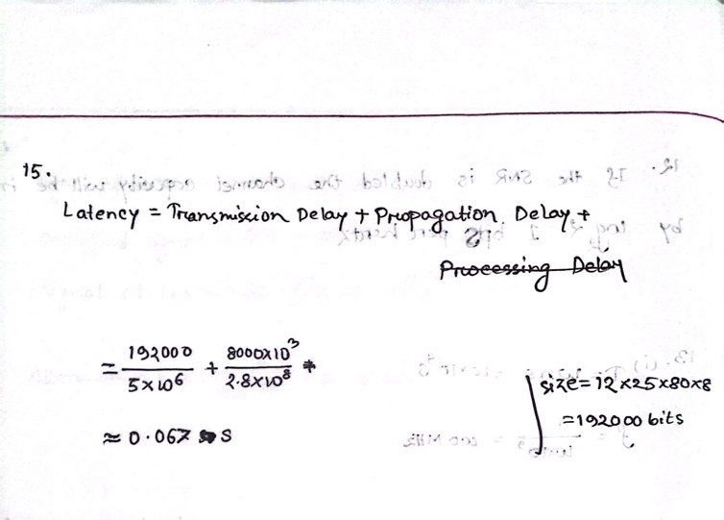

**Answer to the Question No. 16**

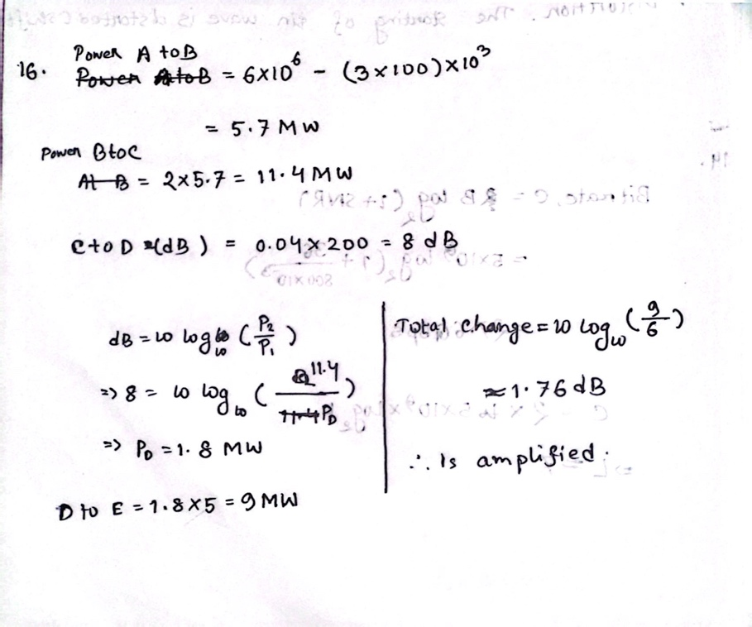

**Answer to the Question No. 17**

**Answer to the Question No. 18**

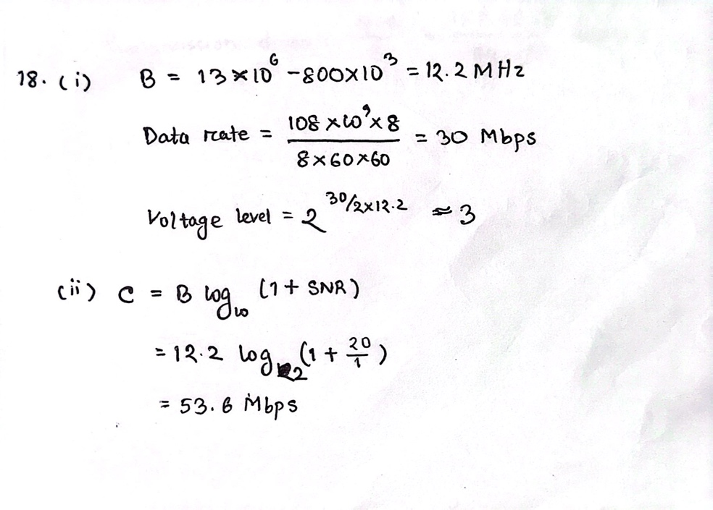

**Answer to the Question No. 19**

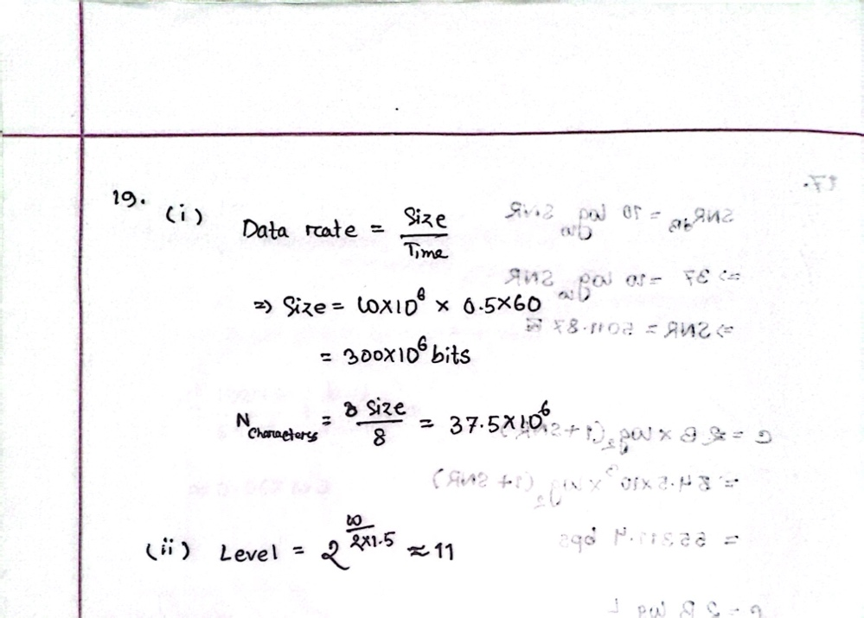

**Answer to the Question No. 20**

