**A Report on My Fictional Company**

**Samsung Electronics**

**SAMSUNG**

**Submitted by**

Md Yamin

Department of Mathematics Studies

University of Barishal.

**Batch 46**

EDGE Digital Skills Training Course

**Date of Submission:** 05/12/ 2024

**Table of Contents**

**Introduction** 3

**Our Product and services** 4

Laptops 4

Desktops 4

Tablets 5

Smartphones **Error! Bookmark not defined.**

**Flow Chart of Business Plan** 6

**Statistics of sold products in the last 3 months** 7

**( January – March 2024)** 7

**Sales Report of Samsung Electronic of the Month January – March 2024** 7

**Yearly report of Samsung Electronics** 8

**Introduction**

Samsung, founded in 1938 in South Korea by Lee Byung-chul, began as a trading company but evolved into one of the largest multinational conglomerates in the world. Known for its innovation and influence across various industries, Samsung has a broad portfolio that spans electronics, shipbuilding, construction, and finance, among other sectors.

Samsung Electronics, one of its most recognizable subsidiaries, is a global leader in consumer electronics, particularly smartphones, televisions, home appliances, and semiconductors. Their Galaxy line of smartphones and tablets has positioned them as a key player in the tech industry, competing with companies like Apple and Huawei.

Samsung is also a pioneer in display technology, 5G networks, artificial intelligence, and smart home ecosystems. Its commitment to research and development, along with a diversified product range, has enabled the company to stay at the forefront of technological advancements while maintaining a strong global presence.

**Our Product and services**

Samsung Electronics offers a diverse range of high-quality electronic products designed to meet the needs of modern consumers. The product lineup includes:

Laptops

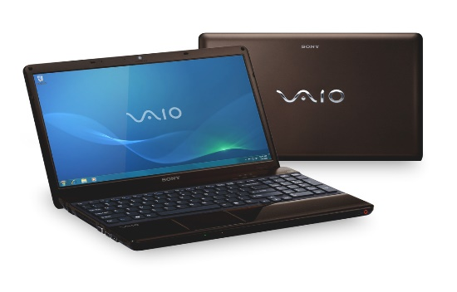

Samsung Vaio laptops are highly regarded for their blend of performance, portability, and affordability. Known for their sleek designs and robust build quality, SONY Vaio laptops cater to a wide range of users from students to professionals. The inclusion of the latest processors and high-definition displays has earned them a reputation for reliability and efficiency.

Desktops

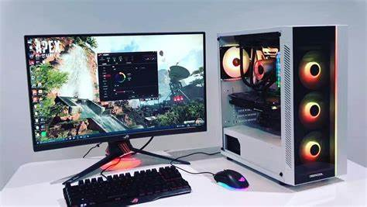

Samsung desktops are synonymous with power and dependability. These desktops are favored by both home users and businesses for their high performance and customizable configurations. With a strong emphasis on quality components and user-friendly designs, SONY desktops are known for their longevity and excellent performance in demanding tasks.

Tablets

Samsung tablets are celebrated for their versatility and innovative features. Popular among digital artists, students, and professionals on the go, these tablets offer high-resolution displays, long battery life, and robust processing power. Samsung focus on user experience and functionality has made their tablets a preferred choice in the market.

Smartphones

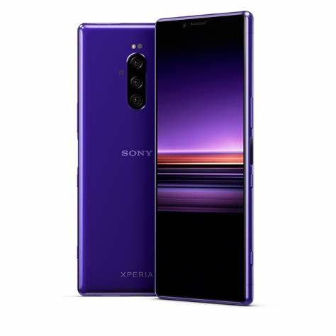

Samsung smartphones enjoy a stellar reputation for advanced features, including high-resolution cameras, fast processors, and 5G capabilities. They are appreciated for their affordability without compromising on quality, making them accessible to a broad audience. The brand's continuous innovation and stylish designs have cemented Samsung smartphones as a leading choice among consumers.

**Flow Chart of Business Plan**

|  |
| --- |
| **The sum of Total Sales (BDT)** |

**Statistics of sold products in the last 3 months**

**( January – March 2024)**

|  |  |
| --- | --- |
| **Product** | **Total** |
| Desktop | 6950000 |
| Laptop | 12250000 |
| Smartphone | 6150000 |
| Tablet | 3320000 |
| **Grand Total** | **28670000** |

**Sales Report of Samsung Electronic of the Month January – March 2024**

|  |  |
| --- | --- |
| **The sum of Total Sales (BDT)** | |
| **Months (Date)** | **Total** |
| January | 8750000 |
| February | 9920000 |
| March | 10000000 |
| **Grand Total** | **28670000** |

**Yearly report of Samsung Electronics**

|  |  |  |  |
| --- | --- | --- | --- |
| **Yearly report** | | | |
| Month | Expenses | Sales | Profit |
| January | 9288500 | 8750000 | -538500 |
| February | 9744300 | 9920000 | 175700 |
| March | 8904700 | 10000000 | 1095300 |
| April | 7345200 | 7957400 | 612200 |
| May | 8987000 | 9876500 | 889500 |
| June | 5215400 | 5164500 | -50900 |
| July | 9976500 | 11543600 | 1567100 |
| August | 7976700 | 8087900 | 111200 |
| September | 9879000 | 9969800 | 90800 |
| October | 6234800 | 7024000 | 789200 |
| November | 4534800 | 4809300 | 274500 |
| December | 8348700 | 8834800 | 486100 |