**ACHARYA INSTITUTE OF GRADUATE STUDIES**

**(NACC “A” RE-ACCREDITED & AFFILIATED WITH BENGALURU CITY**

**UNIVERSITY)**

**Soldevanahalli, Bengaluru – 560107**



**A mini project report on**

**AIGS MCA FORUM**

**Submitted by -**

**Mohammed Faizan - P18AJ21S0139**

**Abhishek Kumar Boby - P18AJ21S0142**

**Under the Guidance of -**

**Mr. Rajesh Rao K**

**Department of Master of Computer Applications**

**2022-23**

AIGS MCA Forum



1

UNDERTAKING

We, **Mohammed Faizan (P18AJ21S0139) and Abhishek Kumar Boby (P18AJ21S0142)** hereby declare that the project report on **“AIGS MCA FORUM”** is carried out and completed successfully by us and is our original work.

**Mohammed Faizan Abhishek Kumar Boby (P18AJ21S0139) (P18AJ21S0142)**

AIGS MCA Forum



2

ACKNOWLEDGMENT

I express my sincere thanks to my internal guide **Mr. Rajesh Rao K**, Assistant Professor, Department of MCA, Acharya Institute of Graduate Studies for his valuable suggestions and guidance throughout the project.

I am thankful to our Head of the Department **Dr. Sudha M**, Department of MCA, Acharya Institute of Graduate Studies for constant encouragement and support throughout the project.

I would also like to extend my gratitude to our Principal **Dr. Gurunath Rao Vaidya**, Acharya Institute of Graduate Studies for constantly evaluating and setting up rules which help the students to learn, innovate and indulge in a better quality of education.

I extend my thanks to all the faculty members and the Management for their constant support and upliftment.

Date –



AIGS MCA Forum

3

**Abstract**

The MCA Department Discussion Forum is an online platform designed to facilitate communication

and collaboration among students, faculty, and alumni of the Master of Computer Applications (MCA) department. The forum aims to provide a space where individuals can engage in meaningful discussions, share knowledge, seek assistance, and foster a sense of community within the MCA department.

The forum serves as a hub for various topics related to computer applications, including programming languages, software development methodologies, database management systems, networking, artificial intelligence, and more. Users can create threads to initiate discussions, pose questions, or share interesting articles and resources. They can also participate in existing threads by providing insights, offering solutions, or engaging in healthy debates.

Our AIGS MCA Department forum encourages active participation and promotes the exchange of ideas and experiences. Students can seek guidance from faculty members and seniors, enabling them to enhance their understanding of complex subjects and improve their academic performance. Faculty members can share their expertise, provide valuable feedback, and facilitate discussions that supplement classroom learning.

AIGS MCA Forum



4

# INDEX

|  |  |  |
| --- | --- | --- |
| **Sr. No.** | **Particular** | **Pg. No.** |
| **1** | **Introduction** | **5** |
|  | 1.1 Project Profile | **5** |
| **2** | **System Environment** | **6** |
|  | 2.1 Hardware Configuration | 6 |
|  | 2.2 Software Configuration | 6 |
| **3** | **Problem Specification** | **7** |
|  | * 1. Introduction      1. Objective and Proposed Method | 7 |
|  | 3.2 System Model | 8 |
|  | 3.3 Feasibility Study | 9 |
|  | 3.3.1 Technical Feasibility | 9 |
|  | 3.3.2 Behavioral Feasibility | 9 |
|  | 3.3.2.1 Functional Requirement | 9 |
| 3.3.2.2 Non-Functional Requirement | 10 |
|  | **Project Analysis and Planning** | **11** |
|  | 4.1 Module specification | 11 |
| 4 | 4.2 Use case Diagram | 13 |
|  | 4.3 DFD Diagram | 15 |
|  | 4.4 Technology used | 17 |
|  | **Implementation** | **20** |
| 5 | * 1. Coding   2. Testing | 20  21 |
|  | 5.3 Risk Identification and Management | 22 |
|  | **Project Design** | **25** |
| 6 | 6.1 Database Tables | 25 |
|  | 6.2 Screenshots | 26 |
| 7 | **Conclusion** | **30** |
| 8 | **Future Scope of the System** | **31** |
| 9 | **References** | **32** |

AIGS MCA Forum



5

# Introduction

The project entitled “AIGS MCA Discussion Forum” allows students from the MCA Department of Acharya Institute of Graduate Studies (AIGS) to establish communication through an online platform, and allows students to help each other on a multitude of things such as Projects, Project Ideas, Coding Errors, etc. They can visit the forum and post questions on the forum, on a specific thread, and other students can reply to those questions.

## Project Profile

**Project Name:** AIGS MCA Forum

**Description:** The project involves the development of an online discussion forum exclusively for the Master of Computer Applications (MCA) department. The forum will serve as a platform for MCA students to communicate, collaborate, and support each other in their academic endeavors.

**Scope:** The MCA Department Discussion Forum will be limited to the MCA department, providing a dedicated space for students to engage in discussions related to programming languages, software development methodologies, database management systems, and other relevant topics. The forum will facilitate peer-to-peer knowledge sharing, question-solving, and fostering a sense of community within the MCA student body.

**Duration:** The project is expected to be completed within a duration of three months, including the development, testing, and deployment phases of the forum.

**Budget:** The project has a zero-budget allocation as it will be undertaken by two MCA students as a collaborative project.

**Resources:** The project is being executed by two MCA students who are responsible for the development and maintenance of the forum. They will utilize their technical skills and knowledge to create an intuitive and user-friendly platform.

AIGS MCA Forum



6

# System Environment

## Hardware Configuration

Platform: Windows 2000 Professional

System: Pentium IV 2.8 GHz

RAM: 512MB

Hard disk: 80GB

## Software Configuration

Web server: XAMPP Server

Back end: MYSQL Server-side scripting: PHP

Client-side scripting: HTML, JavaScript

AIGS MCA Forum



7

## Problem Specification

* + - 1. **Introduction**

Although we have a dedicated website for Acharya University which allows students to admission, pay fees acquire information about the college, and loans, etc, but, right now, Acharya Institute provides a platform on which students can communicate with each other and which would help them to gain additional knowledge outside of their courses provided by the institute.

## Objective and Proposed System Objective:

The primary objective of the MCA Department Discussion Forum is to create an interactive and collaborative platform for MCA students to exchange knowledge, seek guidance, and engage in meaningful discussions related to computer applications. The forum aims to facilitate academic support, foster a sense of community, and enhance the overall learning experience of MCA students.

## Proposed System:

The proposed system is an online discussion forum specifically tailored to meet the needs of the MCA department. It will provide a user-friendly interface that allows students to create and participate in discussions on various topics relevant to their coursework and professional interests. The forum will offer features such as thread creation, posting replies, private messaging, and a search function for easy navigation and information retrieval.

To ensure a productive and engaging environment, the forum will be moderated by administrators who will oversee the discussions and enforce community guidelines. The proposed system will prioritize user interaction, encouraging active participation and knowledge sharing among MCA students. It will serve as a platform for students to seek guidance from peers, share resources, discuss challenging concepts, and collaborate on projects.

The proposed system aims to create a vibrant online community within the MCA department, where students can connect, learn from each other's experiences, and build valuable relationships. By providing a dedicated space for discussions and knowledge exchange, the forum will contribute to the academic and professional growth of MCA students and strengthen the overall MCA department ecosystem.

AIGS MCA Forum



8

## System Model

**User Registration:** The system allows users (MCA students) to create an account by providing their relevant information, such as name, email address, and a chosen password.

**Login and Authentication:** Once registered, users can log in to the forum using their credentials. The system authenticates the user's identity to ensure secure access to their account.

**Forum Home Page:** After logging in, users are directed to the forum home page. They can see the latest threads, popular topics, and relevant announcements here.

**Thread Creation:** Users can create new discussion threads on specific topics of interest. They provide a title, description, and relevant tags to categorize their thread.

**Posting Replies:** Users can read and respond to existing discussion threads by posting replies. They can share their thoughts, ask questions, or provide helpful information to contribute to the ongoing conversation.

**Search Functionality:** The forum includes a search feature that enables users to search for specific threads or topics. This helps users find relevant discussions quickly and easily.

**Moderation:** Administrators and moderators have access to moderation tools to ensure that the forum remains a respectful and constructive environment. They can remove inappropriate content, address violations of community guidelines, and manage user accounts.

**Administration Panel:** Administrators have access to an administration panel, where they can manage user accounts, configure forum settings, and perform system maintenance tasks.

AIGS MCA Forum



9

## Feasibility Study

It is the preliminary exploration of our proposed project to determine its merits and viability. The feasibility study aims to provide an independent assessment that examines our project including technical, economic, financial, legal, and environmental considerations.

## Technical Feasibility:

This project is easy to maintain, user-friendly and cost is effective so that any person can use it.

## Behavioral Feasibility:

This project solves the problem of students who don’t have a meaningful way to communicate with each other on an online platform, on a platform in which all their classmates are available to cooperate and help each other with problems they are facing.

## Functional Requirements ADMIN

* Can add/delete categories.
* Can add/delete the questions and answers.
* Can view/delete users.
* Can view the threads.

## USERS

* Register using appropriate user details.
* Users can view respective categories.
* After viewing the categories, can ask questions on specific categories and create threads, or answer on a specific category or threads.
* They can update their profile.

AIGS MCA Forum



10

## Non-functional Requirements Correctness:

This project is used to provide the actual and correct information about details of the project which was done by students. The admin will have more privileges on the database; the system should always provide correct responses and the data in the database should always be constantly updated with the latest information.

## Reliability:

The system provides the correct information under any situation, in case of any error in input or operation, the system should reflect a proper message or give proper helping information.

## Robustness:

The system must be fault-tolerant concerning illegal user input. Error Checking must be built into the system to prevent system failure.

## Maintainability:

The project will be used for a long time, it must be easy to maintain and easy to incorporate future changes. The design of the system should be module based and changing the design of the one module should not affect the proper operation of the other module.

## Portability:

The system should be portable and can run in any web browser with very little or no modifications.

## Security:

All security precautions are taken to make the product more reliable, only valid i.e., registered persons can access it.

AIGS MCA Forum



11

# Project Analysis and Planning

## Modules

This project has the following modules.

## Categories:

This module manages the categorization of discussion threads on the forum. Users can browse and filter threads based on different categories or topics.

Administrators can create, edit, and delete categories to organize discussions effectively.

## Threads:

This module handles the creation and management of individual discussion threads.

Users can create new threads by providing a title, and description, and selecting a relevant category. Threads allow users to initiate discussions and receive replies from other users.

## Comments:

This module handles the commenting functionality within discussion threads.

Users can post comments to share their thoughts, ask questions, or provide additional information within a specific thread.

Comments allow for interactive and dynamic conversations among users.

## Users:

This module manages user accounts and associated information.

Users can register for an account, log in, and update their profile information.

User management includes features such as password reset, profile customization, and account deletion.

## Registration:

This module handles the registration process for new users. Users can sign up for an account by providing their personal information, such as name, email address, and a chosen password.

AIGS MCA Forum 12

The module verifies the validity of the entered information and checks for unique email addresses to avoid duplicate registrations.

Upon successful registration, users receive a confirmation email or notification to activate their account.

These modules work together to create a comprehensive discussion forum platform for the MCA department. Users can browse and participate in discussions based on different categories, create new threads to initiate conversations, post comments to contribute to existing discussions and manage their user profiles for a personalized experience. The modular approach allows for efficient development, maintenance, and scalability of the forum system.

AIGS MCA Forum



13

## Use Case Diagram

**Admin Use Case:**



Categories

Manage Users

**Admin**

Manage

(posts/com ments)

## User Use Case:

**User**



Register

Login

Create thread

Comment

Report

AIGS MCA Forum



14

## Data Flow Diagram Registration

Registration Module

User_id

username

Registration master

Password

Email_id

**Category Module**

Name

Category

Module

Category master

Category id

AIGS MCA Forum



15

## Post Question

Question

Module

Question

Question Desc.

Question

timestamp

user Id

Category Id

Email_id

**Answer**

Answer Module

Answer

Answers

post Date

Question Id

Email_id

Users

View

New

Post

View

Post Question

Search

Registration

AIGS MCA Forum



16

## Threads

thread Subject

Thread

Module

threads

Content

thread Id

Category Id

**ER-Diagram**

Article

View article

Post Article

AIGS MCA Forum



17

## TECHNOLOGY USED FOR DEVELOPMENT

**Introduction to Java Script**

JavaScript is a **client-side programming language** that you can use for creating interactive web pages. JavaScript uses almost the same ideas present in Java. You can learn JavaScript to embed JavaScript code in HTML pages and the Web browser interprets it accordingly. JavaScript used to be known initially as Mocha and was originally developed by Brendan Each of Netscape. Later on, it was renamed to Live Script, and finally to JavaScript.

Although it shares many of the features and structures of the full Java language, it was developed independently. JavaScript can interact with HTML source code and can help you to spice up your website with dynamic content. It is an open language that you can use without purchasing a license. It is normally used in the form of client-side JavaScript and is implemented as part of a web browser to offer enhanced user interfaces and dynamic websites. However, it is used outside web pages too.

## Introduction to PHP

The past ﬁve years have been fantastic in terms of the explosive growth of the Internet and the new ways in which people can communicate with one another. Spearheading this phenomenon has been the World Wide Web (WWW), with thousands of new sites being launched daily and consumers being consistently offered numerous outstanding services via this new communications medium. With this exploding market has come a great need for new technologies and developers to learn these technologies. Chances are that if you are reading this paragraph, you are one of these Web developers or are soon to become one. Then you’ve heard of the great new technology called PHP.

## Characteristics of PHP:

As you may have realized, the PHP language revolves around the central theme of practicality. PHP is about providing the programmer with the necessary tools to get the job done quickly and efficiently.

Five important characteristics make PHP’s practical nature possible:

* Familiarity
* Simplicity
* Security
* Flexibility
* Efficiency
* It is free (so it makes it interesting)

AIGS MCA Forum



18

## Familiarity:

Programmers from many backgrounds will ﬁnd themselves already accustomed to the PHP language. Many of the language’s constructs are borrowed from C and Perl, and in many cases, PHP code is almost indistinguishable from that found in the typical C or Pascal program. This minimizes the learning curve considerably.

## Simplicity:

A PHP script can consist of 10,000 lines or one line: whatever you need to get the job done. There is no need to include libraries, special compilation directives, or anything of the sort. The PHP engine simply begins executing the code after the ﬁrst escape sequence (<?) and continues until it passes the closing escape sequence (?>). If the code is syntactically correct, it will be executed exactly as it is displayed.

## Efficiency:

Efficiency is an extremely important consideration for working in a multi-user environment such as the [WWW.](http://WWW/) PHP 4.0 introduced resource allocation mechanisms and more pronounced support for object-oriented programming, in addition to session management features. Reference counting has also been introduced in the latest version, eliminating unnecessary memory allocation.

## Security:

PHP provides developers and administrators with a ﬂexible and efficient set of security safeguards. These safeguards can be divided into two frames of reference: system level and application level.

1. System-Level Security Safeguards
2. Application-Level Security Safeguards

## Flexibility:

Because PHP is an embedded language, it is extremely ﬂexible to meeting the needs of the developer. Although PHP is generally touted as being used in conjunction solely with HTML, it can also be integrated alongside languages like JavaScript, WML, XML, and many others. Additionally, as with most other mainstream languages, wisely planned PHP applications can be easily expanded as needed. Browser dependency is not an issue because PHP scripts are compiled entirely on the server side before being sent to the user.

## Introduction to My-SQL

AIGS MCA Forum 19

A database is a structure that comes in two flavors: a flat database and a relational database. A relational database is much more oriented to the human mind and is often preferred over the gabble-de- gook flat databases that are just stored on hard drives like a text file. MySQL is a relational database. In a relational structured database, some tables store data. The columns define which kinds of information will be stored in the table. An individual column must be created for each type of data you wish to store (i.e., Age, Weight, and Height).

On the other hand, a row contains the actual values for these specified columns. Each row will have 1 value for every column. For example, a table with columns (Name, Age, Weight-lbs) could have a row with the values (Bob, 65, 165). If all this relational database talk is too confusing, don't despair. We will talk about and show a few examples in the coming lessons.

Databases are most useful when it comes to storing information that fits into logical categories. For example, say that you wanted to store information about all the employees in a company. With a database, you can group different parts of your business into separate tables to help store your information logically. Example tables might be Employees, Supervisors, and Customers. Each table would then contain columns specific to these three areas. To help store information related to each employee, the Employees table might have the following columns: Hire, Date, Position, Age, and Salary.

## PhpMyAdmin:

Also supplied by most hosting services is phpMyAdmin (you can also install it anywhere you want, as it's open source and free). This tool will allow you to view all the MySQL database, tables, and entries, as well as perform SQL queries remotely through a web browser.

Although we will be teaching how to create databases, tables, and all other MySQL tasks through PHP, we encourage you to learn about phpMyAdmin. Its easy-to-use interface will allow you to do many common MySQL tasks quickly and easily.

AIGS MCA Forum



20

# 5. Implementation

## 5.1 Coding Login page:

**Login handle/validation:**

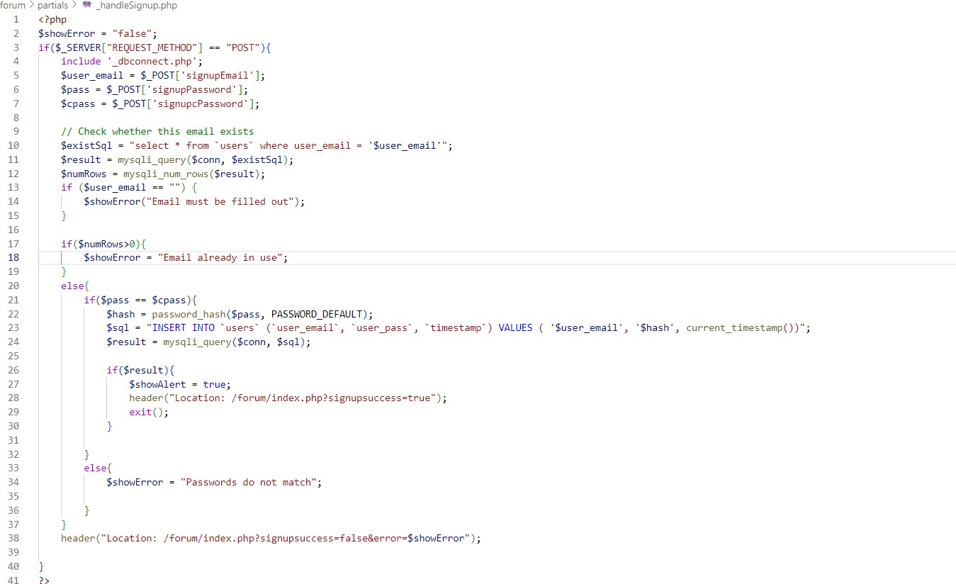

AIGS MCA Forum



21

## 5.2.1 Test Cases and Results (Testing)

**Login Page:**

|  |  |  |
| --- | --- | --- |
| **Input** | **Excepted result** | **Actual result** |
| Click on the Login Button without entering your username and password | The user-friendly error messages should be displayed to the user. | **Respective error messages are displayed to users.** |
| Click on the login button with entering an invalid username and password. | The error message should be displayed. | **The user-friendly error message is displayed.** |
| Click on the Login button by providing a valid email and password. | The user should be login into our application. | **The user is logged into our application.** |

AIGS MCA Forum



22

## 5.3 Risk Identification and Management Security Vulnerabilities:

The forum may be susceptible to security breaches, including unauthorized access, data breaches, or malicious attacks.

## Risk Management Strategy:

Implement robust security measures, such as secure user authentication, encryption of sensitive data, regular security audits, and adherence to industry best practices. Regularly update and patch software to address any known vulnerabilities. Conduct penetration testing to identify potential weaknesses and address them promptly.

## XSS Attack:

XSS (Cross-Site Scripting) is a type of security vulnerability that occurs when an attacker injects malicious scripts into a trusted website or application, which is then executed by the victim's browser. XSS attacks can lead to various harmful consequences, including data theft, session hijacking, defacement of web pages, and unauthorized access to sensitive information.

## Measure Against XSS Attack:

We made sure Input Validation and Sanitization are performed. Implemented strict input validation and sanitization techniques to ensure that user-provided data is properly filtered and validated before being displayed or stored. This includes encoding special characters, blocking or removing potentially malicious scripts, and enforcing strong input validation rules.

AIGS MCA Forum



23

# XSS Attack Screenshots

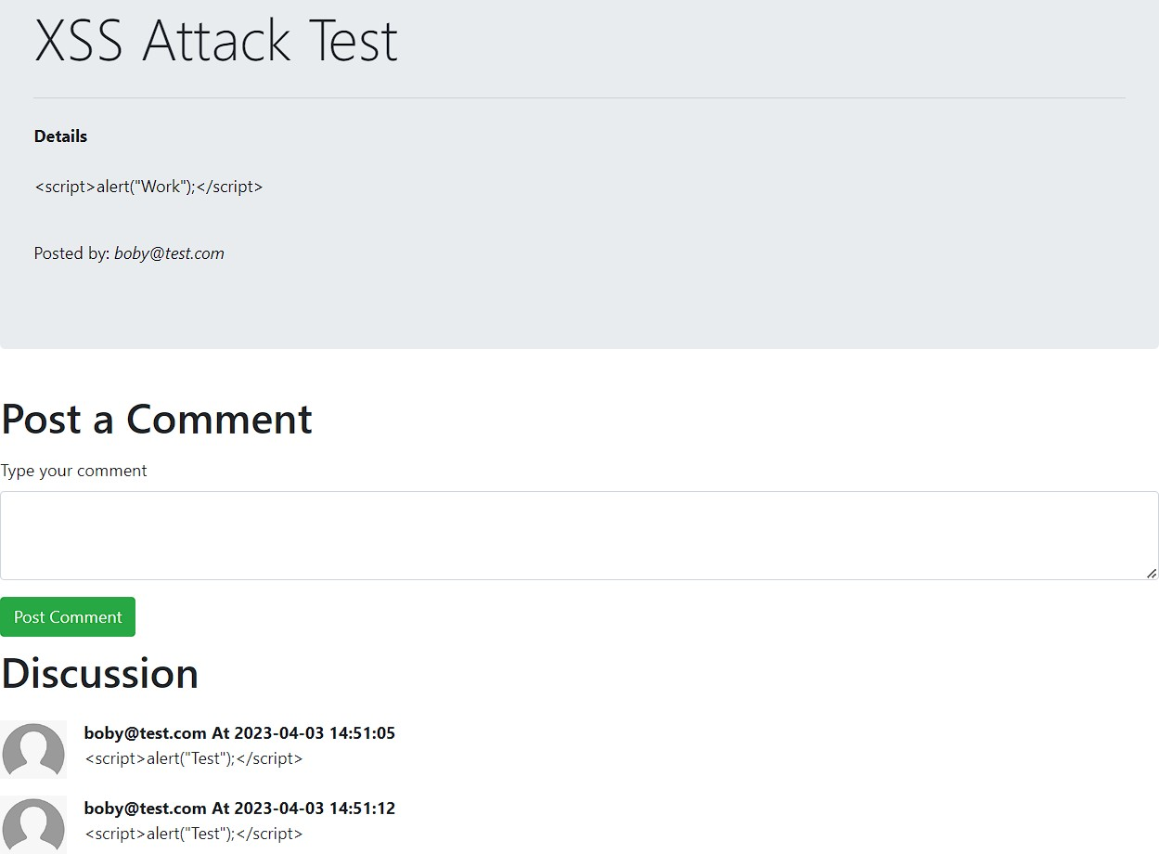

## Code:

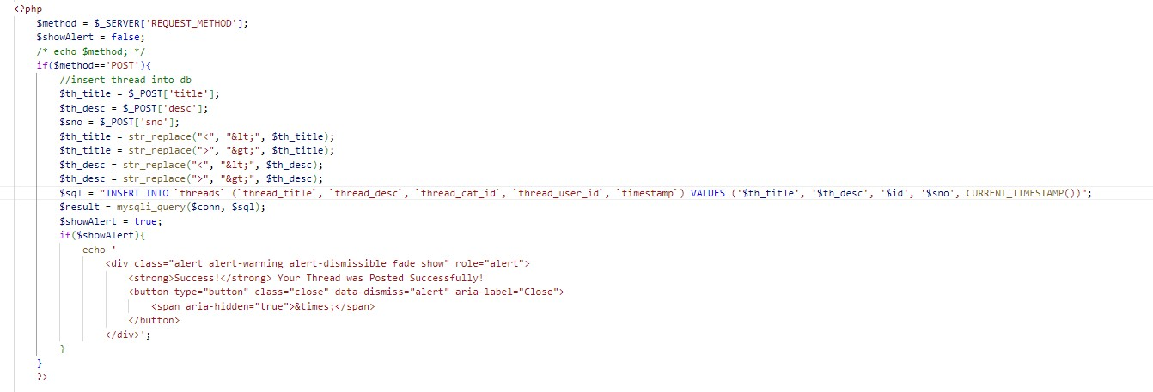

AIGS MCA Forum



24

## Security Measure Against Database Breach

We have implemented password hashing as a robust security measure to protect the passwords of students in the event of a potential database breach. This means that even if unauthorized access is gained to our database, the actual passwords remain securely encrypted and cannot be easily retrieved. By employing password hashing, we are taking proactive steps to ensure the confidentiality and protection of students' sensitive information. This implementation enhances the overall security of the MCA Department Discussion Forum and instills trust in students, assuring them that their passwords are stored with the utmost security measures in place.

## Passwords In Database

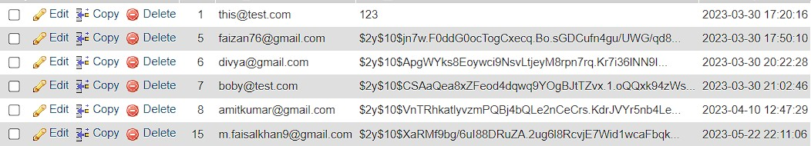

**Hashing Code**

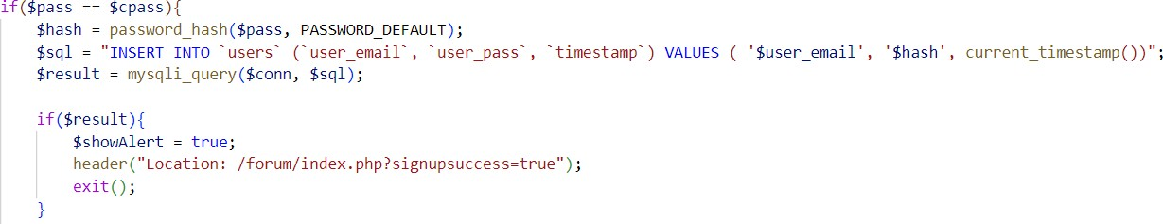

Currently, we are using the PASSWORD_DEFAULT algorithm for password hashing in our system. However, we have plans to upgrade and change the hashing algorithm shortly.

AIGS MCA Forum



25

## 6. Design

* 1. **Database Tables Categories Table:**

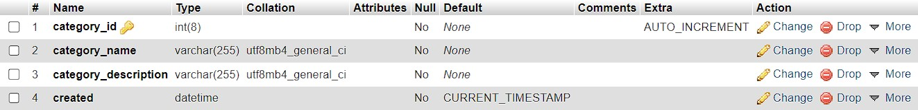

## Comment Table:

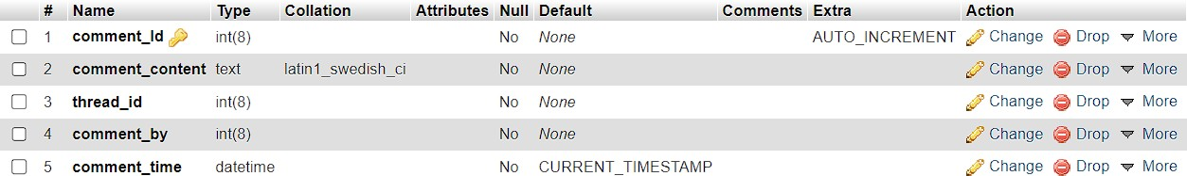

**Thread Table:**

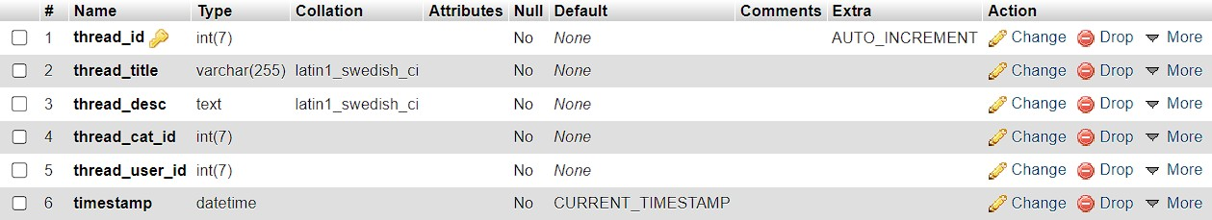

## User Table:

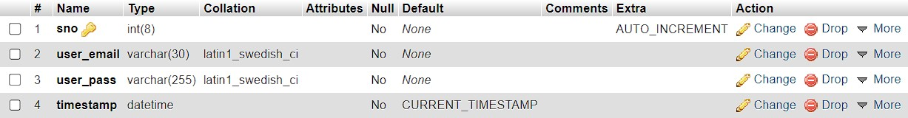

AIGS MCA Forum



26

## Screenshots Home Page View:

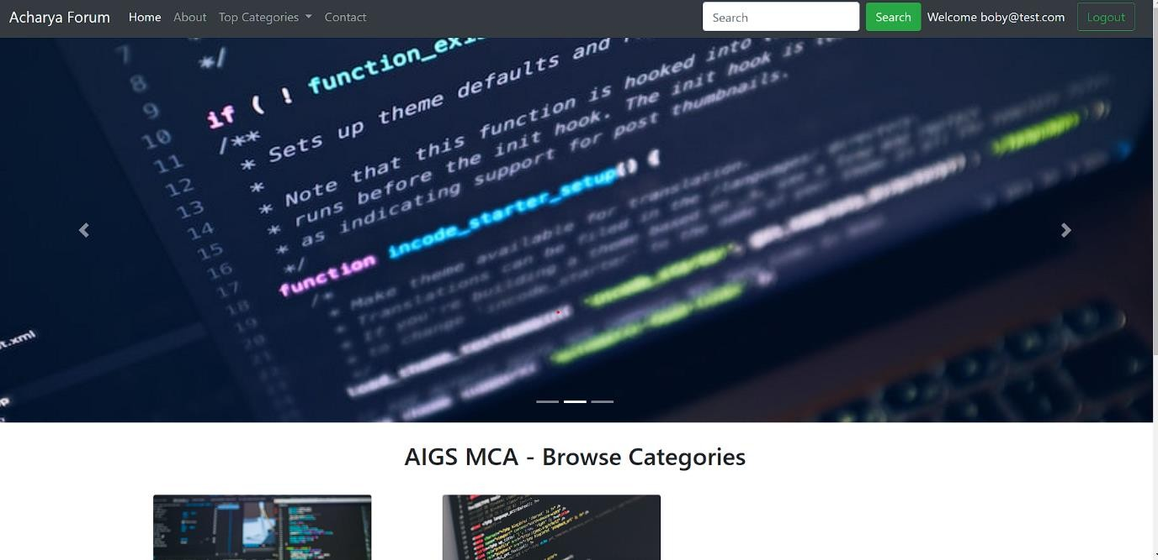



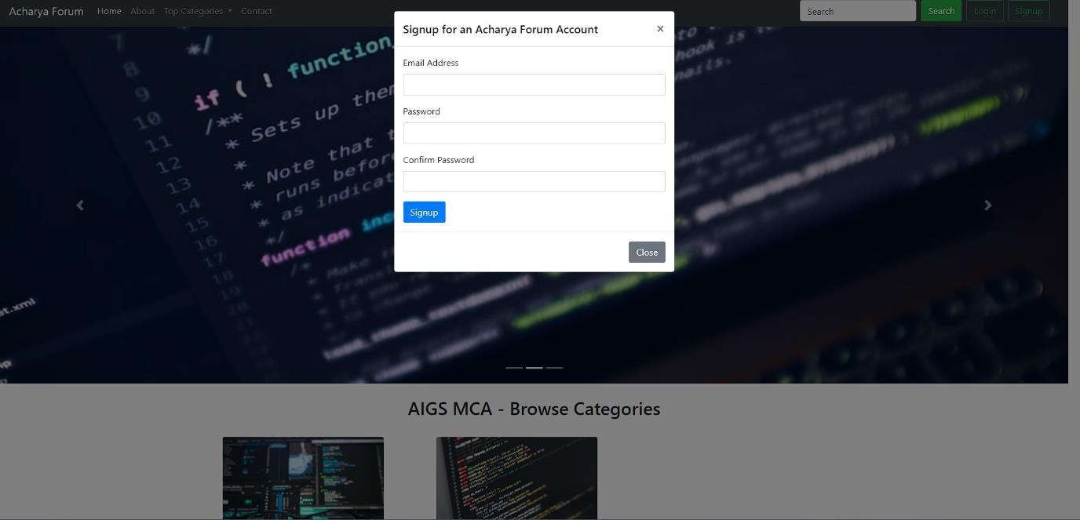

AIGS MCA Forum

27

**Sign up Page:**

**Login Page:**

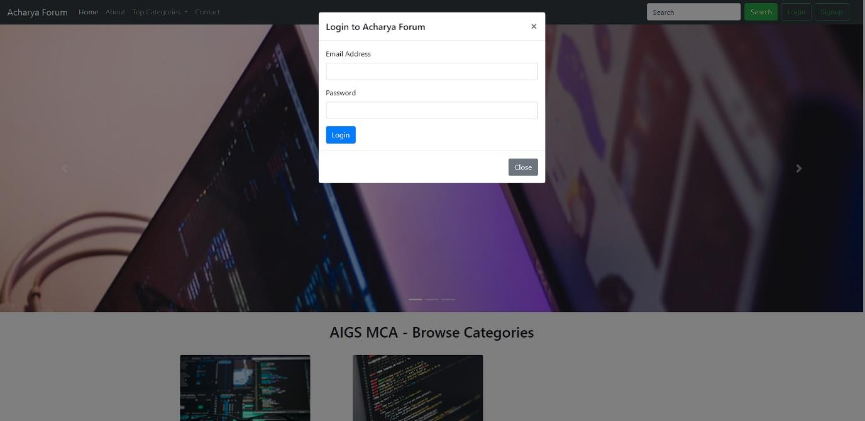

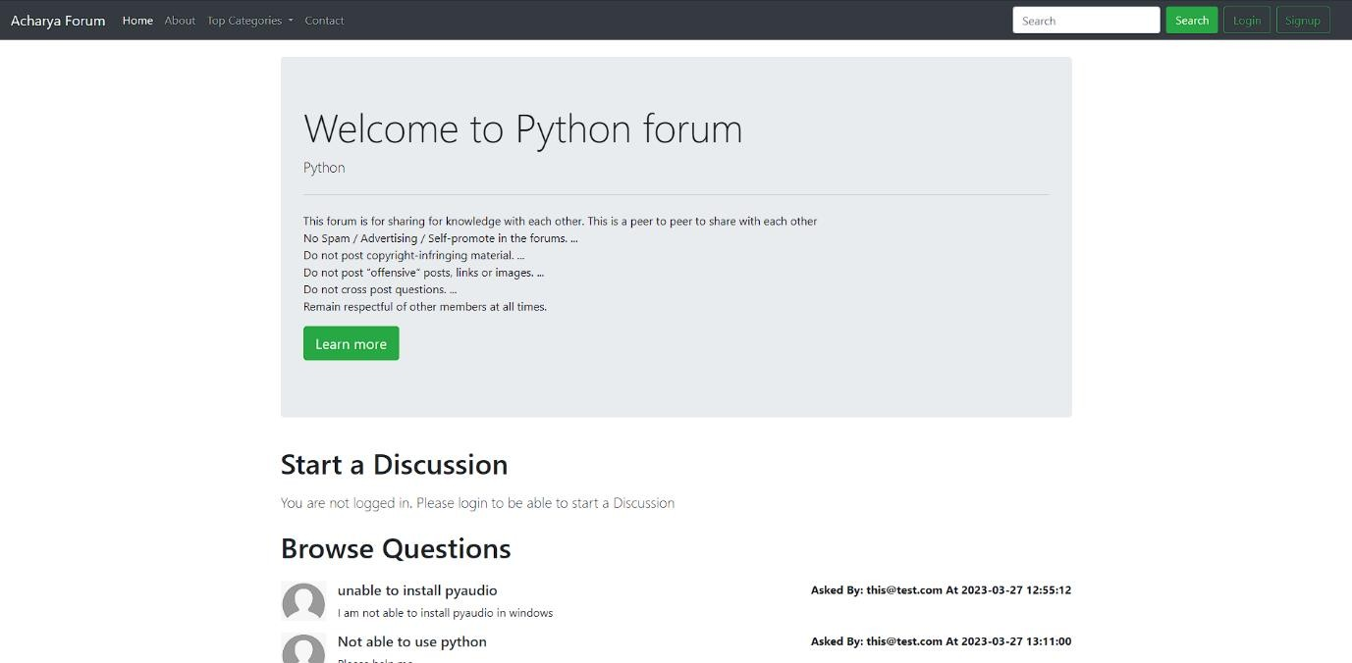

AIGS MCA Forum

28

**Discussion Page:**

## Thread Page



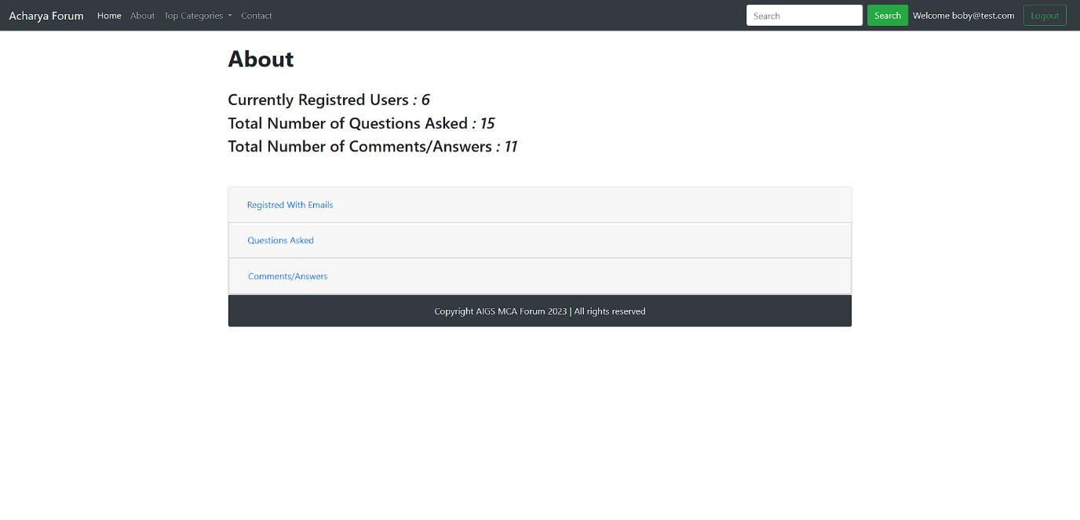

AIGS MCA Forum

29

**About Page**

**Contact Page**

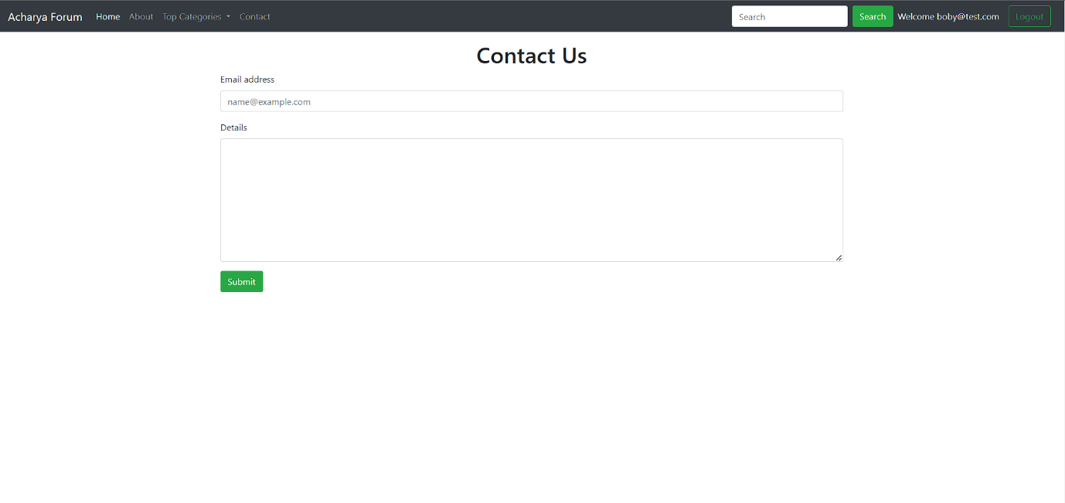

AIGS MCA Forum



30

# 7. Conclusion

In conclusion, an online forum for MCA students is a valuable project that aims to provide a platform for students to communicate, collaborate, and share knowledge. Through the functionalities discussed earlier, such as user management, discussion boards, file sharing, and notifications, the forum creates an interactive and engaging environment for MCA students.

The functionalities of both the admin and client sides contribute to efficient management and participation in the forum. Admin functionalities allow for user management, content moderation, and forum customization, while client functionalities enable users to engage in discussions, share files, and collaborate with peers.

Optimizing the forum's performance through scalable infrastructure, caching mechanisms, database optimization, and code efficiency is crucial to deliver a fast and responsive experience to MCA students.

Database design and structure play a significant role in storing and retrieving data effectively. By defining tables, relationships, and fields, and implementing normalization techniques, data integrity, and efficiency can be maintained.

Overall, an online forum for MCA students project aims to create a collaborative and interactive platform that enhances the learning experience and facilitates knowledge sharing within the MCA student community. By implementing the suggested functionalities, optimizing performance, and designing a robust database structure, the project can successfully achieve its objectives and provide a valuable resource for MCA students.

AIGS MCA Forum



31

# 8. Future Scope of the System

The future scope of an online forum for the MCA students project is vast, with potential enhancements and additions that can further improve the system and meet the evolving needs of the user community. Here are some potential areas of future expansion and development:

User Profiles

User profiles serve as a central point for individuals to showcase their information and engage with

the forum community. Some key aspects of user profiles include Personal Information, Discussion

History, Reputation or Rating System

Administrator Panel:

The administrator panel provides enhanced control and management capabilities for forum administrators.

It includes features such as: User Management, Content Moderation,

User Ability to Remove Comments:

Granting users, the ability to remove their own comments provides greater control over their contributions.

This feature allows users to rectify any mistakes, retract irrelevant or outdated comments, or delete content.

they no longer wish to be associated with. It empowers users to manage their own content, enhancing them.

overall experience and sense of ownership within the forum which include.

Like System, Like Button, Like Count, User Likes, Sorting and Ranking Based on answers.

AIGS MCA Forum



32

**9. References**

https://[www.php.net/manual/en/function.password-hash.php](http://www.php.net/manual/en/function.password-hash.php) https://[www.softwaretestinghelp.com/cross-site-scripting-xss-attack-test/](http://www.softwaretestinghelp.com/cross-site-scripting-xss-attack-test/) <https://getbootstrap.com/docs/4.6/getting-started/introduction/>

https://www.codewithharry.com/

https://sph.unc.edu/iis/discussion-forum-participation-guidelines/

https://www.acharya.ac.in/

https://en.wikipedia.org/wiki/FUDforum

https://en.wikipedia.org/wiki/Internet_forum