# How to setup the MultiSensor

In the following chapters we will go thru the process of: how to flash the MultiSensor unit with Tasmota, how to configure Tasmota so the unit connects to your network, how to configure setting within Tasmota to make sure the sensors and switches send an MQTT signal to Home Assistant, and we will setup Home Assistant so that the sensors and switches show their information properly.

Table of Contents

How to setup the MultiSensor 1

Download the Bin file 2

Flashing the ESP8266 2

Configuring the switches in Tasmota 6

Home Assistant 8

Issues 12

Other sensors I2C sensors 12

Extra Information 12

## Download the Bin file

First download the file “**Tasmota13-LD2410-BME280-SI1145-BH1750.bin**” so we can flash the ESP8266 (Wemos D1 Mini). Visit the GitHub page where the BIN file is stored.

<https://github.com/Roukie686868/MultiSensor/tree/main/Bin>

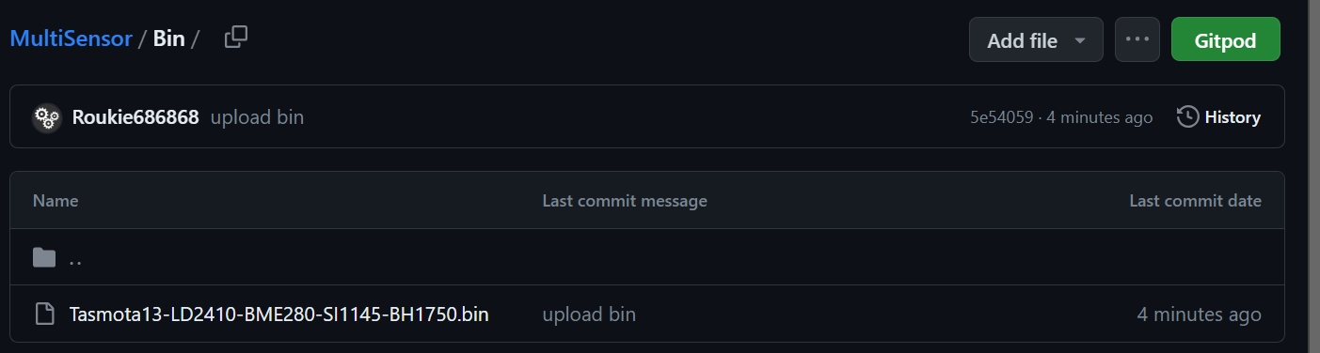

Click the on filename so that it opens, giving you the following view

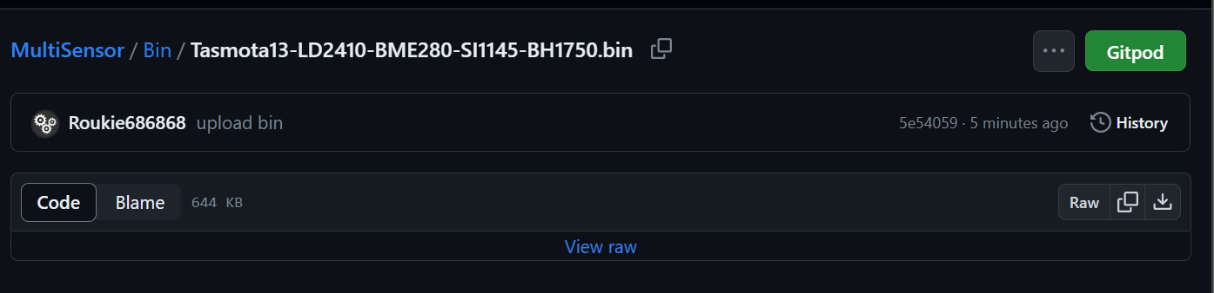

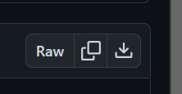Now click on the download icon for the file (you find this all the way to the right of the screen). This is the one where the arrow points downwards into the tray.

The file should download and you should be able to find it in your download folder under your documents (for Windows machines).

## Flashing the ESP8266

The tool we will use to flash the unit is “Tasmotizer”. It works very well for Tasmota devices as it allows to flash and configure the ESP8266 with custom Tasmota BIN file. Go to <https://github.com/tasmota/tasmotizer/releases> and download “**tasmotizer-1.2.exe**” by clicking on the file. (For older PC with a 32-bit system there is the tasmotizer_x86-1.2.exe”)

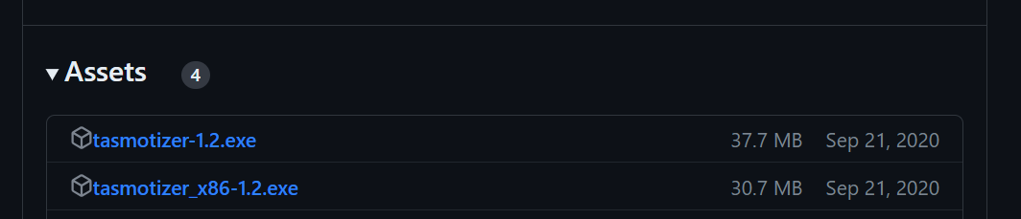

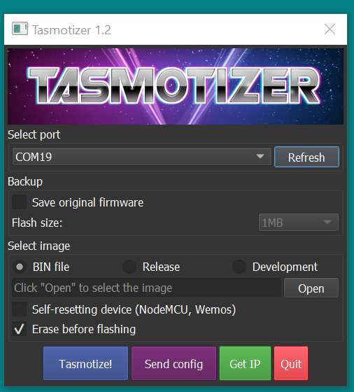The download should start automatically and the file ends up in your download folder under your documents. From this folder you can double click the file and Tasmotizer will start. First thing to do is figure out which COM: port the ESP8266 is using. Click on the dropdown arrow to see which ports are there. Now connect the ESP8266, “Refresh” the ports, and see what appeared new. Now select that port. (When you have multiple EPS8266 units connected to your PC, you don’t want to make the mistake of wiping/flashing the wrong unit.)

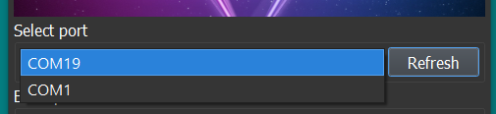

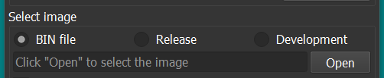Now that we have the right COM: port we need to select the BIN file that we downloaded earlier from the GitHub page. Make sure the “Select image” is set for “BIN file”. Now click on the “Open” button to select the BIN file that you downloaded.

Find your file in the download folder and click “Open”

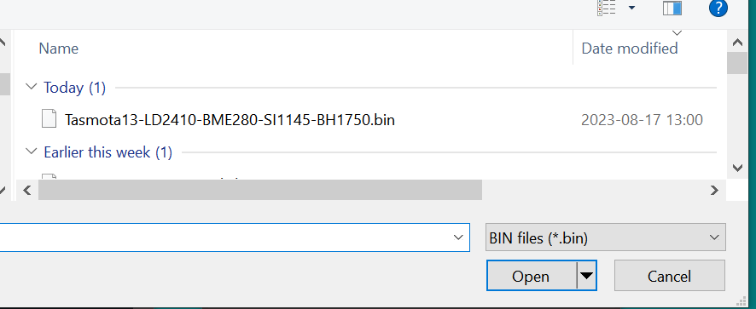

The Tasmota screen should look like the next screenshot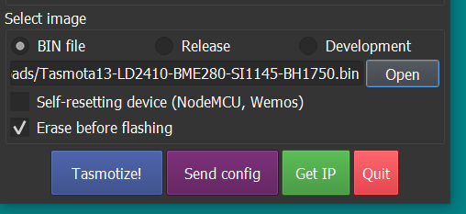

Verify that the “Erase before flashing” is marked. (This to make sure older settings are wiped from the ESP8266)

Now click the blue “Tasmotize!” button to flash the ESP8266.

Tasmotizer will first Erase the content of the ESP8266.

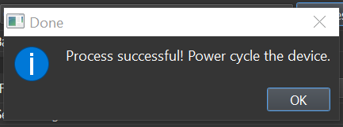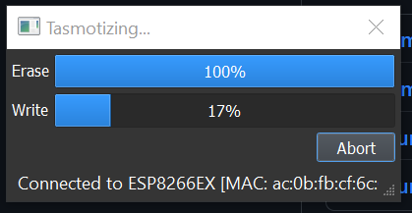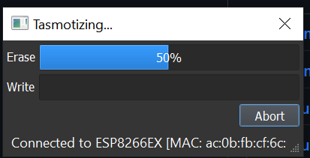Then it will flash the BIN file to the EPS8266.

When the process is successful the last popup will appear telling all worked well. Now Click “OK”. (With the WEMOS ESP8266 there is typically no need to power cycle.)

Now it is time to setup the Network and MQTT configurations. Click the “Send config” button.

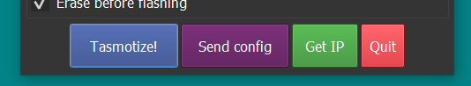

The following configuration menu shows up.

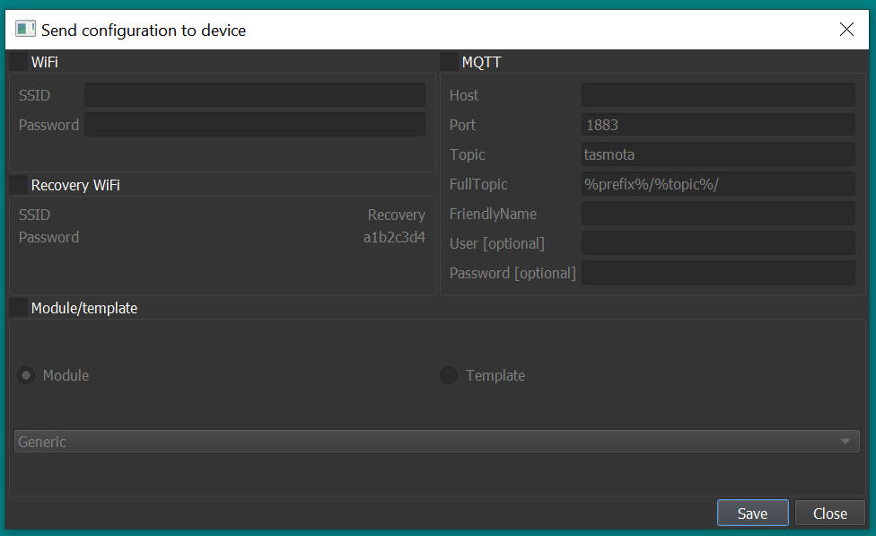

Enable the “WiFi” and “MQTT” boxes so that we can fill in the needed information.

WiFi

* Type your Network name and password in the two fields under WiFi.
* As the password will not be visible it makes sense to first type it in Notepad and then copy and paste it over to Tasmotizer. This to make sure that are no Typos.

MQTT

* HOST - Point to your MQTT server by listing the IP address of the MQTT server
* Port – Standard is 1883 but if you have chosen a different number list it here
* Topic – Give a name you like or start with “tasmota” as we can change that later
* FullTopic – Make sure to not delete anything out of this line. (The prefix is use by Tasmota for cmnd, tele and stat to communicate with Home Assistant)
* FriendlyName - Typically this is the same as the Topic to keep things easy (Again we can all change this later within the Tasmota Webpage)
* User – When you use credentials for the MQTT server than list the username here
* Password - When you use credentials for the MQTT server than list the password here (maybe here as well type it first in a Notepad and copy it over)

Enable the Module/template box

* Select “Template” and copy the line below into the textbox

{"NAME":"MultiSensor","GPIO":[1,9248,1,9280,640,608,0,0,161,1376,160,1,1,1],"FLAG":0,"BASE":18}

This will setup Tasmota with the correct inputs we need for all the sensors.

An example of that below.

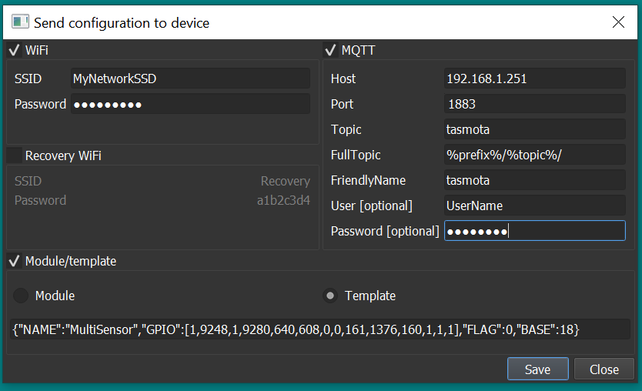

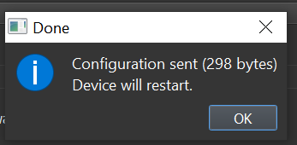Now click save the save button. Tasmotizer will now write your information to the Tasmota software on the ESP8266. Depending the amount of data you have listed the number of bytes will change.

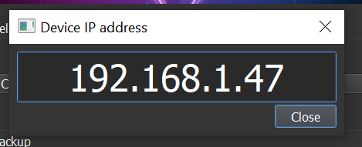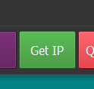Wait about 30 second and click on the Get IP” button. When all went well there should be an IP address listed that we can visit in a browser.

If the IP address shows as xxx.xxx.xxx.xxx then head over to **“Home Assistant”** section to get to the unit. We will come backat this point to configuring the switches in Tasmota.

## Configuring the switches in Tasmota

Open up a web browser and go to the IP address that was listed in your popup.

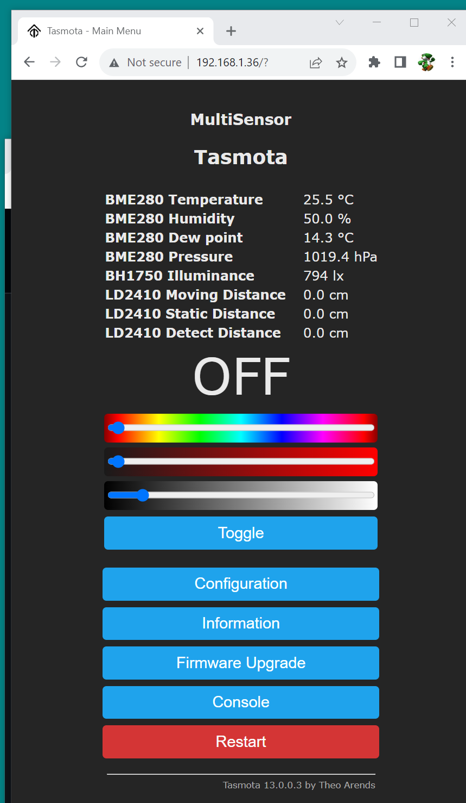

When all was installed properly a similar view as above is what you should see. Depending what sensor units that are installed on the MultiSensor board different measurements will show up. As the LD2410 uses a serial protocol it will always show on the screen even when it is not there. As Tasmota does not transmit the data for the HLK-LD2410 when it is not there, we will not see this info in HA. The HLK-LD2410 and the RCWL-0516 share the same space on the PCB. When the RCWL-0516 is removed the more expensive HLK-LD2410 can be placed later.

Now let’s click on the “Console” button. The console screen will show you what is happening within the unit but it also allows for making modifications to the Tasmota settings. On the command bar enter 5 different commands printed below in **BOLD:**

**SwitchMode1 15** // This command lets switch 1 (The PIR) send MQTT messages

**SwitchMode2 15** // This command lets switch 2 (The Microwave) send MQTT messages

**SetOption114 1** // This command decouples the switches from relays

**SwitchText1 mmWave** // This tells Home Assistant the name of the switch1

**SwitchText2 PIR** // This tells Home Assistant the name of the switch2

If you want to read up on these Tasmota settings they can be found on the following Tasmota webpages:

<https://tasmota.github.io/docs/Buttons-and-Switches/#setoption114>

<https://tasmota.github.io/docs/Buttons-and-Switches/#switchmode-15>

# Home Assistant

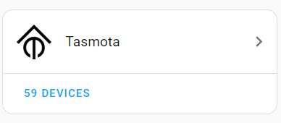Both **MQTT** and **Tasmota** have to be install within Home Assistant. If not do so first. When installed the Device can be found by:

* Click on “Settings” (left bottom corner of the screen)
* Click on “Devices & Services”
* Select the blue “DEVICES” under the Tasmota Icon
* In the list, the device should show up as **“Tasmota”** (or any other name that you use in “Tasmotizer” when sending over the configuration file.
* Click on “Tasmota”

Now a device screen shows up as seen in the next picture. If you had issues with the IP address of the device, click on the blue “Visit” icon in the “Device Info” section to go to the device and make the settings you were not able to do in the previous chapter. When the Tasmota settings are done come back at this point and continue.

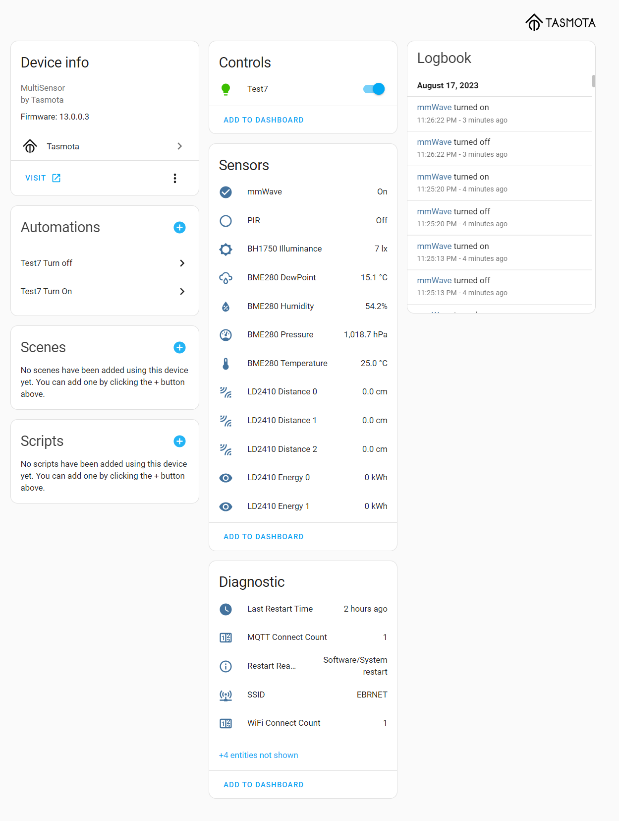

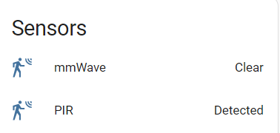Now let’s change the Icon and the text that the sensors display to something that is more meaningful as seen on the right image. Click on the “mmWave” text so that the popup shows as seen in the next image.

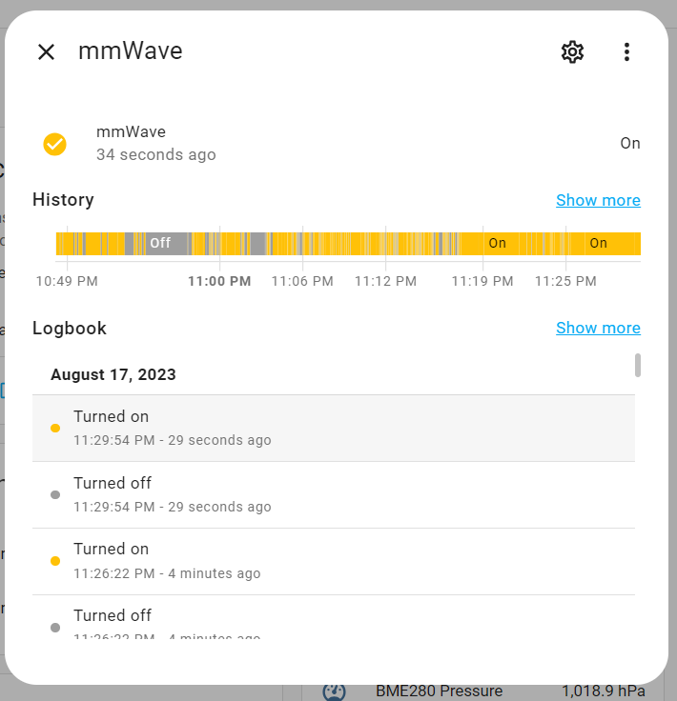

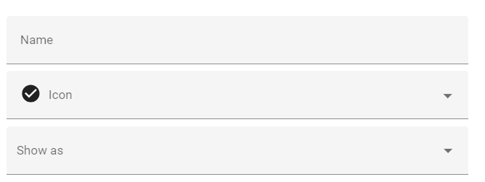Now click on the little star wheel in the top. In the next popup we are going to change the “Icon” and the “Show as” field.

Click right on “Icon” and type the word “motion” in the Icon field (typing “Presence” could be another option) and pick the symbol that you like for this sensor.

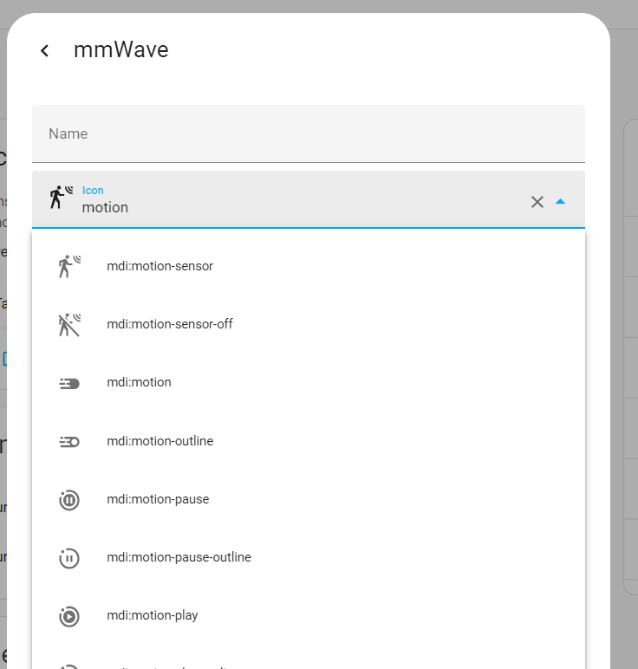

Now click on “Show as” and type motion again (typing “Presence” could be another option)

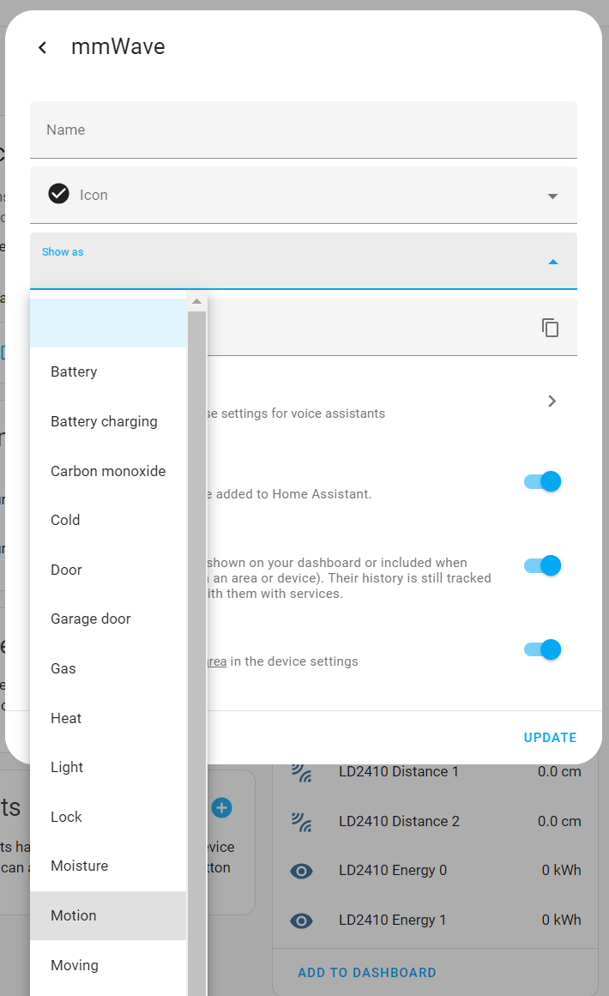

In the right bottom of the popup click on “UPDATE” to make sure your settings are saved.

Below you can see what your changes have accomplished. Repeat the same for the PIR sensor.

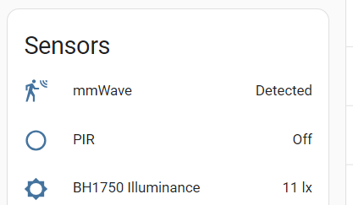

Congratulations. You are ready to further integrate your sensor into you Home Assistance system.

# Issues

* When the switch does not show a reading but says “**unknown**”
  + Go back to the Tasmota console and change the **SwitchText1** or **SwitchText2** for a low case text. Follow this by a **SetOption19 1** to turn the device off in Home Assistant and turn in back on again with **SetOption19 0**. This should reset HA.

# Other sensors I2C sensors

When you add new [I2C](https://en.wikipedia.org/wiki/I%C2%B2C#:~:text=I2C%20(Inter%2DIntegrated,in%201982%20by%20Philips%20Semiconductors.) sensors to the MultiSensor PCB that fits on one of the four female 4-pin headers but they do not show up on the Tasmota screen then the BIN file will have to be upgraded for that sensor. Just send me a request with that sensor and I will make you the new BIN file. I will post that on the GitHub page. One restriction is that the Sensor must be known by Tasmota. Please verify that Tasmota can read your sensor by going to the following Tasmota page: <https://tasmota.github.io/docs/I2CDEVICES/>

# Extra Information

More details on the project can be found on the following GitHub Page <https://github.com/Roukie686868/MultiSensor>