IILM UNIVERSITY
Department of Computer Science and Engineering
INTERNSHIP REPORT
ON
AI-POWERED BUSINESS AUTOMATION ASSISTANT USING LLM INTEGRATION AND MACHINE LEARNING
Submitted in partial fulfilment of the requirements for the degree of
Bachelor of Technology in Computer Science and Engineering
Submitted By
Name of Student: ROUNAK GUPTA
Roll Number: 25SCS1003005151
Batch: 2024–2028
Internship Organization: ADVLST (IT Solutions & AI Automation Company)
Internship Duration: 25 May 2026 – 10 July 2026
Academic Session 2026–27

CANDIDATE'S DECLARATION
I, ROUNAK GUPTA, do hereby declare that the internship report titled “AI-Powered Business Automation Assistant Using LLM Integration and Machine Learning” has been prepared by me to fulfil the academic requirements for the award of the degree of Bachelor of Technology in Computer Science and Engineering. The report is based on the internship learning and project work carried out by me during my tenure at ADVLST. References used in preparing the report have been acknowledged in the bibliography.
I further declare that this report has not been submitted to any other institution for the award of any degree or diploma. I shall be responsible for any copyright or academic-integrity violation arising from material submitted under my name.
Student Name – ROUNAK GUPTA
Roll No. – 25SCS1003005151

ACKNOWLEDGEMENT
I sincerely express my gratitude to everyone who supported me during the internship and the preparation of this report. The internship provided an opportunity to understand practical concepts related to Artificial Intelligence, Machine Learning, Large Language Model (LLM) integration, prompt engineering and AI-driven business automation.
I am thankful to ADVLST for providing the internship learning environment and project-oriented exposure in the AI Research & Development Division. I am especially grateful to Mr. Deepak, HR Head, ADVLST, and Mr. Akshat, Chief Director, ADVLST, for their guidance, support and encouragement throughout the internship period. I also acknowledge the guidance and academic support provided by my university and faculty members at IILM University. I am grateful to my parents and everyone who encouraged me throughout the internship period.
Student Name – ROUNAK GUPTA
Roll No. – 25SCS1003005151

INTERNSHIP COMPLETION CERTIFICATE
The Certificate of Internship issued by ADVLST is reproduced below. The complete offer letter and certificate are also attached in the “Certificate and Communication Proof” section of this report.
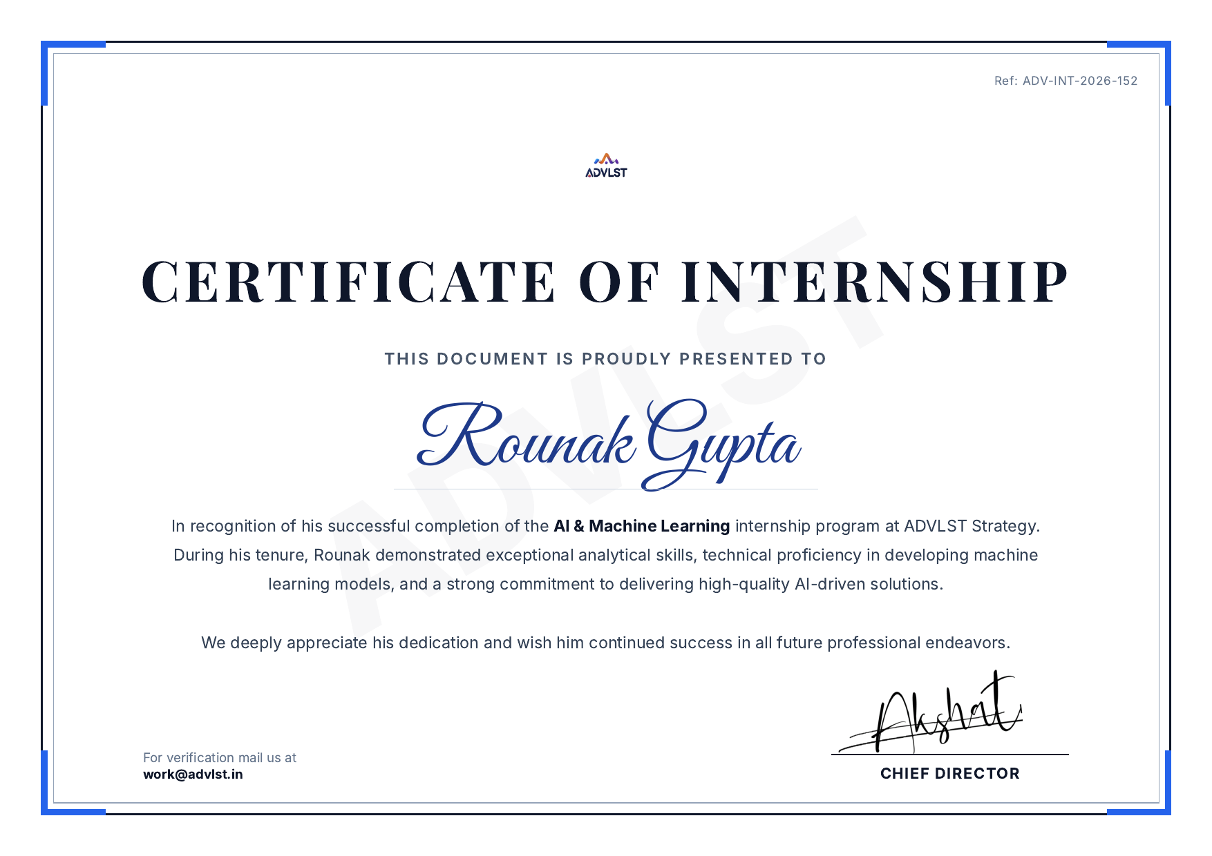

TABLE OF CONTENTS
Chapter No. | Chapter Name | Page No.
1. | Candidate's Declaration | i
2. | Acknowledgement | ii
3. | Internship Completion Certificate | iii
4. | Project Description | 1
4.1 | Introduction | 1
4.2 | Organization Profile | 2
4.3 | Problem Statement | 3
4.4 | Project Objectives | 4
4.5 | Scope of the Project | 4
4.6 | Technologies and Tools Used | 5
4.7 | System Architecture | 6
4.8 | Methodology | 7
4.9 | Expected Outcomes / Learning Outcomes | 9
4.10 | Certificate and Communication Proof | 10
5. | Conclusion | 12
6. | Bibliography / References | 13

LIST OF TABLES
Table No. | Title | Page
Table 4.1 | Internship Details | 2
Table 4.2 | Internship Training Areas | 3
Table 4.3 | Technologies and Tools Used | 5
Table 4.4 | Model Evaluation Measures | 8

LIST OF FIGURES
Figure No. | Title | Page
Figure 4.1 | Proposed System Architecture | 6
Figure 4.2 | Overall Project Methodology | 7
Figure 4.3 | Data & Prompt Processing Workflow | 7
Figure 4.4 | New Request Handling Workflow | 9

4. PROJECT DESCRIPTION

4.1 Introduction
Artificial Intelligence and Machine Learning are increasingly used by organizations to automate repetitive tasks, analyse data and support decision-making. A major recent development in this area is the use of Large Language Models (LLMs), which can understand and generate natural language, and can be integrated into business applications through APIs to build intelligent assistants and automation systems.
During the internship at ADVLST, the project focused on developing an AI-powered automation assistant that combines traditional machine-learning techniques with LLM integration. The system was designed to process data, respond to natural-language requests, and support enterprise workflow automation using prompt engineering and API-based integration with LLM services.
The project follows a practical AI-development workflow: requirement understanding, data collection and preprocessing, model/prompt design, integration with LLM APIs, testing, and evaluation of outputs.

4.2 Organization Profile
ADVLST is an IT Solutions & AI Automation Company based in New Delhi, India, working in the areas of software infrastructure, backend systems and automation solutions. The AI & Machine Learning internship was carried out under the AI Research & Development Division of the organization, which focuses on building machine-learning models, LLM-based integrations and intelligent business-automation systems.
Particular | Details
Organization | ADVLST
Role | AI & Machine Learning Intern
Department | AI Research & Development Division
Duration | 25 May 2026 – 10 July 2026
Mode of Internship | Remote / Work From Home
Working Schedule | Monday to Friday
Reference ID | ADV-INT-2026-152
Table 4.1: Internship Details

Internship Training Areas
Area | Key Learning
Python | Programming and implementation for AI applications
Machine Learning | Developing, testing and optimizing ML models
Large Language Models (LLMs) | Integration of LLMs via APIs into applications
Prompt Engineering | Designing effective prompts for reliable LLM outputs
Data Analysis | Analysing datasets and constructing data pipelines
API Integration | Connecting AI models/services with backend systems
Business Automation | Designing AI-driven automation for workflows
Table 4.2: Internship Training Areas

4.3 Problem Statement
Modern enterprises handle large volumes of repetitive queries, data-processing tasks and communication workflows that consume significant manual effort. Rule-based automation is often rigid and cannot handle the variability of natural-language requests or unstructured data.
The problem addressed by this project was to design and build an AI-driven assistant capable of interpreting natural-language requests, applying machine-learning models where structured prediction was required, and using LLM integration to generate accurate, context-aware responses that support business automation workflows.

4.4 Project Objectives
- Understand the role of Machine Learning and LLMs in business automation.
- Design and preprocess datasets required for model development.
- Build and evaluate machine-learning models for relevant prediction/classification tasks.
- Integrate Large Language Models via APIs for natural-language understanding and generation.
- Apply prompt-engineering techniques to improve the reliability of LLM outputs.
- Design data pipelines connecting data sources, models and the automation layer.
- Evaluate the system's outputs using appropriate performance measures.
- Document the complete workflow and identify areas for future enhancement.

4.5 Scope of the Project
The project focuses on a manageable prototype of an AI-powered automation assistant, combining classical machine-learning components with LLM-based natural-language processing.
Included | Not Included
Data collection and preprocessing | Full enterprise-scale deployment
ML model development and evaluation | Production-grade infrastructure and scaling
LLM API integration and prompt engineering | Fine-tuning of proprietary large-scale LLMs
Prototype automation workflow | Guaranteed accuracy on all real-world edge cases

4.6 Technologies and Tools Used
Technology / Tool | Purpose
Python | Main programming language
Pandas / NumPy | Data handling and numerical operations
Scikit-learn | Machine-learning model implementation
LLM APIs (via Prompt Engineering) | Natural-language understanding and generation
REST APIs | Integration between models, data and application layer
Jupyter Notebook | Development and experimentation
Matplotlib | Data visualization
Table 4.3: Technologies and Tools Used

4.7 System Architecture
The proposed system consists of a data/ML pipeline and an LLM-based response-generation pipeline, connected through a common automation layer.
User Request → Preprocessing → [ ML Model | Prompt Construction + LLM API ] → Response Generation → Automation Action / Output
Figure 4.1: Proposed System Architecture
Structured requests (e.g., classification or prediction tasks) are routed to the trained machine-learning model, while natural-language requests are converted into an engineered prompt and sent to the LLM API. Outputs from either path are passed through a response-generation layer before being delivered to the end user or triggering an automation action.

4.8 Methodology
- Requirement Understanding
- Data Collection and Inspection
- Data Cleaning and Preprocessing
- Feature Engineering (for ML components)
- Model Training and Evaluation
- Prompt Design and LLM API Integration
- Testing of End-to-End Workflow
- Error Analysis and Refinement
- Documentation and Future Enhancement
Figure 4.2: Overall Project Methodology

Data Preprocessing
Data used for the ML components was inspected for missing values, duplicates and class imbalance, and cleaned before feature extraction. For LLM-based components, input text was normalized and structured into consistent prompt templates to ensure reliable outputs.
Figure 4.3: Data & Prompt Processing Workflow

Model Training and Evaluation
Baseline machine-learning models were trained and evaluated using standard classification metrics. LLM outputs were evaluated qualitatively for relevance, correctness and consistency, and iteratively refined through prompt adjustments.
Measure | Purpose
Accuracy | Overall proportion of correct predictions
Precision | Reliability of positive predictions
Recall | Ability to identify relevant positive cases
F1-score | Combined measure of precision and recall
Response Relevance (LLM) | Qualitative assessment of LLM output usefulness
Table 4.4: Model Evaluation Measures

New Request Handling Workflow
New User Request → Preprocessing → Routing (ML / LLM) → Prompt Construction (if LLM) → Model / API Call → Response Delivered
Figure 4.4: New Request Handling Workflow
After development, a new request is passed through the same preprocessing and routing logic used during development, ensuring consistency between the design-time and run-time behaviour of the system.

4.9 Expected Outcomes / Learning Outcomes
- A working prototype combining ML models and LLM-based natural-language processing.
- A structured data pipeline for preprocessing and feature handling.
- Practical experience with prompt engineering and LLM API integration.
- Trained and evaluated machine-learning model(s) for the chosen task.
- Understanding of end-to-end AI-driven automation workflow design.
- Analysis of system outputs and identification of improvement areas.
- A foundation for future enhancement such as advanced fine-tuning or scaling the automation system.
The internship also strengthened understanding of the complete AI-application development lifecycle, including the importance of well-designed prompts, clean data, and consistent processing between development and deployment.

4.10 Certificate and Communication Proof
The internship offer letter and completion certificate issued by ADVLST for Rounak Gupta are reproduced below without altering their substantive content.
Internship Offer Letter
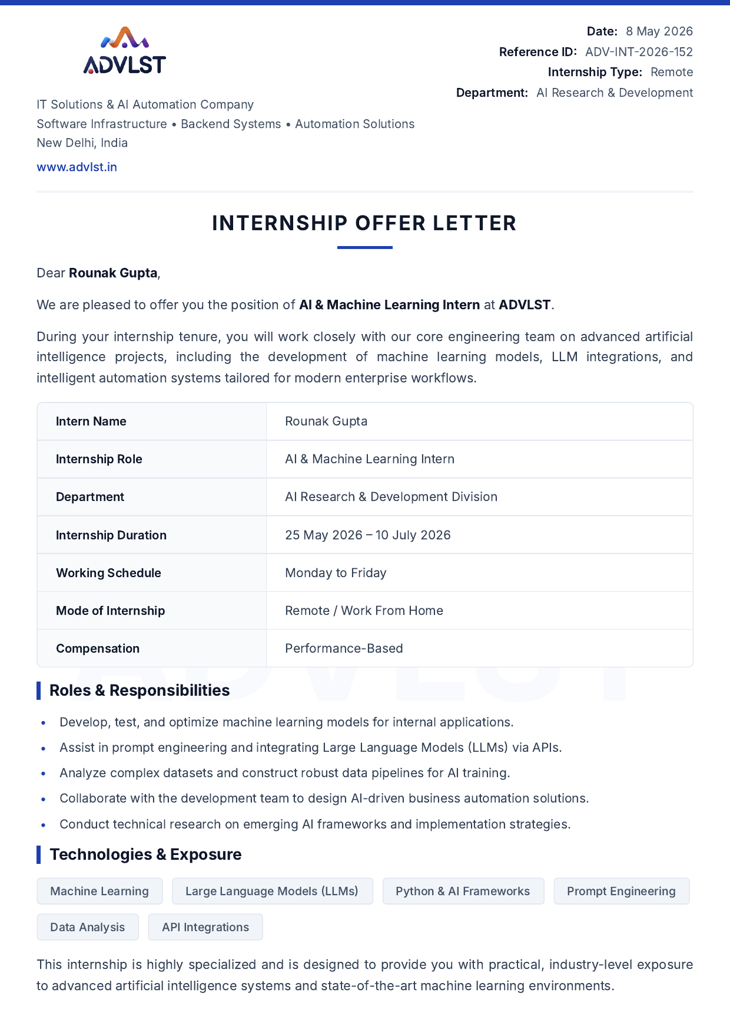



Certificate of Internship

5. CONCLUSION
The internship at ADVLST provided practical, industry-level exposure to Artificial Intelligence and Machine Learning, with a specific focus on integrating Large Language Models into business-automation workflows. The project reinforced classroom concepts of machine learning while introducing newer, industry-relevant practices such as prompt engineering and LLM API integration.
The internship helped build a strong foundation for future work in AI-driven application development and highlighted the importance of combining traditional ML techniques with modern generative-AI capabilities to build practical, real-world solutions.

6. BIBLIOGRAPHY / REFERENCES
ADVLST, “AI & Machine Learning Internship,” ADVLST, official internship offer letter and certificate, Reference ID ADV-INT-2026-152, 2026.
ADVLST, official website, accessed 2026. www.advlst.in
Scikit-learn Developers, “Scikit-learn: Machine Learning in Python,” Journal of Machine Learning Research, vol. 12, pp. 2825–2830, 2011.
OpenAI / relevant LLM provider documentation on prompt engineering and API integration, accessed 2026.
Pandas Development Team, “Pandas Documentation,” accessed 2026.

