The following program proc_parse uses bash commands executed from cpp for the first part, and in the next part, it uses file handling .

1st Version:
If no parameters are passed while execution, the program executes certain bash commands using the system(<args>) function.

Here’s the output as well as the code snippet to display the same.
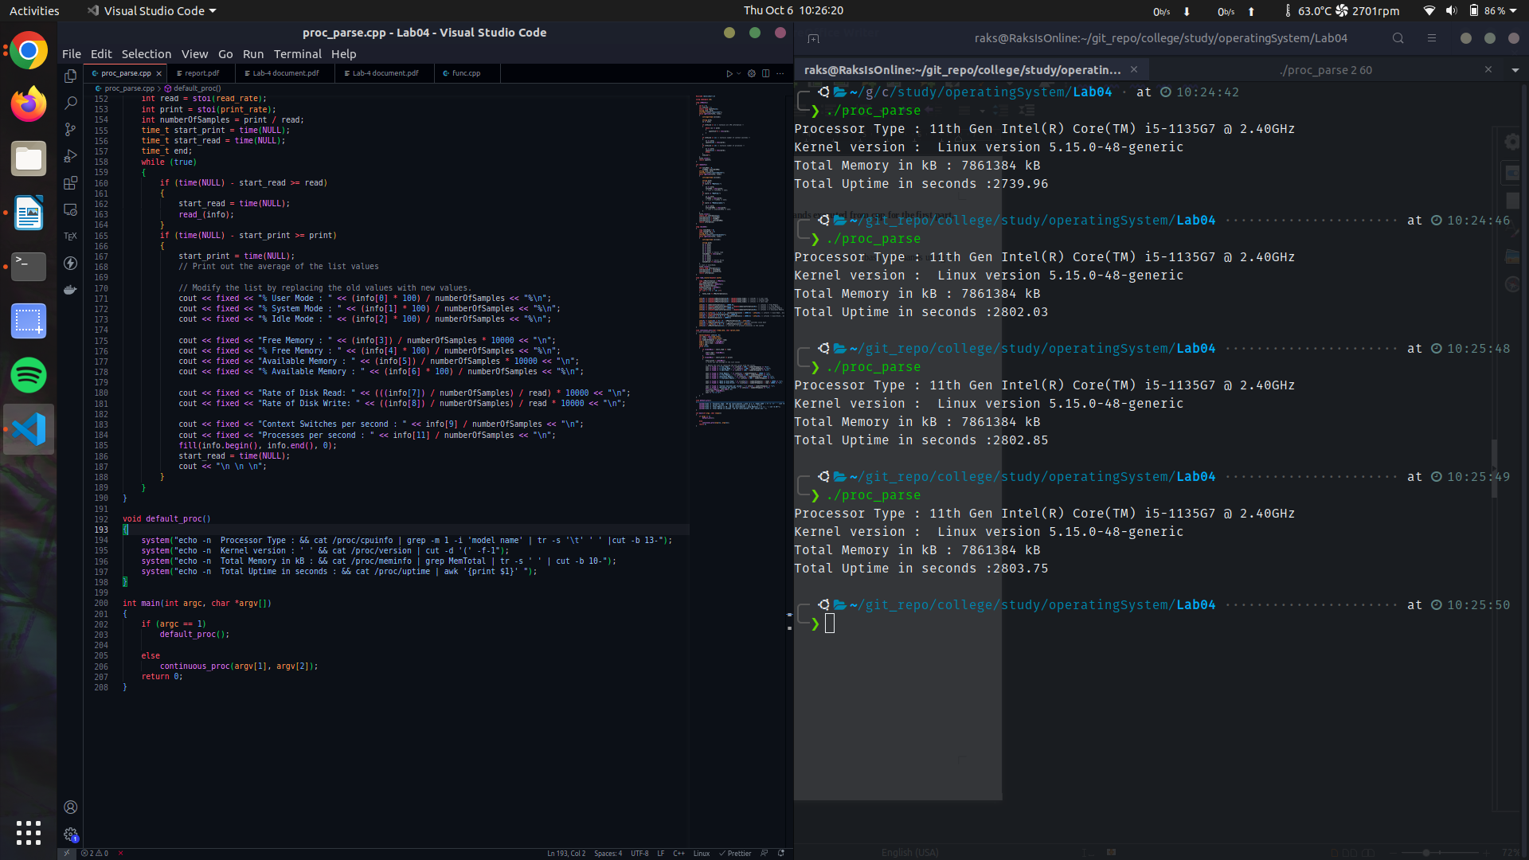

The bash commands used are – cat, awk, tr, and grep.

2nd Version:
As far as the second version of the code is concerned, the output are as follows :

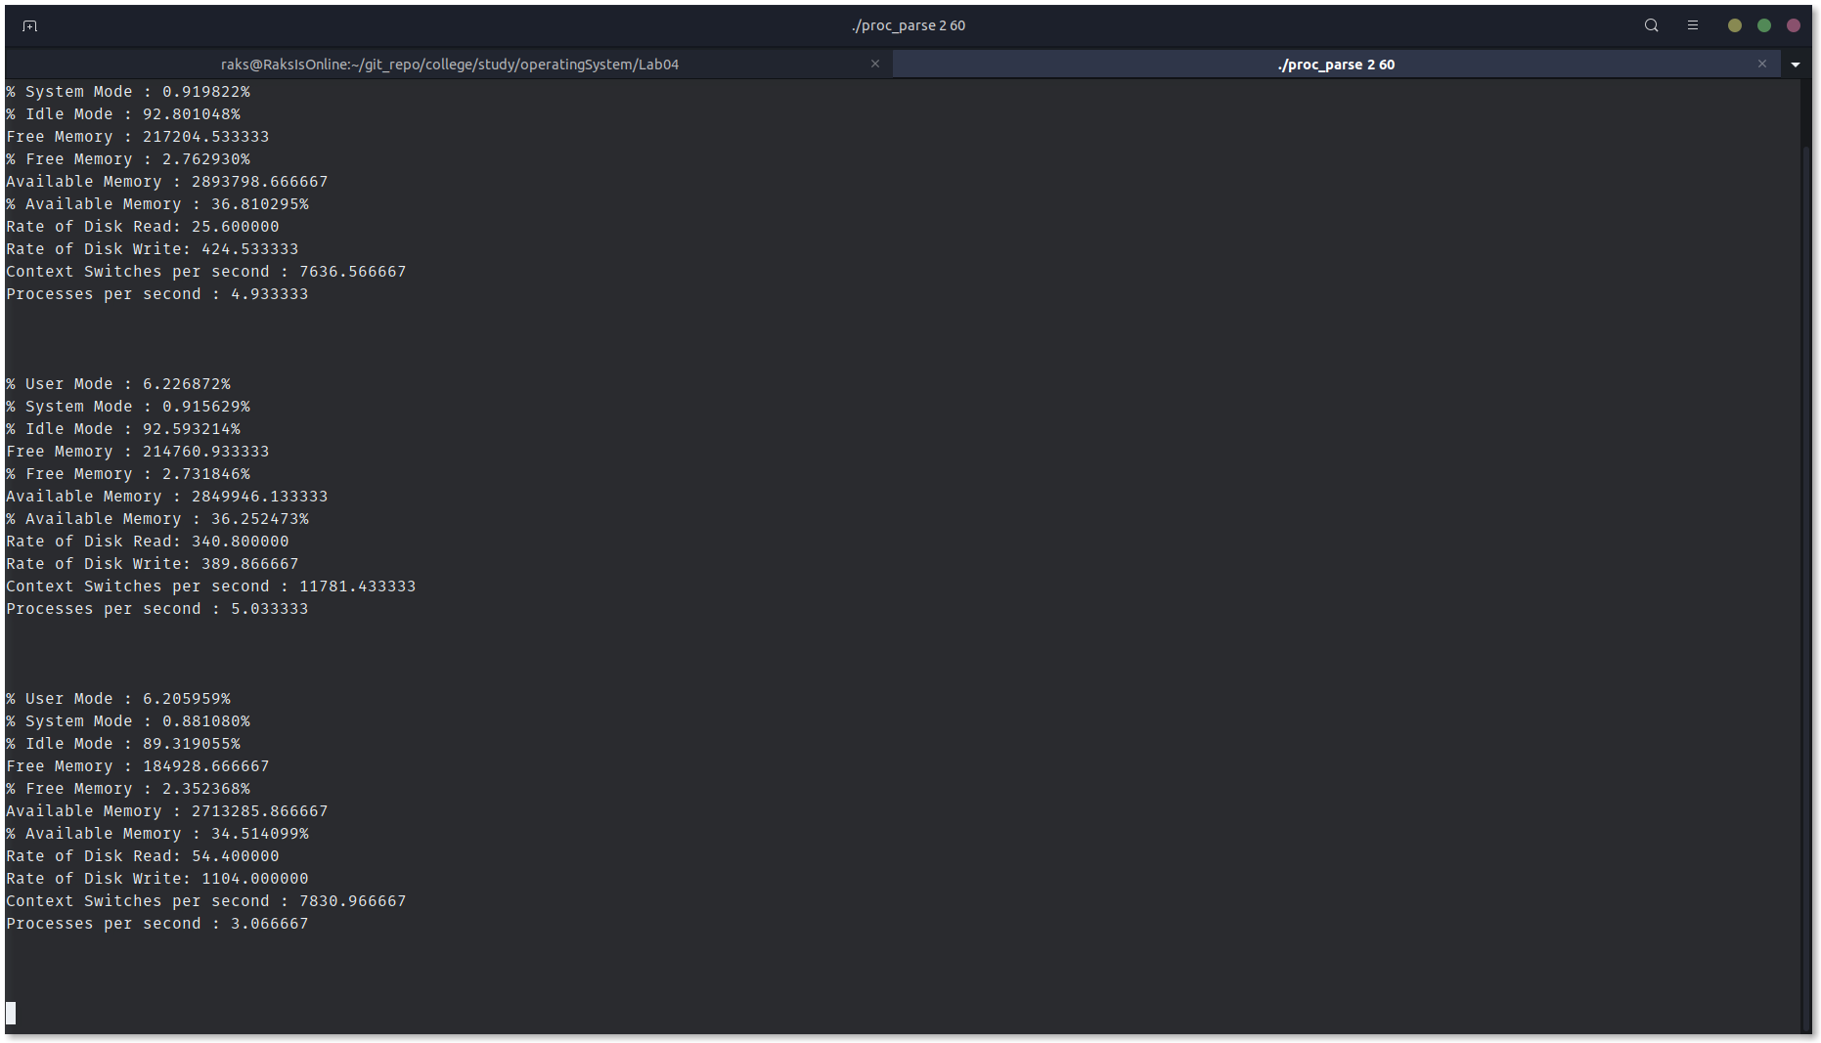

For this part of the code, command line arguments have been used to determine the print and read rate. After that, various /proc files are read via ifstream() to get values of the above. Percentages are calculated, rate is calculated through the read rate and number of samples, etc. Since few values were provided with regards to boot-time, previous values were stored to calculate number of new processes/context switches produced.

Time was calculated using time() function to keep a track of the read rate and print rate. Number of Samples is basically the ratio of print rate and read rate.

The code is as follows :
