Rounak Raj Be Cse
Chitkara University Rajpura, Punjab
rounak2187.be22@chitkara.edu.in
Health and Safety Systems in the Oil and Gas Post-Covid

Jatin Kansal Be Cse
Chitkara University Rajpura, Punjab
jatin1710.be22@chitkara.edu.in

Rahul Thakur Be Cse
Chitkara University Rajpura, Punjab
rahul704.be22@chitkara.edu.in

Rohan Jain Be Cse
Chitkara University Rajpura, Punjab
rohan2175.be22@chitkara.edu.in

Abstract—

This study examines the changing nature of economic growth and the need for a new growth model that ensures inclusive and sustainable development. Traditional development theories emphasized industrialization as the primary driver of growth, often assigning a passive role to agriculture. However, recent global and national trends highlight two major challenges—employment generation and environmental sustainability—which demand a rethinking of growth strategies.
The paper explores the evolving role of agriculture in economic transformation, particularly in the context of developing economies like India. It highlights how technological advancements, changing labour dynamics, and sectoral imbalances have weakened the traditional model of structural transformation. The study also analyses patterns of growth across different Indian states to understand the relationship between agriculture, industry, and services in achieving inclusive growth.
The findings suggest that agriculture-led growth, when followed by industrial development, provides the most balanced and inclusive pathway. The paper concludes by emphasizing the need for a new growth paradigm that integrates agriculture, promotes employment, and ensures sustainable use of natural resources.

Keywords—
Economic Growth; Inclusive Development; Agriculture; Employment; Sustainability; Structural Transformation; Industrialization; India

Introduction—
Economic development has traditionally been understood as a process of shifting resources from agriculture to industry and services. This transformation was considered essential for increasing productivity and raising income levels.
However, the current global scenario presents new challenges. Employment generation has become increasingly difficult due to automation and capital- intensive production methods. At the same time, environmental concerns such as climate change, water scarcity, and land degradation have gained importance.
In this changing context, the role of agriculture is being re- evaluated. Instead of being seen as a backward sector, agriculture is now recognized as a potential driver of
growth, employment, and sustainability.
This paper aims to analyse whether a new growth model is required and how agriculture can contribute to inclusive development.

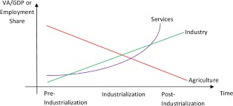

Literature review—
Early theories of economic development focused heavily on structural transformation, particularly the shift of labour from agriculture to industry. One of the most influential contributions in this area described development as a movement from a traditional agricultural sector to a modern industrial sector with higher productivity.
However, later research challenged these assumptions by highlighting the importance of agriculture as an active contributor to growth. Studies in the 1960s and 1970s emphasized that agriculture could generate strong linkages with other sectors through demand for inputs, supply of raw materials, and increased rural consumption.
More recent literature has focused on issues such as jobless growth, income inequality, and environmental sustainability. Researchers have observed that technological advancements, while increasing productivity, often reduce employment opportunities. Similarly, the role of agriculture has expanded beyond food production to include environmental sustainability and energy generation.
This study builds on existing research by integrating traditional and modern perspectives to evaluate the need for a new growth model.
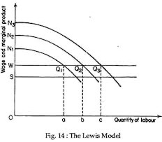

XXX-X-XXXX-XXXX-X/XX/$XX.00 ©20XX IEEE

Changing Role of Agriculture in Development—
Agriculture was once viewed as a low-productivity sector with surplus labour. However, technological advancements such as improved seeds, irrigation, and mechanization have significantly increased agricultural productivity.
Modern agriculture also creates strong linkages with other sectors. It generates demand for industrial inputs like fertilizers and machinery while also supplying raw materials to industries. Additionally, rising agricultural income increases demand for goods and services in rural areas.
These linkages demonstrate that agriculture can act as a growth engine, especially in the early stages of development.
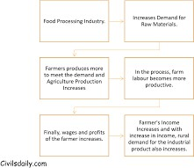

Employment Challenge in Modern Growth—
One of the biggest concerns in today’s economy is the mismatch between economic growth and employment generation. Industrial and service sectors are increasingly adopting automation, artificial intelligence, and machine- based production systems.
As a result, even when output grows rapidly, employment does not increase at the same pace. This phenomenon, often referred to as “jobless growth,” creates income disparities and limits the benefits of development.
In contrast, agriculture remains relatively labour-intensive and has the potential to absorb a large workforce.
Strengthening this sector can therefore help address the employment challenge.
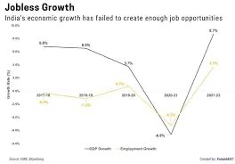
Patterns of Growth in India—
India’s economic growth has evolved through different phases. The first phase was driven by agricultural improvements, particularly during the Green Revolution. The second phase focused on industrial growth following economic reforms. The third phase emphasized services and information technology.
Different states followed different growth paths. Some states achieved inclusive growth through strong agricultural foundations followed by industrial development. Others focused mainly on industry or services, resulting in higher income but greater inequality.
These patterns suggest that the sequence of development matters. Agriculture-led growth followed by industrialization appears to be the most effective strategy for inclusive development.
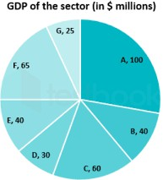
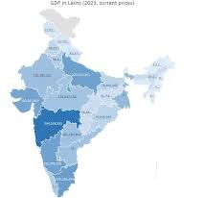

Sustainability and Resource Use—
Sustainability has become a critical aspect of economic development. Agriculture is closely linked to natural resources such as land, water, and air.
Excessive use of water, inefficient irrigation methods, and overuse of fertilizers have led to environmental degradation. At the same time, agricultural activities contribute to greenhouse gas emissions.
However, agriculture also offers solutions. Sustainable farming practices, efficient water management, and use of renewable resources can reduce environmental impact.
Thus, agriculture plays a dual role as both a contributor to and a solution for environmental challenges.

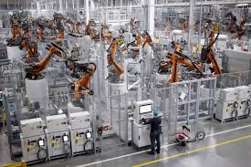
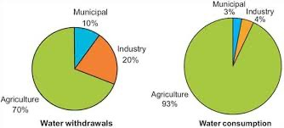

Objectives—
The main objectives of this research are:
To analyze the limitations of traditional growth models
To examine the role of agriculture in inclusive development To study the relationship between growth, employment, and sustainability
To identify suitable strategies for a new growth model

Methodology—
This study is based on qualitative analysis of existing literature and secondary data.
- Data Collection
Academic articles and policy reports Government publications
Case studies of Indian states
- Data Analysis
The data was analyzed using a comparative approach to identify patterns in growth, employment, and sectoral performance.

Results and Findings—

- Agriculture as Growth Driver
Agriculture plays a significant role in reducing poverty and generating employment, especially in early stages of development.
- Sectoral Imbalance
There is a growing gap between output growth and employment in industrial and service sectors.
- Income Inequality
Differences in productivity between agriculture and other sectors lead to income disparities.
- Sustainability Concerns
Unsustainable use of natural resources poses a major challenge to long-term growth.
Discussion—
The findings indicate that traditional growth models are no longer sufficient to address modern challenges. A balanced approach is required that integrates agriculture, industry, and services.
Agriculture should not be neglected in favour of rapid industrialization. Instead, it should be strengthened to create
a strong foundation for development.
At the same time, industrial and service sectors must adopt strategies that promote employment and reduce inequality.

Recommendations—
Promote agriculture-led development in early stages Encourage labour-intensive industries
Invest in sustainable farming practices Improve rural infrastructure and market access Support technological innovation in agriculture
Conclusion—
This study concludes that there is a clear need for a new growth model that focuses on inclusivity and sustainability. Agriculture must play a central role in this model, supported by industry and services.
A sequential approach—starting with agriculture, followed by industrialization and services—offers the most effective path for achieving long-term economic development.
Future Scope—
Future research can focus on:
Quantitative analysis of employment trends Impact of technology on rural economies Comparative studies across countries
Acknowledgment—
The authors express their gratitude to Chitkara University for their support and guidance in completing this research.
References—
- R. Chand, “Economic Growth and Inclusive Development,” NITI Aayog.
- A. Lewis, “Economic Development with Unlimited Supply of Labour,” 1954.
- T. Schultz, “Transforming Traditional Agriculture,” 1964.

- Hayami and Ruttan, “Agricultural Development,” 1971.

- OECD Reports on Growth and Sustainability.

