Document Summariser API
[Development Docs-ReadME]

Functional Requirements
Core Features (MVP)
    - Accept long documents via API (text/file input)
    - Preprocess text (cleaning, truncation, chunking)
    - Generate summary using LLM
    - Return: Short summary, bullet summary
    - Collect user feedback in the form of rating and text.
    - Store:
      - Input text (optional)
      - Generated summary
      - Metadata (latency, tokens used)
      - Feedback
    - No multi-lingual <only english>, no varied sized output, monolithic.
- Non-Functional Requirements
  - Performance
    - Latency: < 3–5 seconds per request
    - Throughput: 5-10 concurrent users
  - Scalability
    - Horizontal scaling via AWS Lambda / ECS
    - Stateless API
  - Reliability
    - Retry mechanism for model failures
    - Graceful fallback (shortened input if token overflow)
  - Security
    - API key authentication
    - Input sanitization
  - Observability
    - Logging:
      - Request time
      - Token usage
    - Metrics
      - Avg latency
      - Failure rate

- Model Architecture
  - Base Model : BART
    - Variant: facebook/bart-large-cnn
    - Source: https://huggingface.co/facebook/bart-large-cnn
    - Why:
      - Designed for summarization
      - Strong baseline on CNN/DailyMail
      - Easy fine-tuning
    - BART learns by corrupting text and reconstructing it, making it strong in generation tasks
  - Dataset
    - CNN/DailyMail: https://huggingface.co/datasets/cnn_dailymail
  - Pipeline:
    - 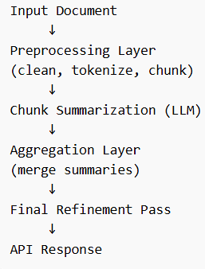

  - System Architecture
    - 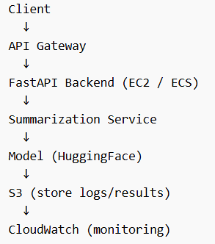
    - Components:

Component | Role
FastAPI | API layer
Huggingface | Model Loading
S3 | Storage
Cloud watch | logs/metrics
Docker | deployment
- Sprint Plan
  - Foundations:
    - Define requirements
    - Setup repo, env, logging
    - Basic FastAPI skeleton
  - Data & Model Setup:
    - Load CNN/DailyMail dataset
    - Test pretrained model (BART)
    - Baseline summarization
  - Pipeline:
    - Chunking logic
    - Hierarchical summarization
    - Evaluation (ROUGE score)
  - API Endpoints:
    - Build endpoints
    - Input validation
    - Error handling
  - Optimization:
    - Reduce latency
    - Token optimization
    - Batch processing
  - Deployment:
    - Dockerize
    - Deploy on AWS
    - Setup monitoring
- Key words for literature survey
  - Topics
    - "Abstractive summarization transformers"
    - "Hierarchical document summarization LLM"
    - "Long document summarization techniques"
    - "CNN DailyMail summarization benchmark"
  - Model Optimization
    - "Efficient transformer for long sequences"
    - "Longformer vs BART summarization"
    - "Token limit handling LLM summarization"
  - MLOps side
    - "MLOps pipeline NLP deployment AWS"
    - "Model serving latency optimization NLP"
    - "Batch inference vs real-time inference NLP"

- Dataset features
  - Data structure:
    - 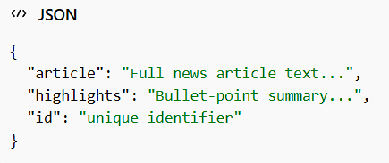
  - Feature level breakdown
    - Article <input feature>
      - Long-form news content
      - Length:
        - Avg: ~700–800 words
        - Max: can exceed token limits
      - What matters:
        - Requires chunking
        - Contains:
          - Redundant info
          - Named entities
          - Context dependencies
    - Highlights <Target Features>
      - Human written summaries
      - Style:
        - Bullet points
        - Abstractive (not copied text)
      - What matters: model must
        - Paraphrase (not extract)
        - Compress information
        - Maintain meaning
    - ID <Metadata Feature>
      - Unique identifier
      - Use:
        - Tracking predictions
        - Logging
        - Debugging failures

  - Derived features
    - Length features:
      - article_length
      - summary_length
      - compression_ratio = summary_length / article_length
      - Helps in:
        - Model evaluation
        - Filtering extreme samples
    - Linguistic features
      - Named entities count
      - Sentence count
      - Readability score
      - Helps in:
        - Understand complexity
        - Improve chunking strategy
    - Tokenization features
      - Token counts
      - Helps in:
        - Avoid overflow errors
        - Optimize batching
    - Redundancy score
      - Measure repeated info in the article
      - Helps in: Better summarization quality

- Data workflow
  - 