**Experiment-2**

**Aim:** For a given set of training data examples stored in a .CSV file, implement and demonstrate the Candidate-Elimination algorithm to output a description of the set of all hypotheses consistent with the training examples.

**Apparatus Required:** Intel(R) Core(TM) i5-1035G1 CPU @ 1.00GHz 1.19 GHz 8.00 GB (7.79 GB usable) Anaconda.

**Theory :** [The candidate elimination algorithm incrementally ***build*** the version space given a hypothesis space H and a set E of examples. The examples are added one by one; each example possibly shrinks the version space by removing the ***hypothesis*** that are inconsistent with the example. The candidate elimination algorithm does this by updating the general and specific boundary for each new example.](https://www.google.com/search?rlz=1C1YTUH_enIN1021IN1021&sxsrf=AJOqlzUijekD4RChxT_3wvJGSAcljfOAtA:1675864821210&q=The+candidate+elimination+algorithm+incrementally+build+the+version+space+given+a+hypothesis+space+H+and+a+set+E+of+examples.+The+examples+are+added+one+by+one;+each+example+possibly+shrinks+the+version+space+by+removing+the+hypothesis+that+are+inconsistent+with+the+example.+The+candidate+elimination+algorithm+does+this+by+updating+the+general+and+specific+boundary+for+each+new+example.&spell=1&sa=X&ved=2ahUKEwjXhPD6iob9AhUSV2wGHZc8AsAQBSgAegQIFRAB)

* You can consider this as an extended form of Find-S algorithm.
* Consider both positive and negative examples.
* Actually, positive examples are used here as Find-S algorithm (Basically they are generalizing from the specification).
* While the negative example is specified from generalize form.

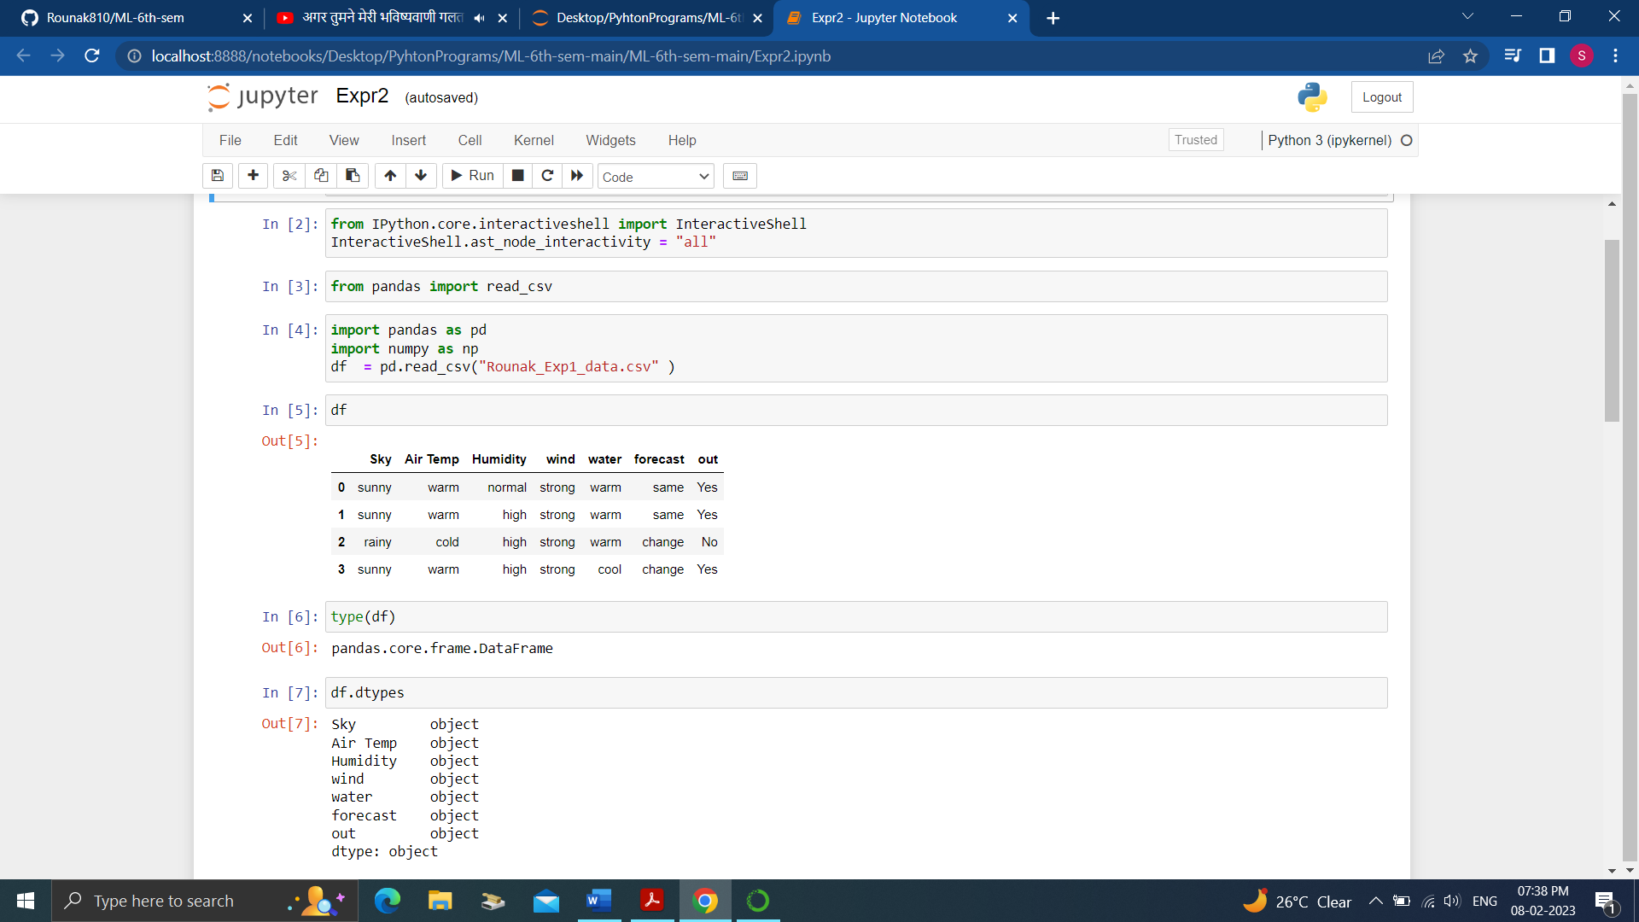**Code:**

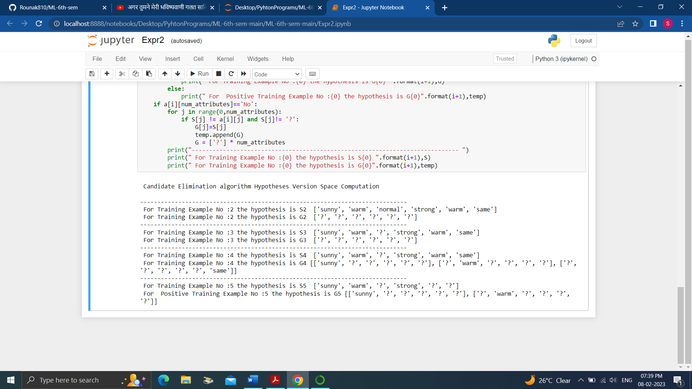**Output:**

**Result:** For a given set of training data examples stored in a .CSV file, implement and demonstrate the Candidate-Elimination algorithm to output a description of the set of all hypotheses consistent with the training examples is done and verified.