**Experiment-3**

**Aim:** Write a program to demonstrate the working of the decision tree based on ID3 algorithm. Use an appropriate data set for building the decision tree and apply this knowledge to classify a new sample.

**Apparatus Required:** Intel(R) Core(TM) i5-1035G1 CPU @ 1.00GHz 1.19 GHz 8.00 GB (7.79 GB usable) Anaconda.

**Theory:** Decision Tree is a **Supervised learning technique**that can be used for both classification and Regression problems, but mostly it is preferred for solving Classification problems. It is a tree-structured classifier, where**internal nodes represent the features of a dataset, branches represent the decision rules** and **each leaf node represents the outcome.**

* In a Decision tree, there are two nodes, which are the **Decision Node** and**Leaf Node.** Decision nodes are used to make any decision and have multiple branches, whereas Leaf nodes are the output of those decisions and do not contain any further branches.
* The decisions or the test are performed on the basis of features of the given dataset.
* ***It is a graphical representation for getting all the possible solutions to a problem/decision based on given conditions.***
* It is called a decision tree because, similar to a tree, it starts with the root node, which expands on further branches and constructs a tree-like structure.
* In order to build a tree, we use the **CART algorithm,** which stands for **Classification and Regression Tree algorithm.**
* A decision tree simply asks a question, and based on the answer (Yes/No), it further split the tree into subtrees.

**Code:**

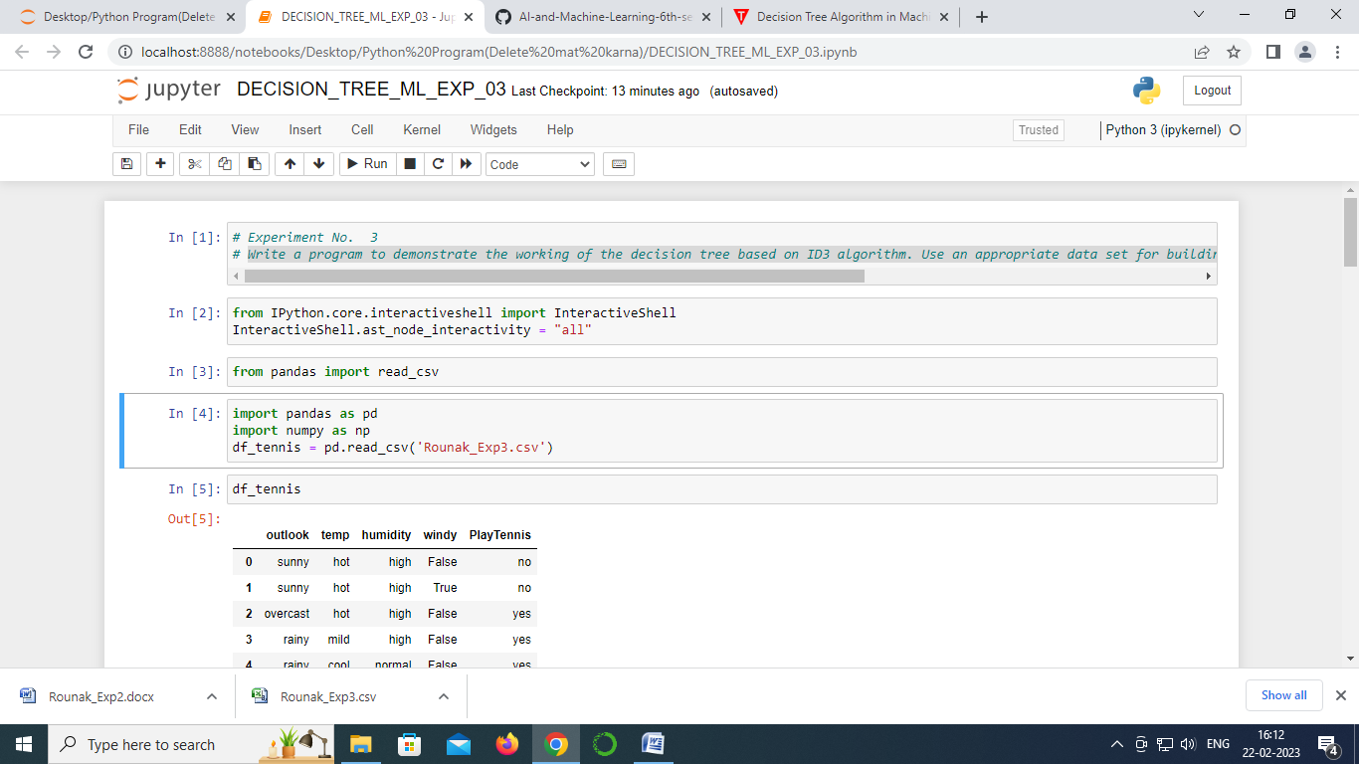

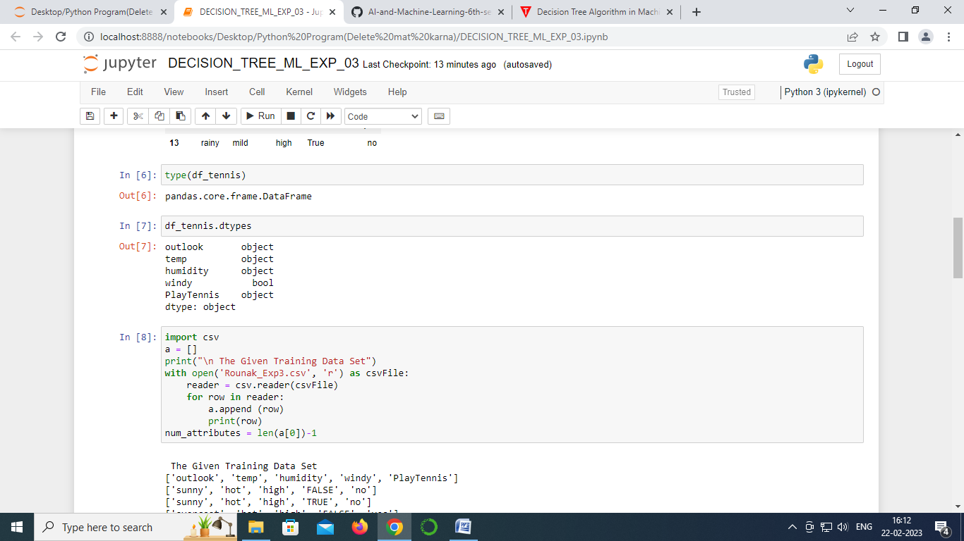

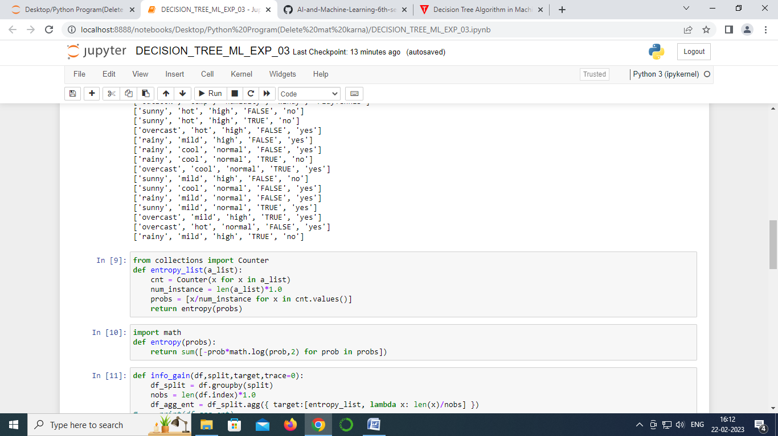

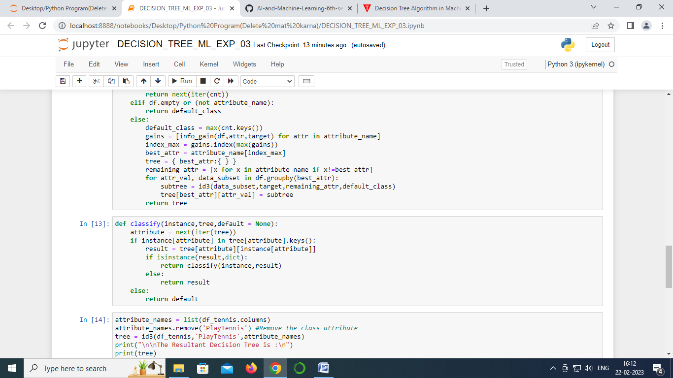

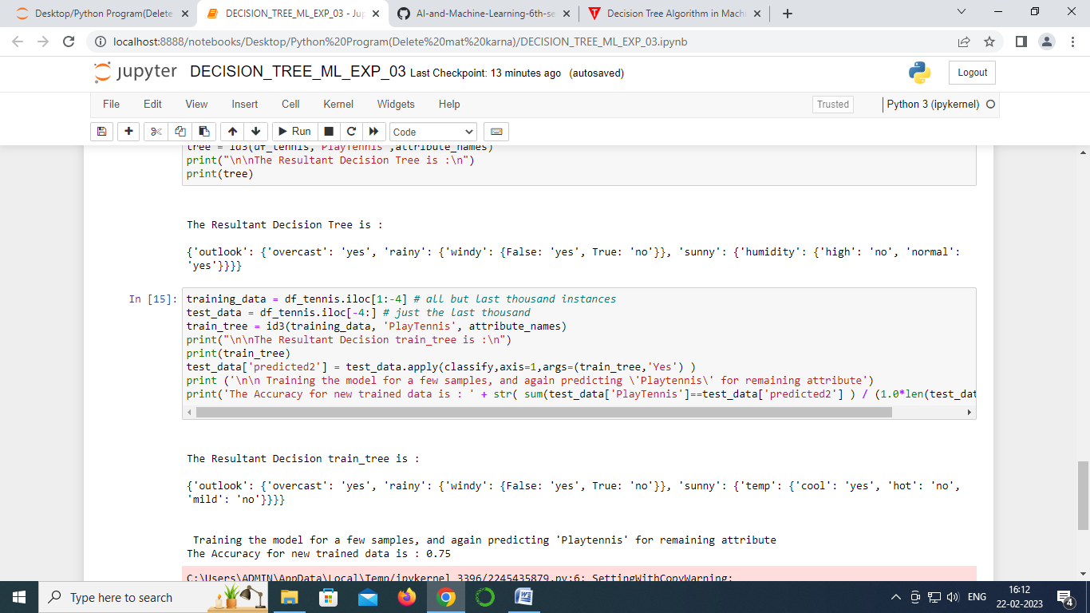

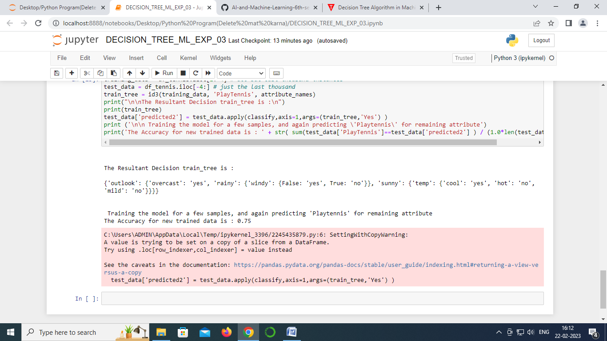**Output:**

**Result:**For a given set of training data examples stored in a .CSV file, implement and demonstrate the Candidate-Elimination algorithm to output a description of the set of all hypotheses consistent with the training examples is done and verified.