GEN-AI Subjective Assessment Project:
CAR Spot: Online Car Purchase Website with Car Cost Prediction Using Linear Regression
Submitted by: 46550_Rounak_Goje
FrontEnd: HTML, CSS, Flask(Python)
BackEnd: MySQL DB, PHP
Machine Learning Model: Linear Regression(with One Hot Encoder, Feature Selector, Column Transfer and Pickle)
GenAI Tools: ChatGPT, BardAI, Cody SurceGraphy, AWS CodeWhisper
Software's Used: VSCode(Code Editor, Juputer Notebook, Python), XAMPP(PHP and MySql DB), PyCharm(Flask APP, Python).
OverView:
A complete and efficient website which can provide all the information of different cars. A web platform where customers can directly deal with cae dealers. Due to the Covid-19 pandemic, it creates the huge demands for various for customers to get cars at affordable price, with best conditions and sanitised cars while test drive at home and after sales service.
System Architecture:
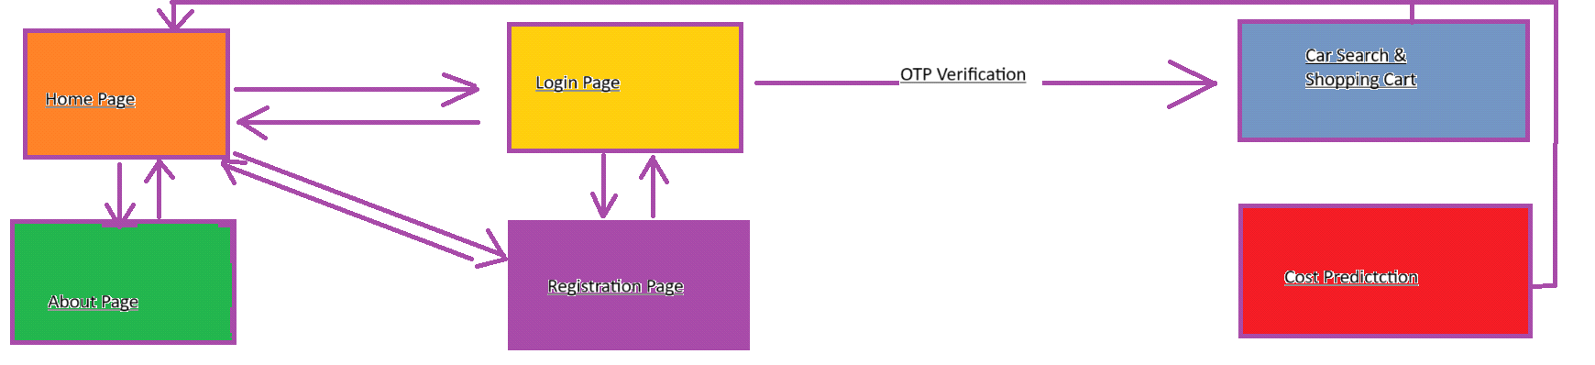
Proposed System(Design):
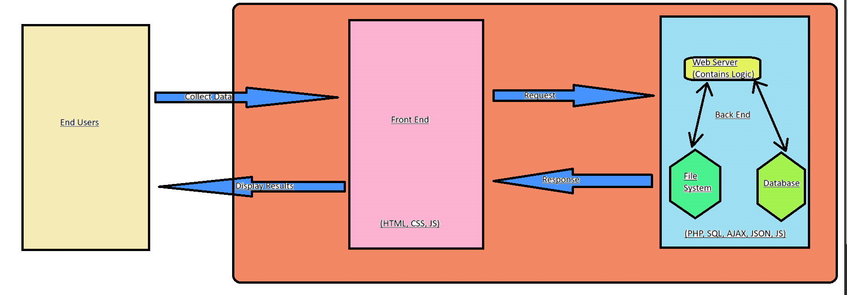

Core Funtionalities and MicroServices:
1) Home Page: With HTML and CSS, implemented 3D cards(in addition).
1) Registration Module: Get the User details by Registration form, and store it in MySql DB.
2) Login Module(with username, password and OTP): Login with username and passwrod, for further authentication, we used OTP.
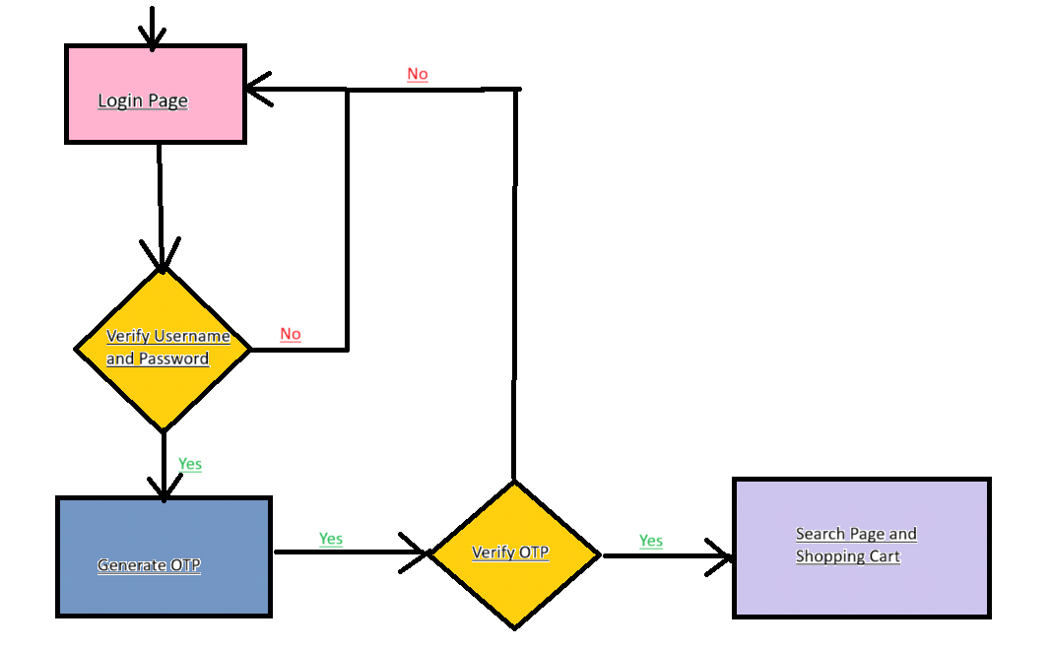

3) Change Password Module: Previous password is matched in MySql DB to change the password.
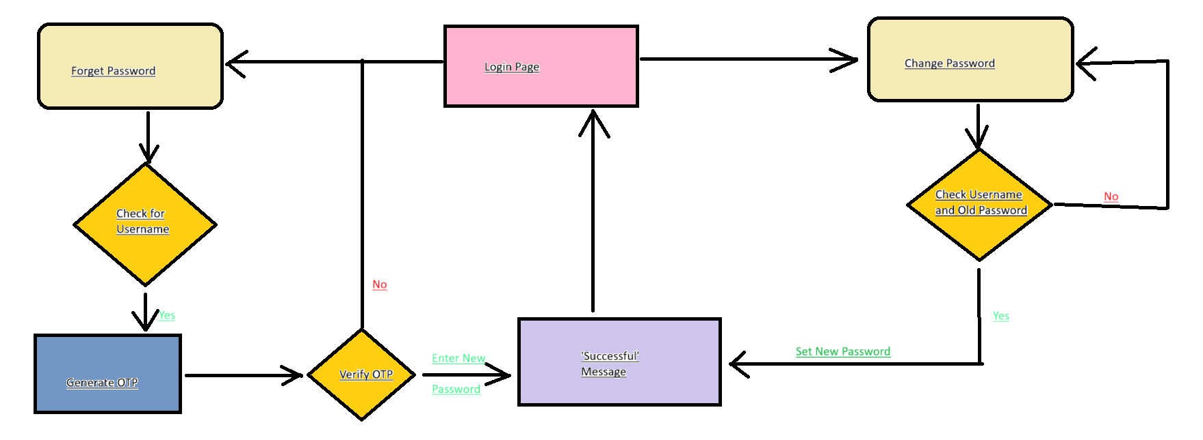

4) Forget Password Module: Need OTP to authenticate and set new password.
5) Catalog with amount, image and description(search page): Can search for different products(cars), add to cart, and further fot checkout.

6) Add to Cart: Add your ptoduct to cart.

7) Checkout and Payment: Checkout your car(product) and further for payment.

8) Cost Prediction Model:
A CSV file contains data stored in tabular form. Pandas ensures to import dataset. Feature Selector is responsible to take minimum input variables. Two sets are developed for training and testing a model. OneHotEncoder converts categorical data into numerical data for feature selector. Column Transformer ensures to select categorical data and numerical data. Pipelining helps to get the value of the feature. Pickle library allows to dump our model.

