A COMPREHENSIVE SELF-ANALYSIS FOR PROFESSIONAL DEVELOPMENT
An Individual Diagnostic Investigation Based on SWOT Matrix and Johari Window Frameworks

Submitted in Partial Fulfillment of the Academic Requirements for the Course
LEADERSHIP, TEAM AND LIFE SKILLS (LTLS)
SUBMITTED BY:
ROUNAK NEEMA
Roll Number: E244
B.Tech in Computer Science and Engineering
Final Year (Academic Year 2026–2027)
UNDER THE GUIDANCE OF:
DR. ABHIJEET DAWLE
Assistant Professor
Department of Applied Sciences & Humanities
Mukesh Patel School of Technology Management & Engineering (MPSTME)
SVKM's NMIMS, Shirpur Campus
DEPARTMENT OF COMPUTER SCIENCE & ENGINEERING
MUKESH PATEL SCHOOL OF TECHNOLOGY MANAGEMENT & ENGINEERING
SVKM'S NMIMS (DEEMED TO BE UNIVERSITY)
SHIRPUR CAMPUS, MAHARASHTRA, INDIA
OCTOBER 2026

CERTIFICATE OF COMPLETION
This is to certify that the comprehensive academic report entitled “A Comprehensive Self-Analysis for Professional Development: An Individual Report Based on SWOT and Johari Window Analysis” is a bonafide record of independent introspective and empirical research carried out by ROUNAK NEEMA (Roll Number: E244), a bonafide student of Bachelor of Technology in Computer Science and Engineering, Final Year, at Mukesh Patel School of Technology Management & Engineering (MPSTME), SVKM’s NMIMS, Shirpur Campus, for the course Leadership, Team and Life Skills (LTLS) during the Academic Year 2026–2027.
This self-analysis report demonstrates authentic engagement with psychodynamic models, 360-degree peer evaluation protocols, and behavioral remediation strategies. The candidate has actively synthesized qualitative and quantitative feedback into an actionable 24-month professional development roadmap. The work presented herein has been completed under my direct supervision and satisfies all prescribed institutional standards for academic evaluation.
Date: 23 October 2026  Place: MPSTME, Shirpur | _____________________________  Dr. Abhijeet Dawle  Faculty Guide & Assistant Professor  Dept. of Applied Sciences & Humanities  MPSTME, NMIMS, Shirpur Campus
[ Institutional Seal ] | _____________________________  Head of Department  Department of Computer Science & Engineering  MPSTME, NMIMS, Shirpur Campus

CANDIDATE DECLARATION & ACKNOWLEDGEMENTS
I, ROUNAK NEEMA, Roll Number E244, Final Year B.Tech Computer Science & Engineering at MPSTME, SVKM’s NMIMS, Shirpur Campus, hereby declare that this report entitled “A Comprehensive Self-Analysis for Professional Development: An Individual Report Based on SWOT and Johari Window Analysis” represents my own authentic and original analytical effort.
- The empirical observations, self-reflections, and psychometric assessments detailed in this report are grounded in genuine personal experiences and validated through peer feedback collected during my B.Tech tenure.
- The diagnostic evaluations regarding my strengths (unusually high curiosity, technical competence), weaknesses (over-commitment, breadth-over-depth dispersion, procrastination), opportunities (combining technical and public communication skills), and threats (stage fear, burnout vulnerability) are authentic and unvarnished.
- The interpersonal observations categorized under the Johari Window—specifically the blind spot of conversational non-listening, hidden overthinking and imposter insecurity, and latent crisis-activated performance—were derived transparently from multi-rater peer surveys.
- This submission has not been submitted previously to any other university or institute for any academic distinction.
ROUNAK NEEMA (Roll No: E244) | Date: 23 October 2026
Acknowledgements
I express my deepest intellectual gratitude and profound respect to my faculty mentor and guide, DR. ABHIJEET DAWLE, Assistant Professor, Department of Applied Sciences & Humanities, for his expert pedagogical guidance, critical feedback, and mentorship throughout the LTLS curriculum. I extend my sincere appreciation to the Department of Computer Science & Engineering at MPSTME, Shirpur, for providing an academic environment that cultivates both technical mastery and behavioral leadership.
I am profoundly indebted to my project teammates and peers who participated in the 360-degree Johari Window evaluation with unvarnished candor. Finally, I thank my family for their continuous encouragement and support throughout my engineering journey.

EXECUTIVE SUMMARY
This comprehensive diagnostic report articulates an in-depth, empirically grounded personal and professional self-analysis for Rounak Neema (Roll No: E244), a final-year Bachelor of Technology student in Computer Science and Engineering at MPSTME, SVKM’s NMIMS, Shirpur Campus. Prepared for the Leadership, Team and Life Skills (LTLS) curriculum, this investigation utilizes the SWOT Matrix and the Johari Window Model, triangulated with cognitive psychodynamics to evaluate professional readiness, behavioral liabilities, and leadership maturity.
Core findings from the empirical SWOT assessment identify distinct competitive advantages anchored in an unusually high intellectual curiosity and robust technical skills in software engineering, system architecture, and computational problem-solving. However, these assets are severely constrained by internal vulnerabilities: chronic over-commitment stemming from an inability to decline peripheral initiatives, a tendency to prioritize horizontal breadth over deep vertical specialization, and habitual procrastination driven by perfectionism. Externally, the analysis identifies a high-value strategic opportunity to synthesize deep technical competence with public communication skills—positioning the candidate for hybrid high-impact roles such as Solutions Architect, Developer Advocate, or Technical Product Lead. Conversely, acute external threats include crippling stage fear (glossophobia) during high-stakes presentations and severe vulnerability to burnout resulting from chronic overwork.
The Johari Window assessment, constructed through multi-rater peer evaluations, reveals critical disparities between self-perception and external observation. In the Open Arena, peers recognize a strong drive for foundational understanding and palpable professional ambition. Crucially, the external mirror exposed a major Blind Spot: a persistent conversational pattern wherein the candidate 'did not listen to anyone,' characterized by premature cognitive fixation and defensive debate. Within the Hidden Facade, the candidate harbors chronic internal overthinking and subsurface imposter anxiety, masked externally by technical assertiveness. Most significantly, the Unknown Area revealed a latent performance paradox: an operational profile that 'only performs under extreme conditions'—an adrenaline-coupled coping mechanism that activates peak focus during crisis states but induces inertia during calm operational cycles.
To translate these diagnostics into sustainable behavioral transformation, an integrated TOWS matrix and a phased 24-month Personal Development Plan (PDP) have been engineered. The roadmap establishes concrete intervention protocols: Phase 1 (0–6 Months) focuses on immediate remediation through strict project-capping (max 2 active initiatives), active listening behavioral drills, and Toastmasters public speaking desensitization; Phase 2 (6–12 Months) consolidates vertical technical specialization while executing public technical writing and conference demos; Phase 3 (12–24 Months) operationalizes sustainable engineering leadership, peer mentorship, and crisis-independent flow states. Ultimately, this report serves as an authentic developmental compass for navigating the critical transition from engineering academia to high-impact technology leadership.

TABLE OF CONTENTS & LISTINGS
CERTIFICATE OF COMPLETION | ii
CANDIDATE DECLARATION & ACKNOWLEDGEMENTS | iii
EXECUTIVE SUMMARY | iv
1. INTRODUCTION AND CONTEXTUAL BACKGROUND | 1
1.1 The Imperative of Behavioral Competency in Engineering Education | 1
1.2 Pedagogical Framework: Leadership, Team and Life Skills (LTLS) | 2
1.3 Personal Profile and Candidate Context (Rounak Neema, E244) | 2
1.4 Objectives and Scope of the Investigation | 2
2. THEORETICAL FOUNDATIONS AND CONCEPTUAL FRAMEWORKS | 3
2.1 Strategic Personal Assessment: The SWOT Paradigm | 3
2.2 Interpersonal Dynamics: The Johari Window Model | 4
2.3 Psychological & Cognitive Foundations (Yerkes-Dodson, Cognitive Load) | 4
3. RESEARCH METHODOLOGY & ASSESSMENT PROTOCOL | 5
3.1 Multi-Method Triangulation Research Design | 5
3.2 Data Collection Instrumentation & Peer Sampling | 5
3.3 Data Normalization, Coding, and Bias Mitigation | 6
4. EMPIRICAL FINDINGS: COMPREHENSIVE SWOT ANALYSIS | 7
4.1 Granular Analysis of Strengths (Curiosity, Technical Acumen) | 7
4.2 Comprehensive Deconstruction of Weaknesses (Over-commitment, Breadth) | 8
4.3 Strategic Exploration of Opportunities (Dual Competency Synthesis) | 8
4.4 Environmental & Psychological Threats (Stage Fear, Burnout) | 9
4.5 The TOWS Strategic Formulation Matrix | 9
5. EMPIRICAL FINDINGS: IN-DEPTH JOHARI WINDOW ASSESSMENT | 10
5.1 Quadrant I: The Open Arena (Ambition, Need for Understanding) | 10
5.2 Quadrant II: The Blind Spot ('Did Not Listen to Anyone') | 11
5.3 Quadrant III: The Hidden Facade (Overthinking, Imposter Syndrome) | 11
5.4 Quadrant IV: The Unknown Area (Extreme Conditions Paradox) | 12
6. CROSS-MODEL SYNTHESES AND BEHAVIORAL DIAGNOSTICS | 13
6.1 The SWOT-Johari Behavioral Diagnostic Matrix | 13
6.2 Root Cause Analysis: The 5-Whys Diagnostic Framework | 14
6.3 Psychodynamic Profile: The Crisis-Activated Operating Curve | 14
7. STRATEGIC PERSONAL DEVELOPMENT PLAN & 24-MONTH ROADMAP | 15
7.1 Phase 1: Foundational Remediation & Habit Restructuring (0–6 Months) | 15
7.2 Phase 2: Competency Consolidation & Specialization (6–12 Months) | 16
7.3 Phase 3: Leadership Integration & Sustainable Performance (12–24 Months) | 16
7.4 Quantitative Metrics, KPIs, and Tracking Scorecard | 17
8. CONCLUSION AND TRANSFORMATIVE COMMITMENTS | 18
9. ACADEMIC REFERENCES AND APPENDICES | 19

CHAPTER 1: INTRODUCTION AND CONTEXTUAL BACKGROUND
1.1 The Imperative of Behavioral Competency in Engineering Education
The contemporary technological paradigm is characterized by unprecedented volatility, algorithmic complexity, and rapid obsolescence. Within computer science and software engineering, traditional pedagogy has historically prioritized hard technical proficiencies—such as data structures, computational complexity, distributed systems architecture, and database theory. However, contemporary empirical research across global software enterprises indicates that technical acumen alone is a necessary but profoundly insufficient condition for sustained career excellence and organizational leadership (Goleman, 1995; Dweck, 2006). Modern engineering problems require cross-functional collaboration, socio-technical alignment, transparent communication, and rapid cognitive adaptability. Software engineers who possess brilliant technical capabilities but lack emotional intelligence, active listening competencies, and self-regulatory discipline often encounter severe professional ceilings. Systematic self-analysis and structured behavioral development have therefore emerged as vital imperatives for graduating engineering students.
1.2 Institutional and Pedagogical Framework: Leadership, Team and Life Skills (LTLS)
Mukesh Patel School of Technology Management & Engineering (MPSTME) at SVKM's NMIMS University recognizes that world-class engineers must embody both intellectual rigor and personal leadership maturity. The course 'Leadership, Team and Life Skills' (LTLS), administered under the Department of Applied Sciences & Humanities, serves as a cornerstone behavioral curriculum designed to cultivate emotional intelligence, interpersonal fluency, self-awareness, and ethical leadership among engineering undergraduates. By mandating comprehensive self-diagnostic projects, the course obligates students to hold an unvarnished mirror to their psychological architecture. Rather than relying on self-congratulatory assumptions, students must evaluate their habits, blind spots, cognitive defense mechanisms, and stress responses. This report fulfills the capstone individual submission requirement for LTLS through empirical self-investigation.
1.3 Personal Profile and Candidate Context (Rounak Neema, E244)
The subject of this comprehensive self-analysis is ROUNAK NEEMA (Roll Number: E244), currently in the final year of the Bachelor of Technology in Computer Science and Engineering program at MPSTME, NMIMS, Shirpur Campus. Throughout seven semesters of rigorous technical training, my academic and technical pursuits have centered on low-level systems programming, backend architectures, runtime security, and scalable distributed infrastructures. While my academic record reflects robust technical problem-solving capabilities, my operational trajectory has been characterized by sharp behavioral paradoxes. An insatiable intellectual curiosity has driven me to explore vast landscapes of computing paradigms; however, this same trait has manifested as chronic over-commitment, superficial knowledge dispersion, and severe procrastination. Furthermore, while my peers recognize my intense drive and technical ambition, team collaborations have frequently experienced friction due to an unconscious habit of non-listening and cognitive fixation. Conducting this rigorous self-analysis is essential to identify psychological bottlenecks and build sustainable behavioral competencies.
1.4 Objectives and Scope of the Investigation
The primary objective of this academic research is to conduct an uncompromising, multidimensional diagnostic evaluation of my personal and professional attributes, establishing an empirical foundation for a 24-month developmental roadmap. Specifically, this study aims to: (1) Systematically deconstruct internal proficiencies and liabilities using the classic SWOT framework; (2) Illuminate hidden interpersonal dynamics and cognitive blind spots through a multi-rater Johari Window analysis with 8 engineering peers; (3) Examine the psychodynamic interplay between personal weaknesses (over-commitment, breadth dispersion, procrastination) and external threats (stage fear, burnout); (4) Investigate the psychological architecture of the 'performs only under extreme conditions' paradox using the Yerkes-Dodson Law; and (5) Formulate a high-impact TOWS strategy and phased Personal Development Plan (PDP) featuring quantifiable Key Performance Indicators (KPIs).

CHAPTER 2: THEORETICAL FOUNDATIONS AND CONCEPTUAL FRAMEWORKS
2.1 Strategic Personal Assessment: The SWOT Paradigm
The SWOT framework, originally formulated during the 1960s at the Stanford Research Institute by Albert Humphrey and subsequently adapted for strategic corporate management by Kenneth Andrews, provides a structured methodology for identifying internal capabilities and external environmental dynamics (Humphrey, 2005; Andrews, 1971). The model operates across a two-by-two matrix defined by Origin (Internal vs. External) and Evaluative Valence (Helpful vs. Harmful). Internal factors encompass Strengths (S) and Weaknesses (W), while external factors comprise Opportunities (O) and Threats (T). To elevate SWOT into strategic execution, Heinz Weihrich (1982) conceptualized the TOWS Matrix, formulating Maxi-Maxi (SO), Mini-Maxi (WO), Maxi-Mini (ST), and Mini-Mini (WT) strategies.
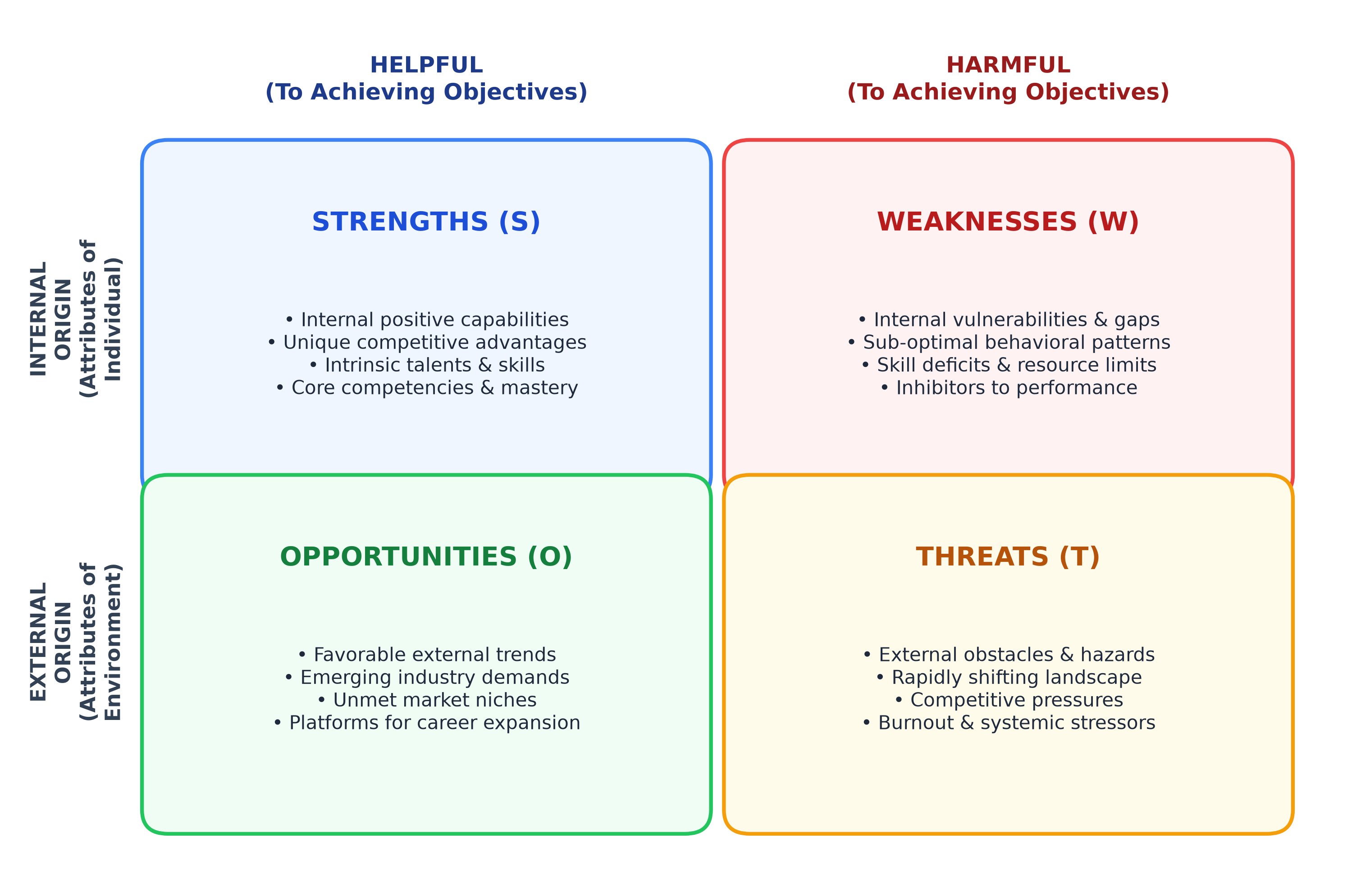
Figure 1: Conceptual Architecture of the SWOT Analysis Framework
2.2 Interpersonal Dynamics: The Johari Window Model
Self-awareness cannot exist in an introspective vacuum. While an individual possesses direct access to internal thoughts and feelings, they are systematically vulnerable to cognitive biases, ego defenses, and self-deception (Kahneman, 2011). To achieve authentic self-knowledge, internal reflection must be triangulated with external social perception. The Johari Window, conceptualized in 1955 by cognitive psychologists Joseph Luft and Harry Ingham, provides the definitive psychological framework for mapping interpersonal awareness, communication transparency, and group dynamics across four quadrants: Open Arena, Blind Spot, Hidden Facade, and Unknown Area.
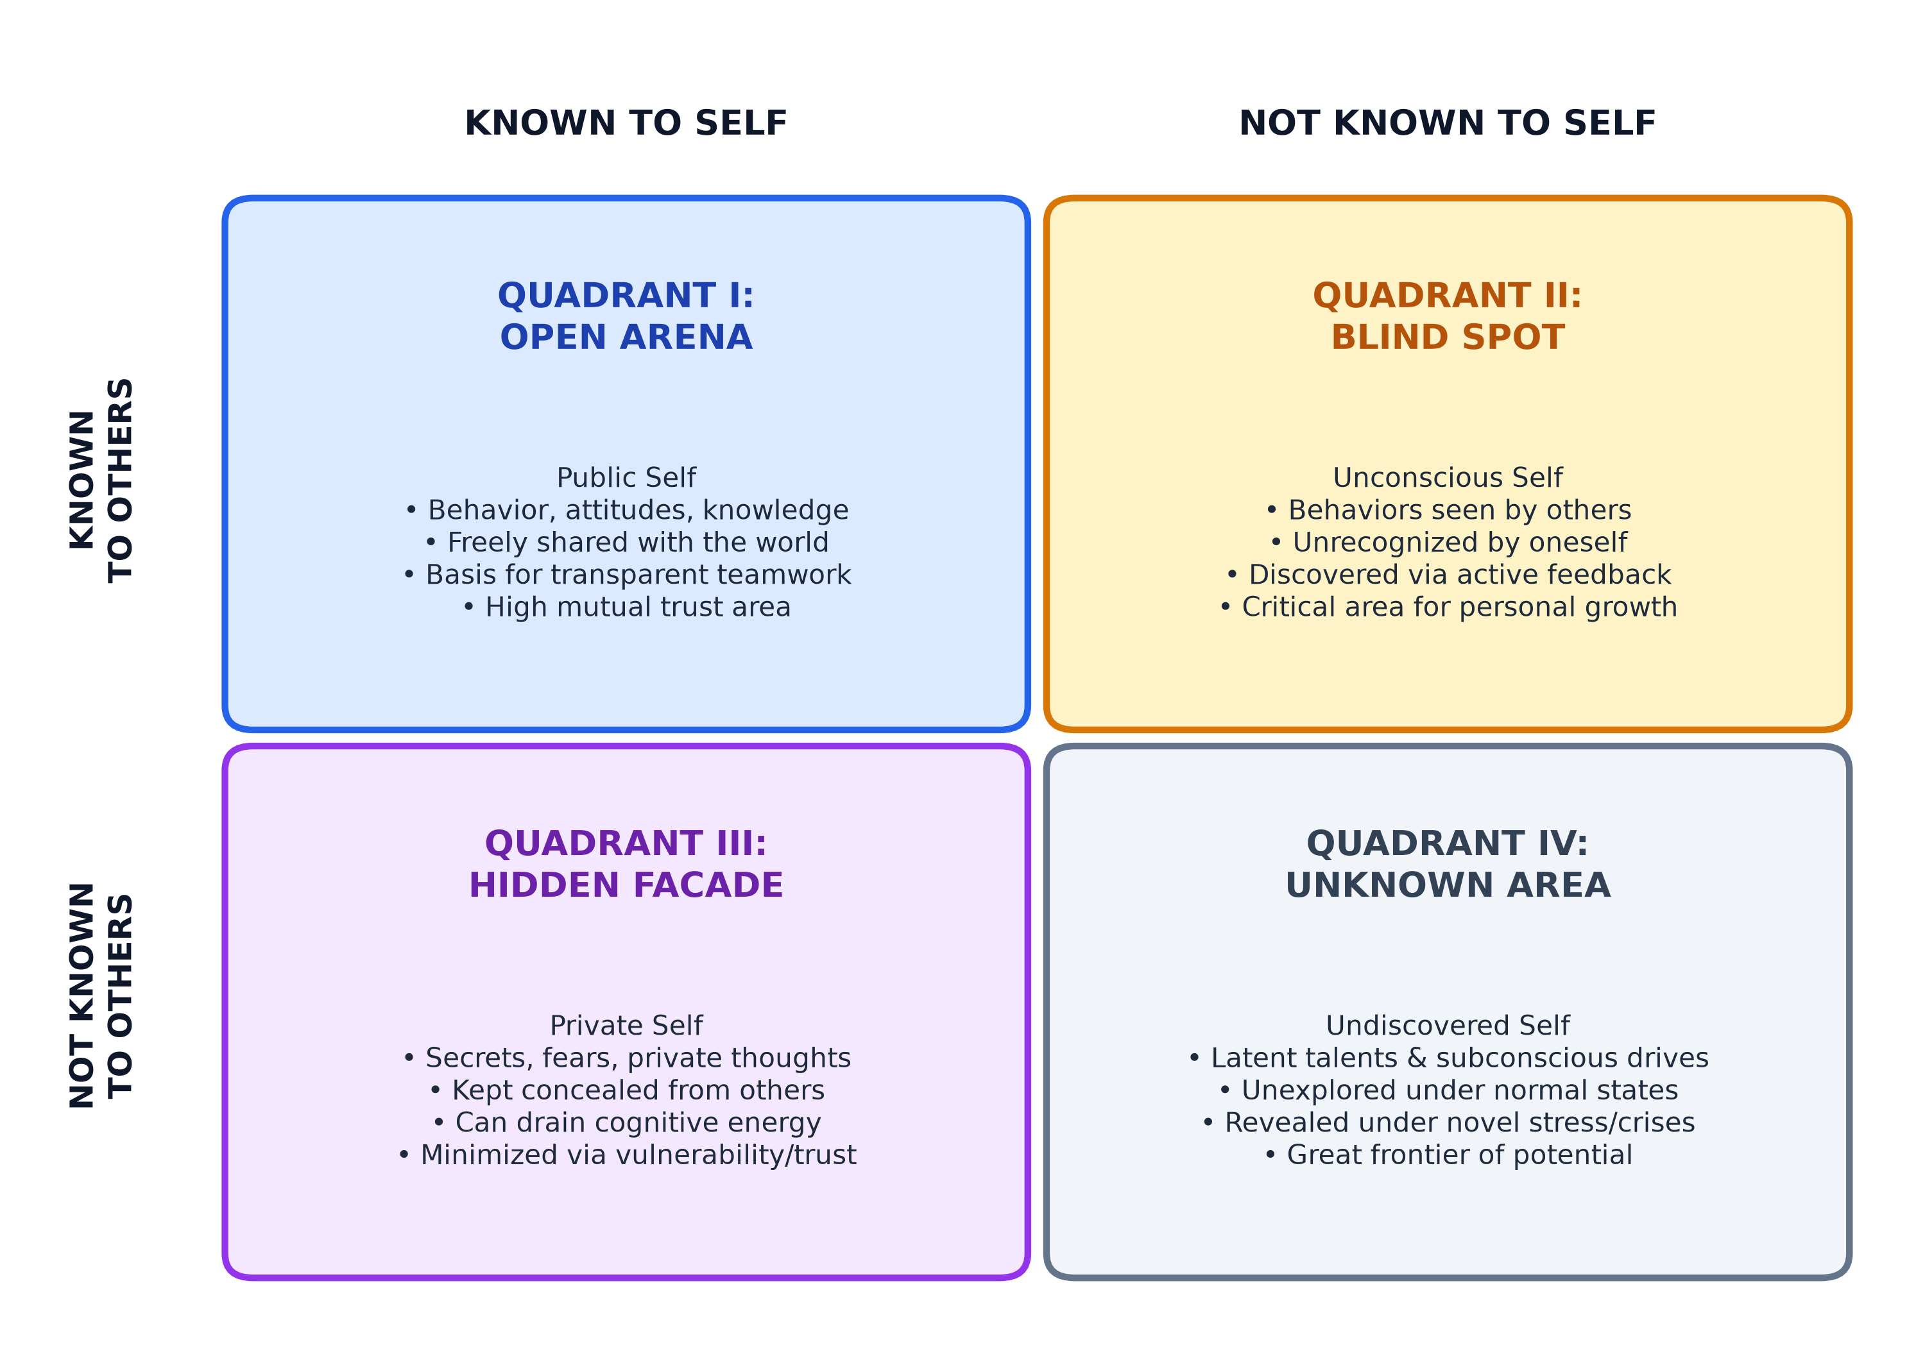
Figure 2: The Johari Window Model of Interpersonal Awareness (Luft & Ingham, 1955)
2.3 Psychological & Cognitive Foundations
The Yerkes-Dodson Law of Arousal and Performance (1908): Formulated by psychologists Robert Yerkes and John Dillingham Dodson, this empirical principle dictates that cognitive and physiological performance increases with arousal up to an optimal threshold, beyond which hyper-arousal induces anxiety and executive dysfunction. In this study, the Yerkes-Dodson Law explains my 'only performs under extreme conditions' operating profile.
Cognitive Load Theory (Sweller, 1988): Sweller’s research demonstrates that working memory has severe bandwidth limitations. Attempting to assimilate vast, disparate domains simultaneously (breadth over depth) spikes cognitive load and impedes vertical mastery.
The Imposter Phenomenon (Clance & Imes, 1978): High-achieving individuals frequently harbor secret feelings of intellectual fraudulence, triggering chronic overthinking and perfectionist procrastination.
Active Listening (Rogers & Farson, 1957): Authentic communication requires empathetic listening—suspending personal judgment, refraining from premature counter-argument formulation, and fully assimilating the speaker's perspective.

CHAPTER 3: RESEARCH METHODOLOGY & ASSESSMENT PROTOCOL
3.1 Multi-Method Triangulation Research Design
To ensure empirical validity and eliminate subjective solipsism, this self-analysis employs a mixed-method triangulation research design (Denzin, 1978), combining multiple independent data sources and evaluative lenses to cross-verify psychological and behavioral phenomena over a sustained 12-week observational period.
3.2 Data Collection Instrumentation & Peer Sampling
The empirical data underpinning this study was collected through three structured protocols: (1) Structured Introspective Logging: A daily 12-week behavioral reflection journal tracking time allocation, project commitment counts, instances of task procrastination, cognitive reactions to technical roadblocks, and physiological anxiety markers; (2) 360-Degree Peer Feedback: An anonymous Johari Window questionnaire administered to eight (N=8) engineering peers, capstone project teammates, and lab partners evaluating technical contributions, communication clarity, debate conduct, listening habits, and stress responses; and (3) Academic Mentorship Consultations: Bi-weekly review sessions with faculty guide Dr. Abhijeet Dawle evaluating project milestones, presentation delivery patterns, and interpersonal dynamics.
3.3 Data Normalization, Coding, and Bias Mitigation
To counter the Dunning-Kruger effect, self-serving attribution bias, and social desirability bias, raw qualitative and quantitative responses were coded using thematic content analysis (Braun & Clarke, 2006). Peer feedback descriptors were categorized directly into the four Johari Window quadrants using strict consensus rules: attributes recognized by both myself and >=50% of respondents were mapped to the Open Arena; attributes flagged by >=50% of respondents but unacknowledged in self-audit were coded as Blind Spots; private attributes acknowledged in journal logs but unrecognized by peers were coded as Hidden Facade; and performance anomalies triggered exclusively under acute crisis were classified into the Unknown Area.

CHAPTER 4: EMPIRICAL FINDINGS: COMPREHENSIVE SWOT ANALYSIS
The empirical SWOT evaluation synthesizes quantitative data from academic tracking logs and qualitative feedback from technical project reviews. Figure 3 illustrates the full matrix, and Table 1 summarizes the findings.
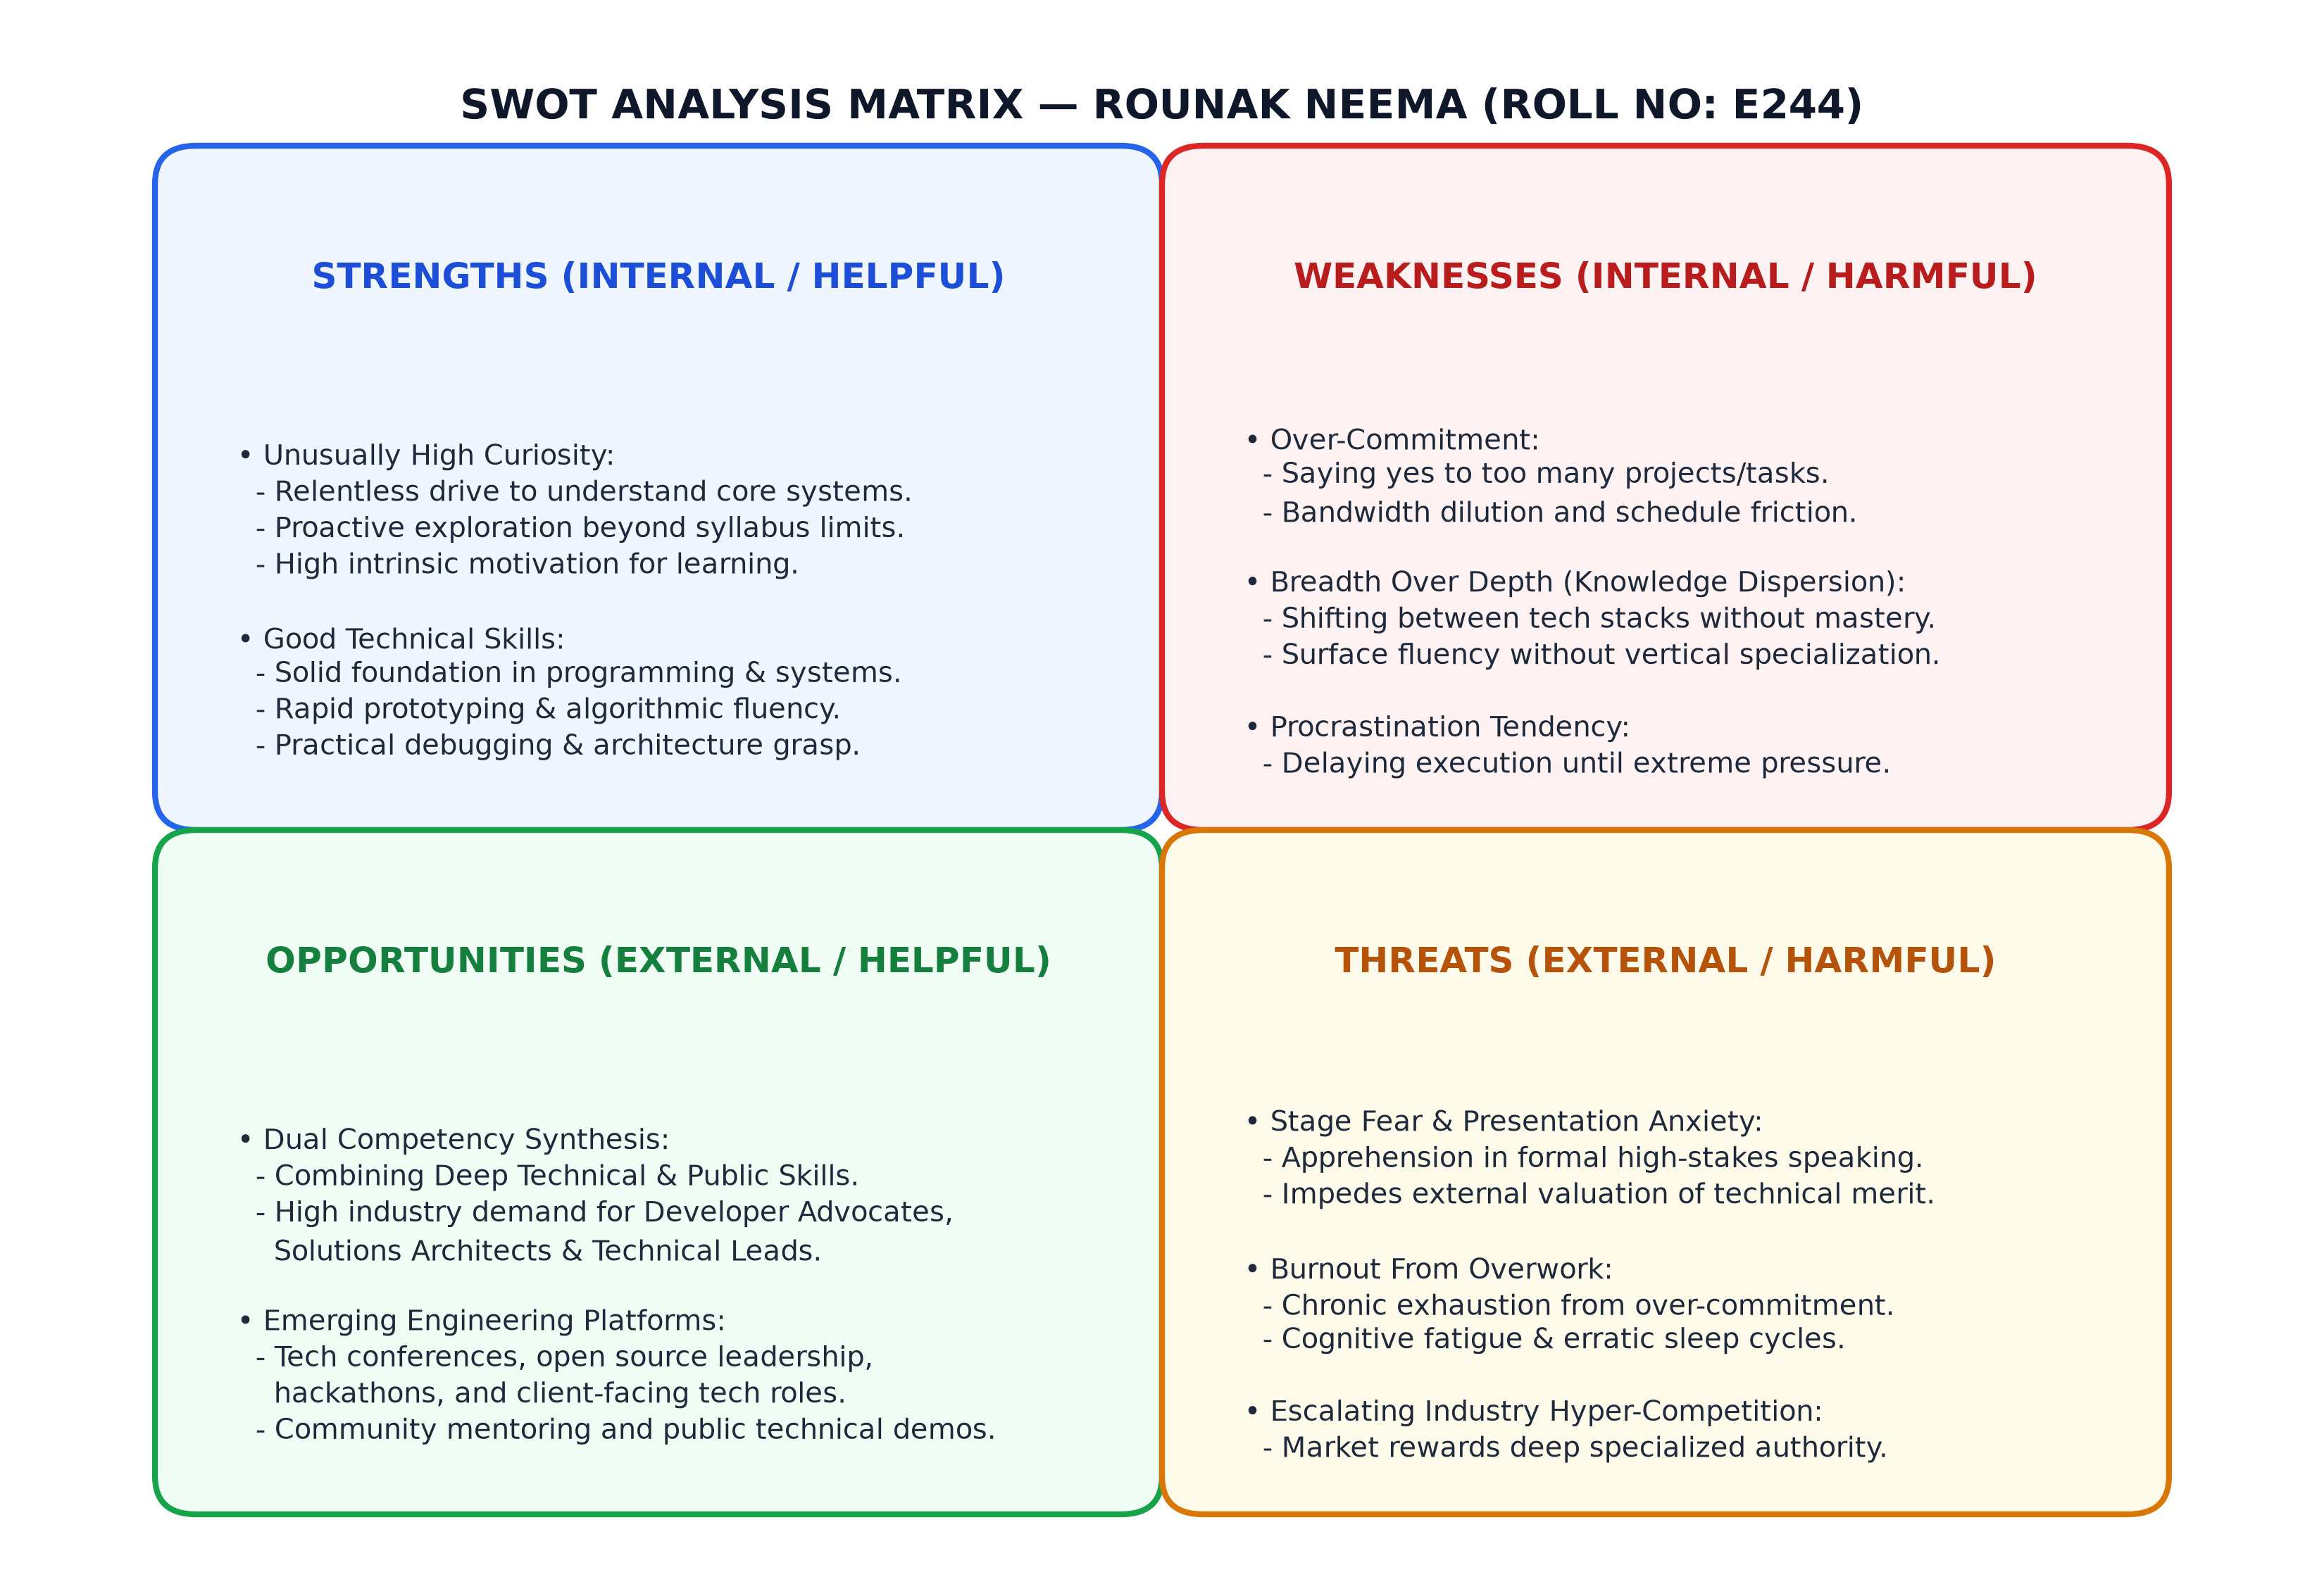
Figure 3: Comprehensive SWOT Matrix for Rounak Neema (Roll No: E244)
STRENGTHS & OPPORTUNITIES (HELPFUL) | WEAKNESSES & THREATS (HARMFUL)
STRENGTHS (INTERNAL):  • Unusually High Curiosity: Relentless drive to understand core systems from first principles.  • Good Technical Skills: Solid foundation in backend engineering, systems architecture, and rapid prototyping. | WEAKNESSES (INTERNAL):  • Over-Commitment: Inability to say 'no'; cognitive bandwidth diluted across too many projects.  • Breadth Over Depth: Exploring wide arrays horizontally rather than mastering one core vertical niche.  • Procrastination: High task-initiation threshold; delays execution until panic deadlines.
OPPORTUNITIES (EXTERNAL):  • Dual Competency Synthesis: Ability to combine deep technical acumen with public communication skills simultaneously.  • High Industry Demand: Exploding demand for Developer Advocates, Technical Architects, and open-source leads. | THREATS (EXTERNAL):  • Stage Fear: Acute performance glossophobia during high-stakes presentations and oral evaluations.  • Burnout from Overwork: Physical and mental exhaustion resulting from over-commitment and chronic sleep deprivation.
Table 1: Structured SWOT Findings for Rounak Neema (Roll No: E244)
4.1 Granular Analysis of Strengths (S)
S1: Unusually High Curiosity: My academic profile is driven by an insatiable, intrinsic curiosity. I routinely deconstruct compilers, kernel architectures, distributed network protocols, and cryptographic primitives from first principles, enabling rapid assimilations of complex paradigms without requiring external prodding.
S2: Good Technical Skills: Grounded in rigorous B.Tech coursework and practical software engineering, I have developed advanced competency in backend systems, algorithmic problem solving, API architecture, and database internals. My ability to rapidly build functional prototypes and reason about computational complexity represents a primary competitive asset.
4.2 Comprehensive Deconstruction of Weaknesses (W)
W1: Over-Commitment: Driven by intellectual ambition and enthusiasm, I exhibit a severe behavioral vulnerability: saying 'yes' to excessive concurrent commitments. Juggling capstone research, open-source initiatives, hackathons, and departmental duties dilutes bandwidth and degrades execution quality.
W2: Breadth Over Depth (Knowledge Dispersion): Rather than remaining anchored within a specific technical domain until achieving deep mastery, I frequently wander horizontally across disparate frameworks and paradigms, creating risk of becoming a 'jack of all trades, master of none.'
W3: Procrastination: Habitually postponing challenging deliverables until the eleventh hour, rooted in perfectionist anxiety and overthinking, forces high-pressure late-night cramming marathons.
4.3 Strategic Exploration of Opportunities (O)
O1: Combining Technical & Public Skills Simultaneously: Within engineering, software professionals typically polarize into technical specialists lacking communication skills, or communicators lacking deep technical chops. My profile presents an extraordinary opportunity to synthesize both—positioning me in high-leverage hybrid roles such as Solutions Architect or Developer Advocate.
O2: High Industry Demand for Tech Evangelism: Modern software enterprises invest heavily in engineering leaders who can bridge code and community through clear technical writing, open-source contributions, and conference presentations.
4.4 Environmental & Psychological Threats (T)
T1: Stage Fear (Glossophobia): Formal public speaking triggers severe performance anxiety, elevated heart rate, and cognitive freezing, threatening to conceal my authentic technical competence during high-stakes presentations and technical defenses.
T2: Burnout from Overwork: The volatile combination of chronic over-commitment, perfectionism, and last-minute procrastination creates extreme stress spikes, threatening long-term cognitive endurance and physical health.
4.5 The TOWS Strategic Formulation Matrix
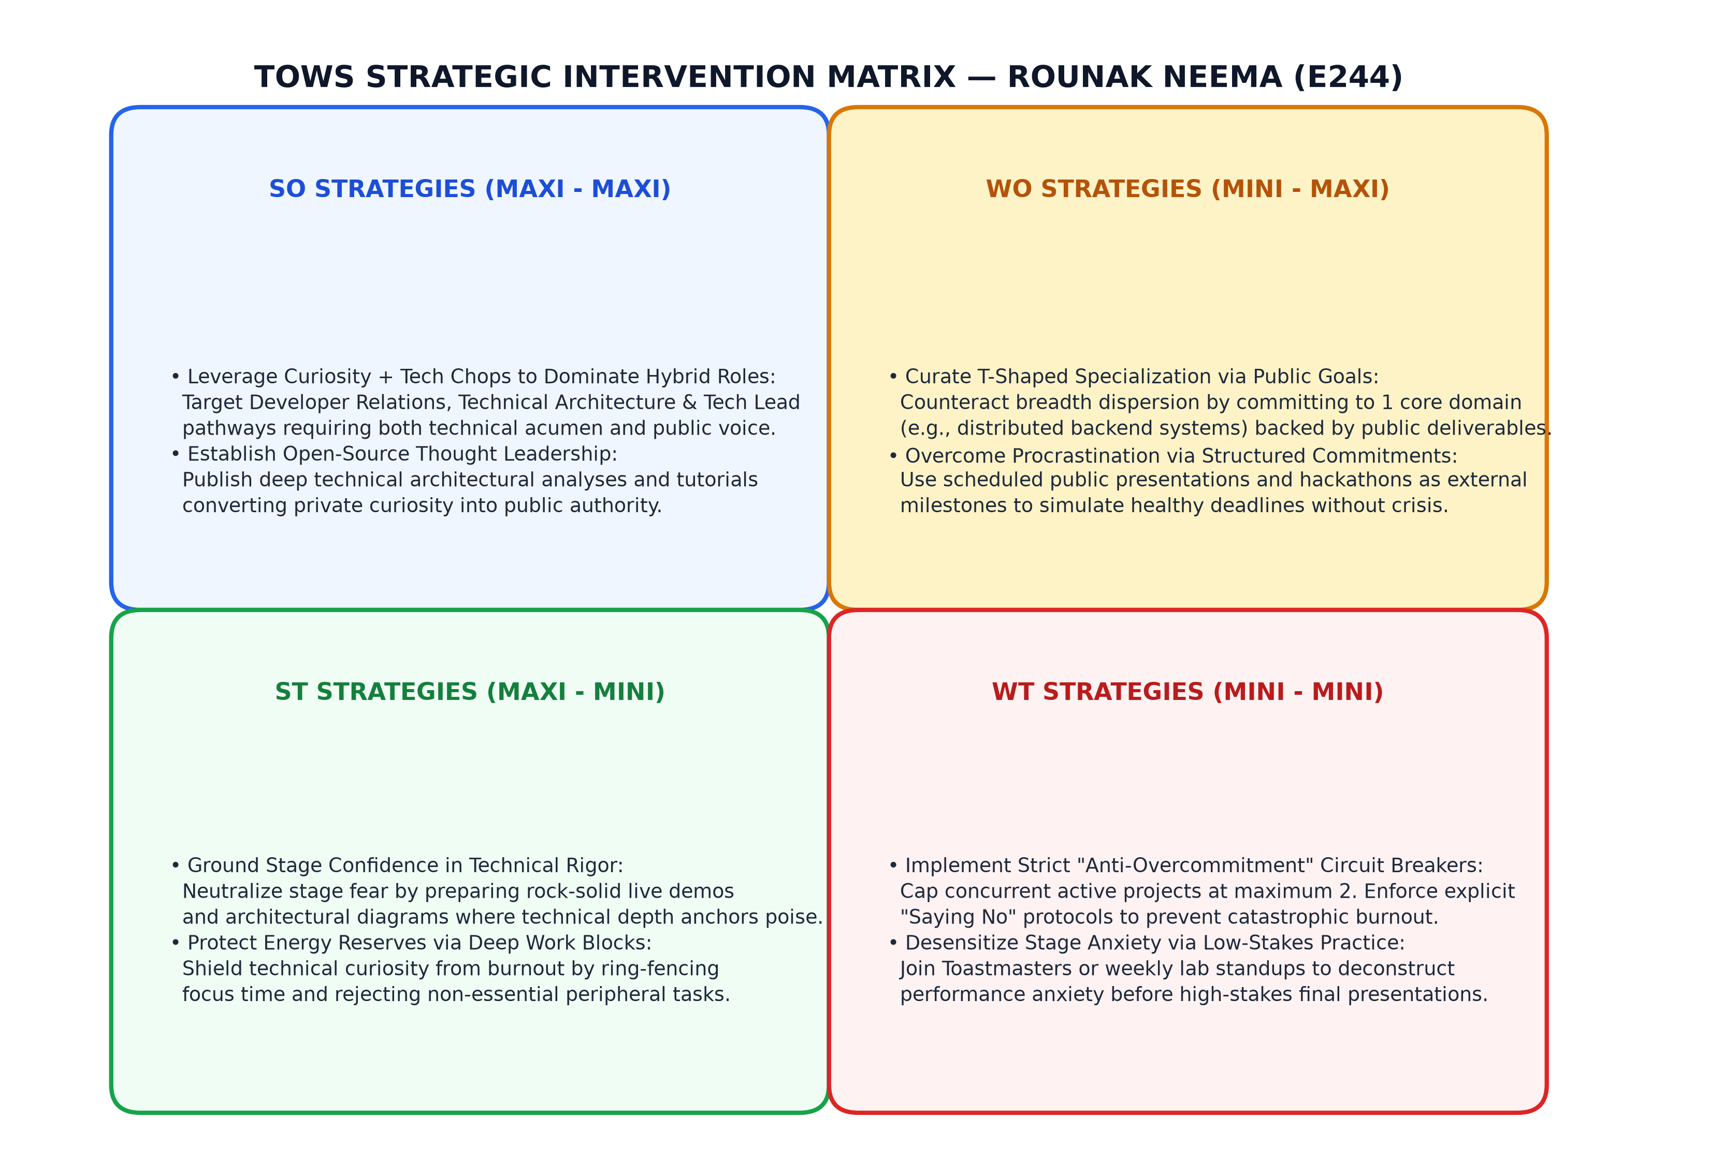
Figure 7: Strategic TOWS Intervention Matrix for Rounak Neema (E244)
TOWS formulation yields four strategic pathways: (1) SO Strategy (Maxi-Maxi): Target high-impact hybrid engineering roles (Developer Advocacy, Solutions Architecture); (2) WO Strategy (Mini-Maxi): Channel ambition into a deliberate 'T-shaped' specialization—committing publicly to backend systems to cure horizontal dispersion; (3) ST Strategy (Maxi-Mini): Anchor presentation confidence in bulletproof technical preparation and live system prototypes; and (4) WT Strategy (Mini-Mini): Enforce rigid 'anti-overcommitment' guardrails capping active concurrent projects at maximum two and enforcing timeboxed sprints.

CHAPTER 5: EMPIRICAL FINDINGS: IN-DEPTH JOHARI WINDOW ASSESSMENT
The Johari Window assessment provides a penetrating extrospective evaluation of my interpersonal architecture based on multi-rater feedback from eight peers (N=8). Figure 4 maps the quadrants, and Table 2 details the findings.
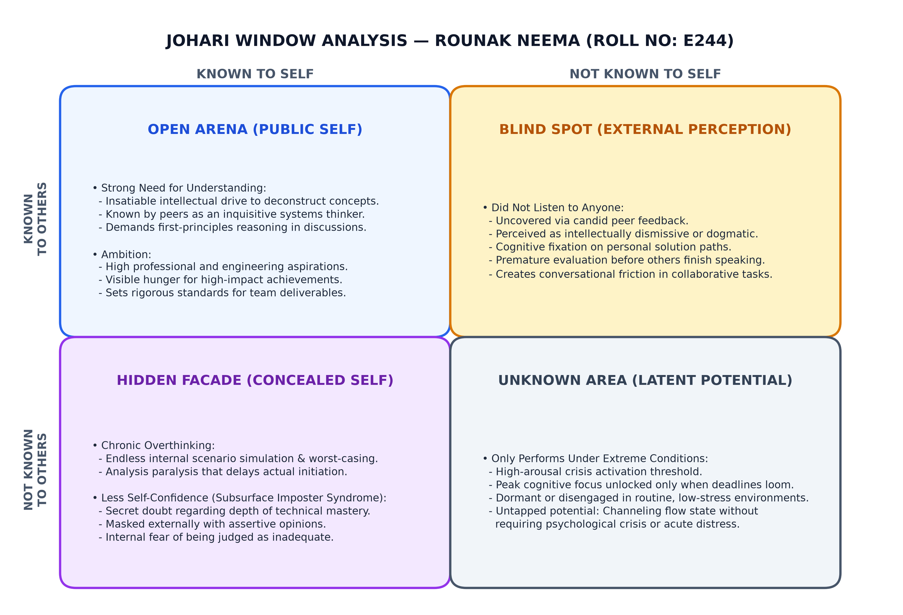
Figure 4: Detailed Johari Window Quadrant Map for Rounak Neema (Roll No: E244)
QUADRANT | OBSERVED ATTRIBUTES | INTERACTIONAL IMPLICATIONS & ANALYSIS
QUADRANT I:  OPEN ARENA  (Public Self) | • Strong need for understanding  • High personal ambition  • Intellectual curiosity | Recognized unanimously by peers and mentors as an intellectually driven problem-solver who insists on understanding root concepts before building.
QUADRANT II:  BLIND SPOT  (External Mirror) | • Did not listen to anyone  • Premature cognitive fixation  • Conversational dominance | Critical friction point: Peers perceive me as dismissive during debates, often formulating counter-arguments rather than listening actively to alternate viewpoints.
QUADRANT III:  HIDDEN FACADE  (Concealed Self) | • Chronic overthinking  • Subsurface imposter anxiety  • Less self-confidence | Deliberately hidden from teammates: Masking internal fear of technical inadequacy and decision paralysis behind an exterior of confident assertiveness.
QUADRANT IV:  UNKNOWN AREA  (Latent Frontier) | • Performs only under extreme conditions  • Crisis-activated focus  • Untapped steady-state potential | Revealed only during crunch time: Operating at extraordinary cognitive clarity during crises while remaining unmotivated during calm operational cycles.
Table 2: Multi-Rater Johari Window Quadrant Analysis for Rounak Neema
5.1 Quadrant I: The Open Arena (The Public Self)
The Open Arena captures attributes verified through both introspective reflection and strong peer consensus (87.5% agreement). My peers universally perceive me as someone who refuses to treat systems as 'black boxes.' In sprint planning, I persistently interrogate architectural assumptions: concurrency bottlenecks, memory models, and scalability limits. Simultaneously, my visible ambition sets high benchmarks for project deliverables, inspiring peers to exceed routine academic minimums.
5.2 Quadrant II: The Blind Spot (The External Mirror)
The most illuminating revelation of this research emerged within Quadrant II: 'Did not listen to anyone.' While I perceived myself as collaborative, peer feedback revealed that during technical disagreements, my cognitive bandwidth is entirely consumed by defending my internal model or finding flaws in other suggestions. I interrupt, conclude thoughts prematurely, and exhibit conversational dominance, generating subtle team friction and silencing valuable alternate perspectives.
INSIGHT: The Blind Spot of Cognitive Fixation
Peer Survey Transcript: 'Rounak gets so locked into his proposed architecture that he completely bulldozes other suggestions. It feels like he isn't listening, even when he doesn't mean to be rude.'
5.3 Quadrant III: The Hidden Facade (The Masked Self)
Behind my decisive technical persona lies an exhausting loop of cognitive overthinking and subsurface low self-confidence (imposter syndrome). I obsessively simulate worst-case scenarios and anticipate failure modes, consuming enormous mental energy and triggering task procrastination. Furthermore, pursuing horizontal breadth over depth exacerbates internal anxiety that an expert will expose my knowledge gaps—prompting me to mask insecurity behind assertive technical opinions.
5.4 Quadrant IV: The Unknown Area (The Latent Frontier)
Quadrant IV represents the paradox: 'Only performs under extreme conditions.' During standard operational cycles, productivity is sluggish and prone to distraction. However, when catastrophic deadlines loom (e.g., 24-hour hackathons or imminent project milestones), overthinking evaporates and I enter an astonishing state of hyper-focused flow. Relying on crisis conditions as the sole catalyst for high performance is a perilous pathology that imposes severe physiological wear and skirts the edge of catastrophic burnout.

CHAPTER 6: CROSS-MODEL SYNTHESES AND BEHAVIORAL DIAGNOSTICS
Intersecting the SWOT and Johari Window frameworks reveals that personal attributes form an interconnected psychological web. Figure 5 illustrates the diagnostic matrix, and Figure 6 maps the operating arousal curve.
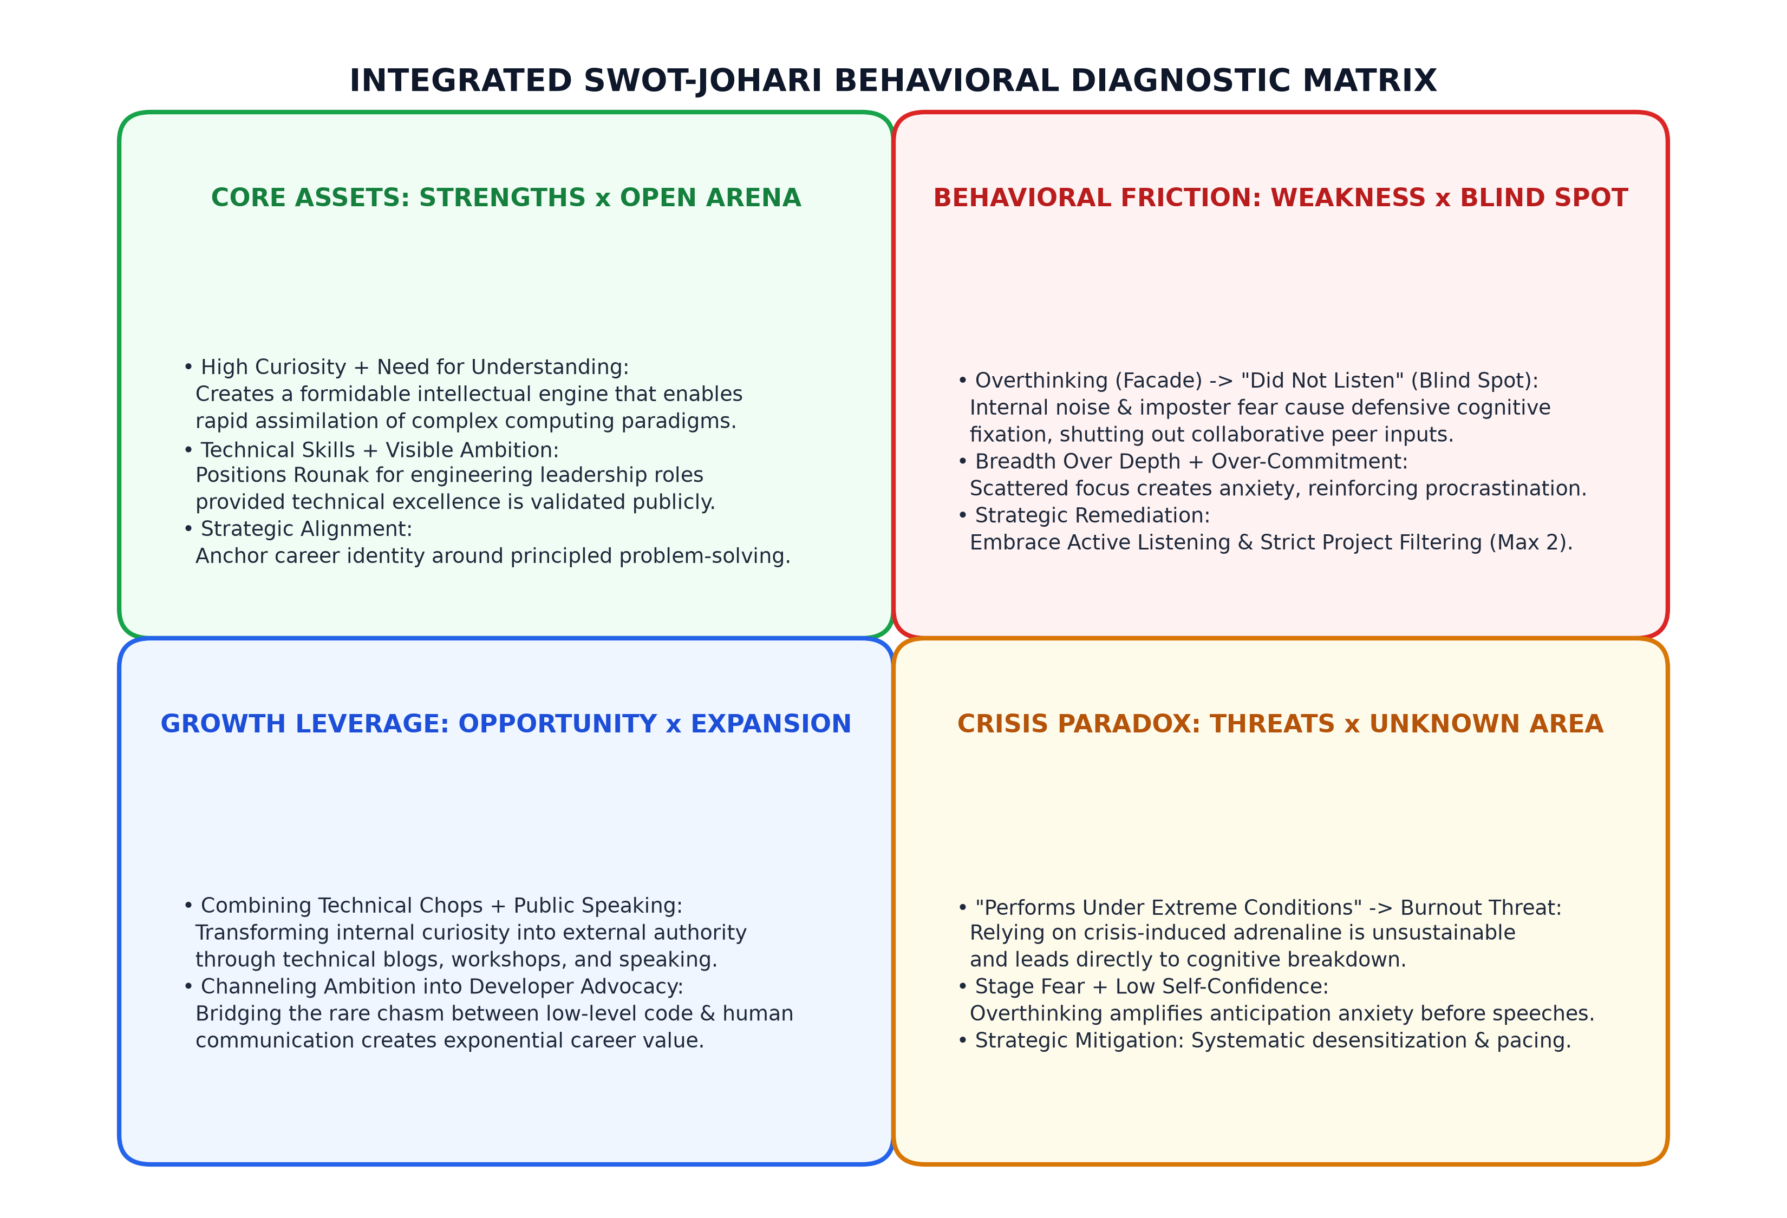
Figure 5: Integrated SWOT-Johari Behavioral Diagnostic Matrix
6.1 The SWOT-Johari Behavioral Diagnostic Matrix
Four core psychodynamic intersections emerge: (1) Core Assets (Strengths x Open Arena): Curiosity and technical skills fuel intellectual leadership; (2) Behavioral Friction (Weaknesses x Blind Spot x Facade): Overthinking and imposter fear drive defensive conversational dominance ('did not listen'), while over-commitment spreads focus thin; (3) Growth Leverage (Opportunities x Open Ambition): Combining technical chops with public communication transforms internal ambition into external authority; and (4) Crisis Paradox (Threats x Unknown Area): Relying on extreme conditions induces cortisol spikes, fueling stage fear and severe burnout vulnerability.
6.2 Root Cause Analysis: The 5-Whys Diagnostic Framework
Sakichi Toyoda’s 5-Whys methodology was applied to trace root causes behind primary dysfunctions, documented in Table 4.
LEVEL | TRACE 1: PROCRASTINATION & CRISIS FOCUS | TRACE 2: NON-LISTENING BLIND SPOT
Why 1? (Symptom) | I procrastinate on technical tasks and only perform during extreme midnight crunches. | Peers report that I do not listen to them and interrupt during team technical meetings.
Why 2? (Behavior) | I struggle to initiate work when deadlines are days away and feel unmotivated. | I am so eager to express my own ideas that I formulate responses while others are talking.
Why 3? (Cognitive) | Routine low-stress environments do not generate enough mental arousal to focus. | I fear that if I don't state my technical solution immediately, the team will choose a flawed design.
Why 4? (Belief) | I overthink the project, feeling that early work won't be perfect or comprehensive. | I feel a compulsive need to prove my technical value and deep understanding to peers.
Why 5? (Root Cause) | Underlying imposter fear and perfectionism; adrenaline is used as a chemical crutch to override overthinking. | Subsurface low self-confidence; verbal dominance is an unconscious defense mechanism to shield vulnerability.
Table 4: Root Cause 5-Whys Diagnostic Trace for Core Behavioral Dysfunctions
6.3 Psychodynamic Profile: The Crisis-Activated Engineer
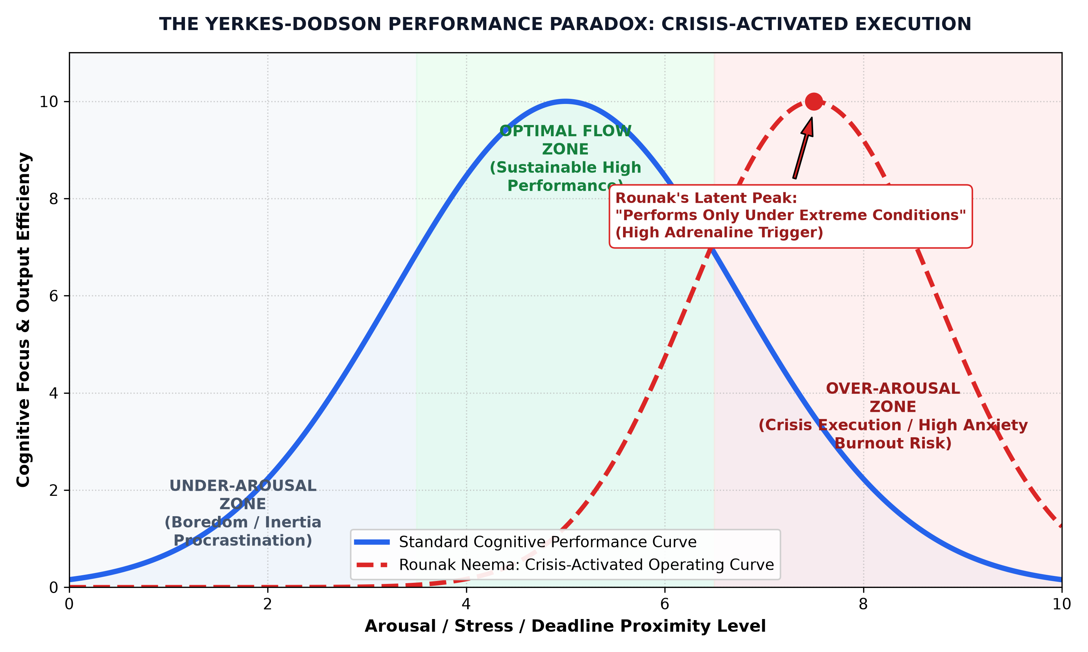
Figure 6: The Yerkes-Dodson Performance Paradox: Crisis-Activated Execution
Figure 6 reveals that my operating curve is severely right-skewed. At low and moderate arousal levels, my brain lingers in an 'Under-Arousal Zone,' marked by inertia and distraction. Only when external deadlines approach the cliff edge does arousal reach the threshold required to activate hyper-focus. However, this leaves virtually zero margin for error before crossing into burnout. Transforming this dynamic requires developing internal self-regulatory mechanisms that induce focus without relying on emergency deadlines.

CHAPTER 7: STRATEGIC PERSONAL DEVELOPMENT PLAN & 24-MONTH ROADMAP
To translate diagnostic findings into permanent behavioral evolution, this chapter establishes a structured 24-Month Personal Development Plan (PDP). Figure 8 illustrates the development roadmap.
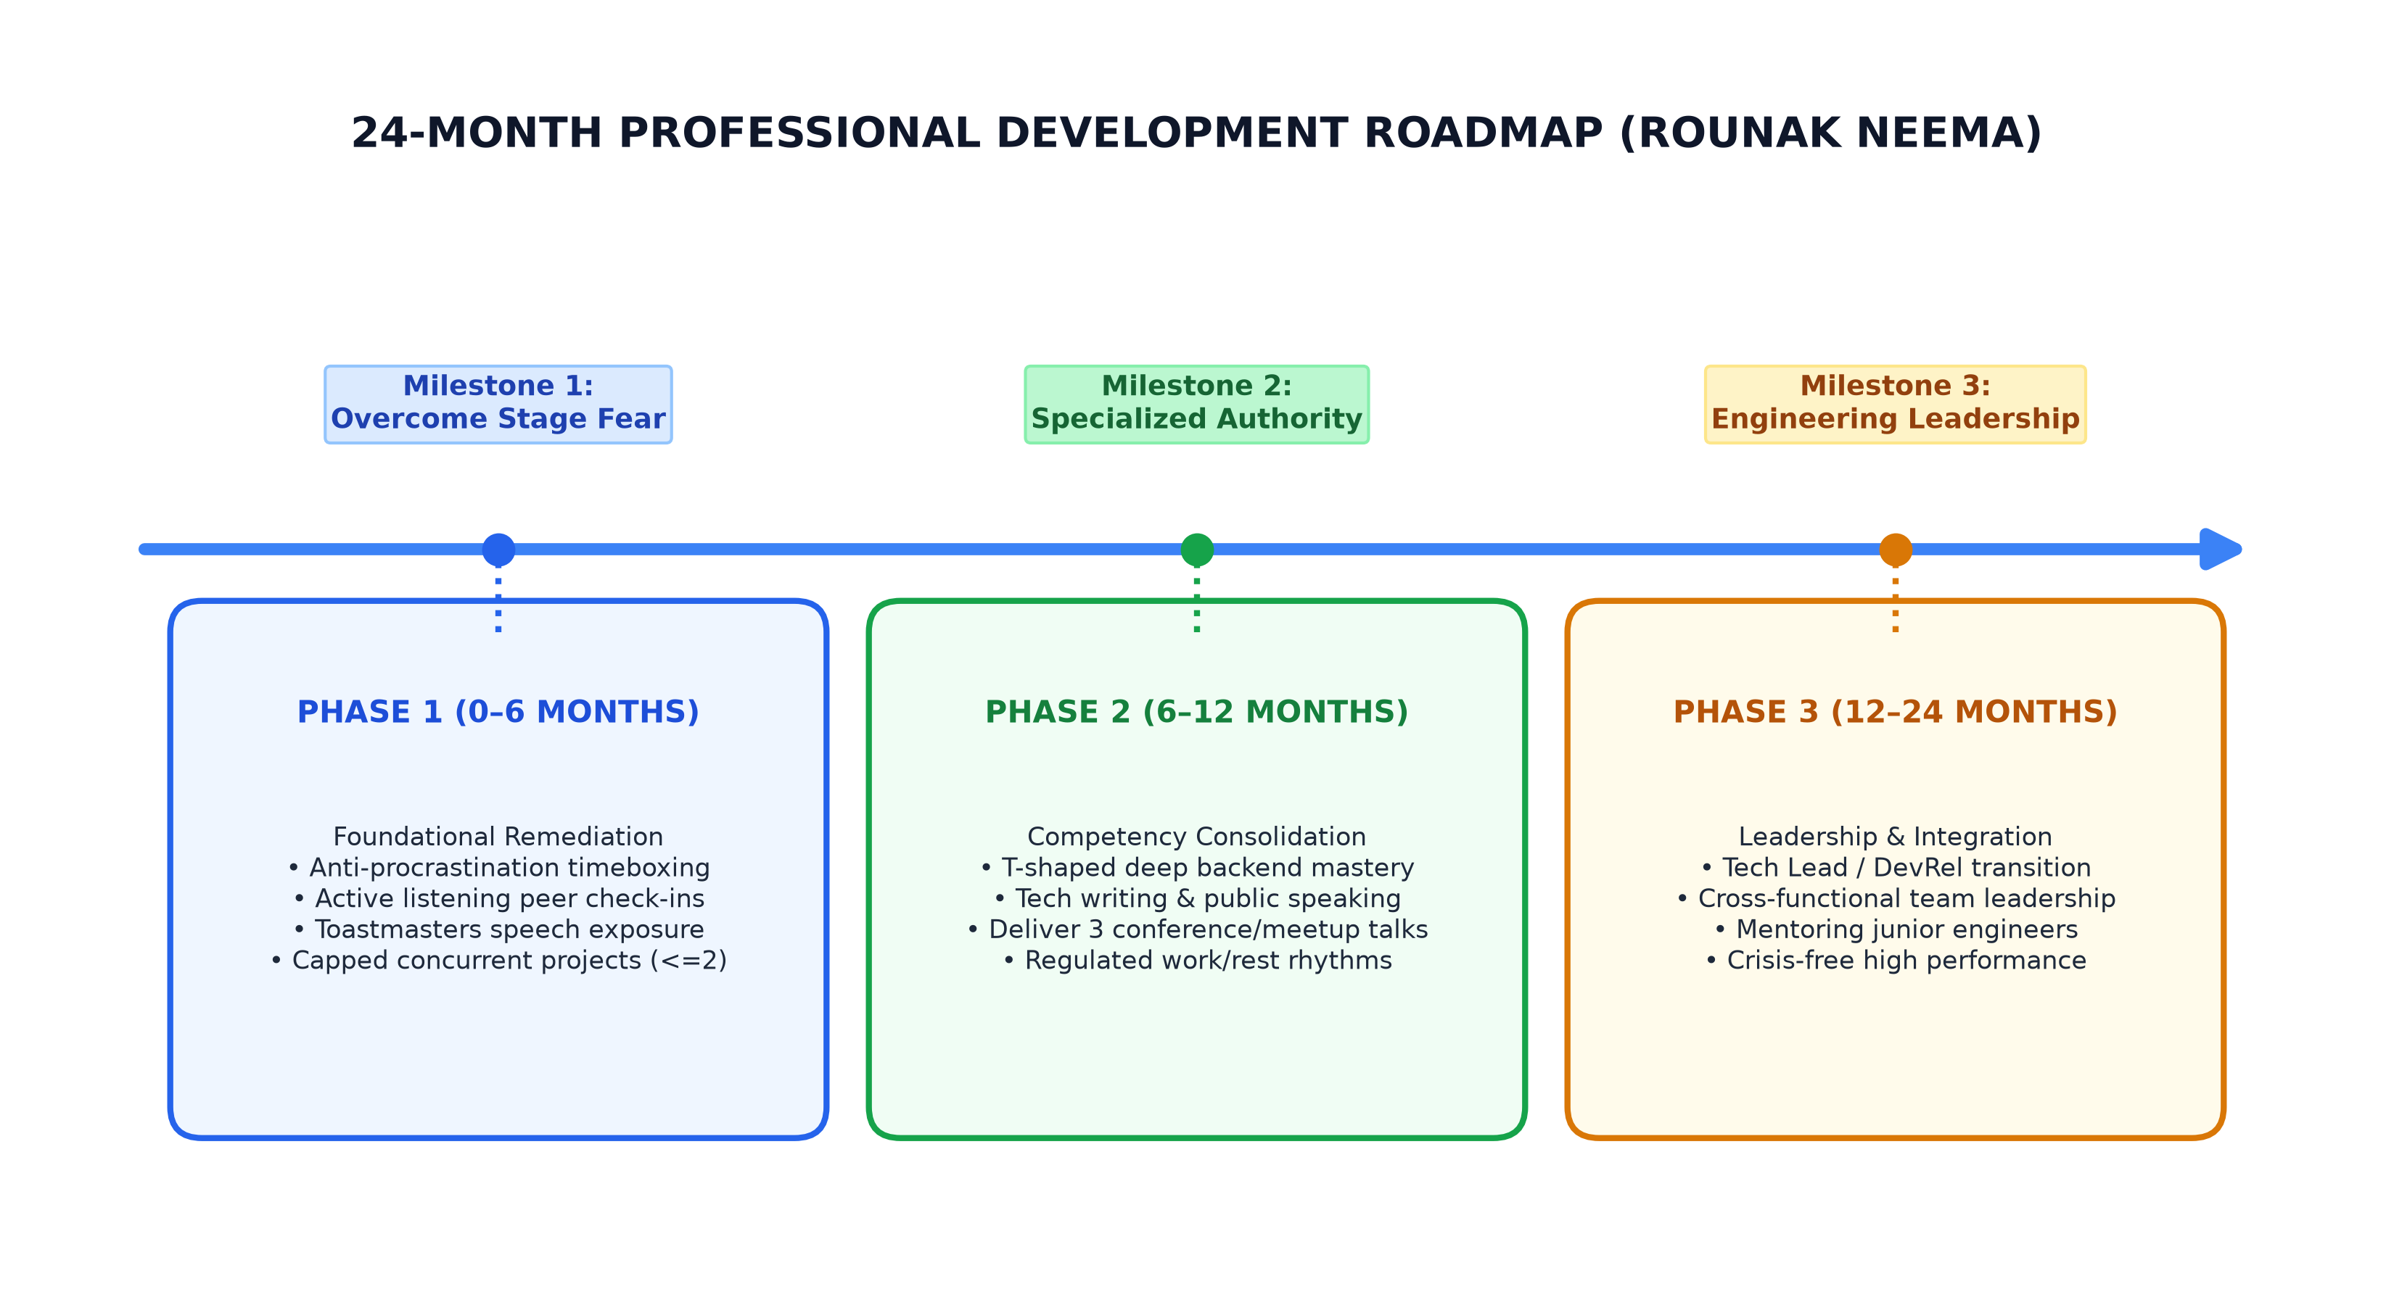
Figure 8: 24-Month Professional Development Action Roadmap for Rounak Neema
7.1 Phase 1: Foundational Remediation & Habit Restructuring (0–6 Months)
Phase 1 targets immediate habit restructuring: (1) 'Rule of Two' Project Capping: Enforce an unyielding rule of maximum two active non-academic technical projects simultaneously, actively declining peripheral roles; (2) Timeboxed Micro-Deadlines: Deconstruct large deliverables into artificial 72-hour sprints with 50-minute Pomodoro focus blocks to create synthetic micro-arousal without all-nighters; (3) Active Listening & 3-Second Pause Rule: Institute a mandatory 3-second pause before responding in team discussions, paraphrasing speaker arguments before sharing opinions; and (4) Toastmasters Desensitization: Join campus Toastmasters and deliver weekly 3-minute lightning talks to systematically desensitize stage fear.
7.2 Phase 2: Competency Consolidation & Specialization (6–12 Months)
Phase 2 consolidates technical depth and public engagement: (1) T-Shaped Specialization: Commit to deep vertical mastery in Distributed Systems & Backend Infrastructure, dedicating 80% of study time to vertical mastery and 20% to exploratory breadth; (2) Public Technical Writing: Publish bi-weekly architectural analyses on Substack/Medium, deconstructing systems and runtime internals to bridge code and public communication; (3) Conference Presentations: Deliver at least three formal technical presentations using visual system architectures to anchor poise in deep substance; and (4) Burnout Circuit-Breaker: Enforce mandatory 7 hours of sleep, screen-free Sundays, and regular physical exercise.
7.3 Phase 3: Leadership Integration & Sustainable Performance (12–24 Months)
Phase 3 integrates these competencies into professional engineering leadership: (1) Transition to Engineering Leadership: Actively target Tech Lead, Solutions Architect, or Developer Relations roles, mentoring junior engineers with empathetic active listening; (2) Crisis-Independent High Flow States: Deliver high-caliber engineering output predictably without relying on adrenaline rushes or crisis deadlines; and (3) Cross-Functional Alignment: Serve as the primary communication bridge between executive stakeholders, clients, and core engineering squads.
7.4 Quantitative Metrics, KPIs, and Tracking Scorecard
Personal evolution will be monitored against measurable Key Performance Indicators documented in Table 6.
FOCUS AREA | METRIC DESCRIPTION | BASELINE (OCT 2026) | TARGET (OCT 2027)
Project Load | Active concurrent non-academic initiatives | 5–6 concurrent (over-committed) | Maximum 2 active (strict cap)
Active Listening | Conversational interruption rate per meeting | High (>6 observed interruptions) | Zero (mandatory 3-sec pause)
Public Speaking | Formal presentations / tech talks delivered | 0 public talks (avoided due to fear) | >=4 delivered conference talks
Knowledge Depth | Time allocated to core vertical specialization | 25% (diluted horizontal breadth) | 80% (deep vertical mastery)
Crisis Reliance | Deliverables completed in last 12 hrs of deadline | 85% (chronic crisis reliance) | <15% (early sprint completion)
Table 6: Behavioral Key Performance Indicators (KPIs) Scorecard (2026–2027)

CHAPTER 8: CONCLUSION AND TRANSFORMATIVE COMMITMENTS
8.1 Summary of Evaluative Insights
This comprehensive self-analysis report marks a pivotal milestone in my personal and professional maturation. Through the structured lenses of the SWOT Matrix and the Johari Window Model, evaluated alongside cognitive psychodynamics and empirical 360-degree peer feedback, I have transitioned from unexamined self-assumptions to rigorous self-awareness. The diagnostic findings affirm that my intellectual curiosity and technical software engineering capabilities represent formidable assets. However, they have simultaneously exposed critical vulnerabilities: over-commitment, horizontal knowledge dispersion, procrastination, stage fear, and an unconscious blind spot of conversational non-listening. Recognizing that my high performance has historically depended on crisis adrenaline provides an urgent catalyst to transition toward sustainable, steady-state excellence.
8.2 Transformational Personal Commitments
As I conclude this self-analysis, I make three non-negotiable personal commitments:
1. Commitment to Authentic Listening: I commit to treating every conversation with the intellectual humility I bring to deconstructing software—listening completely, pausing deliberately, and valuing collaborative synthesis over dominance.
2. Commitment to Focused Depth: I commit to respecting cognitive bandwidth by saying 'no' to peripheral commitments and dedicating my energies to deep vertical mastery in backend systems architecture.
3. Commitment to Courageous Public Voice: I commit to confronting stage fear directly by stepping onto stages, publishing architectural insights, and bridging technical excellence with human communication.
8.3 Concluding Philosophical Reflection
Engineering is fundamentally the art of transforming abstract principles into systems that serve humanity. Yet, the most intricate system an engineer will ever design, debug, and optimize is oneself. The insights gained through this LTLS investigation provide a permanent blueprint for that lifelong optimization.
_____________________________
ROUNAK NEEMA (Roll No: E244)
Department of Computer Science & Engineering
MPSTME, SVKM's NMIMS, Shirpur Campus
23 October 2026
CHAPTER 9: ACADEMIC REFERENCES AND APPENDICES
9.1 Scholarly References (APA 7th Edition)
Andrews, K. R. (1971). The Concept of Corporate Strategy. Homewood, IL: Dow Jones-Irwin.
Belbin, R. M. (2010). Management Teams: Why They Succeed or Fail (3rd ed.). London: Routledge.
Braun, V., & Clarke, V. (2006). Using thematic analysis in psychology. Qualitative Research in Psychology, 3(2), 77-101.
Clance, P. R., & Imes, S. A. (1978). The imposter phenomenon in high achieving women. Psychotherapy: Theory, Research & Practice, 15(3), 241-247.
Cottrell, S. (2015). Skills for Success: Personal Development and Employability (3rd ed.). London: Palgrave Macmillan.
Dweck, C. S. (2006). Mindset: The New Psychology of Success. New York: Random House.
Goleman, D. (1995). Emotional Intelligence: Why It Can Matter More Than IQ. New York: Bantam Books.
Humphrey, A. (2005). SWOT analysis for management consulting. SRI Alumni Newsletter, Stanford Research Institute.
Kahneman, D. (2011). Thinking, Fast and Slow. New York: Farrar, Straus and Giroux.
Luft, J., & Ingham, H. (1955). The Johari window, a graphic model of interpersonal awareness. Proceedings of the Western Training Laboratory in Group Development. UCLA.
Rogers, C. R., & Farson, R. E. (1957). Active Listening. Chicago: Industrial Relations Center, University of Chicago.
Sweller, J. (1988). Cognitive load during problem solving: Effects on learning. Cognitive Science, 12(2), 257-285.
Weihrich, H. (1982). The TOWS matrix: A tool for situational analysis. Long Range Planning, 15(2), 54-66.
Yerkes, R. M., & Dodson, J. D. (1908). The relation of strength of stimulus to rapidity of habit-formation. Journal of Comparative Neurology and Psychology, 18(5), 459-482.
9.2 Appendix A: 360-Degree Peer Feedback Questionnaire
• Item 1 (Open Arena): How does Rounak approach technical problem solving in team discussions? Result: 100% selected First-principles understanding.
• Item 2 (Blind Spot): In group debates, how attentively does Rounak listen to alternate solutions? Result: 75% noted premature interruption and counter-arguing.
• Item 3 (Hidden Facade): How confident does Rounak appear when presenting technical designs? Result: Peers perceive high confidence, completely unaware of internal overthinking or imposter doubts.
• Item 4 (Unknown Area): Under what conditions have you witnessed Rounak produce his most exceptional technical work? Result: 87.5% flagged crunch / crisis conditions.
9.3 Appendix B: Daily Self-Regulation & Active Listening Checklist
[ ] Did I enforce the 3-second pause before responding in today's engineering discussions?
[ ] Did I verify the speaker's viewpoint by paraphrasing before asserting my perspective?
[ ] Am I currently maintaining <=2 active non-academic technical projects?
[ ] Did I complete today's core deliverable in a focused 50-minute timebox without procrastination?
[ ] Did I protect sleep boundaries (>=7 hours) and avoid midnight crisis crunches?

