

**SWP391 – Software development project**

### ARTIX

Version: 1.0



**ARTWORK SHARING PLATFORM**

– Ho Chi Minh, January 2024 –

|  |  |  |
| --- | --- | --- |
| **STT** | **Fullname** | **MSSV** |
| 1 | Nguyễn Dương Gia Bảo | SE171697 |
| 2 | Huỳnh Thiện Nhân | SE171117 |
| 3 | Trần Ánh Tuyết | SE170234 |
| 4 | Nguyễn Minh Thức | SE170592 |
| 5 | Phạm Minh Triều | SE172937 |

# 

**1.2 Database:**

#### 1.2.1 Database schema

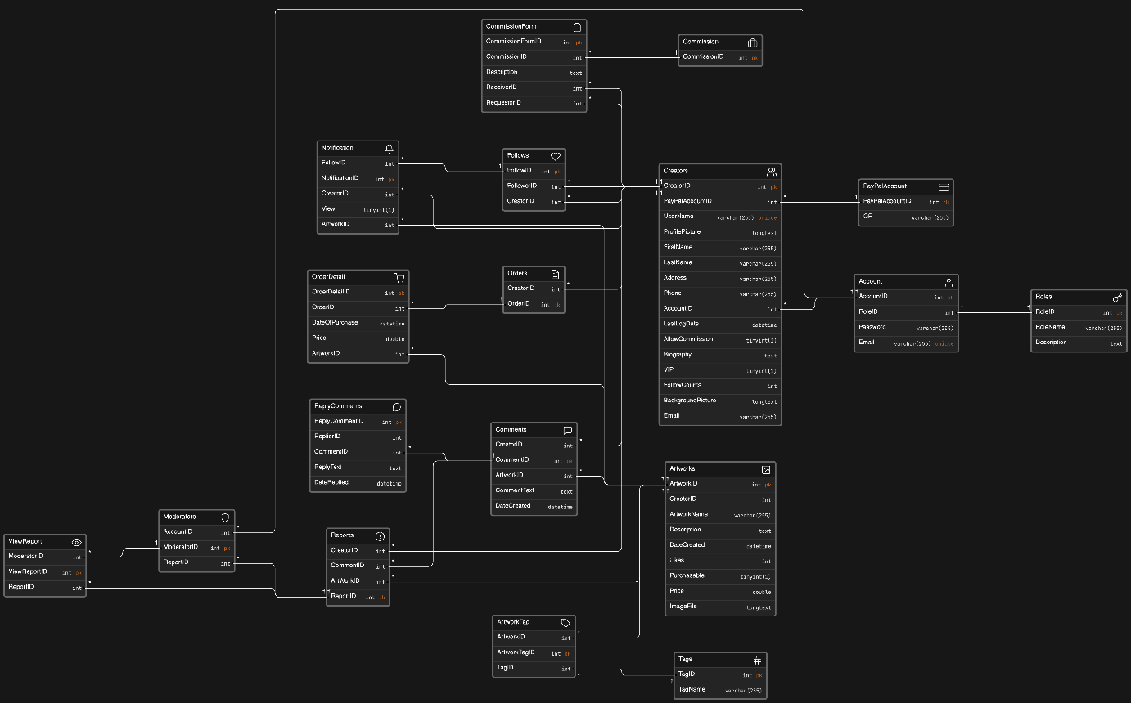

#### 1.2.2 Database tables

1. Artworks

|  |  |  |  |  |  |  |
| --- | --- | --- | --- | --- | --- | --- |
| **Field name** | **Type** | **Size** | **Unique** | **Not Null** | **PK/FK** | **Note** |
| ArtwordID | Integer | 32 | X | X | PK |  |
| CreatorID | Integer | 32 | X | X | FK |  |
| ArtworkName | Varchar | 255 |  |  |  |  |
| Description | Text | 255 |  |  |  | More detail of this Artwork |
| DateCreated | DateTime | 8 |  | X |  |  |
| Likes | Integer | 32 |  |  |  | Start from 0 |
| Purchasable | TinyInt | 1 |  |  |  |  |
| Price | Double | 32 |  |  |  | Price of the artworks if it is purchasable |
| ImageFile | Long Text | 255 | X | X |  | File image of Artwork |

2. Creators

|  |  |  |  |  |  |  |
| --- | --- | --- | --- | --- | --- | --- |
| **Field name** | **Type** | **Size** | **Unique** | **Not Null** | **PK/FK** | **Notes** |
| CreatorID | Integer | 32 | X | X | PK |  |
| AccountId | Integer | 32 | X | X | FK |  |
| PaypalAccountID | Integer | 32 |  | X | FK | Account for creators to receive money |
| UserName | Varchar | 255 | X | X |  |  |
| ProfilePicture | LongText | MAX |  |  |  | Creator's profile picture |
| FirstName | Varchar | 255 |  | X |  |  |
| LastName | Varchar | 255 |  | X |  |  |
| Address | Varchar | 255 |  |  |  |  |
| Phone | Varchar | 255 |  |  |  |  |
| LasrLogDate | DateTime | 8 |  | X |  | Last time logged in to the web of creator |
| AllowCommission | TinyInt | 1 |  |  |  |  |
| Biography | Text | MAX |  |  |  | More info about this Artis |
| FollowCounts | Integer | 32 |  |  |  | Number of Follower on this Artist |
| BackgroundPicture | LongText | MAX |  |  |  |  |
| Email | Varchar | 255 |  |  |  |  |
| VIP | TinyInt | 1 |  |  |  |  |

1. Account

|  |  |  |  |  |  |  |
| --- | --- | --- | --- | --- | --- | --- |
| **Field name** | **Type** | **Size** | **Unique** | **Not Null** | **PK/FK** | **Notes** |
| AccountID | Integer | 32 | X | X | PK |  |
| RoleID | Integer | 32 | X | X | FK |  |
| Password | Varchar | 255 |  | X |  |  |
| Email | Varchar | 255 |  | X |  |  |

1. Roles

|  |  |  |  |  |  |  |
| --- | --- | --- | --- | --- | --- | --- |
| **Field name** | **Type** | **Size** | **Unique** | **Not Null** | **PK/FK** | **Notes** |
| RoleID | Integer | 32 | X | X | PK |  |
| RoleName | Varchar | 255 |  | X | FK |  |
| Description | Text | MAX |  |  |  | More information about what the role can do |

1. Tags

|  |  |  |  |  |  |  |
| --- | --- | --- | --- | --- | --- | --- |
| **Field name** | **Type** | **Size** | **Unique** | **Not Null** | **PK/FK** | **Notes** |
| TagID | Integer | 32 | X | X | PK |  |
| TagName | Varchar | 255 |  | X | FK |  |

1. Follows

|  |  |  |  |  |  |  |
| --- | --- | --- | --- | --- | --- | --- |
| **Field name** | **Type** | **Size** | **Unique** | **Not Null** | **PK/FK** | **Notes** |
| FollowID | Integer | 32 | X | X | PK |  |
| FollowerID | Integer | 32 | X |  | FK |  |
| CreatorID | Integer | 32 | X |  | FK |  |

1. PaypalAccount

|  |  |  |  |  |  |  |
| --- | --- | --- | --- | --- | --- | --- |
| **Field name** | **Type** | **Size** | **Unique** | **Not Null** | **PK/FK** | **Notes** |
| PayPalAccount | Integer | 32 | X | X | PK |  |
| CreatorID | Integer | 32 |  | X | FK |  |
| QR | Varchar | 255 | X | X |  | Customer scan this QR to pay for creator |

1. Comment

|  |  |  |  |  |  |  |
| --- | --- | --- | --- | --- | --- | --- |
| **Field name** | **Type** | **Size** | **Unique** | **Not Null** | **PK/FK** | **Notes** |
| CommentID | Integer | 32 | X | X | PK |  |
| CreatorID | Integer | 32 | X | X | FK |  |
| ArtworkID | Integer | 32 | X | X | FK |  |
| CommentText | Text | MAX |  | X |  | Where user use to chat or comment on the artist's Artwork |
| DateCreated | Datetime | 8 |  | X |  | The date the user commented on Artwork |

1. Report

|  |  |  |  |  |  |  |
| --- | --- | --- | --- | --- | --- | --- |
| **Field name** | **Type** | **Size** | **Unique** | **Not Null** | **PK/FK** | **Notes** |
| ReportID | Integer | 32 | X | X | PK |  |
| CreatorID | Integer | 32 | X | X | FK |  |
| ArtworkID | Integer | 32 | X | X | FK |  |
| CommentID | Integer | 32 | X | X | FK |  |

1. Moderator

|  |  |  |  |  |  |  |
| --- | --- | --- | --- | --- | --- | --- |
| **Field name** | **Type** | **Size** | **Unique** | **Not Null** | **PK/FK** | **Notes** |
| ModeratorID | Integer | 32 | X | X | PK |  |
| ReportID | Integer | 32 | X | X | FK |  |
| AccountID | Integer | 32 | X | X | FK |  |

1. Notification

|  |  |  |  |  |  |  |
| --- | --- | --- | --- | --- | --- | --- |
| **Field name** | **Type** | **Size** | **Unique** | **Not Null** | **PK/FK** | **Notes** |
| NotificationID | Integer | 32 | X | X | PK |  |
| FollowID | Integer | 32 | X | X | FK |  |
| CreatorID | Integer | 32 | X | X | FK |  |
| ArtworkID | Integer | 32 | X | X | FK |  |
| View | TinyIny | 1 |  |  |  |  |

1. ViewReport

|  |  |  |  |  |  |  |
| --- | --- | --- | --- | --- | --- | --- |
| **Field name** | **Type** | **Size** | **Unique** | **Not Null** | **PK/FK** | **Notes** |
| ModeratorID | Integer | 32 | X | X | FK |  |
| ReportID | Integer | 32 | X | X | FK |  |
| ViewReportID | Integer | 32 | X | X | PK |  |

1. Orders

|  |  |  |  |  |  |  |
| --- | --- | --- | --- | --- | --- | --- |
| **Field name** | **Type** | **Size** | **Unique** | **Not Null** | **PK/FK** | **Notes** |
| OrderID | Integer | 32 | X | X | PK |  |
| CreatorID | Integer | 32 | X | X | FK |  |

1. OrderDetail

|  |  |  |  |  |  |  |
| --- | --- | --- | --- | --- | --- | --- |
| **Field name** | **Type** | **Size** | **Unique** | **Not Null** | **PK/FK** | **Notes** |
| OrderDetailID | Integer | 32 | X | X | PK |  |
| OrderID | Integer | 32 | X | X | FK |  |
| ArtworkID | Integer | 32 | X | X | FK |  |
| DateOfPurchase | Datetime | 8 |  | X |  | Date purchase the Artwork |
| Price | Double | 32 |  | X |  | Price of Artwork |

1. Commission

|  |  |  |  |  |  |  |
| --- | --- | --- | --- | --- | --- | --- |
| **Field name** | **Type** | **Size** | **Unique** | **Not Null** | **PK/FK** | **Notes** |
| CommissionID | Integer | 32 | X | X | PK |  |

1. CommissionForm

|  |  |  |  |  |  |  |
| --- | --- | --- | --- | --- | --- | --- |
| **Field name** | **Type** | **Size** | **Unique** | **Not Null** | **PK/FK** | **Notes** |
| CommissionFormID | Integer | 32 | X | X | PK |  |
| CommissionID | Integer | 32 | X | X | FK |  |
| ReceiverID | Integer | 32 | X | X | FK |  |
| RequestorID | Integer | 32 | X | X | FK |  |
| Description | TinyInt | 1 |  |  |  | The detail User want for Arkwork |
| Accept | TinyInt | 1 |  |  |  | The Artist accept the commission of User |

1. ArtworkTag

|  |  |  |  |  |  |  |
| --- | --- | --- | --- | --- | --- | --- |
| **Field name** | **Type** | **Size** | **Unique** | **Not Null** | **PK/FK** | **Notes** |
| ArtworkTagID | Integer | 32 | X | X | FK |  |
| ArtworkID | Integer | 32 | X | X | FK |  |
| TagID | Integer | 32 | X | X | PK |  |

1. ReplyComments

|  |  |  |  |  |  |  |
| --- | --- | --- | --- | --- | --- | --- |
| **Field name** | **Type** | **Size** | **Unique** | **Not Null** | **PK/FK** | **Notes** |
| ReplyCommentID | Integer | 32 | X | X | FK |  |
| ReplierID | Integer | 32 | X | X | FK |  |
| CommentID | Integer | 32 | X | X | PK |  |
| ReplyText | Text | MAX |  |  |  | Artist relies the comments of user |
| DateReplied | DateTime | 8 |  |  |  |  |