
RUNGTA COLLEGE OF ENGINEERING AND TECHNOLOGY
MINOR PROJECT REPORT
CITY/AREA CLUSTERING
Grouping cities by socio-economic, infrastructure,
environmental and quality-of-life characteristics

Submitted by
Student Name | ERP Number
Roushan Kumar | 6606702
Ankit Raj | 6605891
Abhishek Kumar | 6605787
Mintu Kumar | 6605890
Anushri Patel | 6605714

Department: ______________________________
Academic Session: _________________________
Submitted to: _____________________________

Abstract
This minor project applies unsupervised machine learning to group cities with similar characteristics. The City Lifestyle Segmentation Dataset contains 300 synthetic city profiles and eight numerical indicators: population density, average income, internet penetration, average rent, air-quality index, public-transport score, happiness score and green-space ratio. The workflow includes exploratory data analysis, feature scaling using StandardScaler, selection of a suitable cluster count using the Elbow Method and Silhouette Score, K-Means clustering, PCA-based visualization and interpretation of cluster profiles. The final reported solution contains three clusters with 85, 143 and 72 cities respectively. Because the dataset is synthetic, the findings demonstrate a clustering workflow for educational purposes and should not be treated as measured conclusions about real cities.

1. Introduction
Cities and urban areas differ in population density, affordability, digital access, transport, environmental conditions and quality of life. Comparing every area individually can be difficult. Clustering is an unsupervised learning technique that groups observations with similar feature patterns without requiring predefined labels. This project uses K-Means to organize city profiles into groups that can be compared and interpreted.

2. Problem Statement
To group cities/areas having similar characteristics using numerical indicators related to population, income, housing, facilities, environment and quality of life, applying feature scaling and the K-Means clustering algorithm.

3. Objectives
- Understand and summarize the city dataset using descriptive statistics and visualizations.
- Examine feature distributions and correlations.
- Scale numerical features so variables with large ranges do not dominate distance calculations.
- Evaluate candidate cluster counts using the Elbow Method and Silhouette Score.
- Apply K-Means and visualize the discovered groups using PCA and feature-based plots.
- Profile the resulting clusters and describe their distinguishing characteristics.

4. Dataset Description
The project uses the Kaggle dataset titled “City Lifestyle Segmentation Dataset.” Its documentation describes 300 simulated global cities across six geographic regions. The CSV is reported as approximately 300 rows by 10 columns, with two identifier columns and eight numerical features. The dataset is synthetic; city labels and measurements are generated for educational clustering analysis rather than collected as verified observations of actual cities.
Feature | Description | Role in analysis
city_name | City identifier | Display/reference only
country | Region/country category in dataset | Display/reference only; excluded from distance calculation
population_density | Population per square kilometre | Clustering feature
avg_income | Average monthly household income (USD) | Clustering feature
internet_penetration | Internet access percentage | Clustering feature
avg_rent | Average monthly rent (USD) | Clustering feature
air_quality_index | Air quality index; lower values indicate cleaner air in the dataset description | Clustering feature
public_transport_score | Public transportation score | Clustering feature
happiness_score | Subjective happiness/life-satisfaction score | Clustering feature
green_space_ratio | Percentage of city area covered by green space | Clustering feature

The prescribed project fields map to the dataset as follows: population is represented by population density; income by average income; housing by average rent; and facilities by public-transport score and internet penetration. Environmental and quality-of-life features provide additional dimensions for comparing areas.

5. Methodology

5.1 Data understanding and preprocessing
The CSV is loaded into a Pandas DataFrame and inspected using shape, column names, data types, descriptive statistics, missing-value counts and duplicate checks. The two identifier columns are retained for reporting but excluded from the numerical clustering matrix. The eight numerical features are selected for model development. Any missing numerical values, if present, are filled with their column medians; duplicate rows are removed.

5.2 Feature scaling
StandardScaler transforms each selected feature to approximately zero mean and unit variance. This is important because income, rent and population density use different numerical ranges from happiness and percentage-based features. K-Means uses distances, so scaling reduces the chance that large-scale variables dominate the result.

5.3 Exploratory data analysis
Histograms summarize the distributions of the eight features. A correlation heatmap displays pairwise linear relationships, while an income-versus-rent scatter plot illustrates how housing cost varies with income. These visualizations help understand the dataset before clustering and are not used as labels for the unsupervised model.

5.4 Selecting the number of clusters
Candidate values of K from 2 through 10 were evaluated. The Elbow Method compares K-Means inertia, the sum of squared distances from samples to their assigned cluster centres. The Silhouette Score measures how well-separated and compact the clusters are; higher values are generally preferable. The final reported model uses K = 3. The choice should be justified by the plotted metrics together with the interpretability and sizes of the resulting clusters, rather than by a metric alone.

5.5 K-Means and PCA
K-Means assigns each scaled observation to one of K clusters by iteratively updating cluster centres and assignments. PCA is then applied to the scaled feature matrix to project the eight-dimensional observations into two dimensions for visualization. PCA is a visualization step here; the clustering itself is performed on the scaled eight-feature matrix, not on the two PCA components.

6. Results and Discussion
The final reported K-Means output contains three clusters covering all 300 city profiles. Cluster numbers are arbitrary identifiers and do not imply a ranking. The descriptive labels below are interpretations of the standardized feature profile, not official categories.
Cluster | Number of cities | Share of dataset | Interpretation from profile
Cluster 0 | 85 | 28.3% | Lower average income, internet penetration, rent, transport score and happiness than the dataset mean; population density is slightly below average.
Cluster 1 | 143 | 47.7% | Higher average income, internet penetration, rent and happiness; air-quality index is below average, indicating relatively better air quality under the dataset's definition.
Cluster 2 | 72 | 24.0% | Much higher population density and air-quality index, above-average transport score, lower happiness and lower green-space ratio.

These summaries are based on the supplied standardized cluster-characteristics heatmap. Cluster 0 can be described as a lower-income/lower-cost profile, Cluster 1 as a higher-income and higher-rent profile, and Cluster 2 as a denser profile with less green space and a higher air-quality index. These names are concise interpretations, not ground-truth classifications.

6.1 Correlation analysis
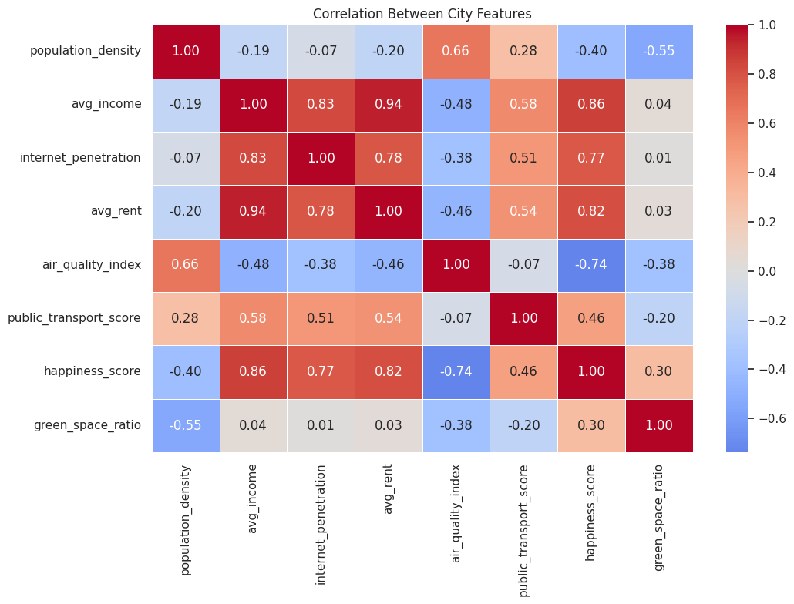
Figure 1. Correlation heatmap of the eight numerical city features.
The supplied heatmap shows a strong positive correlation between average income and average rent (0.94), and between average income and happiness score (0.86). Average income is also positively associated with internet penetration (0.83). Population density has a positive correlation with air-quality index (0.66) and a negative correlation with green-space ratio (-0.55). Correlation indicates association, not causation.

6.2 Choosing K
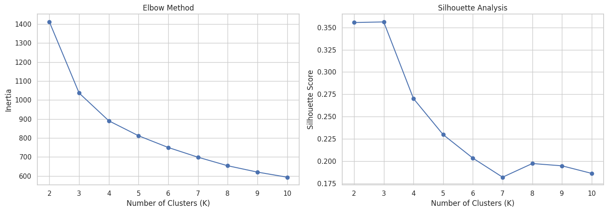
Figure 2. Elbow curve and silhouette scores for candidate cluster counts.
The supplied silhouette plot places K = 3 at or near the highest score among the tested values, while the inertia curve decreases as K increases. The diminishing reduction in inertia and the interpretability of three profiles support the reported three-cluster solution. The silhouette scores for K = 2 and K = 3 appear very close, so K = 3 should also be defended by its more informative segmentation and the resulting cluster profiles.

6.3 PCA visualization
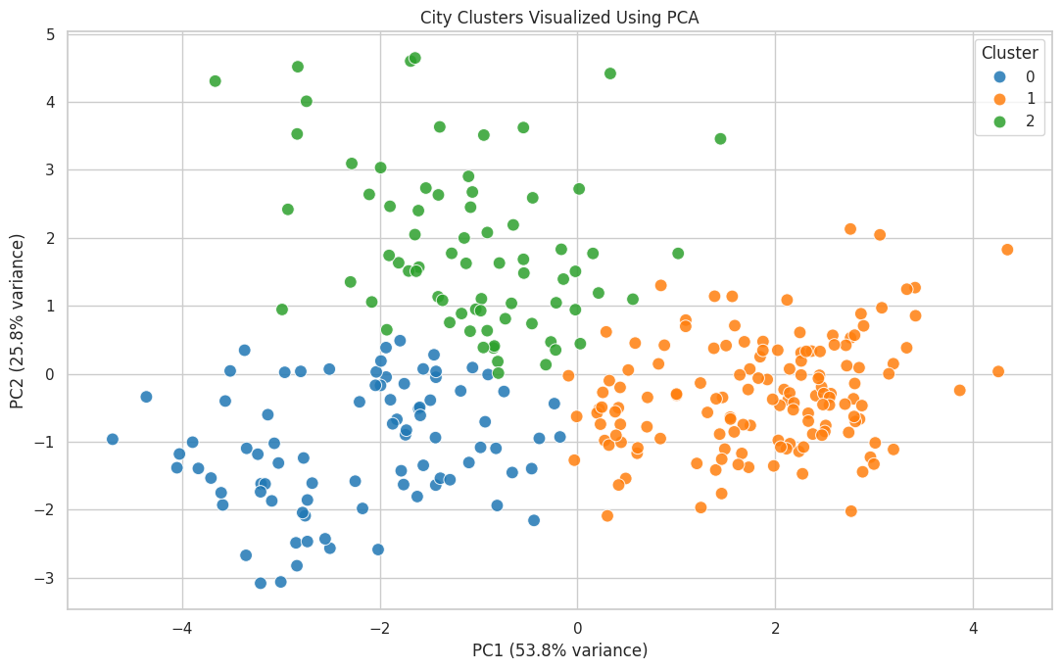
Figure 3. City cluster assignments projected onto the first two principal components.
The PCA plot displays the three assigned groups in two dimensions. The supplied axis labels show that PC1 explains 53.8% of the variance and PC2 explains 25.8%, for approximately 79.6% combined. Some overlap is expected because the visualization compresses eight dimensions into two.

6.4 Cluster characteristics
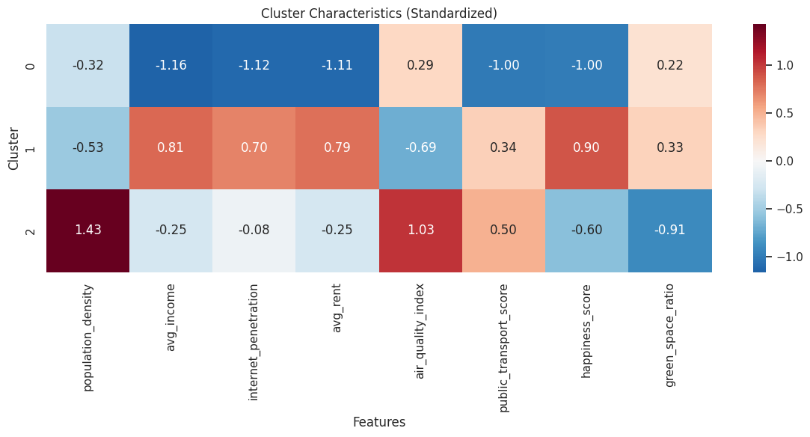
Figure 4. Mean standardized feature values for each cluster.
The heatmap makes relative differences easier to compare. Positive values indicate that a cluster's mean for a feature is above the overall scaled mean; negative values indicate below-average values. The air-quality index requires careful interpretation because a higher index represents worse air quality in the dataset documentation.

6.5 Income and housing comparison
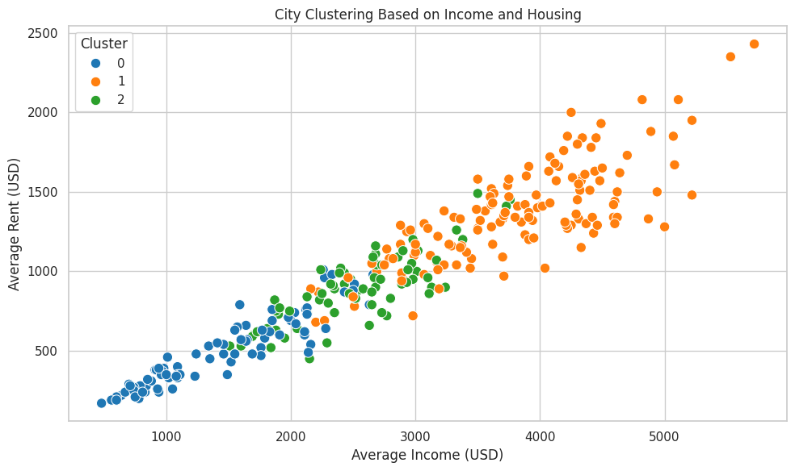
Figure 5. Average income versus average rent, coloured by the assigned cluster.
The scatter plot shows that rent generally rises with income in this synthetic dataset. The higher-income cluster occupies much of the upper-right region, while lower-income and intermediate profiles occupy lower portions of the chart. This two-feature plot is intuitive, but the final clusters were produced using all eight scaled numerical features.

6.6 Example city assignments
The following examples are taken from the final output provided for this report. They illustrate the city identifiers and cluster assignments; the city names and values belong to the synthetic dataset.
City name | Dataset region | Average income (USD) | Average rent (USD) | Cluster
Bridge | Europe | 2660 | 980 | 0
Harborshire | Europe | 1850 | 760 | 0
Old Vista | Europe | 3850 | 1310 | 1
North Falls | Europe | 4640 | 1620 | 1
Woodshire | Europe | 2350 | 740 | 2
Riverford | Asia | 3170 | 1070 | 2

7. Evaluation and Limitations
- The Elbow Method and Silhouette Score provide complementary guidance for choosing K; neither should be interpreted as a guarantee that a single K is objectively correct.
- The PCA plot is a two-dimensional projection and may not show all separations present in the original eight-dimensional feature space.
- K-Means favours compact, roughly spherical groups and can be affected by outliers and feature selection.
- The dataset is synthetic. The clusters demonstrate a machine-learning workflow and should not be presented as evidence about actual cities or used for real urban-policy decisions.
- The country field is used for descriptive comparison only; it is not encoded into the K-Means input in this implementation.

8. Conclusion
This project demonstrates a complete unsupervised learning workflow for City/Area Clustering. Eight numerical features were selected, scaled, explored and used with K-Means. The reported solution groups the 300 synthetic city profiles into three clusters of 85, 143 and 72 observations. PCA, a standardized cluster-profile heatmap and an income-versus-rent plot help explain how the groups differ. The main outcome is a reproducible method for grouping areas with similar characteristics, while the synthetic nature of the data is acknowledged as an important limitation.

9. Tools and Technologies
Tool / Library | Purpose
Google Colab | Cloud-based notebook environment
Python | Programming language
Pandas and NumPy | Data handling and numerical operations
Matplotlib and Seaborn | Charts and exploratory visualizations
Scikit-learn | StandardScaler, K-Means, evaluation metrics and PCA

References
1. UmutUygurr, “City Lifestyle Segmentation Dataset,” Kaggle. Dataset description and README supplied for this project.
2. Scikit-learn documentation: StandardScaler, KMeans, silhouette_score, davies_bouldin_score and PCA.
3. Course/project specification: City/Area Clustering — group areas having similar characteristics using population, income, facilities, housing, scaling and K-Means.

