NFC INSTITUTE OF ENGINEERING AND TECHNOLOGY
Department of Computer Science

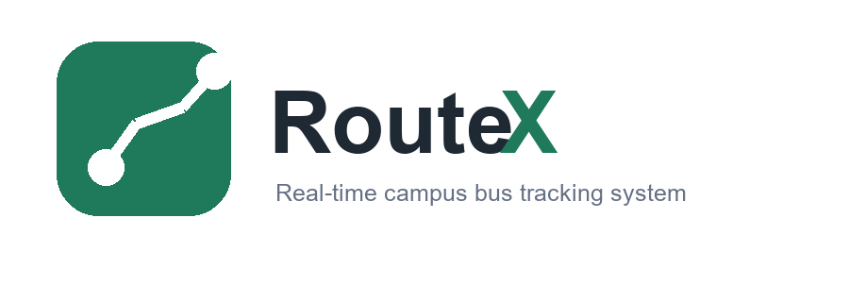
RouteX
Real-Time Campus Bus Tracking System
Final Year Project Report
Submitted By
[Group Member 1 Name] [Roll No.]
[Group Member 2 Name] [Roll No.]
[Group Member 3 Name] [Roll No.]
Supervisor: [Supervisor Name]
Session: 2025-2026

Acknowledgements
We begin this project in the name of Allah, the Wisest and All Knowing. We are thankful to NFC Institute of Engineering and Technology, the Department of Computer Science, our Head of Department, and our respected supervisor for guidance and support throughout the development of RouteX. We also acknowledge the cooperation of our classmates and families who encouraged us during analysis, design, development, and testing.

Undertaking
We undertake that the requirement gathering and analysis, design, development, testing, and documentation of RouteX have been conducted methodically by our project team. The work presented in this report is original to the best of our knowledge and has been prepared for academic evaluation as a Final Year Project.
FINAL YEAR PROJECT UNDERTAKING FORM: Attach the signed institute form here.

Abstract
RouteX is a real-time campus bus tracking frontend designed to improve visibility, safety, and communication in university transport operations. The system provides role-based access for administrators, students, parents, and drivers. Administrators can monitor live buses, routes, fleet status, drivers, students, alerts, and operational summaries. Students and parents can view route information, bus arrival status, digital pass information, and notifications. Drivers can access trip checklists, route stops, and rider manifests. RouteX is built using Angular, Angular Material, PrimeNG, Tailwind CSS, TypeScript, and Leaflet-ready mapping support. The project follows an iterative Agile Scrum process so that each module can be designed, implemented, tested, and improved separately. The outcome is a responsive and user-friendly transport management interface for safer and more organized campus travel.

Logo
RouteX project logo

Contents
Right-click this area in Microsoft Word and choose Update Field / Update Table after final editing.
Chapter 1: Introduction
Chapter 2: Existing System
Chapter 3: Software Process Model
Chapter 4: Proposed System
Chapter 5: System Design
Chapter 6: Development
Chapter 7: Software Testing
Chapter 8: Implementation and Training
Conclusion
References

List of Figures
Figure 1.1: RouteX workflow and project planning overview
Figure 3.1: Agile Scrum / Iterative SDLC model used in RouteX
Figure 5.1: RouteX login interface
Figure 5.2: RouteX admin live tracking interface
Figure 5.3: RouteX student mobile interface
Figure 5.4: ER diagram of RouteX
Figure 5.5: DFD Level 0 of RouteX
Figure 5.6: DFD Level 1 of RouteX
Figure 5.7: DFD Level 2 of tracking process
Figure 5.8: Activity diagram with swimlanes
Figure 5.9: Class diagram of RouteX
Figure 5.10: Sequence diagram for login and dashboard flow
Figure 5.11: Software architectural block diagram

List of Tables
Table 2.1: Existing systems and feature comparison
Table 2.2: Functional requirements
Table 2.3: Non-functional requirements
Table 4.1: Stakeholder profiles
Table 4.2: Project priorities
Table 6.1: Hardware tools
Table 6.2: Software tools and technologies
Table 7.1: Black box test cases

CHAPTER 1
INTRODUCTION

1.1 Domain
The domain of RouteX is intelligent transport management and real-time campus mobility. It focuses on the digital management of university bus operations through a responsive web-based frontend.

Subdomain
The subdomain is real-time bus tracking, route monitoring, student transport safety, and role-based transport communication.

1.2 Problem Statement
Campus transport systems often depend on manual updates, phone calls, and fixed notices. Students and parents may not know the live position of a bus, administrators may struggle to monitor delays, and drivers may not have a centralized digital workflow for trips and rider information. RouteX solves this problem by presenting live tracking, route status, fleet information, role-based mobile views, and notifications in one unified interface.

1.3 Motivation
The motivation behind RouteX is to reduce uncertainty in daily campus travel. A real-time tracking interface helps transport staff make faster decisions, helps students reach stops on time, allows parents to monitor safety, and gives drivers a clearer operational workflow.

1.4 Definition of Terms
Term | Definition
ETA | Estimated Time of Arrival for a bus at the next stop.
Role Guard | Frontend route protection allowing users to access only their role screens.
Fleet | The set of buses available in the transport system.
Route | A planned path consisting of multiple stops.
Manifest | The list of students/riders assigned to a driver or route.
Notification | An alert or message about route, delay, or transport status.

1.5 Workflow
The project workflow started from requirement gathering and continued through UI design, component development, integration, testing, and documentation.
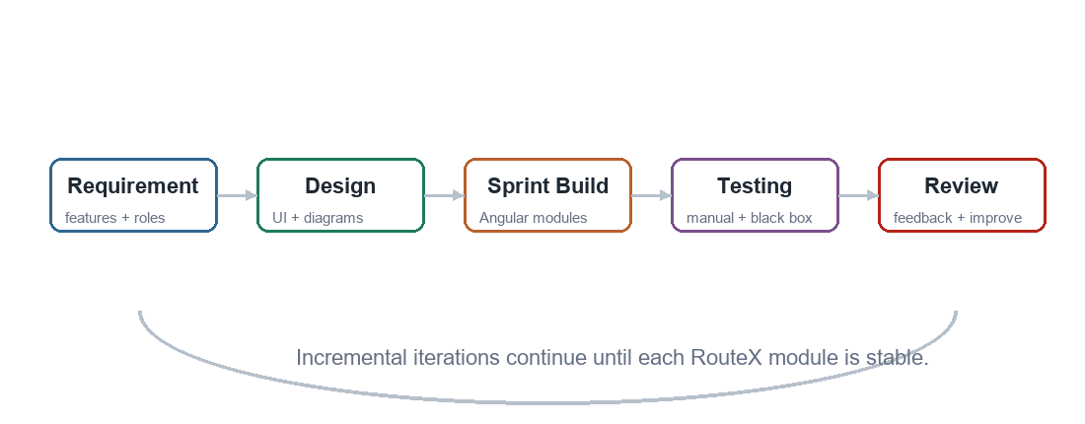
Figure 1.1: RouteX workflow and project planning overview

1.6 Goal of Project
- Provide a modern frontend for campus bus tracking and transport operations.
- Support multiple user roles: admin, student, parent, and driver.
- Display live tracking, bus status, route load, fleet data, and transport notifications.
- Improve communication between transport office, students, parents, and drivers.
- Create a responsive system that works on desktop and mobile screens.

CHAPTER 2
EXISTING SYSTEM

2.1 Relative Work
Several existing systems provide navigation, ride tracking, or fleet management. However, many are general-purpose navigation tools or commercial fleet platforms. RouteX focuses specifically on campus transport, student safety, and role-based academic transport workflows.

2.2 Existing Systems and Their Features
Existing System | Link / Source | Main Features | Limitation Compared to RouteX
Google Maps | https://maps.google.com | Navigation, route directions, traffic view | Not designed for university fleet, student pass, parent monitoring, or driver manifests.
Uber / Careem | Mobile ride-hailing apps | Live driver tracking, ETA, trip status | Focused on private rides, not campus buses or institutional transport.
Fleetio | https://www.fleetio.com | Fleet maintenance and vehicle management | Less student and parent centered.
TransLoc | https://transloc.com | Transit tracking and passenger information | RouteX is customized for FYP campus workflows and role-based portals.

2.3 Novelty
- Role-based single frontend for admin, student, parent, and driver.
- Campus-focused tracking with routes, stops, riders, and alerts.
- Admin dashboard combines operational KPIs, route load, fleet, drivers, students, and notifications.
- Mobile role previews show student pass, parent alerts, and driver checklist workflows.
- A clean modern UI tailored for repeated daily transport operations.

2.4 Solution Available in RouteX
RouteX provides a centralized frontend where the admin can monitor buses, routes, drivers, students, and alerts. Students can view bus arrival and digital pass information. Parents can monitor child travel status and receive alerts. Drivers can prepare for trips using checklists and view route/manifest information.

2.5 Software Requirements Specification

User Interfaces
- Login interface with role selection.
- Admin workspace with sidebar, topbar, live tracking, dashboard, routes, fleet, drivers, students, notifications, and settings.
- Student mobile interface with route status, digital pass, and stops.
- Parent portal for child trip monitoring and messages.
- Driver app for pre-trip checklist, manifest, and route progress.

Hardware Interfaces
Hardware | Minimum Requirement
Processor | Intel Core i3 or equivalent
RAM | 4 GB minimum, 8 GB recommended
Storage | 500 MB free for project files and browser cache
Display | 1366 x 768 desktop display; mobile responsive view supported
Internet | Required for map/API-based live deployment

Software Interfaces
Software | Use in RouteX
Angular 21 | Frontend framework for component-based development.
TypeScript | Typed programming language for Angular components and services.
Angular Router | Role-based screen navigation.
Angular Material | Icons, buttons, and UI controls.
PrimeNG / PrimeIcons | Additional UI components and icon support.
Tailwind CSS | Utility-based styling support.
Leaflet | Map rendering and route visualization support.
RxJS | Reactive state and event handling.
Vitest / Angular testing tools | Frontend unit and behavior testing.

Functional Requirements
ID | Requirement
FR-01 | The system shall allow a user to log in using role selection.
FR-02 | The system shall redirect users to screens according to their role.
FR-03 | The system shall allow the admin to view live bus tracking.
FR-04 | The system shall display route details, bus status, driver, next stop, ETA, capacity, speed, and battery.
FR-05 | The system shall allow filtering buses by route and status.
FR-06 | The system shall display operational dashboard KPIs.
FR-07 | The system shall display route, fleet, driver, and student information.
FR-08 | The system shall display notifications and alert status.
FR-09 | The system shall provide student, parent, and driver mobile role views.
FR-10 | The system shall support session storage and UI feedback.

Use Cases
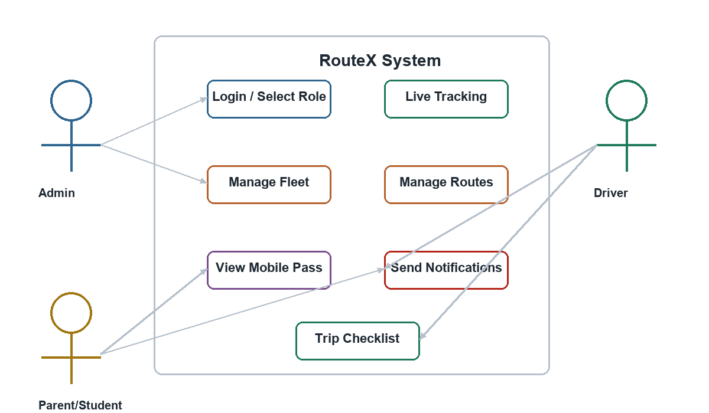
Use case diagram of RouteX

Requirement Shells
Requirement | Description | Rationale | Fit Criterion
Role-based login | User selects admin, student, parent, or driver role. | Each stakeholder needs different screens. | User is redirected to correct role page after login.
Live tracking | Admin views bus status and route positions. | Transport office needs operational visibility. | Bus cards and map pins display current route data.
Notifications | System displays delay, arrival, and system alerts. | Users need timely transport communication. | Unread and read notifications are visible with status.
Driver checklist | Driver completes pre-trip checks before starting trip. | Improves safety and readiness. | Trip start is enabled when checklist is complete.

Non-Functional Requirements
ID | Requirement
NFR-01 | The interface shall be responsive on desktop and mobile screens.
NFR-02 | The design shall be simple, consistent, and user friendly.
NFR-03 | The system shall protect routes using role-based guards.
NFR-04 | The UI shall load quickly using optimized Angular build output.
NFR-05 | The frontend code shall be modular and maintainable.
NFR-06 | The system shall work on modern browsers such as Chrome, Edge, and Firefox.
NFR-07 | The system shall provide clear visual feedback for important actions.
NFR-08 | The system shall be extendable for backend and live GPS API integration.

CHAPTER 3
SOFTWARE PROCESS MODEL

3.1 Software Process Model
RouteX followed the Agile Scrum / Iterative model. The project was divided into small increments such as login, admin tracking, dashboard, management screens, mobile role apps, notifications, and settings. Each increment was designed, developed, tested, and improved.

3.2 Proposed Model with Diagram
Figure 3.1: Agile Scrum / Iterative SDLC model used in RouteX

Reason
- The interface required repeated UI and UX improvement.
- Modules could be developed independently and integrated step by step.
- Testing could be performed after each feature was completed.
- Teacher/supervisor feedback could be included in later iterations.
- The model reduces risk because problems are found early.

3.3 Implementation of Agile Scrum
Sprint / Phase | Work Achieved
Sprint 1 | Requirement analysis, roles, route planning, and project scope.
Sprint 2 | Login screen, role selection, authentication service, and route guards.
Sprint 3 | Admin workspace, sidebar, topbar, and live tracking screen.
Sprint 4 | Dashboard KPIs, routes, fleet, drivers, students, and notification screens.
Sprint 5 | Student, parent, and driver mobile role apps.
Sprint 6 | UI polishing, responsive checks, testing, documentation, and presentation preparation.

CHAPTER 4
PROPOSED SYSTEM

4.1 Need for the Proposed System
A campus transport system needs accurate visibility of buses, drivers, students, route status, and alerts. Manual communication creates delays and confusion. RouteX is needed because it gives each stakeholder a role-specific view of transport operations and allows the transport office to respond faster to route changes or delays.

4.2 Features of Proposed System
- Role-based login and guarded navigation.
- Admin live tracking screen for active, delayed, and idle buses.
- Operational dashboard with ridership, on-time rate, trips, and alerts.
- Route, fleet, driver, and student management views.
- Notification center for delay, arrival, maintenance, and system alerts.
- Student app with bus arrival, route stops, and digital pass information.
- Parent portal with child trip monitoring and alerts.
- Driver app with trip checklist, manifest, and route progress.
- Responsive interface for desktop and mobile screens.

4.3 Business Context
From a business point of view, RouteX can help an educational institute reduce transport complaints, improve safety communication, and make better use of buses and drivers. The system can support transport offices in monitoring service quality and responding to delays before they become larger issues.

4.3.1 Advantages in Business
- Improves trust between institute, parents, and students.
- Reduces manual phone calls and repeated status inquiries.
- Supports better route planning and fleet utilization.
- Improves operational transparency for the transport office.
- Creates a foundation for institutional deployment.

4.3.2 Stakeholder Profiles
Stakeholder | Role in System | Main Need
Admin / Transport Officer | Monitors routes, buses, drivers, students, and alerts. | Operational control and fast decision-making.
Student | Views bus ETA, route, stops, and pass. | Reliable travel information.
Parent / Guardian | Tracks child trip status and receives messages. | Safety assurance and timely updates.
Driver | Uses checklist, manifest, and route progress. | Clear trip workflow.
Institute Management | Reviews transport service quality. | Better transport planning and accountability.

4.3.3 Project Priorities
Priority | Description
High | Role-based login, live tracking, dashboard, route/fleet data, responsive UI.
Medium | Notifications, settings, mobile role apps, filtering, and UI feedback.
Low / Future | Backend database integration, actual GPS devices, SMS/push notification gateway, analytics reports.

4.4 Operating Environment
RouteX operates in a modern web browser. During development it runs through Angular CLI, and after build it can be deployed as a static or server-side rendered Angular application. Users access it from desktops, laptops, tablets, or mobile browsers.

CHAPTER 5
SYSTEM DESIGN

5.1 Brief Description
The design of RouteX is divided into presentation components, route guards, authentication service, role-based layouts, admin screens, and mobile role apps. The admin workspace is optimized for monitoring and repeated operation, while mobile screens focus on quick information access.

5.2 UI/UX Design
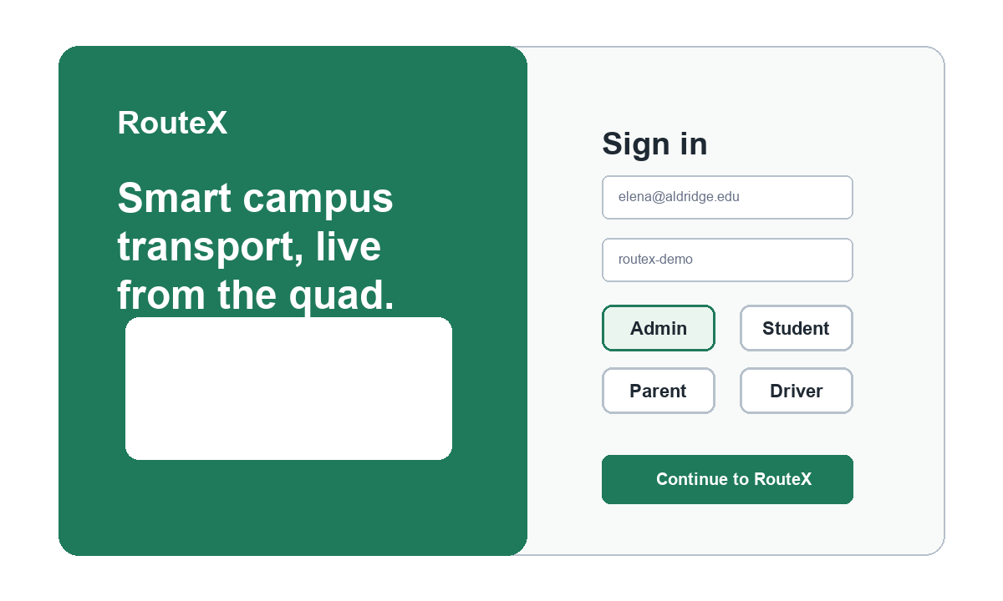
Figure 5.1: RouteX login interface
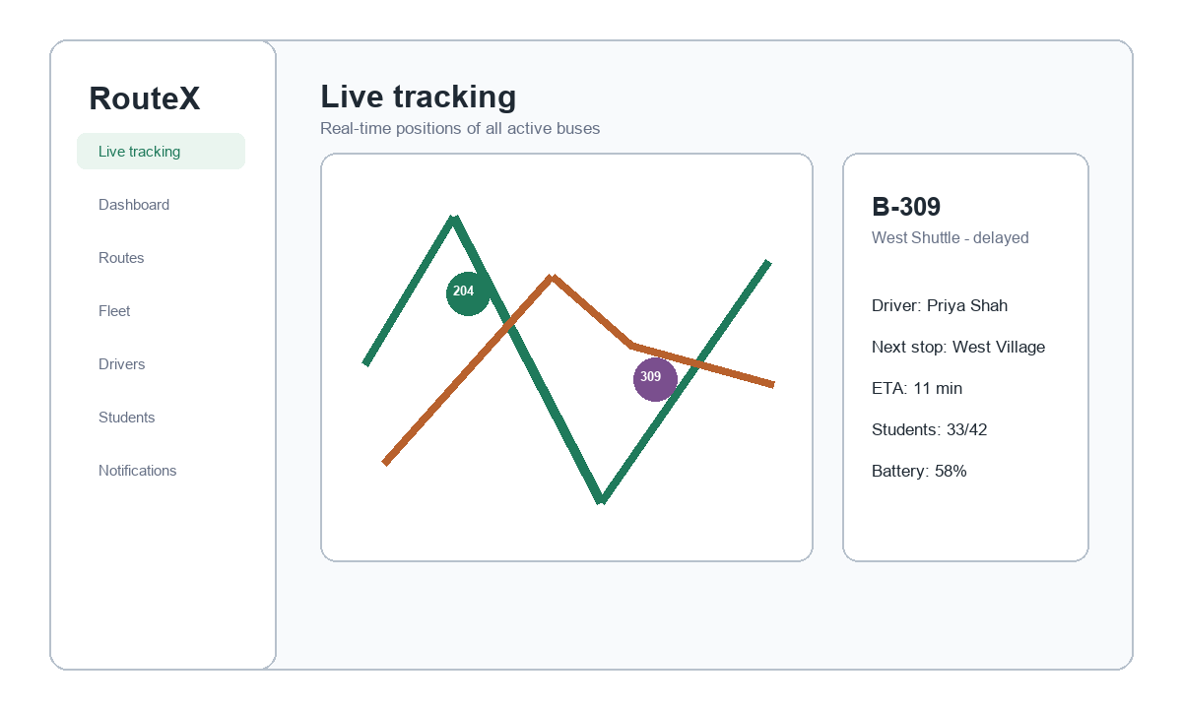
Figure 5.2: RouteX admin live tracking interface
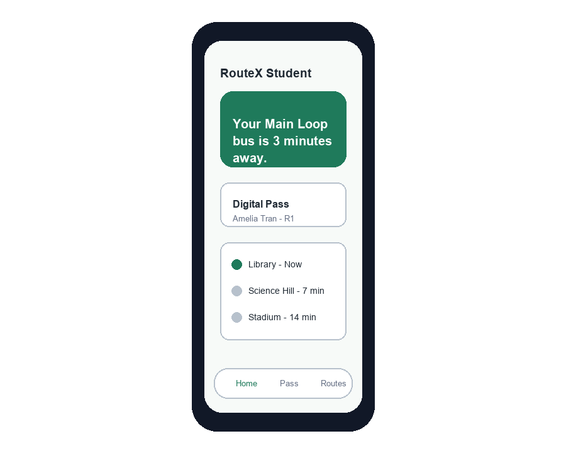
Figure 5.3: RouteX student mobile interface

5.3 ER Diagram
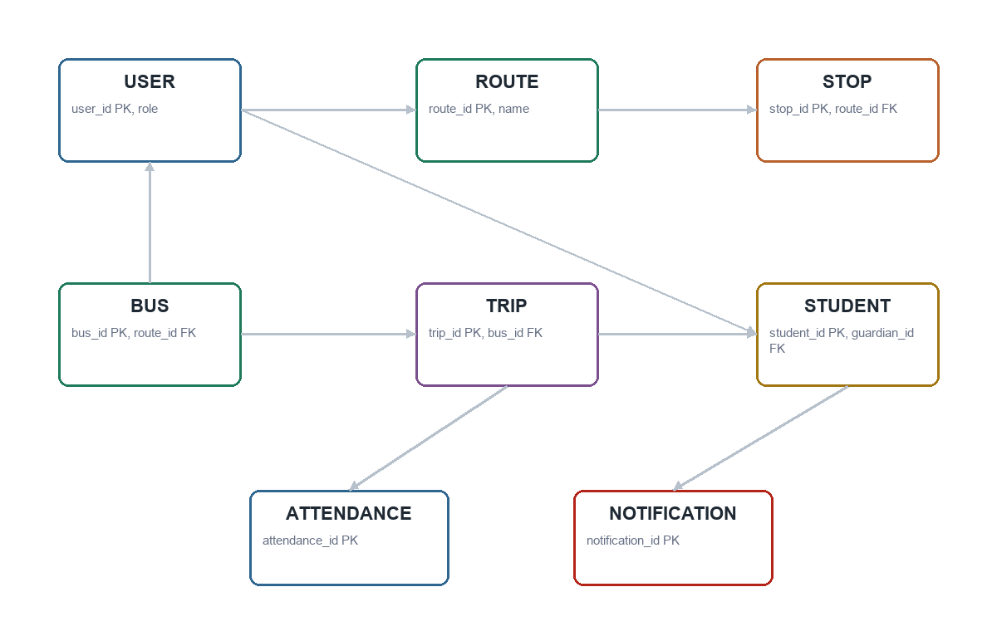
Figure 5.4: ER diagram of RouteX

5.4 DFD Diagram

DFD Level 0
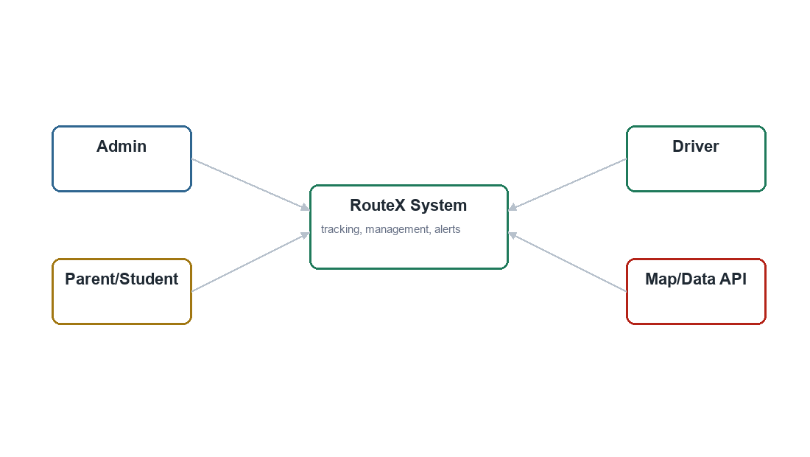
Figure 5.5: DFD Level 0 of RouteX

DFD Level 1
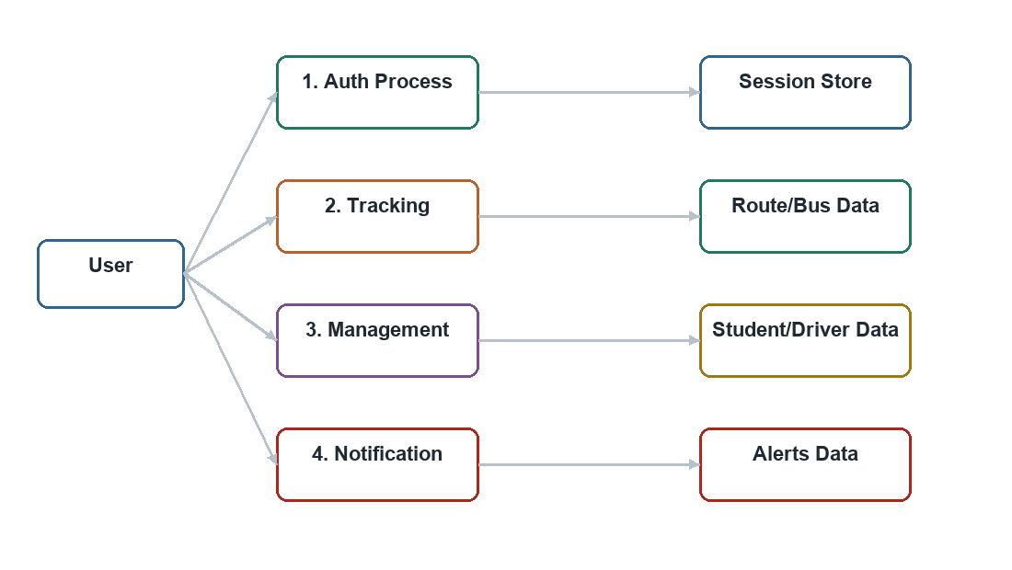
Figure 5.6: DFD Level 1 of RouteX

DFD Level 2
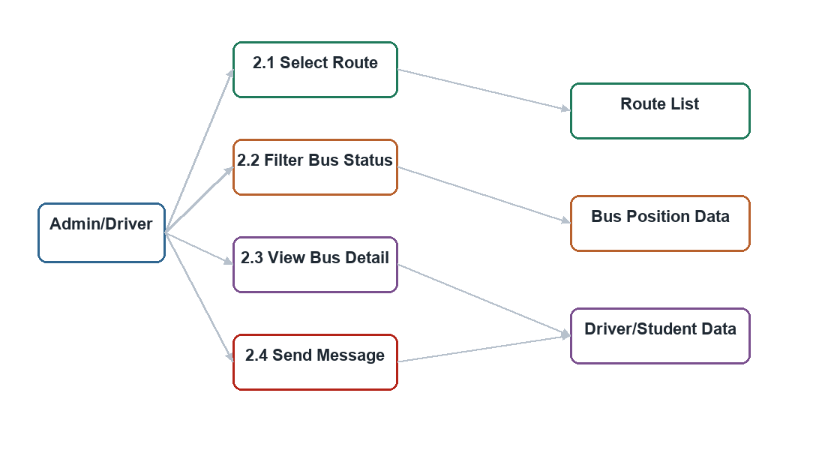
Figure 5.7: DFD Level 2 of tracking process

5.5 Activity Diagram
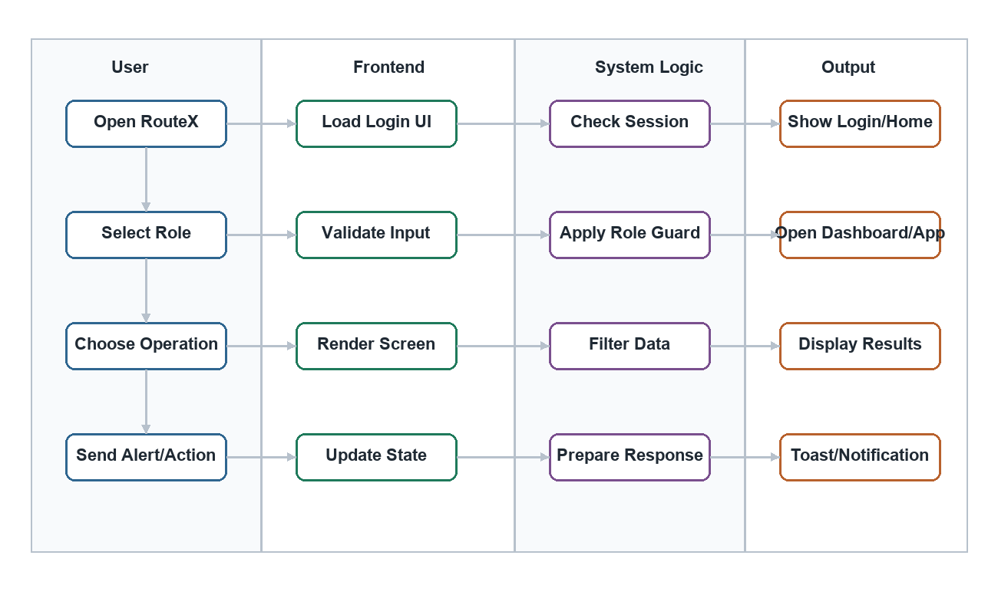
Figure 5.8: Activity diagram with swimlanes

5.6 Class Diagram
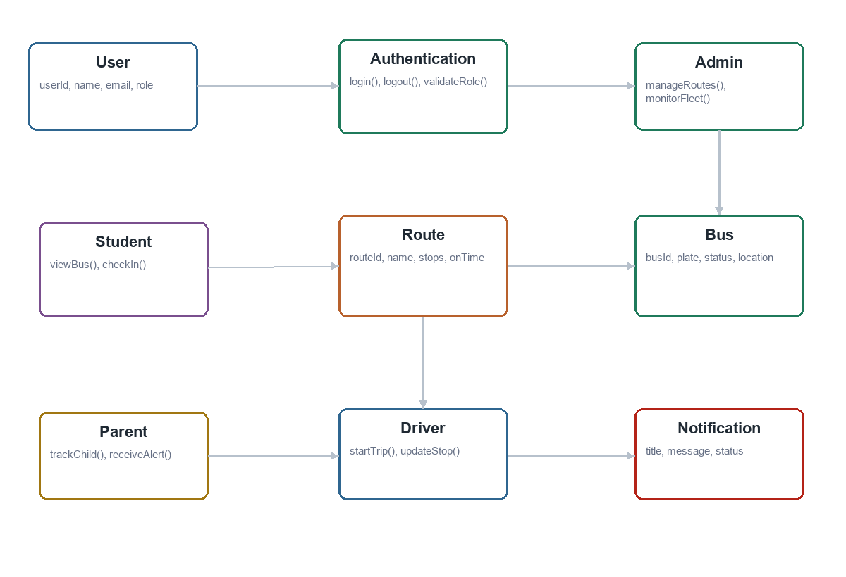
Figure 5.9: Class diagram of RouteX

5.7 Sequence Diagram
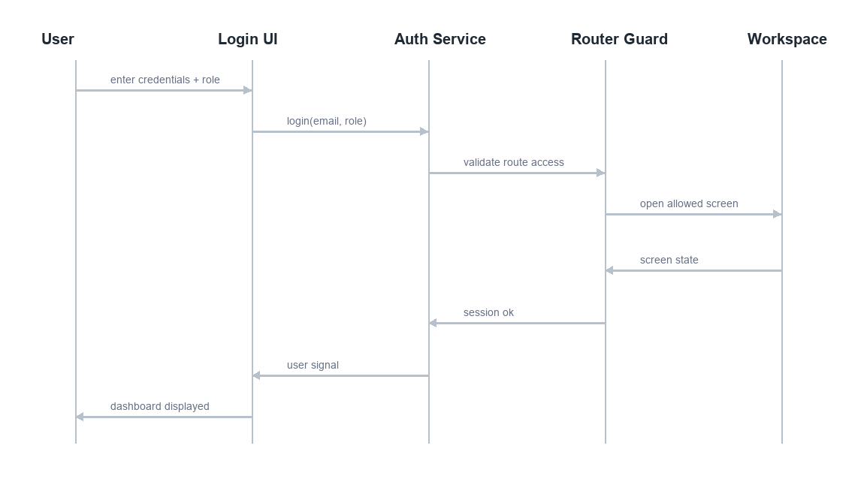
Figure 5.10: Sequence diagram for login and dashboard flow

5.8 Software Architectural Design
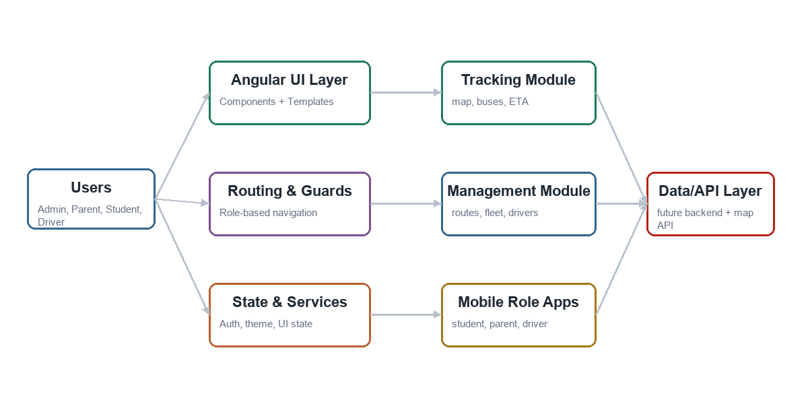
Figure 5.11: Software architectural block diagram
The architecture separates UI components, routing/guards, services/state, feature modules, and future data/API integration. This separation makes the frontend easier to maintain and extend.

CHAPTER 6
DEVELOPMENT

6.1 Selection of Tools and Technology
The tools and technologies were selected according to frontend project needs: fast UI development, modular code, role-based navigation, responsive design, and map-based tracking support.

6.1.1 Hardware
Hardware | Use
Laptop / PC | Development, testing, browser preview, and documentation.
Internet Connection | API documentation, package management, and map integration.
Mobile Browser / Responsive Mode | Testing mobile views for student, parent, and driver.

6.1.2 Software
Tool / Technology | Purpose | Justification
Angular 21 | Frontend framework | Supports component-based, scalable application structure.
TypeScript | Programming language | Improves code reliability through typing.
Angular Router | Navigation | Provides clean role-based routing and guards.
Angular Material | UI controls/icons | Provides consistent buttons, icons, and tooltips.
PrimeNG / PrimeIcons | UI support | Useful for rich admin-style interface components.
Tailwind CSS | Styling | Supports responsive and utility-first design.
Leaflet | Map support | Suitable for route and bus location visualization.
RxJS | Reactive data handling | Useful for UI state and asynchronous events.
LocalStorage | Session persistence | Stores demo user session in browser safely.
VS Code | IDE | Efficient code editing and debugging.
Git / GitHub | Version control | Tracks code changes and collaboration.
Vitest / Angular Tests | Testing | Supports frontend test execution.

Justification for Techniques
- Component-based development keeps login, admin, layout, and mobile views reusable.
- Role-based route guarding prevents users from opening screens outside their assigned role.
- Responsive design ensures the same system works on desktop and mobile devices.
- Mock data allows the frontend workflow to be demonstrated before backend integration.
- Black box testing verifies the system from the user perspective.

CHAPTER 7
SOFTWARE TESTING

7.1 Software Testing
Software testing was important for RouteX because transport systems must show correct information to different users. Testing focused on login, routing, UI behavior, validation, role access, notifications, responsiveness, and main workflows.

7.2 Testing Process
- Identify functional requirements from the SRS.
- Prepare positive and negative test cases for each feature.
- Run the application in browser and perform manual UI testing.
- Check role-based navigation for admin, student, parent, and driver.
- Verify responsive behavior using desktop and mobile screen sizes.
- Record expected and actual results.

7.3 Black Box Testing
Black box testing was used because the main objective was to verify visible system behavior from the user point of view. Testers did not need to inspect internal code; they checked whether input actions produced the expected output.

7.4 Test Cases
TC ID | Test Case | Input / Action | Expected Result
TC-01 | Open RouteX | Open app URL | Login page loads successfully.
TC-02 | Admin login | Select admin and continue | Admin live tracking page opens.
TC-03 | Student login | Select student and continue | Student mobile app opens.
TC-04 | Parent login | Select parent and continue | Parent portal opens.
TC-05 | Driver login | Select driver and continue | Driver app opens.
TC-06 | Role guard check | Student tries admin route | System redirects to allowed role screen.
TC-07 | Route filter | Select route R1 | Only relevant buses/routes are highlighted.
TC-08 | Status filter | Select delayed status | Delayed bus information is displayed.
TC-09 | Bus detail view | Click bus B-309 | Driver, ETA, next stop, speed, capacity, and battery are shown.
TC-10 | Notification screen | Open notifications | Unread and read alerts are displayed.
TC-11 | Driver checklist | Complete all checks | Trip start action becomes available.
TC-12 | Responsive test | Open mobile width | Mobile layout fits without overlap.
TC-13 | Theme toggle | Click theme button | Theme changes visually.
TC-14 | Logout | Click logout/sign-in screen | Session clears and login is shown.

CHAPTER 8
IMPLEMENTATION AND TRAINING

8.1 Implementation
RouteX was implemented as an Angular frontend. The system uses standalone components, Angular routing, authentication and role guards, responsive CSS, UI component libraries, and mock route/fleet/student data. The current implementation demonstrates the full frontend workflow and is ready for backend/API integration in future work.

8.2 Project Overview

Key Features
- Secure role-based login flow.
- Admin live tracking and operational dashboard.
- Route, fleet, driver, student, notification, and settings screens.
- Student, parent, and driver mobile apps.
- Responsive design and browser session persistence.
- Map and route visualization support.

Expected Outcome
The expected outcome is a working frontend prototype that demonstrates how a university can monitor bus routes, improve communication, and provide transport visibility to students, parents, drivers, and administrators.

8.3 Training
Users need basic computer or smartphone skills to operate RouteX. Admin users require short training on dashboard navigation, route filters, bus detail views, alerts, and settings. Students and parents require guidance on reading ETA, route status, digital pass, and notifications. Drivers require training on checklist completion, manifest viewing, and route progress updates.

Conclusion
RouteX is a real-time campus bus tracking frontend that improves transport visibility and communication. The system supports admin, student, parent, and driver roles through separate user experiences. Its main features include live tracking, dashboard KPIs, route/fleet/driver/student views, notifications, mobile role apps, and responsive design. Angular and related frontend technologies were selected because they support modular and maintainable development. The Agile Scrum / Iterative model was suitable because the project was built module by module and improved after testing. Black box and manual testing were used to verify behavior from the user perspective. RouteX can be extended in the future with backend databases, actual GPS devices, push notifications, and analytics reporting.

References
Angular Documentation: https://angular.dev
Angular Material Documentation: https://material.angular.dev
PrimeNG Documentation: https://primeng.org
Leaflet Documentation: https://leafletjs.com
Tailwind CSS Documentation: https://tailwindcss.com
IEEE Software Requirements Specification concepts and UML design references
Google Maps and public transport tracking concepts for comparative study

