URL: <https://github.com/RouthKiranBabu/Masai-School-Journey/tree/main/Lectures/ManualTesting/Theory/RTM>

Checkout the Gif or alternative of downloading the test_result mp4.

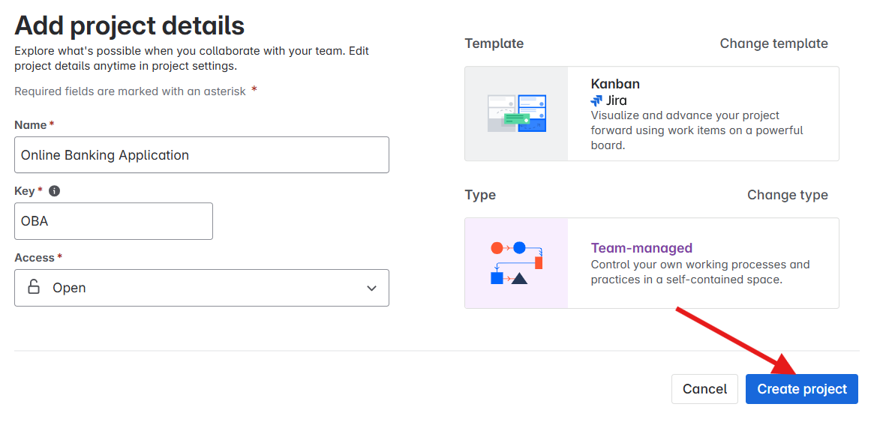

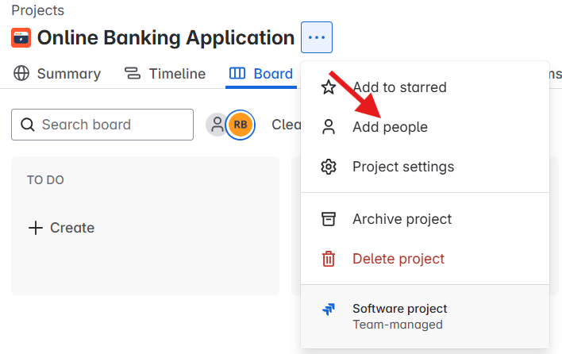

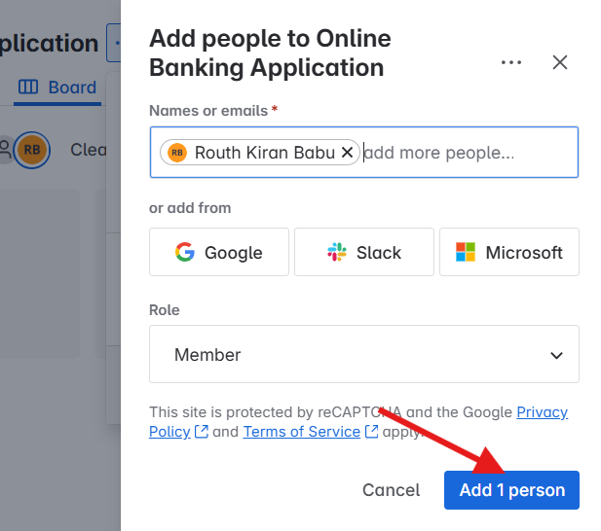

# Created Three Tasks:

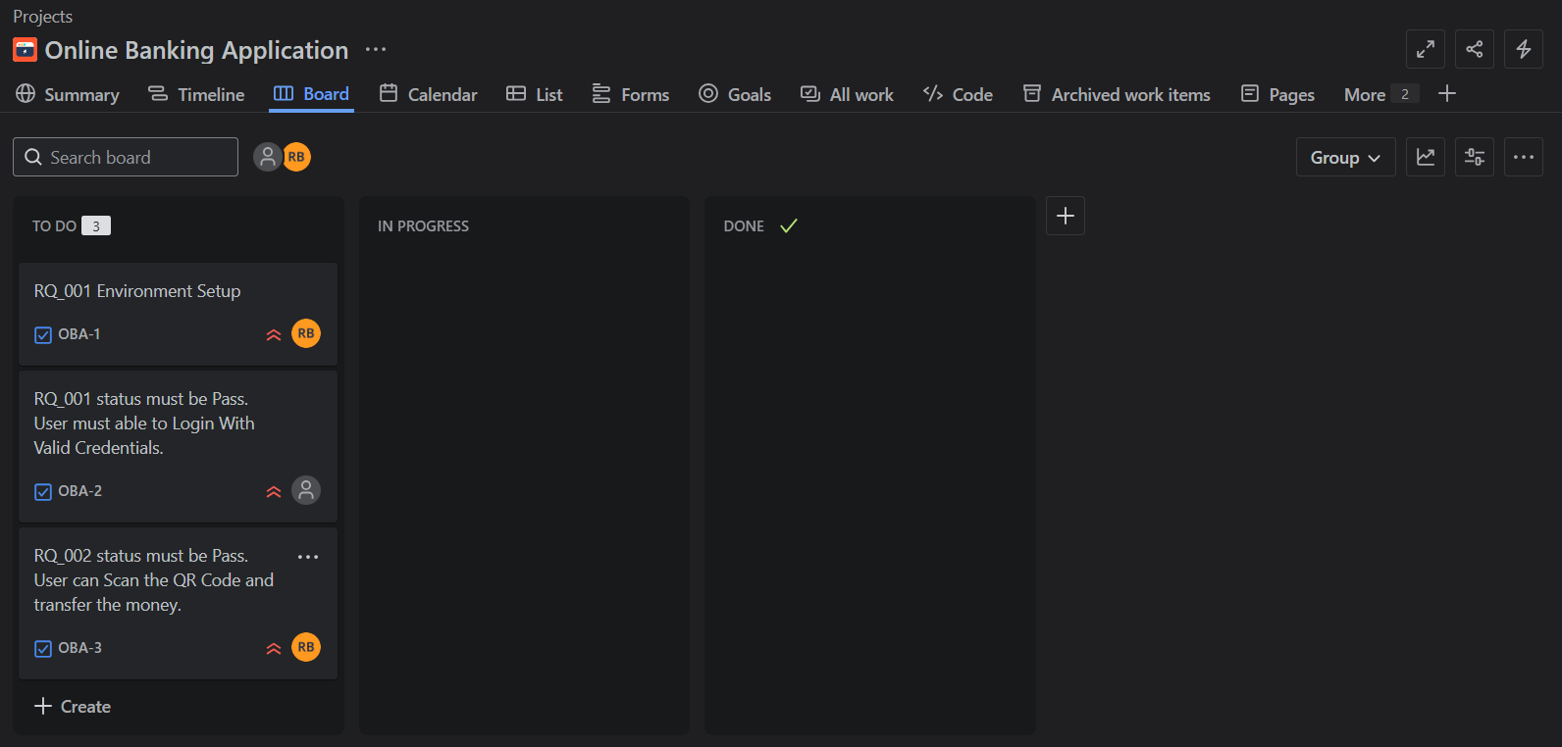

Procedural video: <https://github.com/RouthKiranBabu/Masai-School-Journey/blob/main/Lectures/ManualTesting/Theory/RTM/Created%20Tasks.mp4>

# Configure:

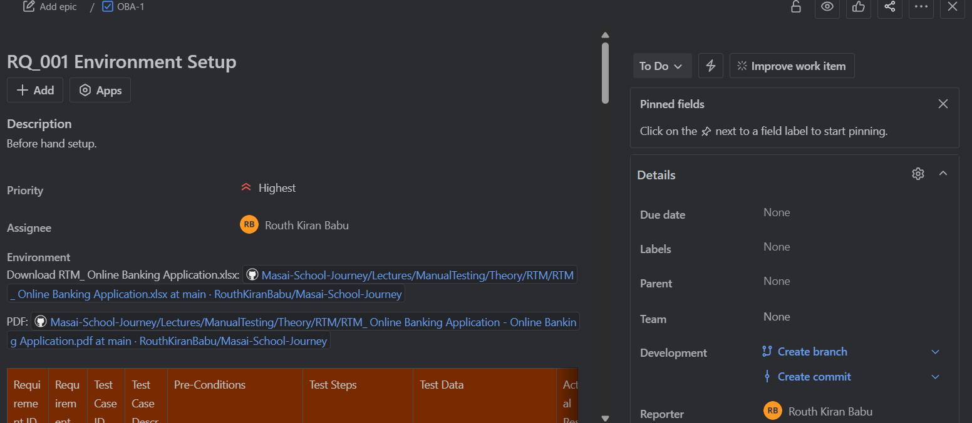

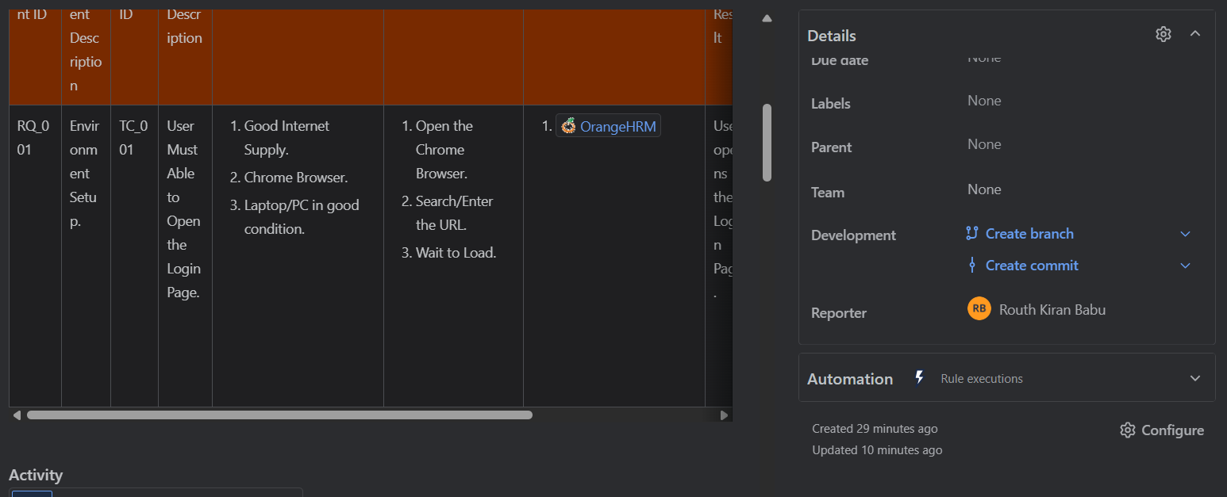

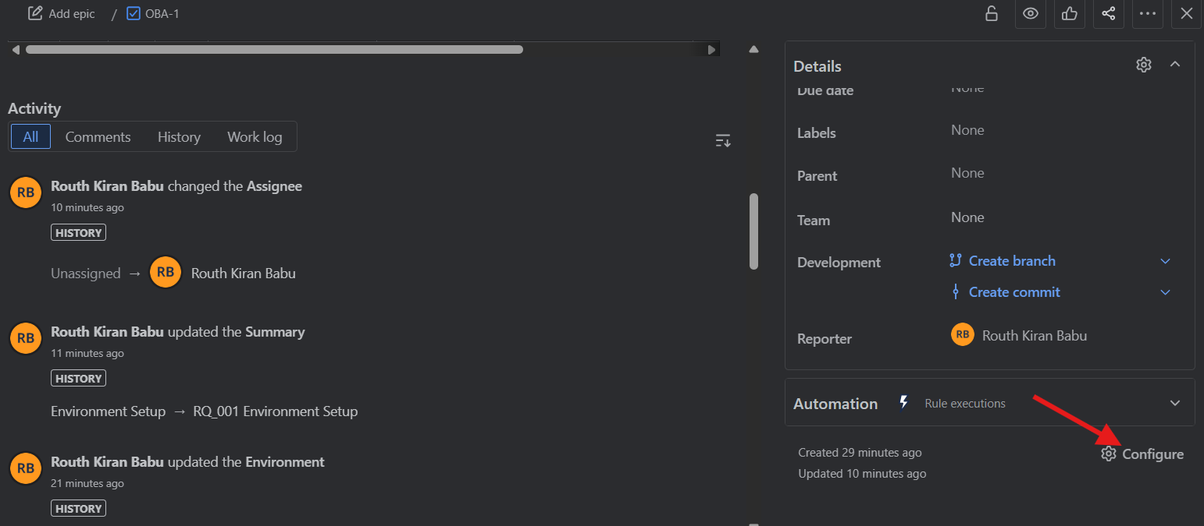

Click on the Configure to costomize the content like priority should be below description, etc.

# Jira as the Project Management Tool

Enables to choose the templates based on requirements.

Better visualisation to track tasks.

Organize task in a better way.

Enables team to collaborate to one other.

## Key features:

1. Issue and Task tracking.
2. Custom workflow.
3. Scrum and Kanban board.
4. Integration.
5. Reports and Dashboards.
6. Roadmaps and sprint planning.
7. Roles and permissions.
8. Autmation.
9. Custom fields and screens.
10. Cloud and server option.

## Kanban board influence the project on the following reasons:

Better visualisation on different phases like To do, In Progress, Done and we can add number of columns. Can configure and drag and drop task as the requirment.

We can integrate confluence with jira.

We can see in the List view for each task.

# Zephyr for Test Management

## Installed

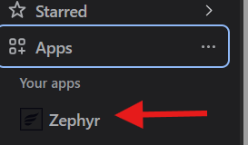

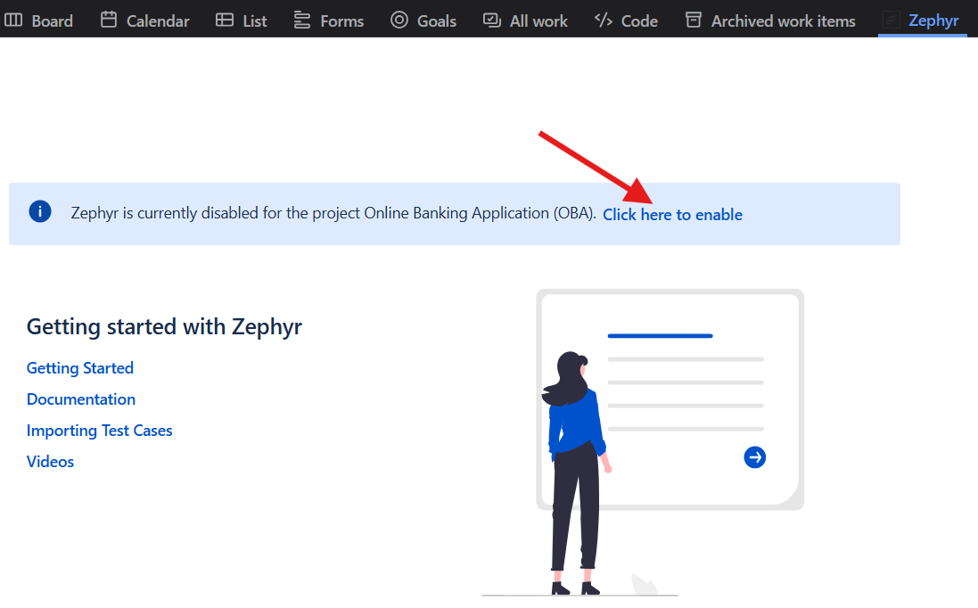

## Import Excel file:

Download the Excel in form of CSV.

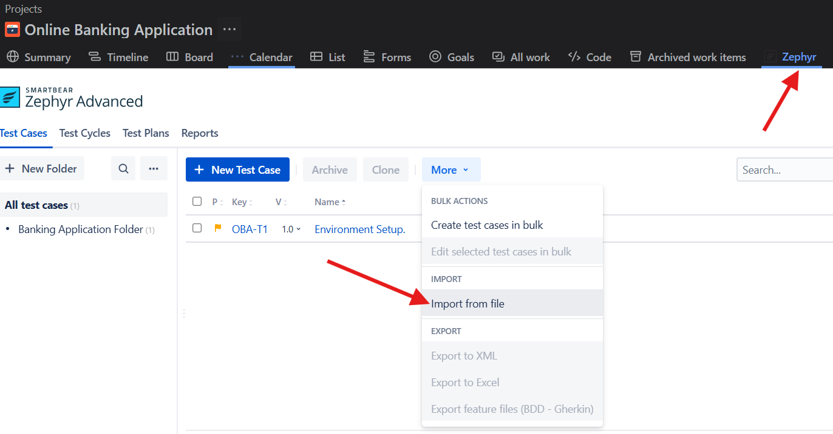

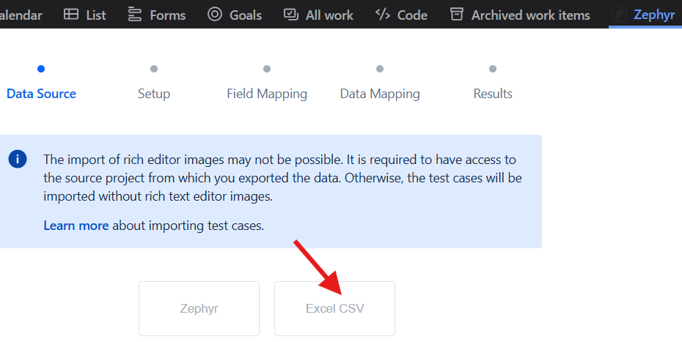

Then choose the Downloaded CSV file type from Excel sheet.

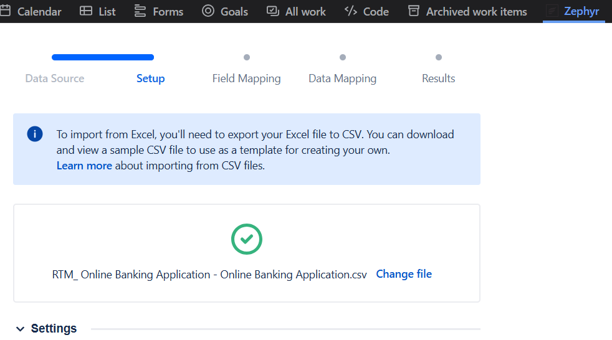

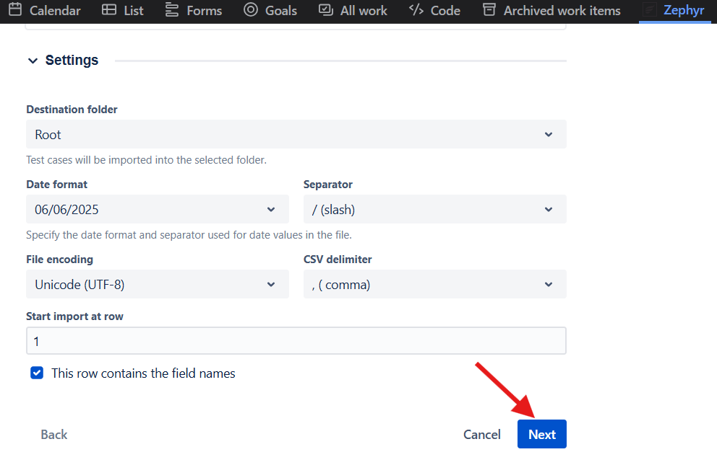

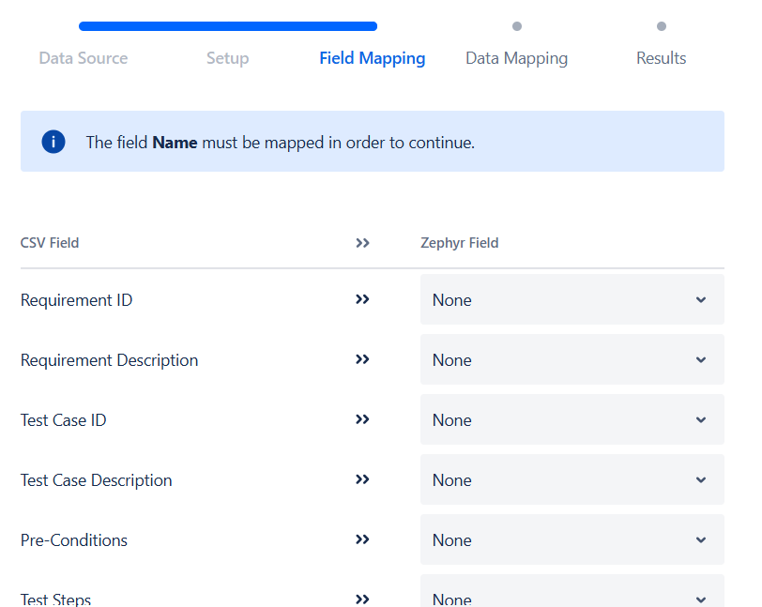

## Convert to

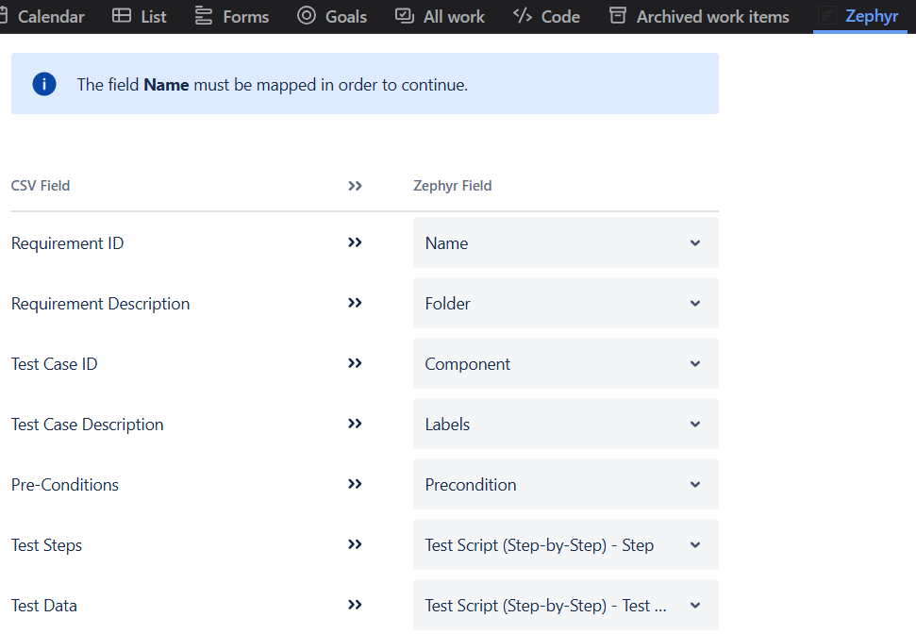

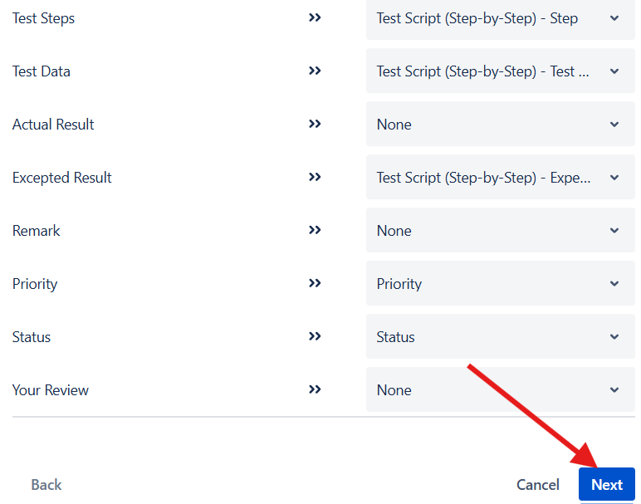

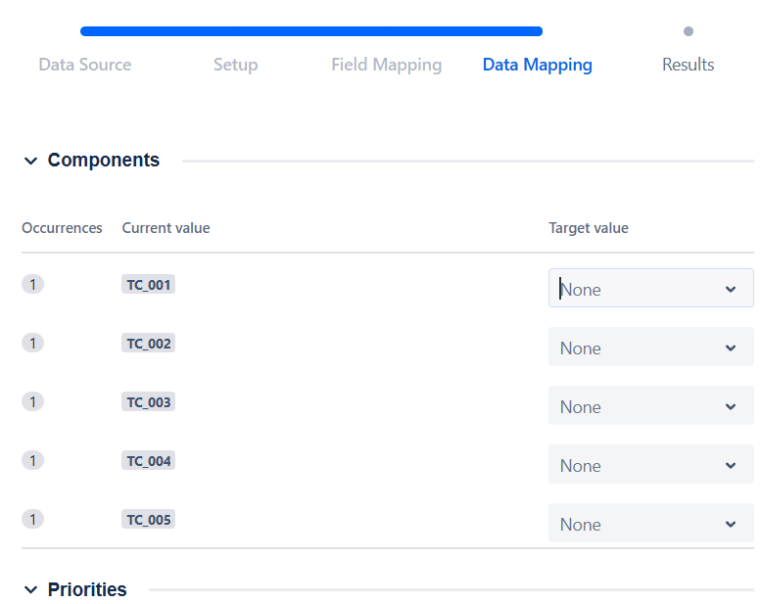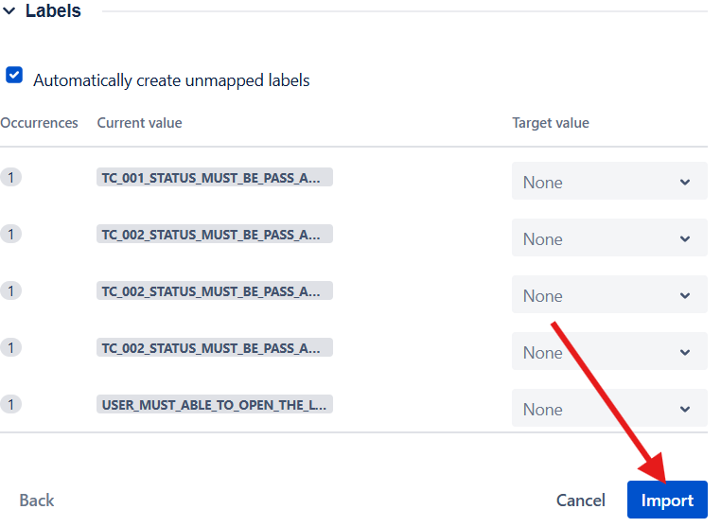

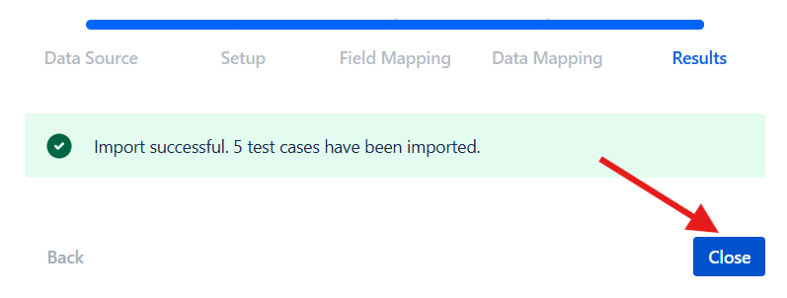

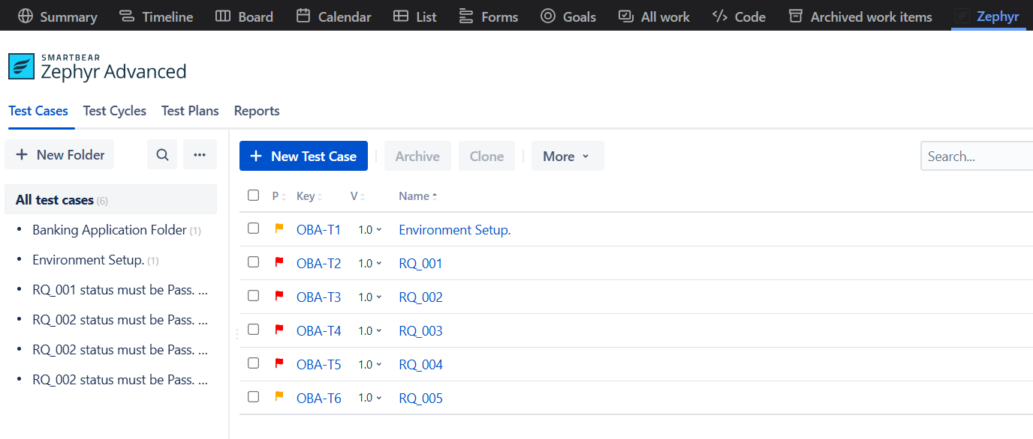

Instead of manually providing data we can import excel and it automatically does add test cases.

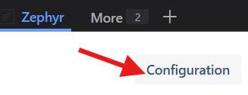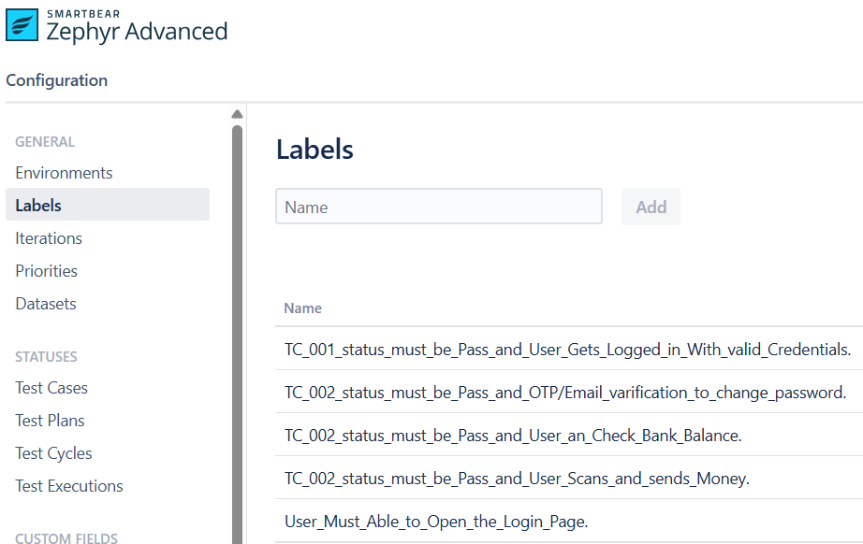

# Create Test Cycle

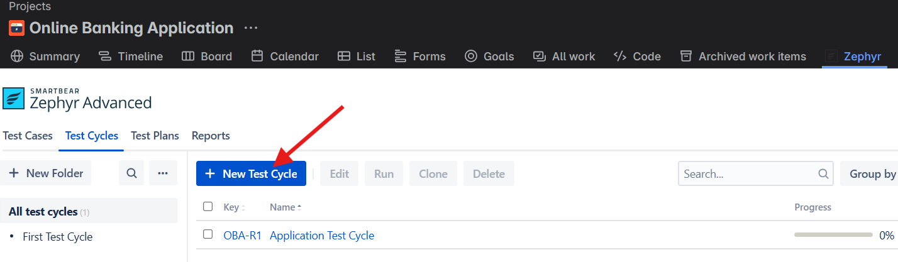

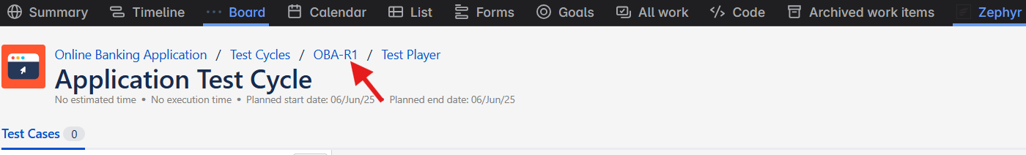

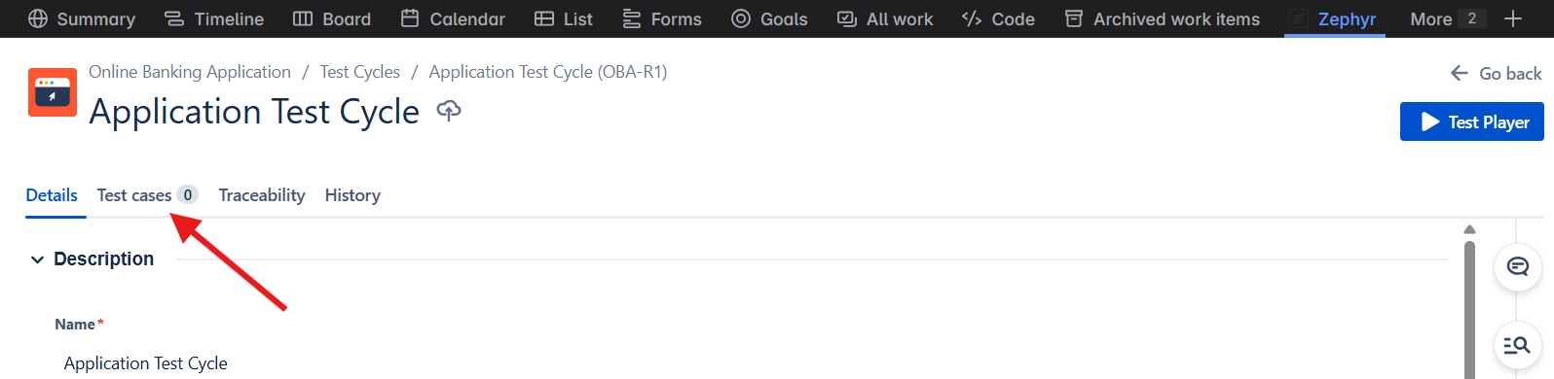

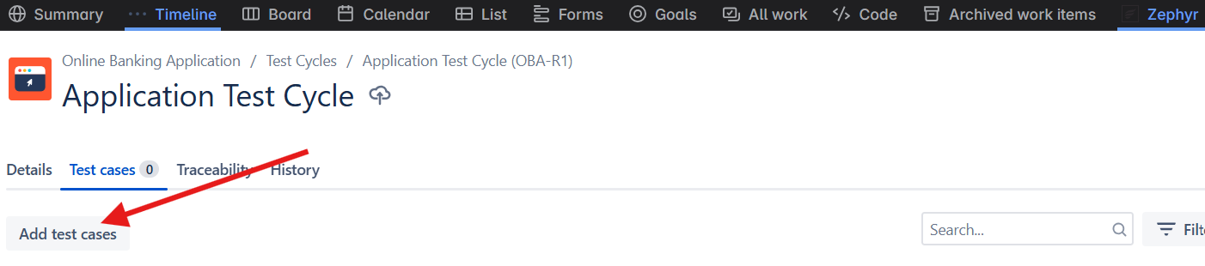

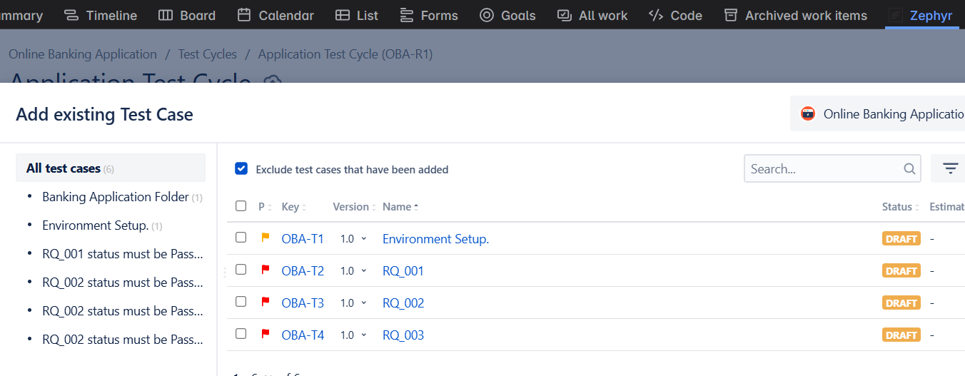

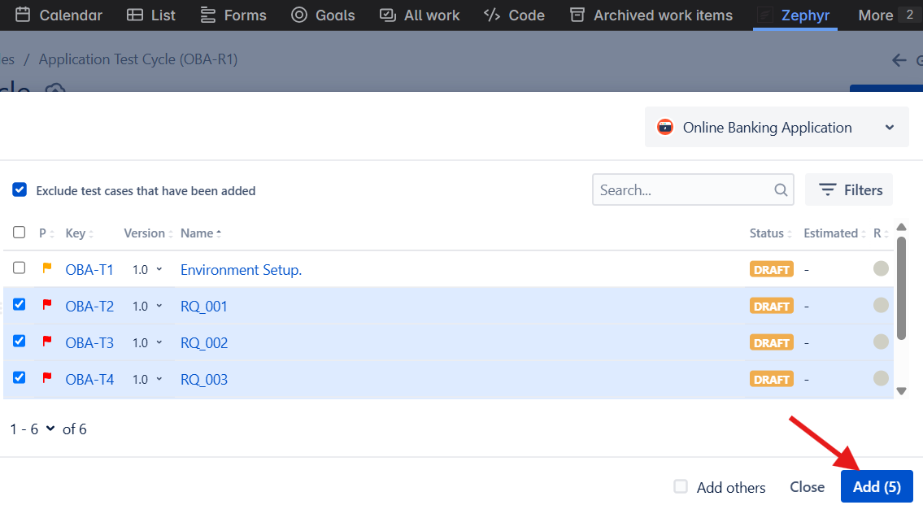

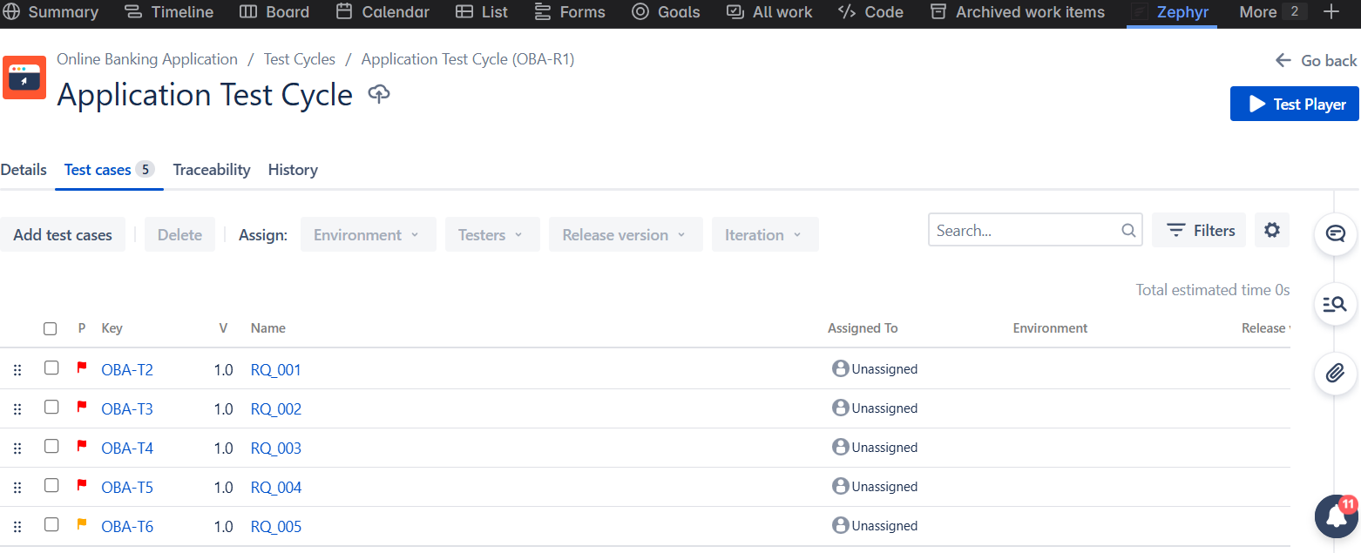

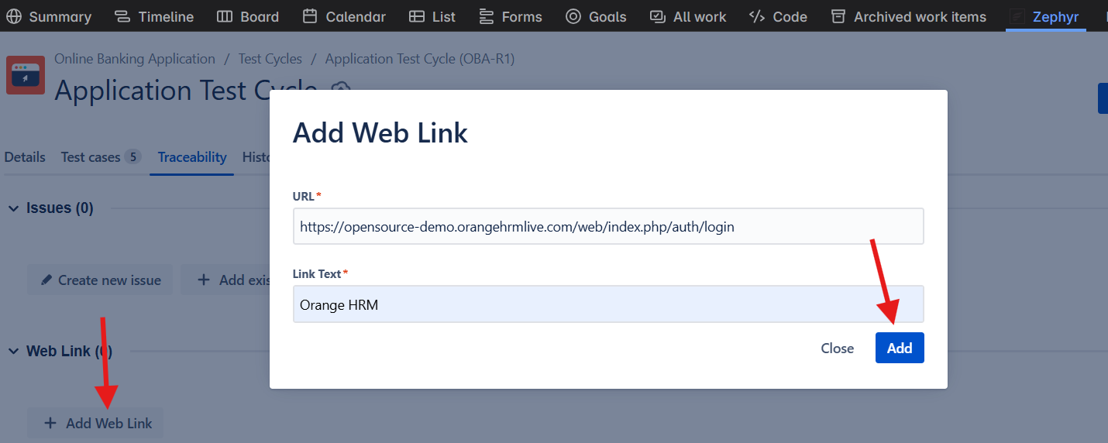

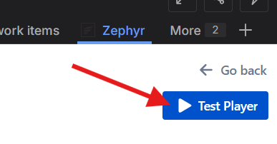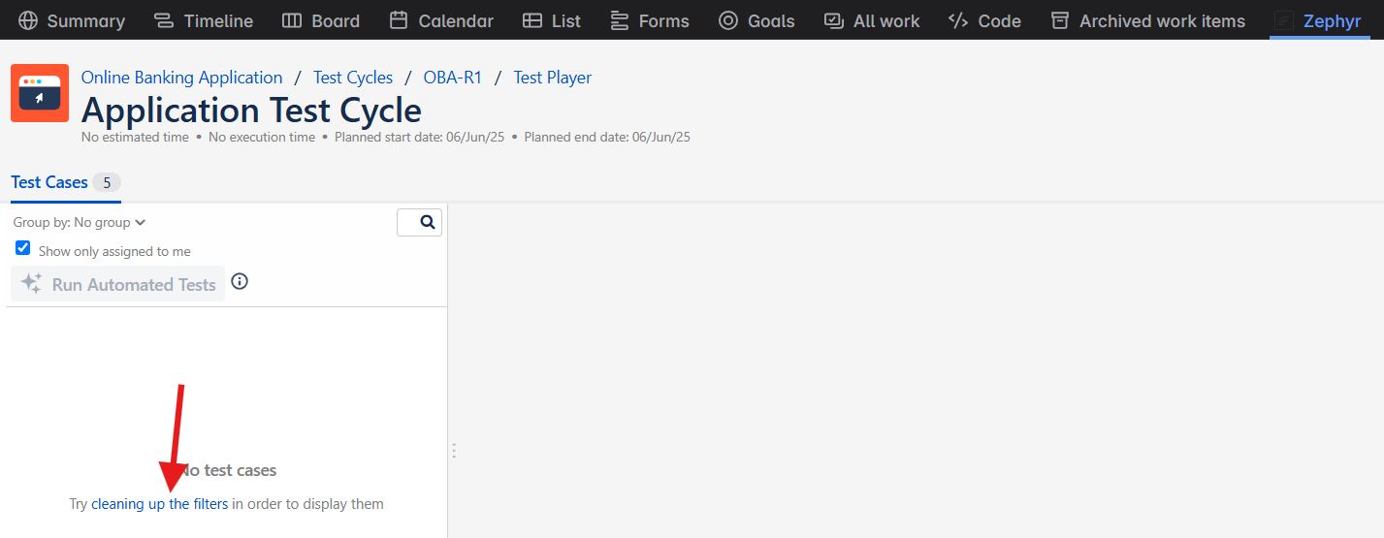

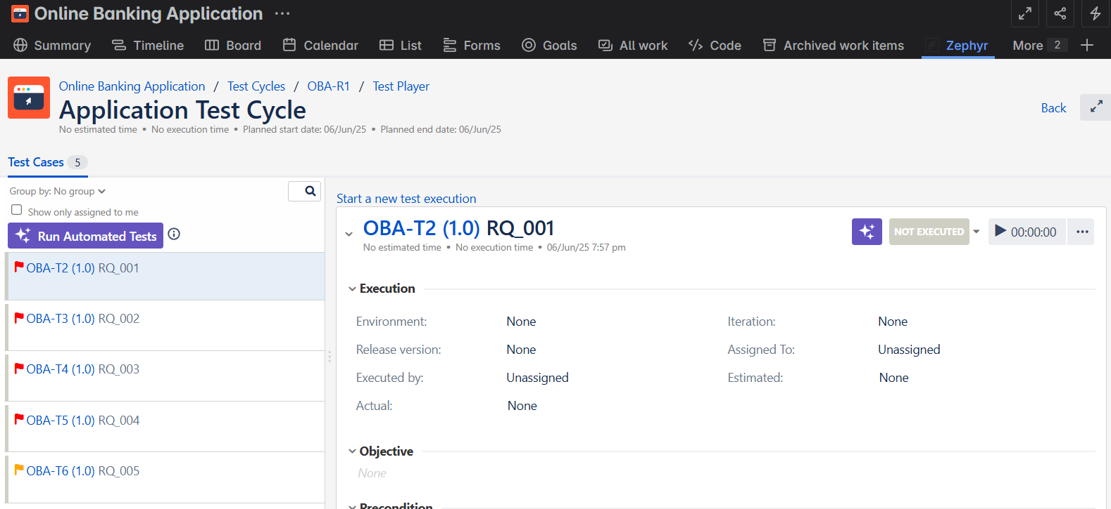

You can set the status

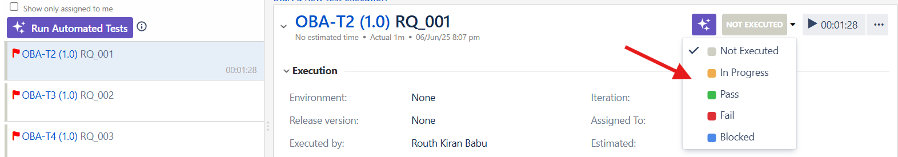

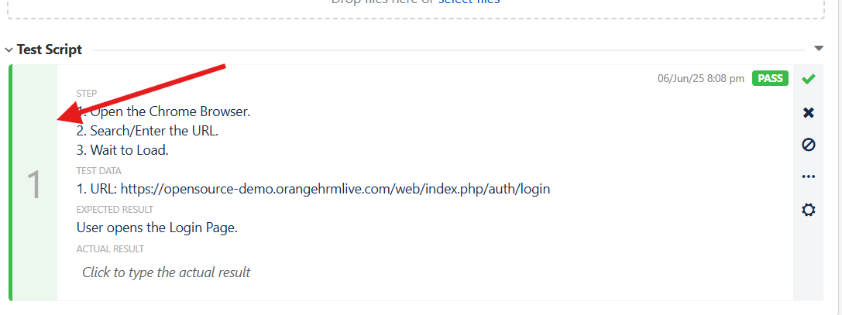

The above green bar rises based on below start and end date.

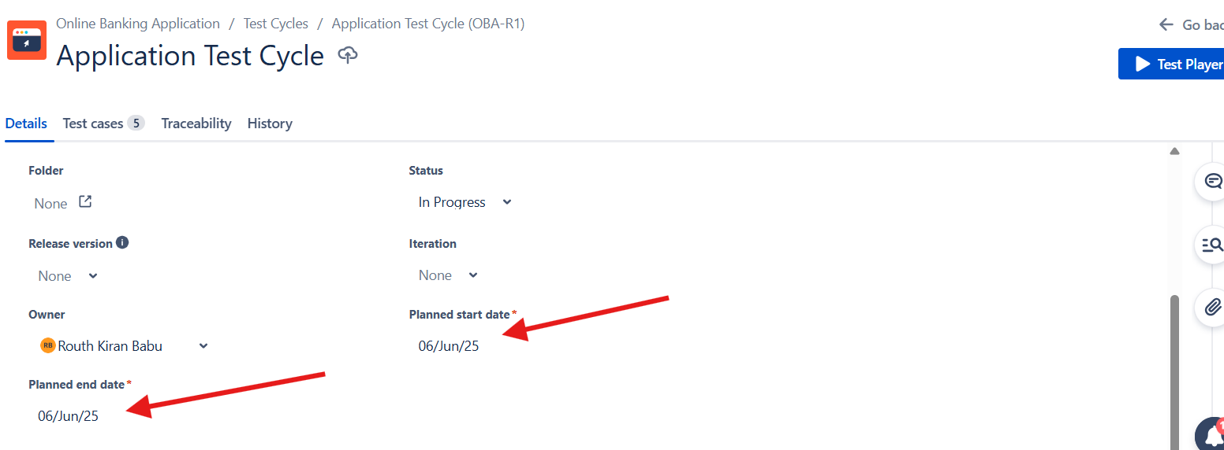

Cross mark is chosen within time means it has failed the test. So it turns to red.

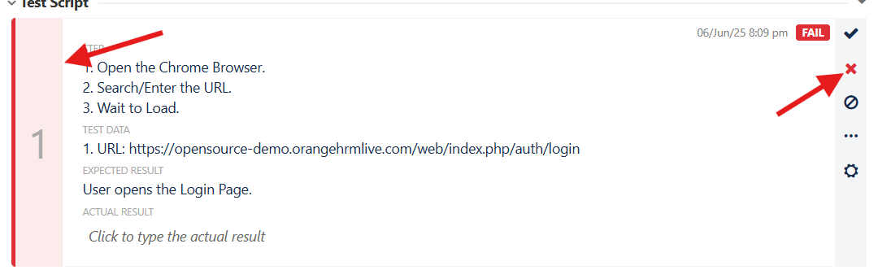

Shows Progress

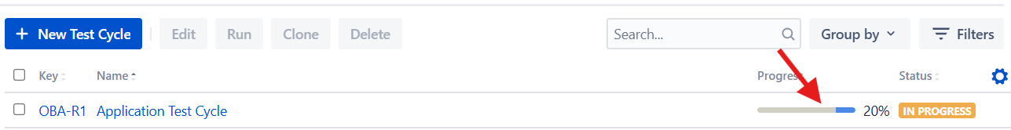

# To run the Test Script

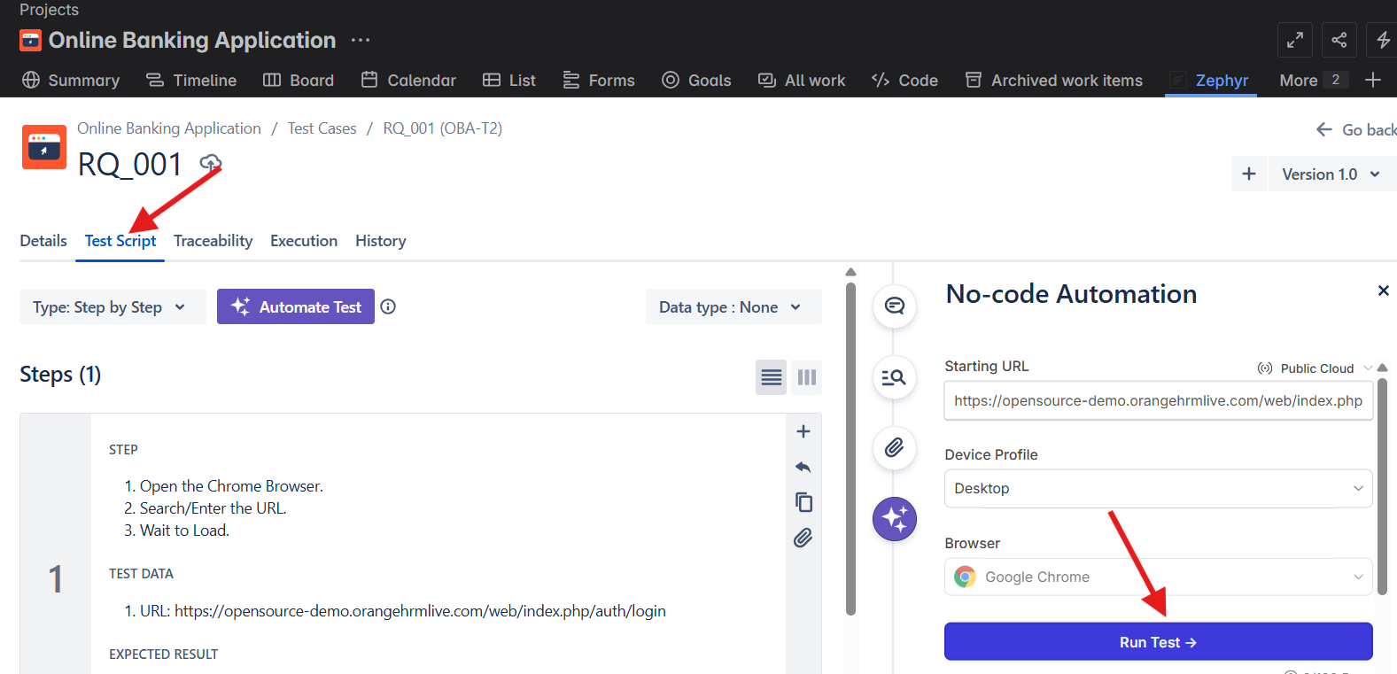

# To run Test Case

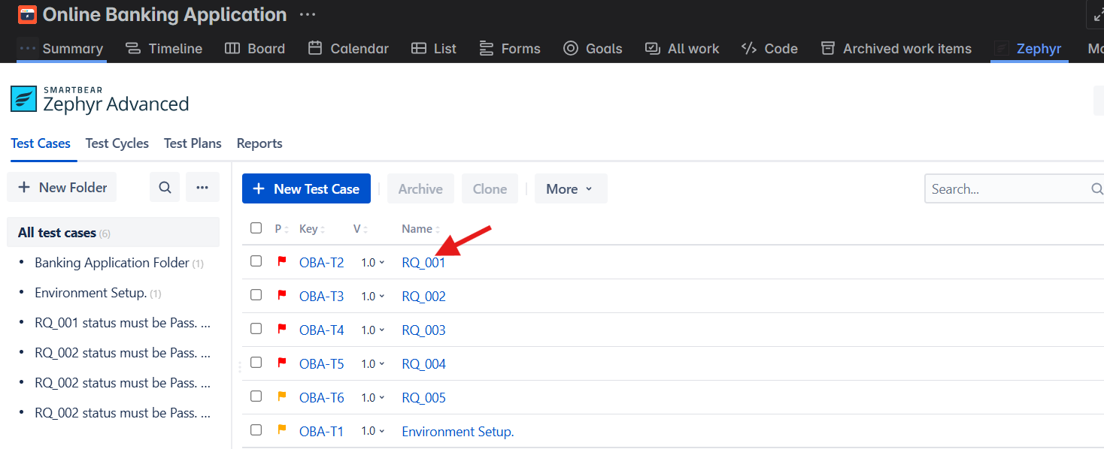

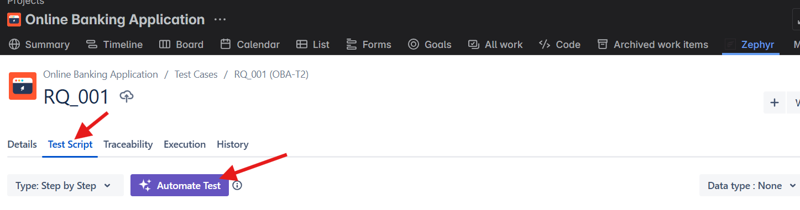

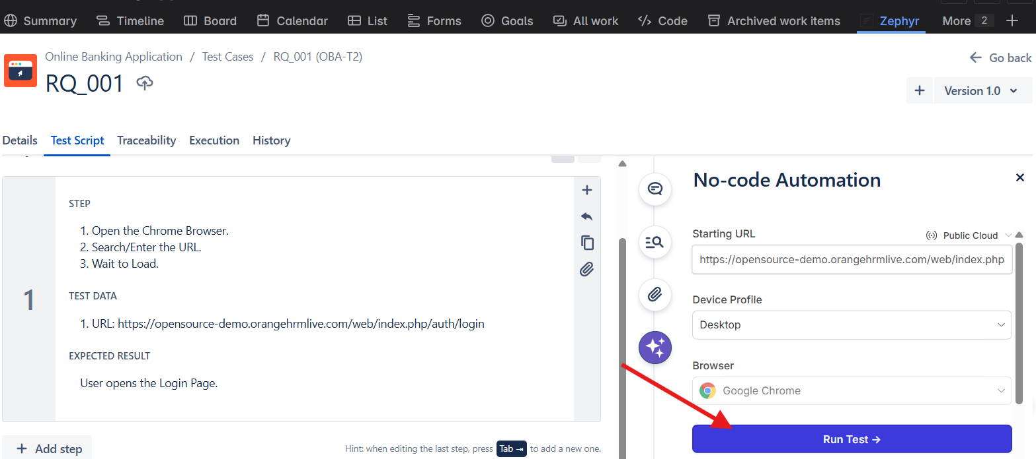

# Test Result: (Click Approve and Run for more insight)

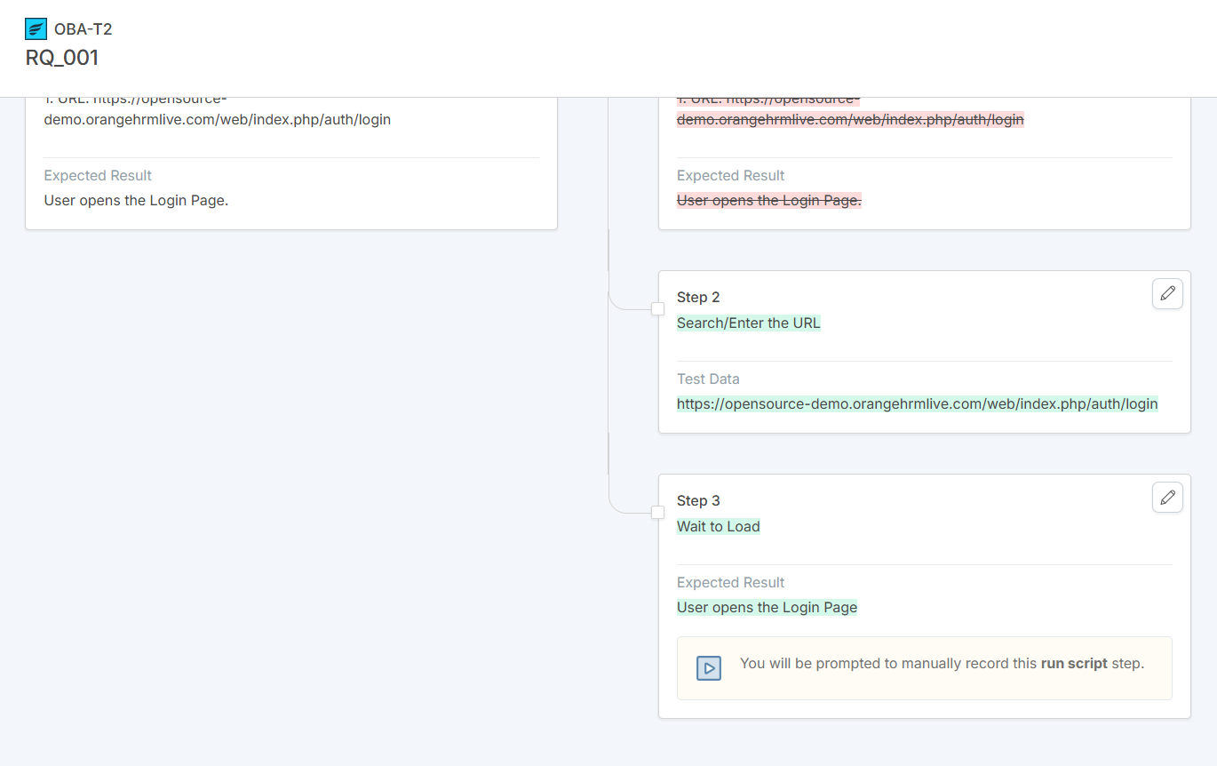

# For RQ_002

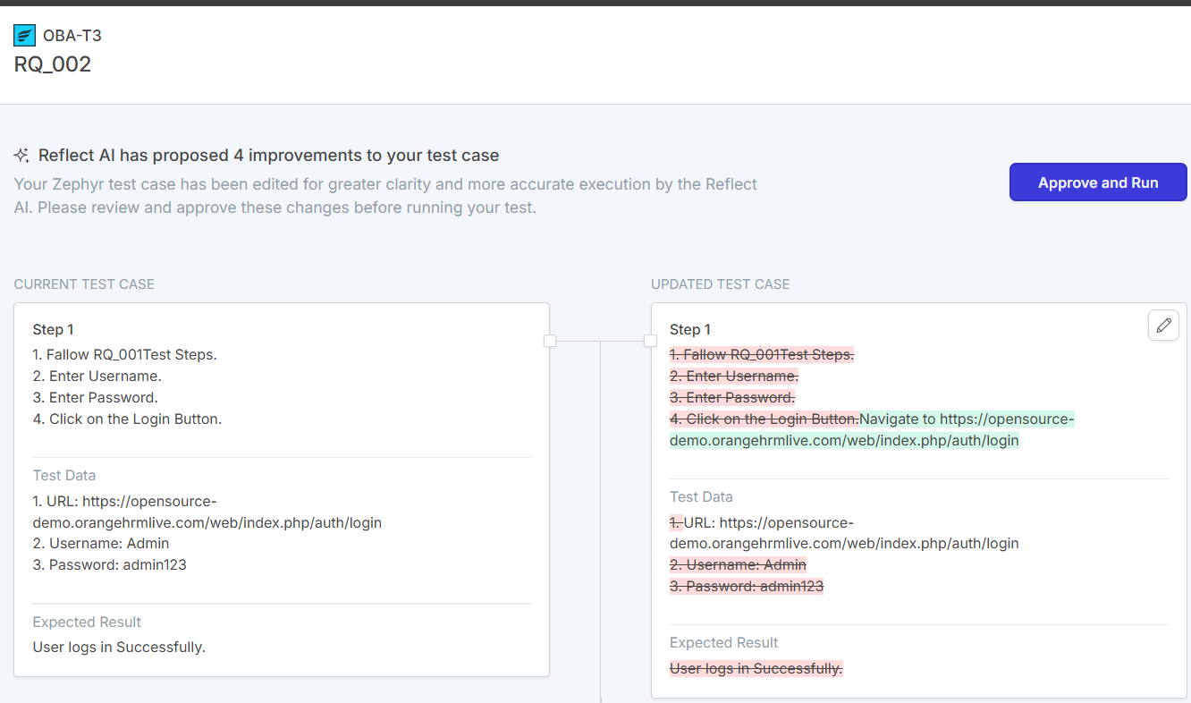

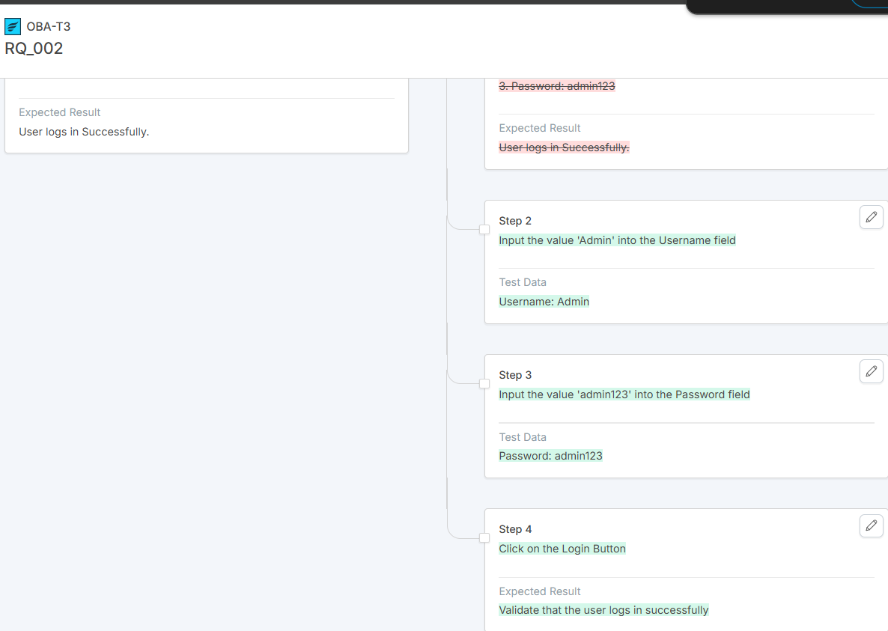

# Test Execution Report

