**MASTER DEGREE PROGRAM IN DATA SCIENCE AND ADVANCED ANALYTICS | NOVA IMS**

**Computational Intelligence for Optimization Project Report**

**Pneumonia Detection from Chest X-Ray Images**

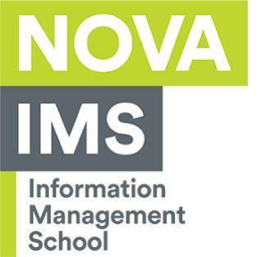April, 2022

Diogo   
Mohamed Ali Felfel m20211322  
Sergio Alfonso Corral Sobrevilla, m2021101

Jessica Routzahn, m20210987