- 配置
实验环境：SQLite
机器配置：windows11
- 实验内容
参考实验六的两张表Employees和Departments
建表：
-- 创建部门表
CREATE TABLE Departments (
dept_id INT PRIMARY KEY,
dept_name VARCHAR(50) NOT NULL,
location VARCHAR(50) NOT NULL
);

-- 创建雇员表（通过dept_id关联部门）
CREATE TABLE Employees (
emp_id INT PRIMARY KEY,
emp_name VARCHAR(50) NOT NULL,
gender CHAR(2) NOT NULL,
hire_date DATE NOT NULL,
base_salary DECIMAL(10,2) NOT NULL,
bonus DECIMAL(10,2) NOT NULL,
subsidy DECIMAL(10,2) NOT NULL,
dept_id INT,
FOREIGN KEY (dept_id) REFERENCES Departments(dept_id)
);

INSERT INTO Departments (dept_id, dept_name, location)
VALUES
(1, '人事部', '广州'),
(2, '财务部', '深圳'),
(3, '技术部', '深圳'),
(4, '市场部', '广州'),
(5, '行政部', '深圳');

INSERT INTO Employees (emp_id, emp_name, gender, hire_date, base_salary, bonus, subsidy, dept_id)
VALUES
(1001, '张三', '男', '2020-03-15', 6000.00, 1000.00, 300.00, 3),
(1002, '李四', '女', '2021-06-20', 7000.00, 800.00, 200.00, 2),
(1003, '王五', '男', '2019-11-10', 9000.00, 2000.00, 500.00, 3),
(1004, '张菲', '女', '2022-01-05', 5000.00, 500.00, 100.00, 1),
(1005, '孙伟', '男', '2023-09-12', 6500.00, 700.00, 200.00, 4),
(1006, '赵武', '男', '2021-02-18', 8000.00, 1500.00, 400.00, 3),
(1007, '周韵', '女', '2018-07-22', 9500.00, 2500.00, 500.00, 2),
(1008, '张亦明', '男', '2020-10-11', 7200.00, 900.00, 300.00, 4),
(1009, '郑文', '女', '2019-12-25', 5800.00, 600.00, 200.00, 1),
(1010, '冯俊', '男', '2023-04-10', 6700.00, 500.00, 150.00, 5);

- 使用生成列或触发器，将总薪资字段修改成自动更新的。当base_salary、bonus、subsidy修改时，自动更新总薪资。插入记录时，自动生成总薪资。
-- 新建列total_salary
ALTER TABLE Employees ADD COLUMN total_salary DECIMAL(10,2) NOT NULL DEFAULT 0;
UPDATE Employees SET total_salary = base_salary + bonus + subsidy;

-- 插入触发器
CREATE TRIGGER trg_emp_insert_total_salary
AFTER INSERT ON Employees
FOR EACH ROW
BEGIN
-- 更新当前插入行的total_salary
UPDATE Employees
SET total_salary = NEW.base_salary + NEW.bonus + NEW.subsidy
WHERE emp_id = NEW.emp_id;
END;

-- 更新触发器
CREATE TRIGGER trg_emp_update_total_salary
AFTER UPDATE OF base_salary, bonus, subsidy ON Employees
FOR EACH ROW
BEGIN
-- 更新当前修改行的total_salary
UPDATE Employees
SET total_salary = NEW.base_salary + NEW.bonus + NEW.subsidy
WHERE emp_id = NEW.emp_id;
END;

插入验证：
修改验证：
- 将技术部的所有员工的base_salary提高20%;
UPDATE Employees
SET base_salary = base_salary * 1.2
WHERE dept_id = (
SELECT dept_id FROM Departments WHERE dept_name = '技术部'
);
检查：
SELECT emp_name, base_salary, (base_salary / 1.2) AS original_salary
FROM Employees
WHERE dept_id = (SELECT dept_id FROM Departments WHERE dept_name = '技术部');
- 统计各部门在2021.01.01之后入职的员工人数;
SELECT
d.dept_id,
d.dept_name,
COUNT(e.emp_id) AS emp_count -- 统计入职员工数
FROM
Departments d
LEFT JOIN
Employees e ON d.dept_id = e.dept_id AND e.hire_date >= '2021-01-01'
GROUP BY
d.dept_id, d.dept_name
ORDER BY
emp_count DESC;
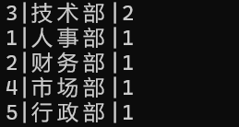
- 将总支出大于22000部门的所有员工的bonus减少200;
UPDATE Employees
SET bonus = bonus - 200
WHERE dept_id IN (
-- 子查询：统计各部门总支出，筛选>22000的部门
SELECT dept_id
FROM Employees
GROUP BY dept_id
HAVING SUM(total_salary) > 22000
);
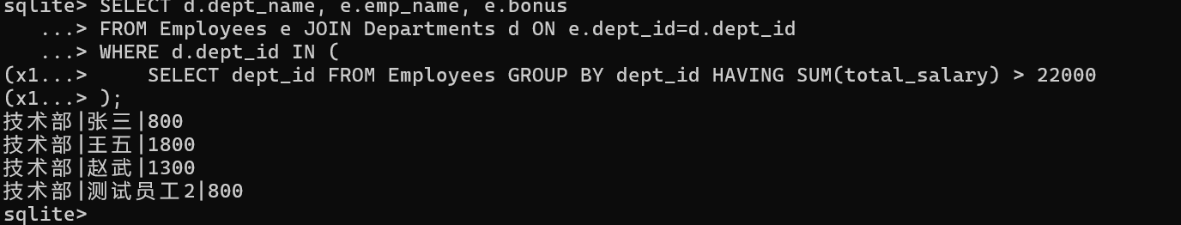
- 建立表Employees2，表结构和Employees相同，往Employees2插入以下记录：
(1014, '张丹', '女', '2017-02-22', 7500.00, 2500.00, 500.00, 2)
(1015, '孙冰', '女', '2021-10-11', 8200.00, 600.00, 400.00, 3)
(1016, '赵兰舟', '男', '2019-01-25', 6800.00, 600.00, 200.00, 1)
(1017, '肖秀容', '男', '2021-11-04', 6800.00, 500.00, 150.00, 5)
CREATE TABLE Employees2 (
emp_id INT PRIMARY KEY,
emp_name VARCHAR(50) NOT NULL,
gender CHAR(2) NOT NULL,
hire_date DATE NOT NULL,
base_salary DECIMAL(10,2) NOT NULL,
bonus DECIMAL(10,2) NOT NULL,
subsidy DECIMAL(10,2) NOT NULL,
dept_id INT,
total_salary DECIMAL(10,2) GENERATED
ALWAYS AS (base_salary + bonus + subsidy) STORED,
FOREIGN KEY (dept_id) REFERENCES Departments(dept_id)
);

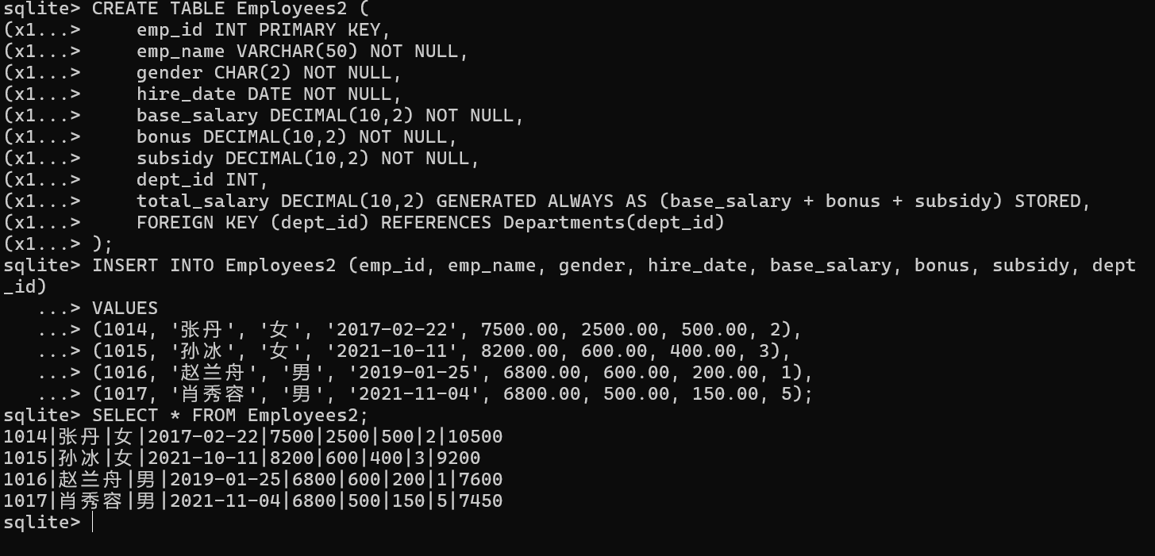
- 将Employees2的所有记录合并到Employee中，删除表Employees2;
INSERT OR IGNORE INTO Employees (emp_id, emp_name, gender, hire_date, base_salary, bonus, subsidy, dept_id)
SELECT emp_id, emp_name, gender, hire_date, base_salary, bonus, subsidy, dept_id FROM Employees2;
-- 删除Employees2
DROP TABLE Employees2;
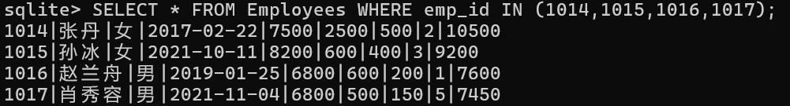
- 将总薪资最低的5名员工的base_salary提高10%;
UPDATE Employees
SET base_salary = base_salary * 1.1
WHERE emp_id IN (
SELECT emp_id FROM Employees ORDER BY total_salary ASC LIMIT 5
);
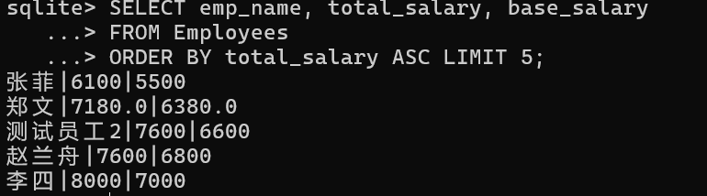
- 实验总结
本次实验主要熟悉训练了update的使用，完成表中数据的更新，用UPDATE （表名）SET （参数）=（新参数）WHERE …来实现。用触发器来实现插入后或修改后数据的自动更新。以及整表的插入和删除。难点在于需准确区分WHERE（行过滤）与HAVING（分组过滤）的适用场景，避免统计逻辑错误。

