- 配置
实验环境：SQLite
机器配置：windows11
- 实验内容
参考实验六的两张表Employees和Departments

建表：
-- 创建部门表
CREATE TABLE Departments (
dept_id INT PRIMARY KEY,
dept_name VARCHAR(50) NOT NULL,
location VARCHAR(50) NOT NULL
);

-- 创建雇员表（通过dept_id关联部门）
CREATE TABLE Employees (
emp_id INT PRIMARY KEY,
emp_name VARCHAR(50) NOT NULL,
gender CHAR(2) NOT NULL,
hire_date DATE NOT NULL,
base_salary DECIMAL(10,2) NOT NULL,
bonus DECIMAL(10,2) NOT NULL,
subsidy DECIMAL(10,2) NOT NULL,
dept_id INT,
FOREIGN KEY (dept_id) REFERENCES Departments(dept_id)
);

INSERT INTO Departments (dept_id, dept_name, location)
VALUES
(1, '人事部', '广州'),
(2, '财务部', '深圳'),
(3, '技术部', '深圳'),
(4, '市场部', '广州'),
(5, '行政部', '深圳');

INSERT INTO Employees (emp_id, emp_name, gender, hire_date, base_salary, bonus, subsidy, dept_id)
VALUES
(1001, '张三', '男', '2020-03-15', 6000.00, 1000.00, 300.00, 3),
(1002, '李四', '女', '2021-06-20', 7000.00, 800.00, 200.00, 2),
(1003, '王五', '男', '2019-11-10', 9000.00, 2000.00, 500.00, 3),
(1004, '张菲', '女', '2022-01-05', 5000.00, 500.00, 100.00, 1),
(1005, '孙伟', '男', '2023-09-12', 6500.00, 700.00, 200.00, 4),
(1006, '赵武', '男', '2021-02-18', 8000.00, 1500.00, 400.00, 3),
(1007, '周韵', '女', '2018-07-22', 9500.00, 2500.00, 500.00, 2),
(1008, '张亦明', '男', '2020-10-11', 7200.00, 900.00, 300.00, 4),
(1009, '郑文', '女', '2019-12-25', 5800.00, 600.00, 200.00, 1),
(1010, '冯俊', '男', '2023-04-10', 6700.00, 500.00, 150.00, 5);

- 计算各部门2021.01.01之后入职员工的base_salary的均值;

SELECT d.dept_id,d.dept_name,AVG(e.base_salary) AS avg_base_salary FROM Departments d LEFT JOIN Employees e ON d.dept_id = e.dept_id WHERE e.hire_date > '2021-01-01' GROUP BY d.dept_id, d.dept_name;

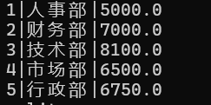

- 查询出在2019.12.31之前入职并且base_salary在8000以下的员工;

SELECT * FROM Employees WHERE hire_date <= '2019-12-31' AND base_salary < 8000;

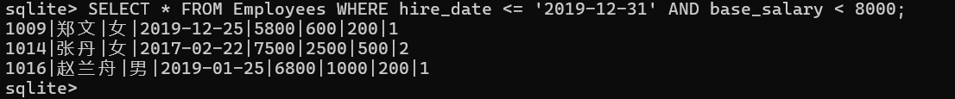

- 将第2问查询出的员工的base_salary增加1000，如果增加之后不足8000，则更新为8000;

UPDATE Employees SET base_salary = CASE WHEN(base_salary + 1000) < 8000 THEN 8000 ELSE(base_salary + 1000) END WHERE hire_date <= '2019-12-31' AND base_salary < 8000;

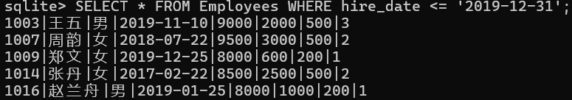

- 创建一个触发器，每插入一条新纪录，就将人事部的所有员工的bonus都提高100。注意，如果当前插入的记录属于人事部的，则该记录应该排除在外，即bonus不应该提高100。
插入以下记录测试：
(1020, '刘善', '女', '2018-01-22', 8200.00, 500.00, 500.00, 2)
(1021, '王君', '女', '2022-11-11', 7500.00, 600.00, 400.00, 1)
(1022, '张武', '男', '2020-01-15', 7300.00, 600.00, 200.00, 3)
(1023, '马文', '男', '2021-04-03', 7000.00, 500.00, 150.00, 1)

CREATE TRIGGER UpdatePersonnelBonus
AFTER INSERT ON Employees
BEGIN
UPDATE Employees
SET bonus = bonus + 100
WHERE dept_id = 1
AND emp_id != NEW.emp_id;
END;

INSERT INTO Employees (emp_id, emp_name, gender, hire_date, base_salary, bonus, subsidy, dept_id)
VALUES
(1020, '刘善', '女', '2018-01-22', 8200.00, 500.00, 500.00, 2),
(1021, '王君', '女', '2022-11-11', 7500.00, 600.00, 400.00, 1),
(1022, '张武', '男', '2020-01-15', 7300.00, 600.00, 200.00, 3),
(1023, '马文', '男', '2021-04-03', 7000.00, 500.00, 150.00, 1);

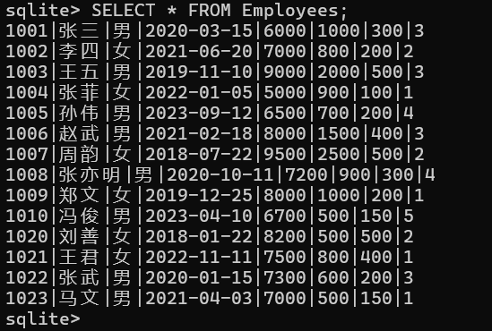

- 出差的员工有：张菲、周韵、赵兰舟、肖秀容。更新出差员工的bonus，如果出差员工的部门所在地location是广州，则bonus增加400，如果location是深圳，则bonus增加500。

UPDATE Employees
SET bonus = bonus + CASE
location
WHEN (SELECT location FROM Departments WHERE dept_id = Employees.dept_id) = '广州' THEN 400
WHEN (SELECT location FROM Departments WHERE dept_id = Employees.dept_id) = '深圳' THEN 500
END
WHERE emp_name IN ('张菲', '周韵', '赵兰舟', '肖秀容');

