1. **配置**

实验环境：SQLite

机器配置：windows11

1. **实验内容**

**建表：**

-- 创建表格 'T2023103896'

CREATE TABLE T2023103896 (

Title TEXT,

Author TEXT,

BookID TEXT PRIMARY KEY,

Price REAL,

Publisher TEXT

);

-- 插入数据

INSERT INTO T2023103896 (Title, Author, BookID, Price, Publisher) VALUES

('计算机原理', '张一平', 'S3092', 20.80, '暨南大学'),

('C 语言程序设计', '李华', 'H1298', 15.30, '电子工业'),

('数据库原理', '王家树', 'D1007', 22.70, '高等教育'),

('计算机网络', '高明', 'S5690', 18.90, '高等教育'),

('Artificial Intelligence', 'P. Winston', 'D2008', 20.80, '电子工业'),

('Expert Systems', 'R. Ullman', 'H3067', 17.00, '清华大学'),

('软件工程', '鲁延琦', 'S2005', 35.00, '暨南大学'),

('Fortran 程序设计', '顾学峰', 'S5006', 18.00, '高等教育'),

('Algorithm Design', 'Cormen', 'A1001', 45.00, 'MIT'),

('Advanced Database Systems', 'Ozsu', 'A1002', 52.00, 'Springer'),

('Applied Cryptography', 'Schneier', 'A1003', 38.50, 'Wiley');

1. ****在T**表的基础上，添加一个属性：出版时间，并插入相应内容****

**首先添加一列作为新属性：**

**ALTER TABLE** T2023103896 **ADD COLUMN PublishDate;**

**然后更新属性内容：**

**UPDATE** T2023103896 **SET PublishDate = 2020 WHERE BookID = 'S3092';**

**UPDATE** T2023103896 **SET PublishDate = 2019 WHERE BookID = 'H1298';**

**UPDATE** T2023103896 **SET PublishDate = 2021 WHERE BookID = 'D1007';**

**UPDATE** T2023103896 **SET PublishDate = 2018 WHERE BookID = 'S5690';**

**UPDATE** T2023103896 **SET PublishDate = 2016 WHERE BookID = 'D2008';**

**UPDATE** T2023103896 **SET PublishDate = 2017 WHERE BookID = 'H3067';**

**UPDATE** T2023103896 **SET PublishDate = 2020 WHERE BookID = 'S2005';**

**UPDATE** T2023103896 **SET PublishDate = 2015 WHERE BookID = 'S5006';**

**UPDATE** T2023103896 **SET PublishDate = 2019 WHERE BookID = 'A1001';**

**UPDATE** T2023103896 **SET PublishDate = 2018 WHERE BookID = 'A1002';**

**UPDATE** T2023103896 **SET PublishDate = 2020 WHERE BookID = 'A1003';**

**展示表格所有内容：**

**SELECT * FROM** T2023103896**;**

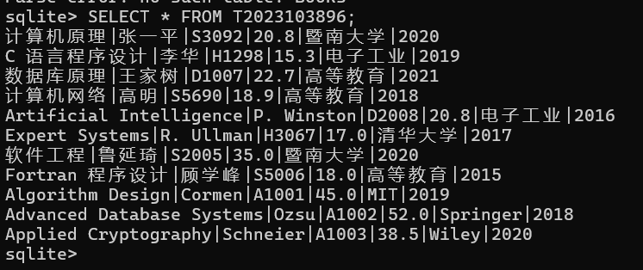

2.****用子查询方式建新表****

新表名以ST开头，后面为学好，新表需包括“书名”和“价格”两个属性。

CREATE TABLE ST2023103896 AS

...> SELECT Title,Price FROM T2023103896;

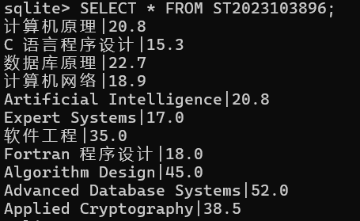

1. ****按“书号”建立索引****

**CREATE INDEX idx_books_bookid ON** T2023103896**(BookID);**

**SELECT name, sql FROM sqlite_master WHERE type='index' AND tbl_name='**T2023103896**';**



****4.用子查询方式建立视图****

**CREATE VIEW View_Books_PriceOver20 AS**

**...> SELECT Title,Author,Price,Publisher FROM** T2023103896

**...> WHERE Price > 20;**

**SELECT name, sql FROM sqlite_master WHERE type='view' AND name = 'View_Books_PriceOver20';**

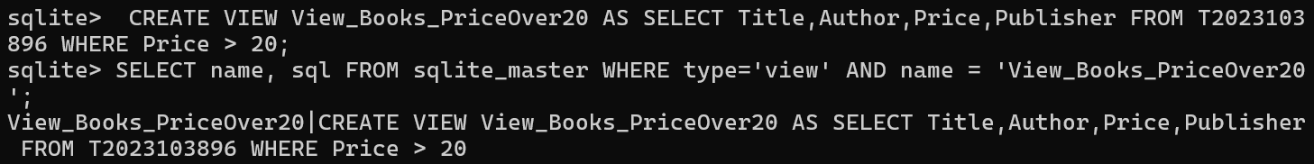

1. ****删除以ST**命名的表****

**DROP TABLE ST2023103896;**

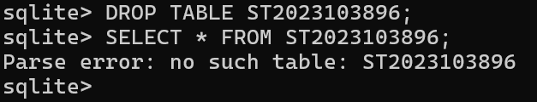

1. ****删除建立的索引和视图****

**DROP INDEX idx_books_bookid;**

**DROP VIEW View_Books_PriceOver20;**

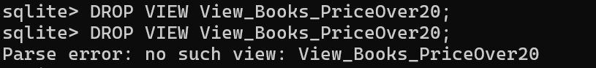

三、个人总结

这次实验我动手操作了SQLite里的建表、索引和视图相关操作。

给Books表加PublishDate列时，一开始没注意字段类型，后来对照书号一条一条更新数据，才摸清了表结构修改的思路。

用子查询建ST2023103896表和View_Books_PriceOver20视图时，一开始漏选了属性，调整后才成功。

一开始删除建立的索引和视图时，我写成“DROP INDEX sqlite_autoindex_

T2023103896_1|;”。然而这个索引是创建idx_books_bookid;时自动创建的主键索引，所以无法删除。