Contents

1- Design specification 6

a. Basic value 6

b. Design spec 6

c. Limit 6

d. Mechanical Specification 6

18mm=709 mil 140mm=5512 mil 21.4mm=843 mil 40mm=1575 mil 6

37.5mm=1476 mil 59mm=2323 mil 128mm=5039 mil 6

Grow 10mm higher 6

2- Calculation 7

a. Power Analysis 7

i. 16V 8

ii. 5V 8

L_Encoder: 5/1K*2=10mA 8

R_Encoder: 5/1K*2=10mA 8

USB V_Bus: 5/200K=0.025mA 8

Total: 10+10+0.025=20.025mA 8

iii. 3.3V 8

Microcontroller: <250mA 8

Others: 0.2mA 8

Mosfet Driver1: 4mA 8

Mosfet Driver2: 4mA 8

Mosfet Driver3: 4mA 8

Total:250+0.2+12=262.2mA 8

iv. Heat 8

1. Power Diode 8

2. Microcontroller 8

3. Passive components circuit 8

4. H-bridge 8

5. 8

b. Mosfet 9

c. H-bridge cap 9

d. Back emf sensing 9

e. Big-Cap Charging circuit 9

f. H-bridge driver circuit 10

g. Zener Diode 14

h. Pre charge circuit calculation 14

14

3- Components choice 14

a. Current sensing 14

i. ZXCT1009 14

ii. ZXCT1012 15

4- Data variables 15

Typedef struct {int16_t data[3]; } MOTOR_DATA_3EL_16BI; 16

Typedef struct {int16_t data[2]; } MOTOR_DATA_2EL_16BI; 16

Typedef struct {int32_t data[3]; } MOTOR_DATA_3EL_32BI; 16

Typedef struct {int32_t data[2]; } MOTOR_DATA_3EL_32BI; 16

Typedef struct {int8_t data[3];} MOTOR_DATA_3EL_8BI; 16

Typedef struct{float data[4][3]; } MOTOR_DATA_CTRL; 16

# 16

Variable Name 16

Comments 16

Read/Write 16

Type 16

Range/Element Range 16

REG_MOTOR_VELOCITY 16

0— Motor 1 velocity 16

1— Motor 2 velocity 16

2— Motor 3 velocity 16

DEVICE_WRITE 16

MOTOR_DATA_3EL_16BI 16

-1023~+1023 16

REG_FAN_VELOCITY 16

0— Fan 1 velocity 16

1— Fan 2 velocity 16

DEVICE_WRITE 16

MOTOR_DATA_2EL_16BI 16

0~1023 16

REG_MOTOR_FB_RPM 16

0— Motor1 RPM 16

1— Motor2 RPM 16

DEVICE_READ 16

MOTOR_DATA_2EL_32BI 16

REG_FLIPPER_FB_POSITION 16

0— Pot 1 16

1— Pot 2 16

DEVICE_READ 16

MOTOR_DATA_2EL_16BI 16

0~1023 16

REG_MOTOR_FB_CURRENT 16

0— Motor 1 current 16

1— Motor 2 current 16

2— Motor 3 current 16

DEVICE_READ 16

MOTOR_DATA_3EL_16BI 16

0~1023 16

REG_MOTOR_ENCODER_COUNT 16

0— Motor 1 Encoder Count 16

1— Motor 2 Encoder Count 16

DEVICE_READ 16

MOTOR_DATA_2EL_32BI 16

REG_MOTOR_KP 16

REG_MOTOR_KP[i][j] 16

i: control mode 16

j: 0-Motor1, 1-Motor 2, 2-Motor 3 16

DEVICE_WRITE 16

MOTOR_DATA_CTRL 16

REG_MOTOR_KI 17

REG_MOTOR_KI[i][j] 17

i: control mode 17

j: 0-Motor1, 1-Motor 2, 2- 17

Motor 3 17

DEVICE_WRITE 17

MOTOR_DATA_CTRL 17

REG_MOTOR_KD 17

REG_MOTOR_KD[i][j] 17

i: control mode 17

j: 0-Motor1, 1-Motor 2, 2- 17

Motor 3 17

DEVICE_WRITE 17

MOTOR_DATA_CTRL 17

REG_MOTOR_CTRL_MODE 17

0— Motor 1 ctrl mode 17

1— Motor 2 ctrl mode 17

2— Motor 3 ctrl mode 17

DEVICE_WRITE 17

MOTOR_DATA_3EL_16BI 17

REG_MOTOR_FAULT_FLAG 17

0— Motor 1 driver fault 17

1— Motor 2 driver fault 17

DEVICE_READ 17

MOTOR_DATA_2EL_8BI 17

REG_MOTOR_TEMP 17

0— Thermistor 1 17

1— Thermistor 2 17

2— On board thermal chip 17

DEVICE_READ 17

MOTOR_DATA_3EL_16BI 17

REG_PWR_BAT_VOLTAGE 17

0— CELL_A voltage 17

1— CELL_B voltage 17

DEVICE_READ 17

MOTOR_DATA_2EL_16BI 17

REG_PWR_TOTAL_CURRENT 17

DEVICE_READ 17

Uint16_t 17

0~1023 17

5- Pin Configuration 17

Available Pins: 19

Reserved Pins: 19

6- Part list 22

1. Design specification
   1. Basic value

Battery voltage: 10~16.5V

Max Current: 10.9A

Highest PWM driving frequency: 10K

* 1. Design spec

System input voltage: 24V

Max Current: 20A

* 1. Limit

Battery max current limit: 18A per cell

Motor cut off current: 21A

Surge cut off time: 30ms

* 1. Motors:

Driving Motor: 770-8525F

<http://www.nichibo-motor.com/proType_e.php?proType=65>

Flipper motor: HD3SFN-6035

http://www.nichibo-motor.com/proType_e.php?proType=53

1. Calculation
   1. Power Analysis
      1. 16V
      2. 5V

L_Encoder: 5/1K*2=10mA

R_Encoder: 5/1K*2=10mA

USB V_Bus: 5/200K=0.025mA

Total: 10+10+0.025=20.025mA

* + 1. 3.3V

Microcontroller: <250mA

Others: 0.2mA

Mosfet Driver1: 4mA

Mosfet Driver2: 4mA

Mosfet Driver3: 4mA

Total:250+0.2+12=262.2mA

* + 1. Heat
       1. Power Diode
       2. Microcontroller
       3. Passive components circuit
       4. H-bridge

Current : 20A

Field discharge time:<5us

Power: (assume current change is linear)

U-voltage drop on the diode

I-max current flowing into the diode

T-field collapse time

f- driving PWM signal frequency

* 1. Mosfet

Max stall current of motors is 10.9A, so the mosfet should be able to support 20A at least. Drain-to-source voltage should be around 30V.

* 1. H-bridge cap
  2. Back emf sensing

Voltage divider:

Scale battery voltage to 3.3 logic level:

R12=10K(5%)

R11=39K(5%)

R12=10K(5%)

R11=43K(5%)

* 1. Big-Cap Charging circuit

R=3.6 ohm

Choose C=10mF

Rising time:

Fully charge time

Try 1mF,10mF,100mF,1000mF,

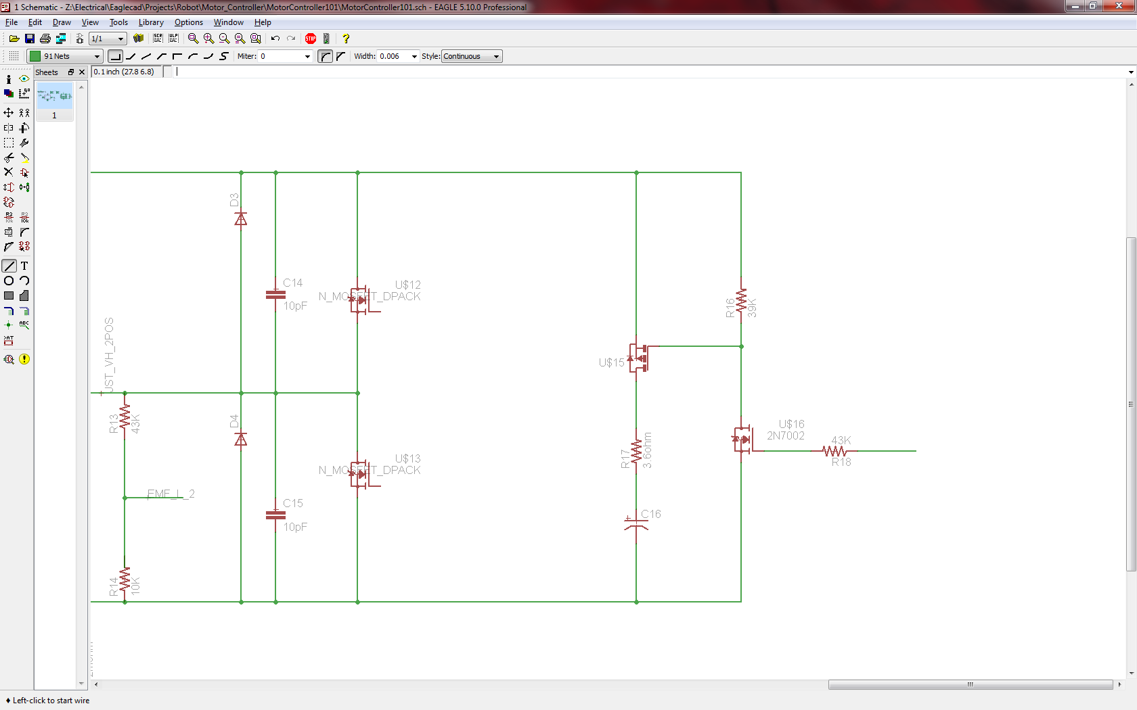

* 1. H-bridge driver circuit



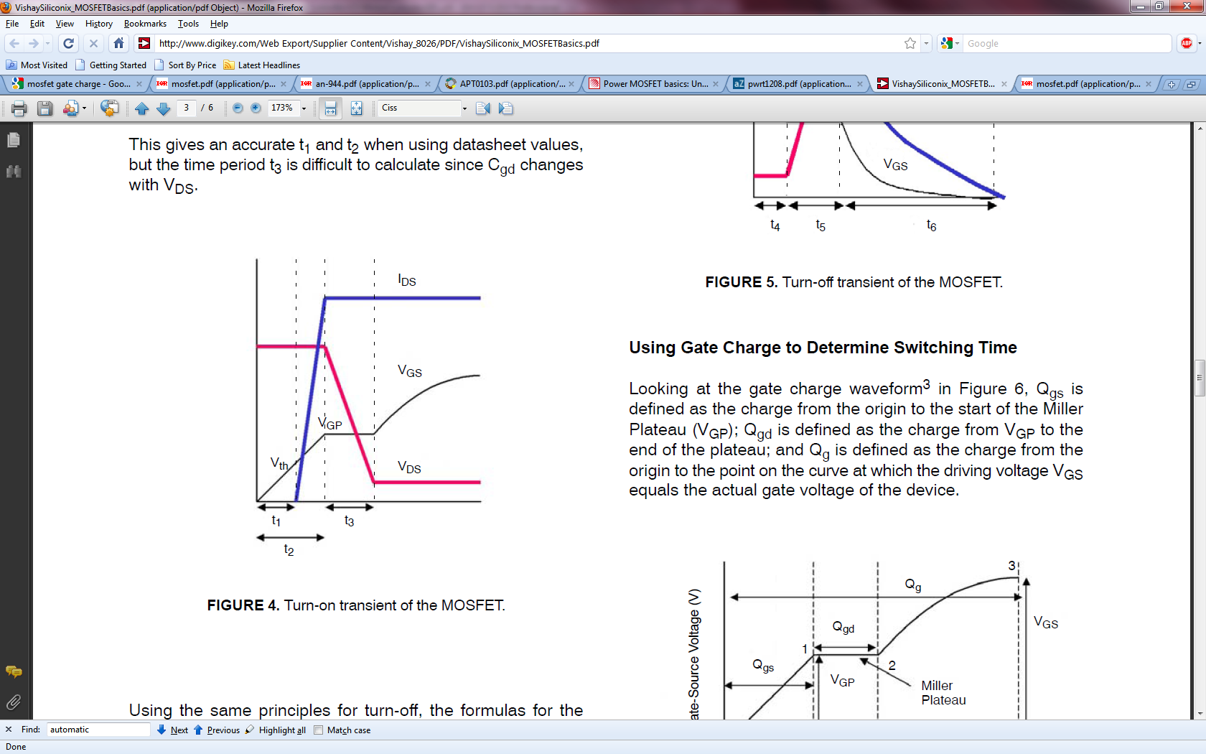

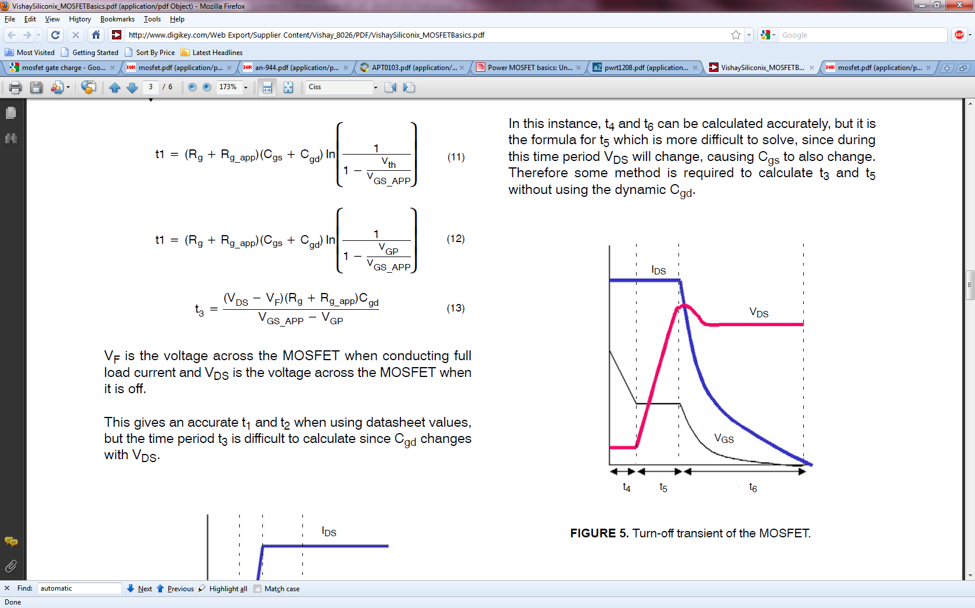

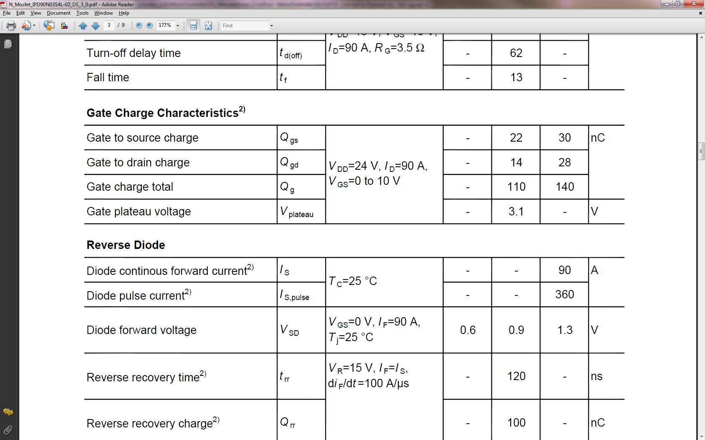

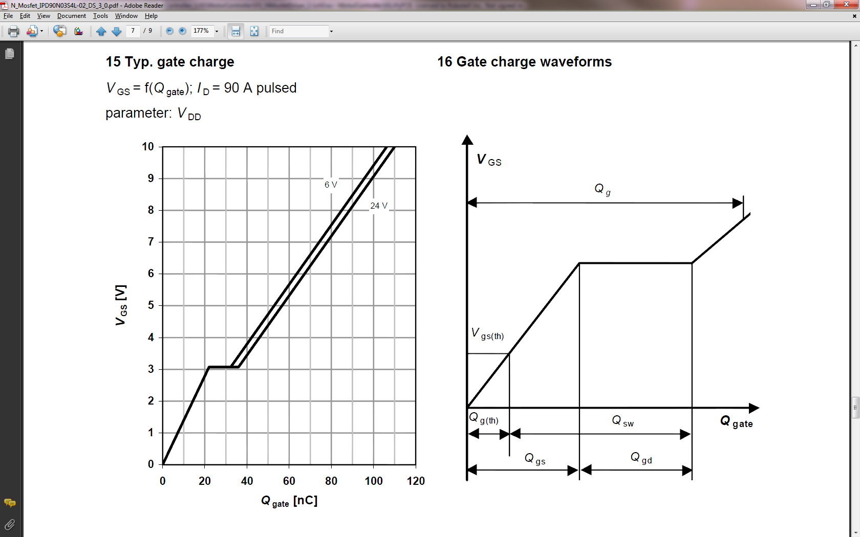

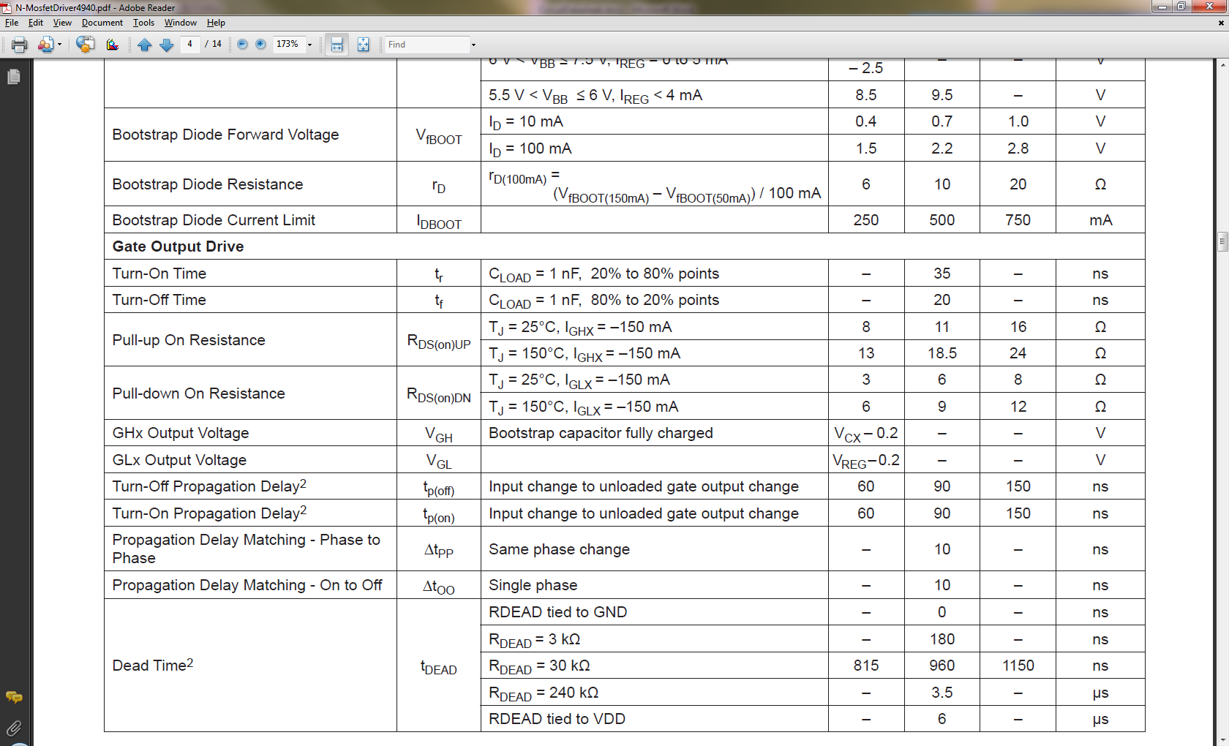

(20 is not enough according to experiment)

* 1. Zener Diode

Voltage drop: smaller than N-mosfet Vds 30V, bigger than the max battery voltage plus two catch diodes’ voltage drop: 16.5+0.5*2=17.5V

* 1. Pre charge circuit calculation



1. Components choice
   1. Current sensing

Accuracy, speed, range, repeatability, cost

* + 1. ZXCT1009

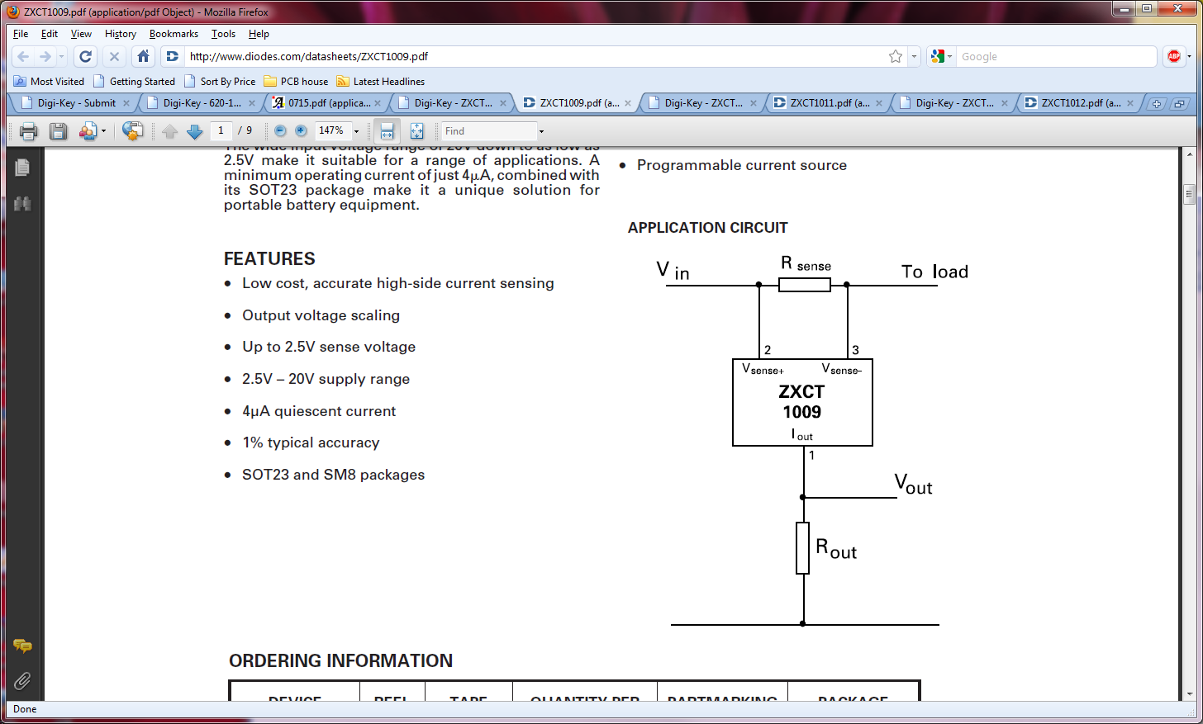

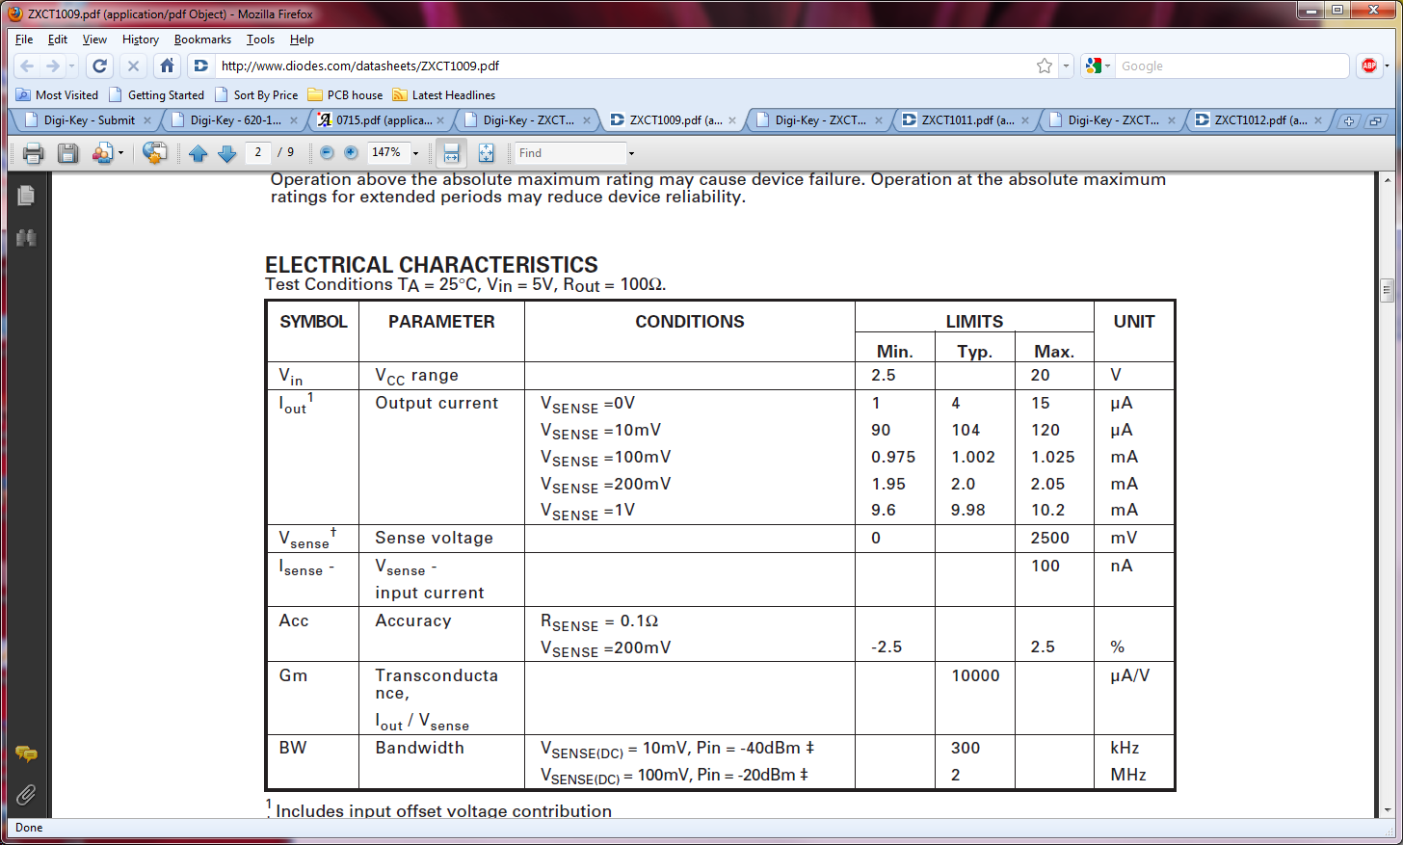

When I=20A, R_sense=0.001 ohm, V_sense=20mV, I_out_max=240uA,

R_out=3.3/I_out_max=13750 ohm,

Choose R_out=130K ohm

Testing result:

R=43K, 1.3V-2.38A

R=43K/(22/3.3/(2.38/1.3))=11.8K

* + 1. ZXCT1012

1. Data variables

Typedef struct {int16_t data[3]; } MOTOR_DATA_3EL_16BI;

Typedef struct {int16_t data[2]; } MOTOR_DATA_2EL_16BI;

Typedef struct {int32_t data[3]; } MOTOR_DATA_3EL_32BI;

Typedef struct {int32_t data[2]; } MOTOR_DATA_3EL_32BI;

Typedef struct {int8_t data[3];} MOTOR_DATA_3EL_8BI;

Typedef struct{float data[4][3]; } MOTOR_DATA_CTRL;

|  |  |  |  |  |  |
| --- | --- | --- | --- | --- | --- |
| # | Variable Name | Comments | Read/Write | Type | Range/Element Range |
|  | REG_MOTOR_VELOCITY | 1. Motor 1 velocity 2. Motor 2 velocity 3. Motor 3 velocity | DEVICE_WRITE | MOTOR_DATA_3EL_16BI | -1023~+1023 |
|  | REG_FAN_VELOCITY | 1. Fan 1 velocity 2. Fan 2 velocity | DEVICE_WRITE | MOTOR_DATA_2EL_16BI | 0~1023 |
|  | REG_MOTOR_FB_RPM | 1. Motor1 RPM 2. Motor2 RPM | DEVICE_READ | MOTOR_DATA_2EL_32BI |  |
|  | REG_FLIPPER_FB_POSITION | 1. Pot 1 2. Pot 2 | DEVICE_READ | MOTOR_DATA_2EL_16BI | 0~1023 |
|  | REG_MOTOR_FB_CURRENT | 1. Motor 1 current 2. Motor 2 current 3. Motor 3 current | DEVICE_READ | MOTOR_DATA_3EL_16BI | 0~1023 |
|  | REG_MOTOR_ENCODER_COUNT | 1. Motor 1 Encoder Count 2. Motor 2 Encoder Count | DEVICE_READ | MOTOR_DATA_2EL_32BI |  |
|  | REG_MOTOR_KP | REG_MOTOR_KP[i][j]  i: control mode  j: 0-Motor1, 1-Motor 2, 2-Motor 3 | DEVICE_WRITE | MOTOR_DATA_CTRL |  |
|  | REG_MOTOR_KI | REG_MOTOR_KI[i][j]  i: control mode  j: 0-Motor1, 1-Motor 2, 2-  Motor 3 | DEVICE_WRITE | MOTOR_DATA_CTRL |  |
|  | REG_MOTOR_KD | REG_MOTOR_KD[i][j]  i: control mode  j: 0-Motor1, 1-Motor 2, 2-  Motor 3 | DEVICE_WRITE | MOTOR_DATA_CTRL |  |
|  | REG_MOTOR_CTRL_MODE | 1. Motor 1 ctrl mode 2. Motor 2 ctrl mode 3. Motor 3 ctrl mode | DEVICE_WRITE | MOTOR_DATA_3EL_16BI |  |
|  | REG_MOTOR_FAULT_FLAG | 1. Motor 1 driver fault 2. Motor 2 driver fault | DEVICE_READ | MOTOR_DATA_2EL_8BI |  |
|  | REG_MOTOR_TEMP | 1. Thermistor 1 2. Thermistor 2 3. On board thermal chip | DEVICE_READ | MOTOR_DATA_3EL_16BI |  |
|  | REG_PWR_BAT_VOLTAGE | 1. CELL_A voltage 2. CELL_B voltage | DEVICE_READ | MOTOR_DATA_2EL_16BI |  |
|  | REG_PWR_TOTAL_CURRENT |  | DEVICE_READ | Uint16_t | 0~1023 |

1. Pin Configuration

|  |  |  |  |  |  |  |  |
| --- | --- | --- | --- | --- | --- | --- | --- |
|  | Pin Name | Pin # | Description | Funtion | Input/Output | Digital/Analog | Comment |
| 1 | **RP20**/PMRD/CN14/RD5 | 53 | L_Encoder_A | IC | Input | Digital | IC1 |
| 2 | **RP25**/PMWR/CN13/RD4 | 52 | L_Encoder_B | IC | Input | Digital | IC2 |
| 3 | AN14/CTPLS/**RP14**/PMA1/CN32/RB14 | 29 | M1_AHI | IO | Output | Digital |  |
| 4 | **RP16**/USBID/CN71/RF3 | 33 | M1_ALO | PWM | Output | Digital | OC1 |
| 5 | RTCC/DMLN/**RP2**/CN53/RD8 | 42 | M1_BHI | IO | Output | Digital |  |
| 6 | AN15/**RP29**/REFO/PMA0/CN12/RB15 | 30 | M1_BLO | PWM | Output | Digital | OC2 |
| 7 | VCPCON/**RP24**/CN50/RD1 | 49 | M1_Fault | IO | Input | Digital |  |
| 8 | TMS/CVREF/AN10/PMA13/CN28/RB10 | 23 | M1_LeftBackEMF | A/D | Input | Analog |  |
| 9 | TDO/AN11/PMA12/CN29/RB11 | 24 | M1_RightBackEMF | A/D | Input | Analog |  |
| 10 | TCK/AN12/PMA11/CTED2/CN30/RB12 | 27 | M1_Current | A/D | Input | Analog |  |
| 11 | **RP22**/PMBE/CN52/RD3 | 51 | R_Encoder_A | IC | Input | Digital | IC3 |
| 12 | DPH/**RP23**/CN51/RD2 | 50 | R_Encoder_B | IC | Input | Digital | IC4 |
| 13 | C1IND/**RP21**/PMA5/CN8/RG6 | 4 | M2_AHI | IO | Output | Digital |  |
| 14 | C1INC/**RP26**/PMA4/CN9/RG7 | 5 | M2_ALO | PWM | Output | Digital | OC3 |
| 15 | C2IND/**RP19**/PMA3/CN10/RG8 | 6 | M2_BHI | IO | Output | Digital |  |
| 16 | **RP27**/PMA2/C2INC/CN11/RG9 | 8 | M2_BLO | PWM | Output | Digital | OC4 |
| 17 | PMD5/CN63/RE5 | 1 | M2_Fault | IO | Input | Digital |  |
| 18 | PGEC3/AN5/C1INA/VBUSON/**RP18**/CN7/RB5 | 11 | M2_LeftBackEMF | A/D | Input |  |  |
| 19 | PGED3/AN4**/**C1INB/USBOEN/**RP28**/CN6/RB4 | 12 | M2_RightBackEMF | A/D | Input |  |  |
| 20 | AN3/C2INA/VPIO/CN5/RB3 | 13 | M2_Current | A/D | Input |  |  |
| 21 | SOSCI/C3IND/CN1/RC13 | 47 | M3_AHI | IO | Output | Digital |  |
| 22 | DMH/**RP11**/INT0/CN49/RD0 | 46 | M3_ALO | PWM | Output | Digital | OC5 |
| 23 | SOSCO/T1CK/C3INC/**RPI37**/CN0/RC14 | 48 | M3_BHI | IO | Output | Digital |  |
| 24 | **RP12**/PMCS1/CN56/RD11 | 45 | M3_BLO | PWM | Output | Digital | OC6 |
| 25 | AN8/**RP8**/CN26/RB8 | 21 | M3_Current | A/D | Input | Analog |  |
| 26 | AN9/**RP9**/PMA7/CN27/RB9 | 22 | M3_POSFB_1 | A/D | Input | Analog |  |
| 27 | TDI/AN13/PMA10/CTED1/CN31/RB13 | 28 | M3_POSFB_2 | A/D | Input | Analog |  |
| 28 | C3INA/CN16/RD7 | 55 | Fan1_Fail | IO | Input | Digital |  |
| 29 | C3INB/CN15/RD6 | 54 | Fan2_Fail | IO | Input | Digital |  |
| 30 | SCL3/PMD6/CN64/RE6 | 2 | FAN_I2C_SCL | I2C | Output | Digital |  |
| 31 | SDA3/PMD7/CN65/RE7 | 3 | FAN_I2C_SDA | I2C | Output | Digital |  |
| 32 | VCMPST2/CN69/RF1 | 59 | Cell_A_MOS | IO | Output | Digital |  |
| 33 | VBUSST/VCMPST1/CN68/RF0 | 58 | Cell_B_MOS | IO | Output | Digital |  |
| 34 | AN2/C2INB/VMIO**/RP13**/CN4/RB2 | 14 | Total_Cell_Current | AD | Input | Analog |  |
| 35 | PGEC1/AN1/VREF-/**RP1**/CN3/RB1 | 15 | V_Cell_A | AD | Input | Analog |  |
| 36 | PGED1/AN0/VREF+/**RP0**/PMA6/CN2/RB0 | 16 | V_Cell_B | AD | Input | Analog |  |
| 37 | SDA2/**RP10**/PMA9/CN17/RF4 | 31 | SMBUS_A_DA | I2C | Output | Digital |  |
| 38 | SCL2/**RP17**/PMA8/CN18/RF5 | 32 | SMBUS_A_CL | I2C | Output | Digital |  |
| 39 | DPLN/SDA1/**RP4**/CN54/RD9 | 43 | SMBUS_B_DA | I2C | Output | Digital |  |
| 40 | SCL1/**RP3**/PMCS2/CN55/RD10 | 44 | SMBUS_B_CL | I2C | Output | Digital |  |
|  |  |  | Servo2_Input | IC | Input | Digital | IC6 |
|  |  |  | Servo1_Input | IC | Input | Digital | IC5 |
|  |  |  | UART_TX | TX | Output | Digital |  |
|  |  |  | UART_RX | RX | Input | Digital |  |
|  |  |  | M3_Fault | IO | Input | Digital |  |
|  |  |  |  |  |  |  |  |

Available Pins:

|  |  |  |  |
| --- | --- | --- | --- |
|  |  |  |  |
| 1 |  |  |  |
| 2 |  |  |  |

Reserved Pins:

|  |  |  |  |
| --- | --- | --- | --- |
|  |  |  |  |
| 1 | MCLR | 7 |  |
| 2 | VSS | 9 |  |
| 3 | VDD | 10 |  |
| 4 | PGEC2/AN6/**RP6**/CN24/RB6 | 17 |  |
| 5 | PGED2/AN7/**RP7**/RCV/CN25/RB7 | 18 |  |
| 6 | AVDD | 19 |  |
| 7 | AVSS | 20 |  |
| 8 | VSS | 25 |  |
| 9 | VDD | 26 |  |
| 10 | VBUS | 34 |  |
| 11 | VUSB | 35 |  |
| 12 | D-/RG3 | 36 |  |
| 13 | D+/RG2 | 37 |  |
| 14 | VDD | 38 |  |
| 15 | OSCI/CLKI/CN23/RC12 | 39 |  |
| 16 | OSCO/CLKO/CN22/RC15 | 40 |  |
| 17 | VSS | 41 |  |
| 18 | VCAP/VDDCORE | 56 |  |
| 19 | ENVREG | 57 |  |
| 20 | PMD0/CN58/RE0 | 60 |  |
| 21 | PMD1/CN59/RE1 | 61 |  |
| 22 | PMD2/CN60/RE2 | 62 |  |
| 23 | PMD3/CN61/RE3 | 63 |  |
| 24 | PMD4/CN62/RE4 | 64 |  |

Analog Register:

|  |  |  |  |  |  |  |  |  |  |  |  |  |  |  |  |
| --- | --- | --- | --- | --- | --- | --- | --- | --- | --- | --- | --- | --- | --- | --- | --- |
| AN15 | AN14 | AN13 | AN12 | AN11 | AN10 | AN9 | AN8 | AN7 | AN6 | AN5 | AN4 | AN3 | AN2 | AN1 | AN0 |
| 1 | 1 | 0 | 0 | 0 | 0 | 0 | 0 | 1 | 1 | 0 | 0 | 0 | 0 | 0 | 0 |

I/O pin mapping:

|  |  |  |  |  |  |  |  |  |  |  |  |  |  |  |  |
| --- | --- | --- | --- | --- | --- | --- | --- | --- | --- | --- | --- | --- | --- | --- | --- |
| _TRISB15 | _TRISB14 | _TRISB13 | _TRISB12 | _TRISB11 | _TRISB10 | _TRISB9 | _TRISB8 | _TRISB7 | _TRISB6 | _TRISB5 | _TRISB4 | _TRISB3 | _TRISB2 | _TRISB1 | _TRISB0 |
| 0 | 0 |  |  |  |  |  |  |  |  |  |  |  |  |  |  |

|  |  |  |  |  |  |  |  |  |  |  |  |  |  |  |  |
| --- | --- | --- | --- | --- | --- | --- | --- | --- | --- | --- | --- | --- | --- | --- | --- |
| _TRISC15 | _TRISC14 | _TRISC13 | _TRISC12 | _TRISC11 | _TRISC10 | _TRISC9 | _TRISC8 | _TRISC7 | _TRISC6 | _TRISC5 | _TRISC4 | _TRISC3 | _TRISC2 | _TRISC1 | _TRISC0 |
|  | 0 | 0 |  |  |  |  |  |  |  |  |  |  |  |  |  |

|  |  |  |  |  |  |  |  |  |  |  |  |  |  |  |  |
| --- | --- | --- | --- | --- | --- | --- | --- | --- | --- | --- | --- | --- | --- | --- | --- |
| _TRISD15 | _TRISD14 | _TRISD13 | _TRISD12 | _TRISD11 | _TRISD10 | _TRISD9 | _TRISD8 | _TRISD7 | _TRISD6 | _TRISD5 | _TRISD4 | _TRISD3 | _TRISD2 | _TRISD1 | _TRISD0 |
|  |  |  |  | 0 | 0 | 0 | 0 | 1 | 1 | 1 | 1 | 1 | 1 | 1 | 0 |

|  |  |  |  |  |  |  |  |  |  |  |  |  |  |  |  |
| --- | --- | --- | --- | --- | --- | --- | --- | --- | --- | --- | --- | --- | --- | --- | --- |
| _TRISE15 | _TRISE14 | _TRISE13 | _TRISE12 | _TRISE11 | _TRISE10 | _TRISE9 | _TRISE8 | _TRISE7 | _TRISE6 | _TRISE5 | _TRISE4 | _TRISE3 | _TRISE2 | _TRISE1 | _TRISE0 |
|  |  |  |  |  |  |  |  | 0 | 0 | 1 |  |  |  |  |  |

|  |  |  |  |  |  |  |  |  |  |  |  |  |  |  |  |
| --- | --- | --- | --- | --- | --- | --- | --- | --- | --- | --- | --- | --- | --- | --- | --- |
| _TRISF15 | _TRISF14 | _TRISF13 | _TRISF12 | _TRISF11 | _TRISF10 | _TRISF9 | _TRISF8 | _TRISF7 | _TRISF6 | _TRISF5 | _TRISF4 | _TRISF3 | _TRISF2 | _TRISF1 | _TRISF0 |
|  |  |  |  |  |  |  |  |  |  | 0 | 0 | 0 |  | 0 | 0 |

|  |  |  |  |  |  |  |  |  |  |  |  |  |  |  |  |
| --- | --- | --- | --- | --- | --- | --- | --- | --- | --- | --- | --- | --- | --- | --- | --- |
| _TRISG15 | _TRISG14 | _TRISG13 | _TRISG12 | _TRISG11 | _TRISG10 | _TRISG9 | _TRISG8 | _TRISG7 | _TRISG6 | _TRISG5 | _TRISG4 | _TRISG3 | _TRISG2 | _TRISG1 | _TRISG0 |
|  |  |  |  |  |  | 0 | 0 | 0 | 0 |  |  |  |  |  |  |

1. Part list