* Snapshot of Kanban board :-

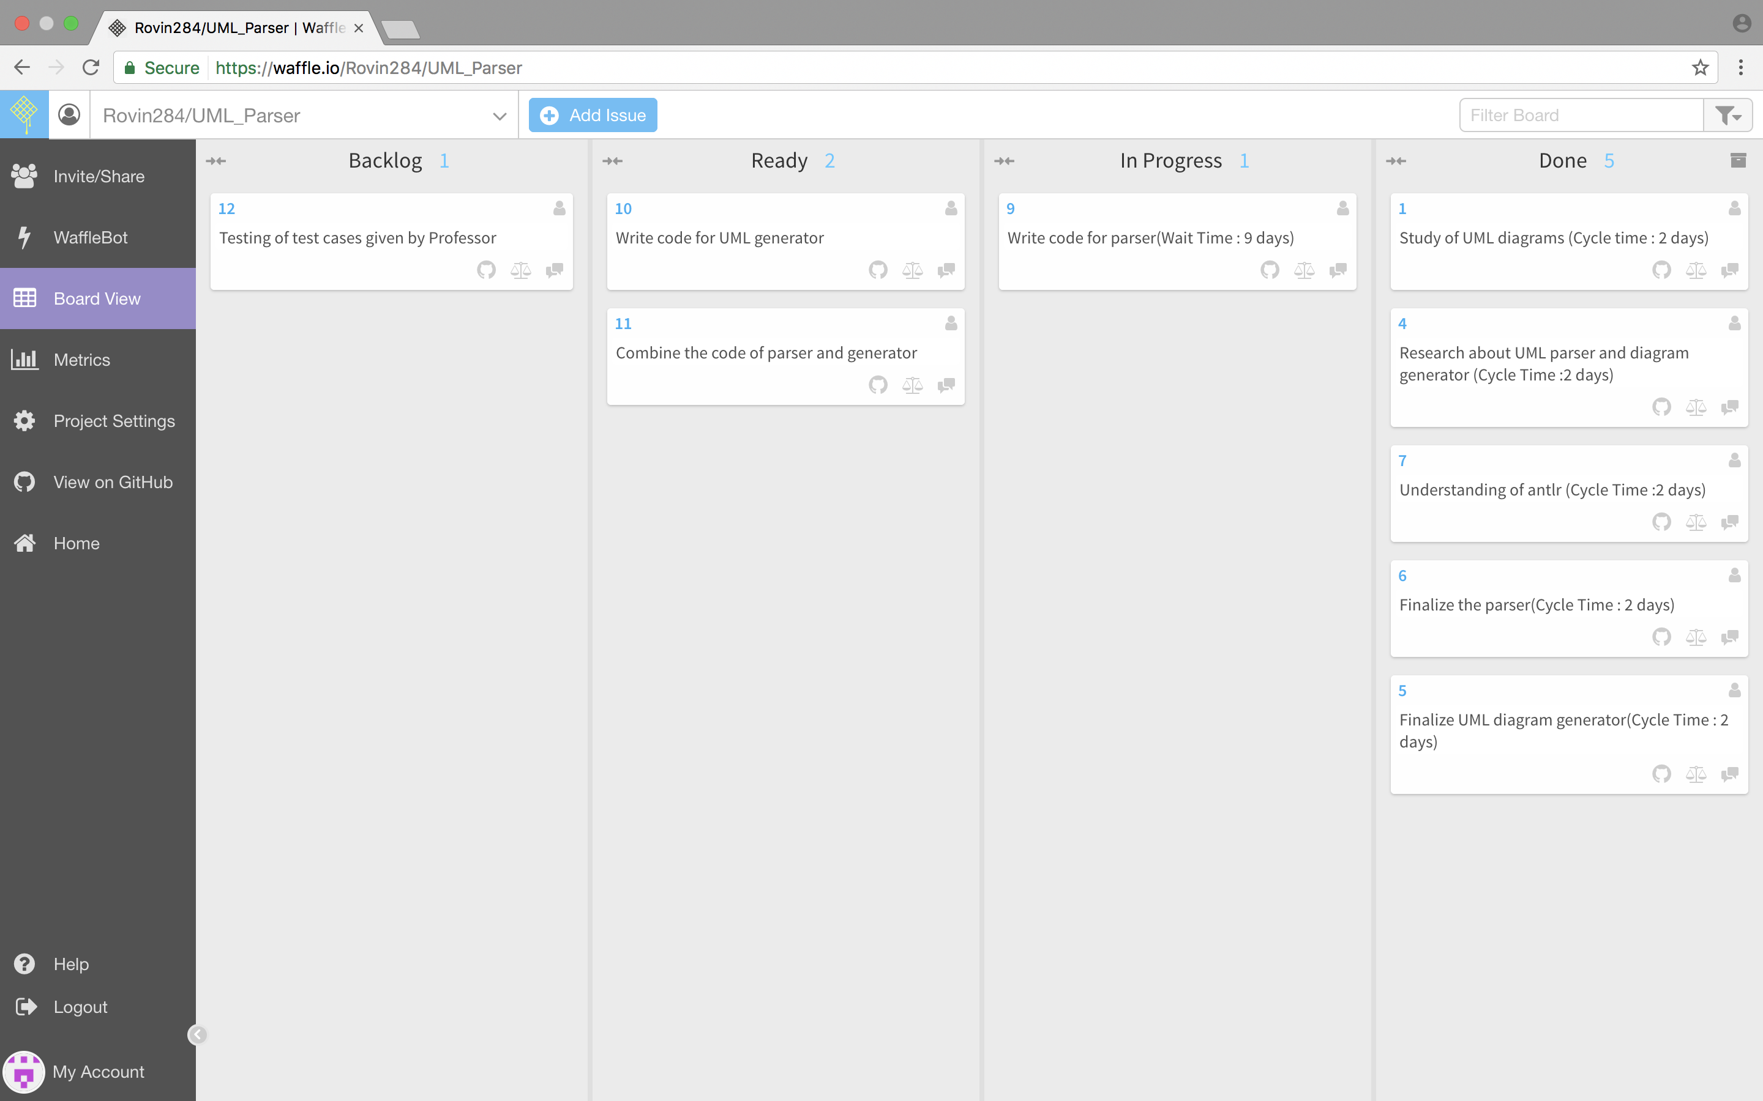

* URL link to Waffle Board -: <https://waffle.io/Rovin284/UML_Parser>
* URL link to GitHub Repository -: <https://github.com/Rovin284/UML_Parser.git>
* “Wait Time” and “Total Cycle Time” for all the cards in “In Progress” and “Done” column on the board -:

|  |  |  |  |
| --- | --- | --- | --- |
| **Card** | **Column** | **Wait Time** | **Cycle Time** |
| Study of UML diagrams | Done | - | 2 days |
| Understanding the requirements of UML parser | Done | - | 1 day |
| Understanding GitHub repository and its setup | Done | - | 1 day |
| Research about UML parser and diagram generator | Done | - | 1 day |
| Understanding of antlr | Done | - | 2 days |
| Understanding of Java Parser | In Progress | - | 2 days |
| Finalize the parser | Done |  | 2 days |
| Finalize UML generator | In Progress | - | 2 days |
| Write code for Parser | In Progress | 9 days | - |