**CS111-Computer Programming**

**Windows Form Application:**

**CookUp**

Masarap Kahit!Basta Masarap!

**By:**

**Group 11**

**BSIT-1204**

**Group Members:**

Codillio, Ezekiel Robin

Ajero, Cassandra Jazer

Algaba, Iel Denz

Lagao,Gerald

**May 2023**

1. **INTRODUCTION**

CookUp is an online cook book that offers a vast collection of delicious recipes, complete with detailed descriptions and step-by-step procedures. Our user-friendly platform is designed to make cooking easy and accessible for everyone, regardless of skill level. In this documentation, you will find everything you need to know about using CookUp, including how to navigate the application, how to search for and save your favourite recipes, and how to create and share your own recipes with our community of passionate foodies. We hope that this documentation will provide you with all the information you need to start cooking up a storm with CookUp!

1. **2.1 Sketch**

This is the Sketch of our Application.

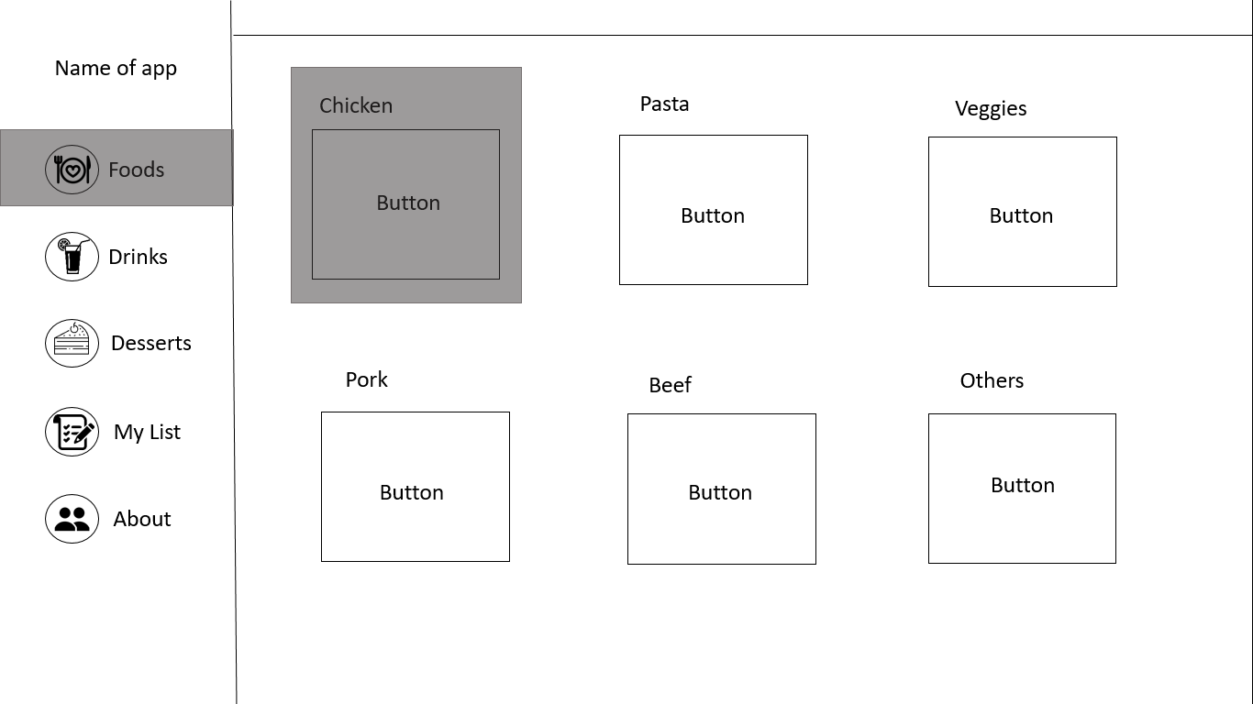

**II**. **2.2 TOE**

The table below is the TOE of our first form.

|  |  |  |
| --- | --- | --- |
| Task | Object | Event |
|  | lblapp |  |
| Show food recipe | btnfoods | click |
| Show variation of drinks | btndrinks | click |
| Show variation of desserts | btndessert | click |
| Show listed recipes | btnlist | click |
| Show information about app | btnabout | click |
|  | lblchicken |  |
|  | lblpasta |  |
|  | lblveggies |  |
|  | lblpork |  |
|  | lblbeef |  |
|  | lblfish |  |
| Show chicken styles | btnchicken | click |
| Show pasta options | btnpasta | click |
| Show vegetables recipes | btnveggies | click |
| Show pork styles | btnporkb | click |
| Show beef styles | btnbeef | click |
| Show fish styles | btnfish | click |

1. **DESIGN**

This is a visual representation of our Design.

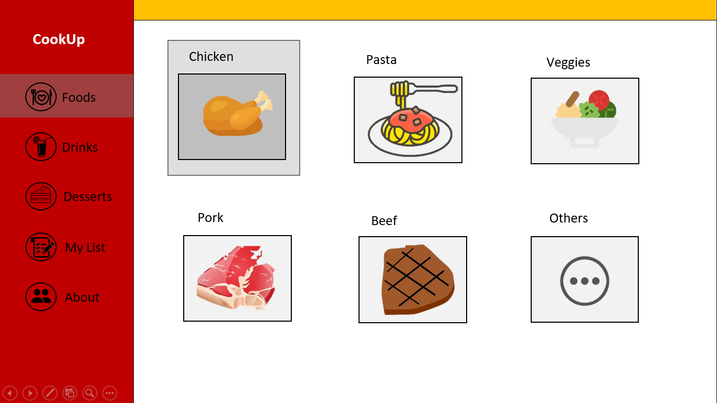

1. **4.1 Pseudocode**

Start

btn_foods_selection = Button("Foods Selection")

btn_drinks_selection = Button("DrinksSelection")

btn_desserts_selection = Button("Desserts Selection")

btn_mylist= Button("My List")

btn_about= Button("About")

btn_chicken = Button("Chicken")

btn_pasta = Button("Pasta")

btn_veggies = Button("Veggies")

btn_pork = Button("Pork")

btn_beef = Button("Beef")

btn_others = Button("Others")

function handleButtonClick(event):

if event.target == btn_foods_selection:

showFoodsSelection()

else if event.target == btn_drinks _selection:

showDrinksSelection()

else if event.target == btn_desserts _selection:

showDessertsSelection()

else if event.target == btn_mylist:

showMyList()

else if event.target == btn_about:

showAbout()

if event.target == btn_chicken:

showChicken()

else if event.target == btn_pasta:

showPasta()

else if event.target == btn_veggies:

showVeggies()

else if event.target == btn_pork:

showPork()

else if event.target == btn_beef:

showBeef()

else if event.target == btn_others:

showOthers()

function showFoodSelectionOptions():{

// Show the list of available food options, including chicken, pasta, veggies, pork, beef, and others}

function showChickenOptions():{

// Show the different chicken recipes available, including Japanese, Korean, Filipino, Middle-Eastern, Thai, and Italian-American styles}

btn_food_selection.addEventListener("click", handleButtonClick);

btn_chicken.addEventListener("click", handleButtonClick);

btn_pasta.addEventListener("click", handleButtonClick);

btn_veggies.addEventListener("click", handleButtonClick);

btn_pork.addEventListener("click", handleButtonClick);

btn_beef.addEventListener("click", handleButtonClick);

btn_others.addEventListener("click", handleButtonClick);

btn_back.addEventListener("click", handleButtonClick);

End

**IV. 4.2 FLOW CHART**

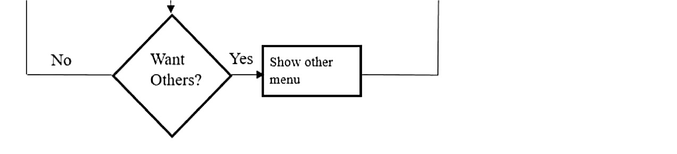

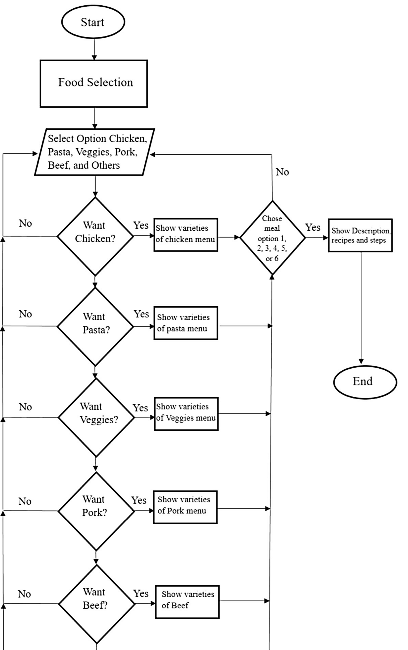

1. **SUMMARY**

CookUp is an online cook book that provides a wide range of mouth-watering recipes with detailed descriptions and step-by-step procedures. The user-friendly platform is accessible to everyone regardless of their cooking skills. This documentation offers a comprehensive guide on how to navigate the application and save favourite recipes. By following this documentation, users will have all the information they need to start cooking up a storm with CookUp.

**References:**

1. https://youtu.be/znANTJNf8wI