**Master Data**

**Inventory Location:**

When Create- (http://103.78.53.73:750/paragoan_dev/inventory/manage/locations2.php?)

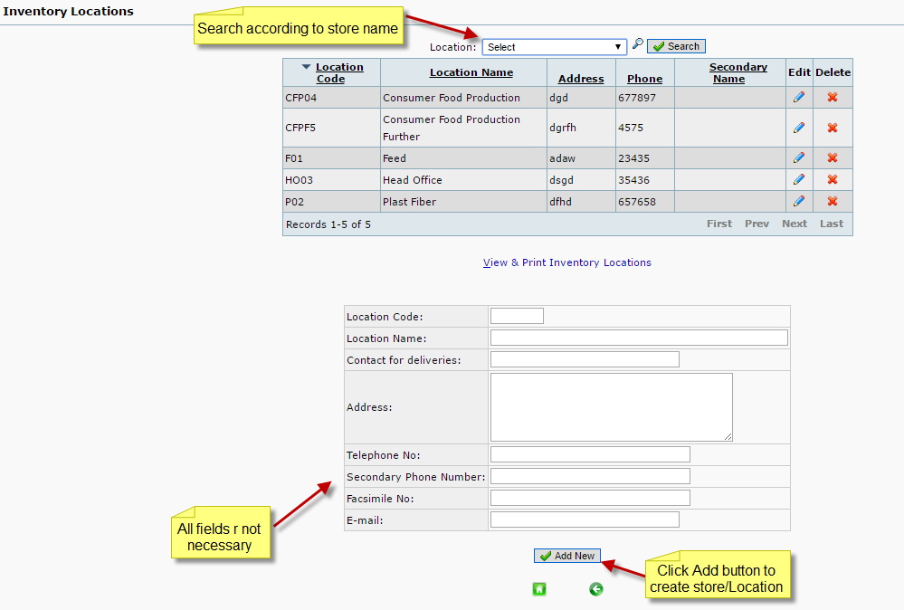

When click edit Icon- (<http://103.78.53.73:750/paragoan_dev/inventory/manage/locations2.php>?)

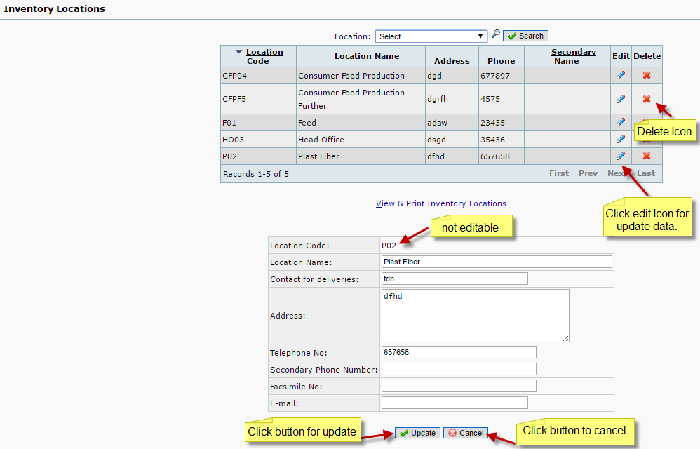

When click delete Icon- (http://103.78.53.73:750/paragoan_dev/inventory/manage/locations2.php?)

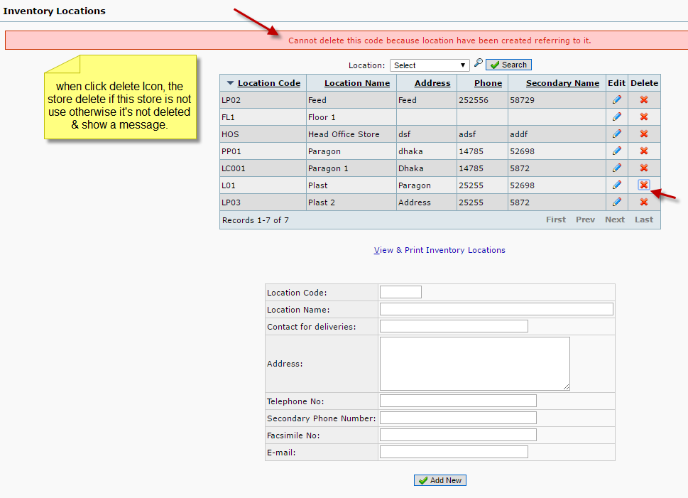

**Units of Measure**

When Create- (<http://103.78.53.73:750/paragoan_dev/inventory/manage/item_unit2.php>?)

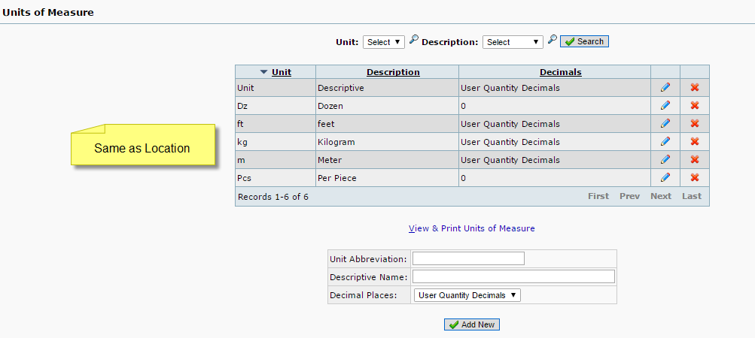

When click edit Icon- (<http://103.78.53.73:750/paragoan_dev/inventory/manage/item_unit2.php>?)

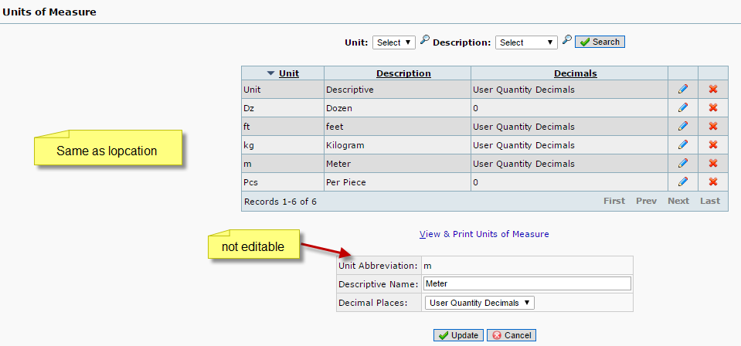

When click delete Icon- (<http://103.78.53.73:750/paragoan_dev/inventory/manage/item_unit2.php>?)

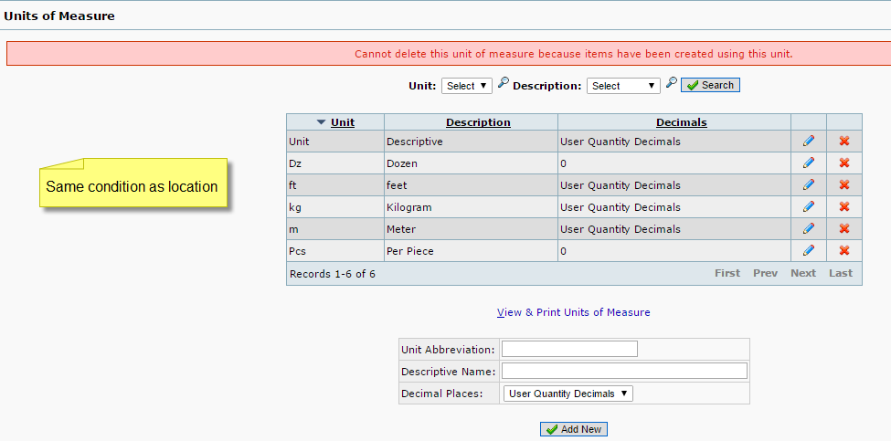

**Category**

When Create- (<http://103.78.53.73:750/paragoan_dev/inventory/manage/item_categories.php>?)

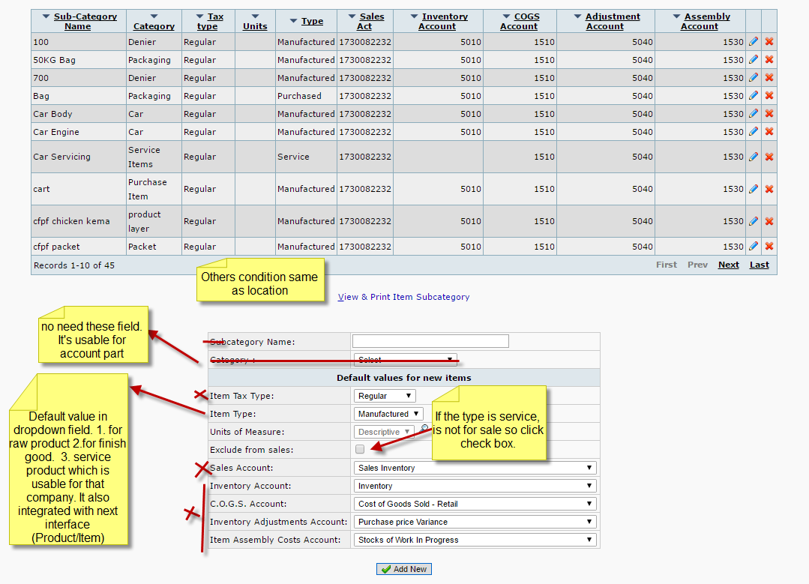

**Items/products**

When Create- (<http://103.78.53.73:750/paragoan_dev/inventory/manage/items.php>?)

