Assignment 3 Report
Class hierarchy:
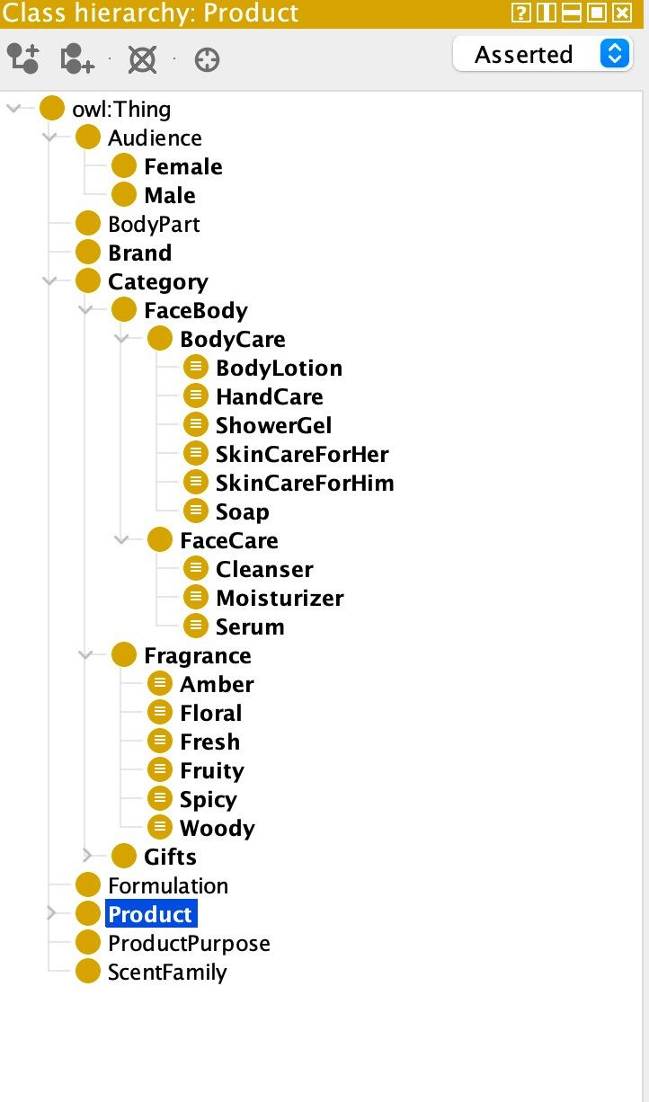

Ontology Design and Implementation
The development process commenced with the establishment of the ontology's core structure. This included defining the main classes and the properties that connect them. Following this, detailed logical axioms were created to formally define the semantics of each class. The final phase involved populating the ontology with specific product individuals to test and demonstrate the reasoning capabilities.
Class and Property Hierarchy
The ontology is organized around three primary product categories: Fragrance, FaceBody, and Gifts. These are modeled as subclasses of a general Category class. These main categories are further refined into more specific subcategories. For instance, FaceBody is parent to BodyCare and FaceCare, while Fragrance contains subcategories such as Floral, Woody, and Spicy.
A set of object properties was defined to represent relationships between entities. For example, the isAppliedTo property links a product to a BodyPart, and hasFormulation links it to a Formulation type like Lotion or Gel. A key relationship between a Product and its Brand is captured by the hasBrand object property, which is defined as an inverse of isBrandOf.
Several structural constraints were implemented. A crucial one, enforced using a qualified cardinality restriction, ensures that every Product is associated with exactly one Brand. Furthermore, an existential restriction on the Category class mandates that each category must contain at least one subcategory, enforced via the hasSubcategory property. The Product class is similarly constrained to belong to at least one Category.
Formal Class Definitions
A core element of the ontology is the use of equivalentClass axioms to provide formal definitions for subcategories. These definitions allow the reasoner to automatically classify products based on their properties. A variety of logical operators were used to create these definitions:
Conjunction: The BodyLotion class is defined as any Product that simultaneously has a Lotion formulation and is applied to the Body. The formal expression is: Product ⊓ (hasFormulation value Lotion) ⊓ (isAppliedTo value Body).
Negation: The SkinCareForHer class demonstrates the use of negation. It is defined as a body lotion intended for an audience that is not Male, using the complementOf operator on the Male class.
Disjunction: The definition for GiftsForKids includes a disjunction (unionOf) to specify that the product's audience can be Female or Male.
Universal Restriction: The GiftsForHer class uses a universal restriction (allValuesFrom) to classify any gift product for which the intended audience consists exclusively of individuals from the Female class.
Individuals and Automated Classification
The ontology was populated with individuals to test its logical structure. For example, an individual named Ali was created as an instance of Product and was asserted to have the properties hasFormulation Lotion and isAppliedTo Body. Without any manual classification, the reasoner correctly infers that Ali must be an instance of the BodyLotion class, as it perfectly matches the logical definition provided in the equivalentClass axiom for BodyLotion. This successful inference demonstrates that the ontology's axioms are functioning as intended. The individual Dior was created as an instance of the Brand class to be linked with products like MissDior.
Detailed OWL Feature Implementation
The construction of the ontology leveraged a range of OWL features to ensure a high degree of expressivity and logical soundness:
Inverse Properties: The reciprocal relationship between a product and its brand was modeled using the hasBrand and isBrandOf object properties, which are explicitly defined as inverses of each other.
Subproperties: Hierarchical relationships were created between properties. For instance, hasFragranceFamily and hasGiftType were defined as subproperties of the more general hasCategory property.
Property Characteristics: Properties were assigned specific characteristics to refine their behavior. The isSimilarTo property was made symmetric, while hasSubcategory was defined as transitive and asymmetric. The hasBrand property was designated as functional.
Disjointness Axioms: To enforce mutual exclusivity between classes, disjointness axioms were asserted. For example, the Female and Male audience classes were declared disjoint, as were the GiftsForHer, GiftsForHim, and GiftsForKids classes.
Domain and Range Restrictions: Every object and data property was defined with a specific domain and range, ensuring that relationships could only be formed between appropriate types of individuals. This improves the overall consistency and integrity of the ontology.

Team Contribution
Taha Koc: Subtask 1, help with other tasks
Fernando Cabria Serena: CSV for Subtask 2
Rowaid Asaba: Protege Implementation Subtask 2
Adel Assad: Subtask 3

