Weel,Rowan R.W. van der

AI-core-AI4-RB04

20-3-2024

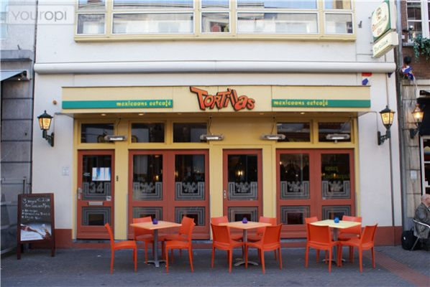

Predictive Analytics for Tortillas

Contents

Introduction 2

Plan Overview 3

Domain understanding 4

Result 5

Interview 8

Negative Effects 9

Competitors 10

Conclusion 10

Data 11

Limitations 11

End Product 12

References 16

Version 16

# Introduction

**Problem**

One of the challenges businesses always face in the restaurant industry is the inability to predict the number of guests each day. Without a reliable way of predicting how many people will walk through the door, restaurants often deal with inefficiencies Overstaffing leads to unnecessary labor costs, while understaffing can lead to long wait times, poor service, and dissatisfied customers. Also, incorrect estimates of guest counts can lead to excessive food preparation, resulting in wasted inventory and increased costs.

**Idea**

Understanding the significance of tackling this problem, predictive analytics can be utilized to forecast daily guest numbers. By considering various factors such as historical visitor data, weather conditions, local events like PSV matches, Effenaar concerts, train delays, etc., a reliable model can be developed to predict future demand accurately.

**Solution**

The proposed solution involves developing a custom predictive analytics model tailored to meet the restaurant's needs. Through thorough data analysis, important trends and patterns will be identified. These insights will guide the creation of a predictive model capable of accurately forecasting daily guest numbers.

By implementing this predictive model, informed decisions can be made regarding staffing levels and inventory management. Staffing schedules can be adjusted based on expected demand, ensuring there are enough staff members during busy times. Additionally, inventory levels can be managed more efficiently to match predicted guest counts, reducing waste and costs.

Ultimately, using predictive analytics in restaurant operations promises to improve efficiency, enhance customer satisfaction, and drive long-term success in a competitive industry. By anticipating changes in demand and organizing resources accordingly, the restaurant can improve its operations and provide exceptional experiences to its customers.



# Plan Overview

**Stakeholders**

As a member of the "Tortillas" restaurant team, my primary stakeholder is the boss/owner Randy van den Broek, who will oversee the project's progress. The boss/owner will also work with others who have the necessary data or information for the project. Additionally, teachers' input and feedback will be important for improving the project.

**Timeline**

The project will span until week 12 and will be divided into three distinct phases: A, B, and C, with a midterm evaluation included. Each phase will have specific objectives and deliverables, ensuring steady progress towards project completion within the designated timeframe.

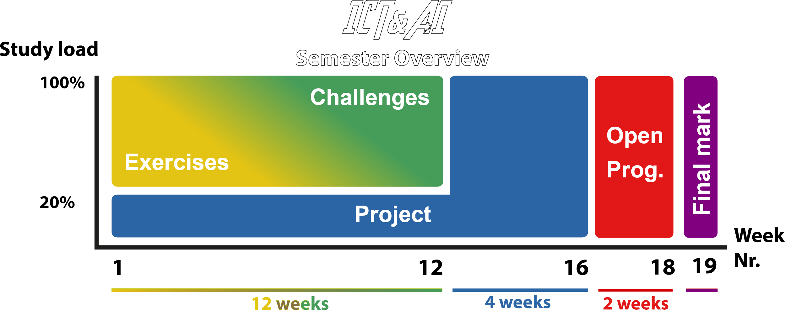

**Resources**

To gather information about the restaurant, the boss/owner will provide relevant data and insights. Additionally, external sources such as the internet, events like Effenaar or PSV matches, will be utilized for datasets and calendar information. Efforts will also be made to explore available APIs, such as those provided by NS, to access relevant data efficiently.



# Domain understanding

To improve our ability to predict restaurant guest numbers, brief research will be reviewed. This will help us determine if similar efforts have been successful and if such predictions are feasible for our restaurant and project.

Main question

How do you accurately predict the number of guests a restaurant will receive?

Sub questions:

1. What are the key factors influencing restaurant guest numbers?
2. Are there existing models or frameworks in the industry for predicting restaurant guest numbers?
3. How can the accuracy of the prediction models be evaluated and improved over time?

After looking at some research to see if other projects like ours have worked, we'll tackle the main question: How do we guess how many guests a restaurant will have? Then, we'll break it down into smaller questions like what things affect how many people come to a restaurant, if there are already ways to guess this, and how we can make our guesses better over time.

## Result

**What are the key factors influencing restaurant guest numbers?**

Understanding why people choose to dine at restaurants is important for improving restaurant operations. This analysis examines two primary categories of factors: internal factors, which pertain to aspects within the restaurant, and external factors, which are influenced by elements outside the restaurant's control. By exploring these factors, restaurants can gain insights into customer behavior and improve their overall performance.

|  |  |
| --- | --- |
| **Internal Factors** | **External Factors** |
| Price | Location |
| Staff Quality | Events |
| Reviews | Weather/Season |
| Decoration/Ambiance | Holidays |

Improving internal factors within a restaurant is straightforward, as there is a wealth of resources available online offering tips and guidance on enhancing various aspects of the dining experience. For instance, like [this](https://medium.com/@willisftw/elevating-the-brand-experience-the-10-essential-touchpoints-for-restaurants-ced177e77807) article provide valuable insights into optimizing key elements such as ambiance, service quality, and customer interactions. By leveraging these resources and implementing recommended strategies, restaurants can effectively elevate their brand experience and attract more guests.

<Discuss further external factors with Randy>

**Are there any existing models or frameworks in the industry for predicting restaurant guest numbers?**

There are tools like [5Out](https://www.5out.io/post/leveraging-predictive-analytics-tools-for-success-in-the-restaurant-industry#:~:text=Restaurant%20predictive%20analytics%20is%20a,informed%20predictions%20about%20future%20trends.), that are utilized in the restaurant industry to make informed predictions about future trends. Additionally, platforms such as [Kobas](https://www.kobas.co.uk/blog/ai-restaurants-guest-experiences/) and [Lineup AI](https://lineup.ai/how-to-create-restaurant-sales-forecast/#:~:text=Collect%20and%20analyze%20historical%20sales,point%20for%20your%20sales%20forecast.) provide insights into leveraging AI for enhancing guest experiences and creating restaurant sales forecasts respectively. The Kobas article explores how AI can be used to elevate guest experiences in restaurants, while Lineup AI offers guidance on collecting and analyzing historical sales data to create accurate sales forecasts.

A student from Oregon State University conducted a machine learning project aimed at predicting dinner guest counts for a local restaurant in Corvallis, Oregon. The project sought to address the challenge faced by restaurant management in accurately estimating customer numbers for staffing and inventory management purposes. Leveraging a decomposable time series model, the student aimed to provide a more reliable method for forecasting guest counts, leading to more efficient staffing decisions and potential cost savings for the restaurant. Ongoing efforts are focused on refining the algorithm by incorporating additional data sources, such as weather conditions and local events, to further enhance prediction accuracy (Lusardi, 2020).

A study demonstrates the utilization of various features for training a dataset aimed at predicting customer arrivals in restaurants. These features include weather conditions such as temperature, humidity, precipitation, and wind speed, as well as temporal factors like day of the week, month, and season. Additionally, the study incorporates information on holidays and special events, which can significantly influence restaurant traffic. By analyzing these diverse features, the model aims to accurately forecast customer arrivals, enabling restaurants to optimize staffing levels and operational efficiency (Tanizaki, Kozuma, & Shimmura, 2021).

In conclusion, as evidenced by the examples provided, there are notable advancements in leveraging predictive analytics tools and machine learning algorithms within the restaurant industry. These developments offer promising opportunities to enhance operational efficiency and guest experiences. Given the demonstrated potential of these technologies, further exploration and implementation in restaurant management practices are warranted.

**How can the accuracy of the prediction models be evaluated and improved over time?**

According to the AI methodology, the process involves iterating and improving the model over time. This iterative approach allows for continuous refinement and enhancement based on feedback from model evaluations. [This methodology](https://fhict.instructure.com/courses/13770/pages/ai-project-methodology?module_item_id=1071124) ensures that every project follows a structured process, facilitating clear understanding and effective execution of tasks.

Expanding on feature engineering involves enriching the dataset by adding more features to make it wider. This process goes beyond simply collecting more data points; it entails identifying and incorporating relevant variables or attributes that can provide valuable insights into the underlying patterns of the data.

One approach is to explore new variables that may influence the outcome of interest. This could involve gathering additional data sources that are related to the problem domain. For example, in the context of predicting restaurant guest numbers, new features might include demographic information about the local population, nearby points of interest, or social media activity related to dining trends.

By expanding the dataset with new features and creatively engineering existing ones, we can enhance the model's ability to capture complex relationships within the data, leading to more accurate predictions.

Furthermore, seeking guidance from machine learning teachers and actively engaging in practical exercises can provide valuable insights into refining prediction models. By adjusting settings like hyperparameters, which control how algorithms learn, students can iteratively enhance model performance and gain deeper understanding of machine learning concepts.







## Interview

What's the optimal approach for conducting research? Simple, it involves interviewing an expert! I've had a conversation with my boss (the restaurant owner) about this idea and suggested some research questions, which he kindly answered. Below, I'll present a transcript of our discussion. Please note: The interview was conducted in Dutch, and I'll do my best to provide an accurate translation into English.

**Would the Predictor-Guests-Tool (PGT) be valuable?**

It could be valuable. It could potentially save a lot of costs and losses regarding inventory and personnel expenses. You would then know how much to purchase and how many staff members you need for an evening.

**What kind of impact would the PGT have on you?**

It would have a positive impact. In theory, you could reduce costs and increase revenue by planning more efficiently and making better purchases. It would earn me more money and reduce stress.

**Is the PGT a realistic concept?**

Yes and no. All activities that take place (Effenaar, PSV, etc.) can be included, which would help. But the weather is too unpredictable. Because even if it's cloudy and dry, you still don't know, for example, if the terrace will be open/busy. Guests behave flexibly.

**Would you use the PGT if it operates optimally?**

Yes, it could be very useful, as I mentioned. I would mainly use it for staff planning. Then you know if there are enough staff members in the service and in the kitchen.



## Negative Effects

Understanding the negative effects of a technology tool is important because it helps observing the bigger picture. Just like how we learn from our mistakes, recognizing the downsides of a tool allows us to use it more responsibly. By considering both the good and the bad, we become smarter users, making informed decisions, and ensuring that technology enhances our lives and dealing less harm.

**TICT**

The Technology Impact Cycle Tool (TICT) is like a guide that helps us think about how new technology affects us and our world. It asks us questions about things like what problems the technology solves, how it respects our privacy, and if it's good for the environment. TICT was made by Fontys University to help us understand the good and bad sides of technology so we can make smarter choices. Whether we're designing new tech or just trying to figure out if a new app is a good idea, TICT helps us think it through and make better decisions for everyone (TICT-tool helpt bij ethische afwegingen bij nieuwe technologie, 2022).

I've created a cycle tool for the Tortillas tool. Check out the quick scan below and click [here](https://www.tict.io/tool/b32c7be7-c7ee-469e-a366-c1f682111a47) for the full scan.

## Competitors

Competitors play a big role in understanding customer behavior and trends in the restaurant industry. In Dommelstraat, where Tortillas is located, there are many other restaurants. While they compete for business, they also support each other by creating a warm dining scene that attracts more customers to the area.

It's essential to note that Tortillas is relatively small compared to some of the other restaurants in the neighborhood. Therefore, comparing absolute numbers doesn’t provide a fair perspective. However, observing overall trends alongside other restaurants can offer valuable insights into broader patterns of customer behavior.

For example, during events like Glow, all restaurants in Dommelstraat experience a huge number of customers, highlighting the impact of local events on customer traffic. Additionally, while some days may be busier at one restaurant, the next day could see increased activity at another establishment. This shows how customer behavior changes a lot and why it's important to look at what makes each restaurant unique when studying trends.

If this analysis were to be applied on a larger scale, it would be important to examine features specific to each restaurant to accurately assess performance and make informed decisions. By understanding the competitive landscape and observing trends across multiple establishments, businesses can better adapt and respond to changing market conditions.

This tool is currently designed specifically for Tortillas, but many of its features could apply to other restaurants on Dommelstraat. However, if you're looking at a different city or country, you'll probably need different datasets and features.

## Conclusion

In summary, predicting restaurant guest numbers offers significant benefits for improving efficiency and customer satisfaction. By using predictive analytics tools and machine learning, restaurants can better anticipate demand and make informed decisions about staffing and inventory. Exploring key factors affecting guest numbers and discovering existing models highlight the potential of data-driven approaches in restaurant management. Continued efforts to refine prediction models, expand feature engineering, and collaborate with machine learning instructors are essential for improving accuracy and ensuring long-term success in this field. With a proactive approach to data-driven solutions, restaurants can thrive in the competitive hospitality industry.

# Data

To accurately predict customer numbers, we need a variety of information beyond just basic counts. Factors like events happening in the area, foot traffic patterns, and even weather conditions all contribute to the big picture. For instance, the computer system tracks daily customer visits and group sizes. While I initially wanted to use this data to anticipate food and drink orders, ethical considerations for the restaurant prevented me from doing so. At first, I wanted to use this info to guess what food and drinks people would want, but due ethical reasons, the restaurant said no.

On sunny days, our terrace fills up quickly, because there is a higher chance people are willing to go outside. Conversely, on rainy or windy days, fewer people go out for a meal. Weather also has a big influence on the mood of your customers and staff. Weather is something that should be considered, but if there is a project you want to investigate further, do it (Devincent-Reinbold, sd). The problem with weather is it’s too unpredictable, you still don’t know if people are willing to go eat outside or rather inside. So, is it reliable for predicting the number of guests? Probably not.

Interestingly, sports events, particularly PSV matches, have a notable impact on customer numbers. As an employee I’ve noticed a high peek before and/or after the match. Events at the Effenaar, like concerts, bring in lots of people before and during breaks. You can tell because of how they dress and what they talk about. It will most likely improve the amount of guests by a bit, so it is reliable.

Beyond sports and concerts, city-wide events like King's Day celebrations, the Glow light festival, and Dutch Design Week significantly boost customer traffic at Tortillas. Big events in the city, like King's Day or Dutch Design Week, make our restaurant busy. It shows how connected local events are to bringing in customers. Taking that into consideration.

I talked with Randy about which features matter. Next, I'll dive into the data with DAIA to understand it better and see how it really affects things. It's all about iterating and improving.

## Limitations

Limitations are things that hold us back or make it harder to understand stuff. For example, in the dataset, there is no info about NL-alerts in Eindhoven. Randy said when there's a NL-alert, lots of people call to cancel reservations. But we don't have data for that, so we can't fully know how it affects customer behavior.

Also, I’ve served multiple people, and several times I’ve heard people say they eat here before going to the nearby cinema (Pathé). But according to Randy it doesn't really change customer numbers much. But it's tough to get data on that. These limitations show us where our dataset falls short and remind us to be careful when drawing conclusions.

# End Product

The product of this project could be a user-friendly software application or platform customized specifically for restaurant owners and managers. This application would integrate predictive analytics models and machine learning algorithms to accurately forecast daily guest numbers. It would offer a comprehensive dashboard displaying predicted guest counts, along with insights into key factors influencing these predictions, such as weather conditions, local events, and historical data.

Features of the product could include:

* Prediction Dashboard: A user-friendly interface providing real-time predictions for daily guest numbers based on the developed predictive models.
* Historical Data Analysis: Tools for analyzing historical guest count data to identify trends and patterns, helping restaurant owners make informed decisions.
* Integration with External Data Sources: Integration with external data sources such as weather APIs, event calendars, and local news feeds to enhance prediction accuracy.

Overall, the product aims to empower restaurant owners and managers with actionable insights and tools to optimize operations, improve customer experiences, and drive Tortillas success in the competitive restaurant industry.

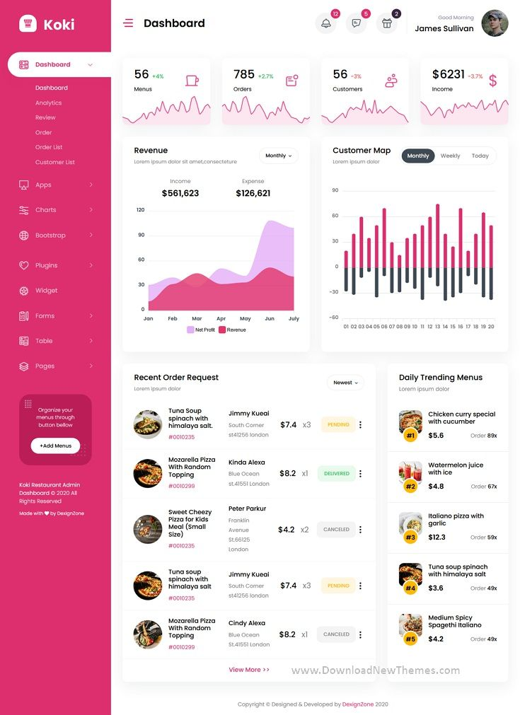

**Wireframe**

The next part is creating a lay-out. I’ll stick with the general idea of a web application/dashboard situation. I’ve picked a darker(blue) color palette and then went to work in Figma.

I've thought about an end product and my idea was making a sort of dashboard application where you can see the history of the number of customers, and the forecast. And a sort of calendar where you can see how the forecast is being calculated. Also there needs to be a function where you can enter the number of guests and see some features as well. The weather feature could be automatically integrated with the [KNMI API](https://weerlive.nl/delen.php), the holidays could be automatically integrated with the [rijksoverheid](https://www.rijksoverheid.nl/opendata/schoolvakanties), the other features should be clicked manually.

You can click [here](https://www.figma.com/file/0rDSaqNKDDB3AthyeX6YbG/Tortillas) to see the actual file, but I provide some images too.

**Feedback**

I asked Randy for his opinion on the final product, and he liked it. He suggested including a window with moving images to visualize the weather (especially rain), so you can plan accordingly. So, I want to build in a tab in the weather forecast window to make it possible to select the overall weather forecast for the day and the option to see the rain forecast. You could get the rain forecast with KNMI API, however that’s per hour. There is also a [buienradar library](https://pypi.org/project/buienradar/), it’s easier to integrate it with Python.

# References

Devincent-Reinbold, K. (sd). *How Does Weather Impact Restaurants? New Study Says Inclement Weather Kills the Mood*. Opgehaald van Toast.

Lusardi, A. (2020, December 23). *Machine Learning Can Now Predict How Many Customers to Expect in Your Restaurant Tonight.* Opgehaald van Linkedin: https://www.linkedin.com/pulse/machine-learning-can-now-predict-how-many-customers-expect-lusardi/

Tanizaki, T., Kozuma, S., & Shimmura, T. (2021, August 31). *Forecasting the Number of Customers Visiting Restaurants Using Machine Learning and Statistical Method*. Opgehaald van Springer link: https://link.springer.com/chapter/10.1007/978-3-030-85906-0_21

*TICT-tool helpt bij ethische afwegingen bij nieuwe technologie*. (2022, April 20). Opgehaald van ICT&health: https://icthealth.nl/nieuws/tict-tool-helpt-bij-ethische-afwegingen-bij-nieuwe-technologie/

# Version

|  |  |
| --- | --- |
| **When?** | **What?** |
| 20-02-2024 | Introduction + Domain understanding |
| 20-03-2024 | Results + First version |
| 26-04-2024 | Brought everything over from the notebook to this file. Added more context and research. |
| 30-04-2024 | Provided interview + feedback End product |
| 01-05-2024 | Cleanup + Second version |