Problem 1.5

The three main type of error are: **(Compiler errors, Runtime errors, Logical errors)**

1. **Compiler errors: (Syntax errors)**

It occurs when the programmer makes a syntax mistake during writing the code.

They are detected by the compiler and shown to the programmer via the IDE.

1. **Runtime errors: (Thrown during the program execution)**

Runtime errors are the ones that occur when the program is running. The program must

have been compiled correctly, so they were no compilation errors, but something goes

wrong during the execution of the program. **For example**, attempting to divide a number

by zero leads to undefined behavior and can cause a runtime error.

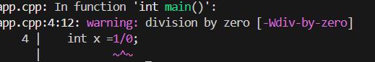

1. **Logical errors:**

Occurring when the program works without crushing, but it does not produce a correct result. **For example,** Incorrect Condition in If Statement The condition number > 5 && number < 15 is correct, but the message printed is misleading. The correct message should reflect the actual range checked by the condition.

Problem 7

In this program we want to calculate miles per gallon.

1.Start with initializing a global constant variable to convert from liter to gallon.

2.then initialize function to calculate miles per gallon takes two parameters first one is for number of liter and second parameter for number of miles then convert liter to gallon and calculate miles per gallon which equal to (miles / gallon).

In main function the user enters the liters and miles traveled by car and then output will appear. last things repeat the process as the user want.

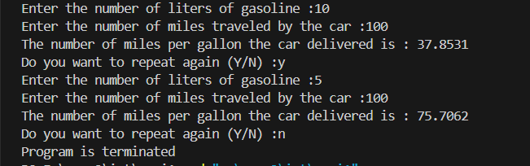

Problem 8

In this program we will calculate the gravitational force.

1. first, we initialize constant double universal gravitational.
2. then we define gravitational Force function which takes three parameters (mass1, mass2, distance between two objects then it returns the calculation of force.

Gravitational Force = (G*m1*m2) /d^2

1. in main function the user enters the masses of object one and two and the distance between two objects then the result will calculated. last things repeat the process as the user want.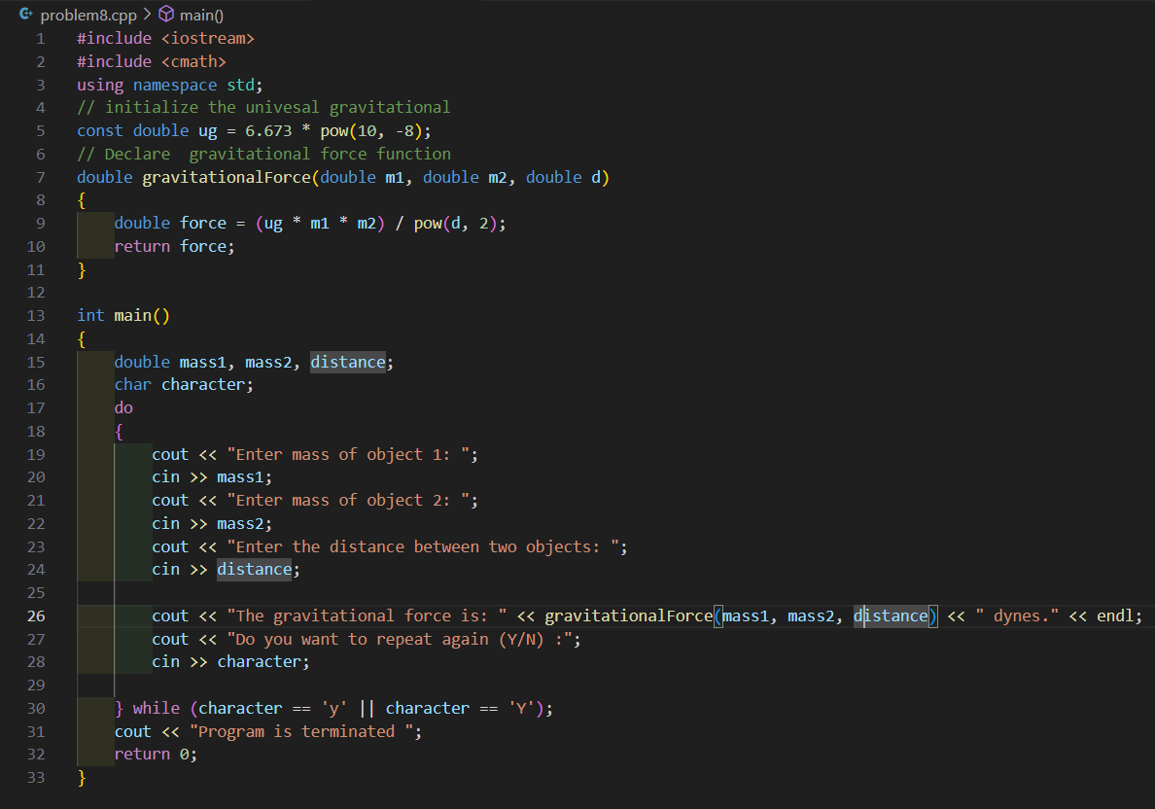

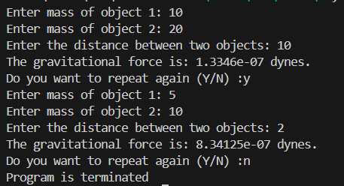

Problem 12

this program for palindrome checking.

1.first, we define tolowerCase function to convert a character to lowercase. the function checks if the character is an uppercase letter, converts the uppercase letter to lowercase by adjusting its ASCII value. And returns the character unchanged if it's not an uppercase letter.

2. we check the if character is letter of number through Alphanumeric function.

3.define a Boolean function to check if the string is palindrome or not

- We initialize the left index to the start of the string. And initializes the right index to the end of the string.

-First while loop runs as long as the left index is less than the right index meaning there are still characters to compare.

- second and third while loops skip the non-alphanumeric characters from the left and right side of the string.

-And then condition for comparing the characters at the left and right indices in a case-insensitive manner. Which checks if these characters are different. If they are, the function returns false, indicating the string is not a palindrome.

