COS1511/102/0/2023



**Tutorial Letter 102/0/2023**

**Introduction to Programming I**

**COS1511**

**Year 2023**

**School of Computing**

This tutorial letter contains Assignment 2 for year 2023.

**BARCODE**



## CONTENTS

1 INTRODUCTION 3

2 ASSIGNMENT 2 3

3 CALCULATION OF THE YEAR MARK 3

4 DUE DATES OF ASSIGNMENT 4

5 SUBMISSION OF ASSIGNMENT 2 4

6 ASSIGNMENT 2: YEAR 2023 5

# INTRODUCTION

Dear student,

Hope you are well. This tutorial letter contains Assignment 2. Assignment 2 contributes 40% towards your year mark and requires you to write and submit programming code.

# ASSIGNMENT 2

Assignment 2 is a practical assignment and thus must be written and submitted.

* We urge you to do and submit this assignment; otherwise you will find it very difficult in the examination.
* For this assignment you have to write, compile and run programs using the software that you have installed.
* Students must submit this assignment via *myUnisa*.
* Assignment 2 must be submitted in **PDF format**. See Additional Resources on the COS1511 course website for instructions on how to create an assignment as a PDF file.
* Keep to the submission date for the assignment as stated in the study plan of this letter.
* We do not necessarily mark all questions. You will get 0% if you do not submit the questions that are marked.
* The system does not allow for late submission of assignments. This means that you may submit the assignment up to 4 days after the due date, without making special arrangements with the lecturers. Although *myUnisa* will give you a message to say that your assignment is late, the assignment will still be accepted by the *myUnisa* system.
* The programs must be written in C++. You may not use any other high-level language for COS1511. Your programs must follow the programming style used in the Study Guide. In the assignments and the examination, marks are awarded for **programming** **comments, programming style, syntax and logic.**
* The input data as specified in the questions will be used to test your programs.
* No marks are allocated for programs that do not compile.

# CALCULATION OF THE YEAR MARK

The marks that you obtain for Assignments 1, 2 and 3 form the year mark for COS1511. The year mark forms 20% of the final mark for the module. The weights of the COS1511 assignments are indicated in the table below:

|  |  |
| --- | --- |
| Assignment number | Weight |
| 1 | 35% |
| 2 | 35% |
| 3 | 30% |

*An example follows*: Suppose a student gets 60% for Assignment 1, 45% for Assignment 2 and 65 for Assignment 3. In order to calculate the year mark, the mark obtained for the specific assignment is multiplied by the weight. This then forms part of the 20% that the year mark contributes to the final mark. Therefore:

|  |  |  |  |  |
| --- | --- | --- | --- | --- |
| Assignment | Marks obtained | Weight | Contribution to year mark | |
| 1 | 60% | 35% | 60/100 x 35/100 x 20 | 4.2 |
| 2 | 68% | 35% | 68/100 x 35/100 x 20 | 4.76 |
| 3 | 65% | 30% | 65/100 x 30/100 x 20 | 3.9 |
| TOTAL |  |  |  | 13 |

In this example the student has a year mark of 13 out of 20. **The year mark will not form part of the final mark of a supplementary examination.**

# DUE DATES OF ASSIGNMENT

The table below gives the due dates of the assignments for this module.

|  |  |  |
| --- | --- | --- |
| **Assignment** | **Due Date year 2023** | **Weight** |
| 1 | 11 April | 35% |
| 2 | 31May | 35% |
| 3 | 05 June l | 30% |

# SUBMISSION OF ASSIGNMENT 2

Submit assignment 2 (as a .pdf file) via *myUnisa.* No assignments in the wrong format can be accepted.

Instructions on how to register to become a *myUnisa* user, and how you should format your assignments before you submit them electronically, are given on the website. The two most important things to remember are that your submission must consist of a single text file, and that you may submit an assignment only once.

To submit an assignment through *myUnisa*:

* go to *myUnisa*
* log in with your student number and password
* select the module
* click on assignments in the menu on the left-hand side of the screen
* click on the assignment number that you wish to submit
* follow the instructions

PLEASE NOTE: Assignments can be tracked (e.g. whether or not the University has received your assignment or the date on which an assignment was returned to you) on *myUnisa*.

# ASSIGNMENT 2: YEAR 2023

**SUBMISSION**: **Electronically via *myUnisa***

**Please note that we automatically give four days extension for this assignment.** It will be to your own advantage to check after a few days whether the assignment has been registered on the system. If you have not completed the assignment by the extension date, submit whatever you have completed – you will get marks for everything that you have done.

If *myUnisa* is off-line when you want to submit the assignment, you need not contact us, because we will be aware of it. Simply submit it as soon as *myUnisa* is available again.

|  |  |
| --- | --- |
| DUE DATE | **31 May** |
| UNIQUE NUMBER | 393126 |
| EXTENSION | There is an automatic extension until 31 **May**. You do not need to phone or send an e-mail to request automatic extension |
| TUTORIAL MATTER | Study Guide, Lessons 17 – 23 |
| CONTRIBUTION WEIGHT TO YEAR MARK | 35% |
| QUESTIONS | Practical exercises |

**QUESTION 1:**

### Question 1a

Suppose we want to input and validate the age of students that qualify for an internship, as well as the final mark obtained for the examination, in a while loop. To qualify, the student should be younger than 30 with a final mark of more than 65%. Read in values util a suitable candidate is found. Display appropriate messages, wheter successful or not. The variable names are age and finalMark respectively. Complete the while loop below. You only have to write down the completed while loop.

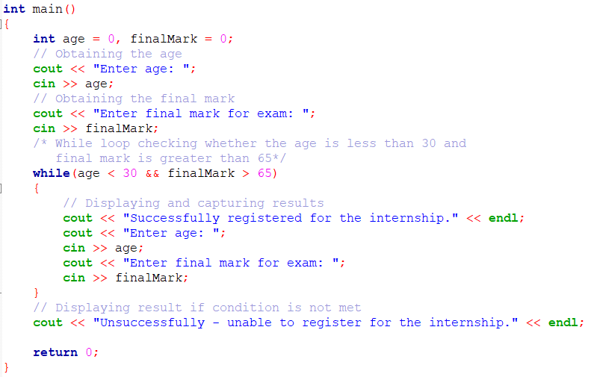

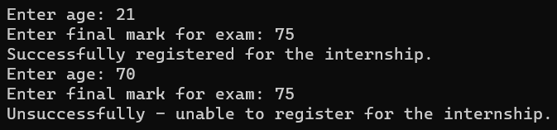

### Question 1b

State what output, if any, results form each of the following statement by first working it out on paper and then including it is a program. Submit a completed table as below:

|  |  |  |
| --- | --- | --- |
|  | **CODE** | **OUTPUT** |
| example | for (int i = 0; i < 10; i++) cout << i;  cout << endl; | 0123456789 |
| a. | for (int i = 1; i <= 1; i++) cout << “*”;  cout << endl; | * |
| b. | for (int i = 2; i >= 2; i++) cout << “*”;  cout << endl; | Infinite loop of * |
| c. | for (int i = 1; i <= 1; i--) cout << “*”;  cout << endl; | Infinite loop of * |
| d. | for (int = 12; i >= 9; i--) cout << “*”;  cout << endl; | **** |
| e. | for (int i = 0; i <= 5; i++) cout << “*”;  cout << endl; | ****** |
| f. | for (int i = 1; i <= 5; i++) cout << “*”; i = i + 1;  cout << endl; | *** |

### Question 1c

Include the for loop below in a small program and complete the program. The loop should be executed 10 times. Do not change the for loop below. Compile and run your program to see for yourself that it works. You do not have to submit this program and output.

for (int i = 0; i <= n; i++) if (i < 5 && i != 2) cout << 'X';

Now convert the for loop into a while loop and add any variable initialisations that you think are necessary. Compile and run your program.

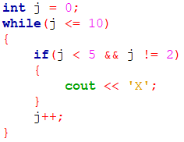

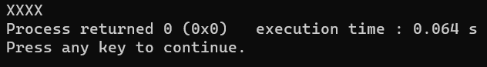

### Question 1d

When running the program given, it is supposed to give the output bewlow. However, the program contains erros that prevent it from compiling and/or running. Correct the program so that it works properly.

The output:

Please enter 10 integers, positive, negative, or zeros. The numbers you entered are:

2

7

-4

-3

0

7

4

0

-9

-4

There are 6 evens, which includes 2 zeros. The number of odd numbers is: 4

The program:

#include <iostream> using namespace std; const int LIMIT = 10;

int main ()

{ float counter; int number;

int zeros; int odds; int evens;

cout << "Please enter " << Limit << " integers, " << "positive, negative, or zeros." << endl; cout << "The numbers you entered are:" << endl;

for (counter = 1; counter <= LIMIT; counter++)

{ cin << number;

switch (number / 2)

{ case 0:

evens++; if (number = 0) zeros++;

case 1: case -1:

odds++;

}

} cout << endl;

cout << "There are " << evens << " evens, "

<< "which includes " << zeros << " zeros."

<< endl; cout << "The number of odd numbers is: " << odds << endl;

return 0;

}

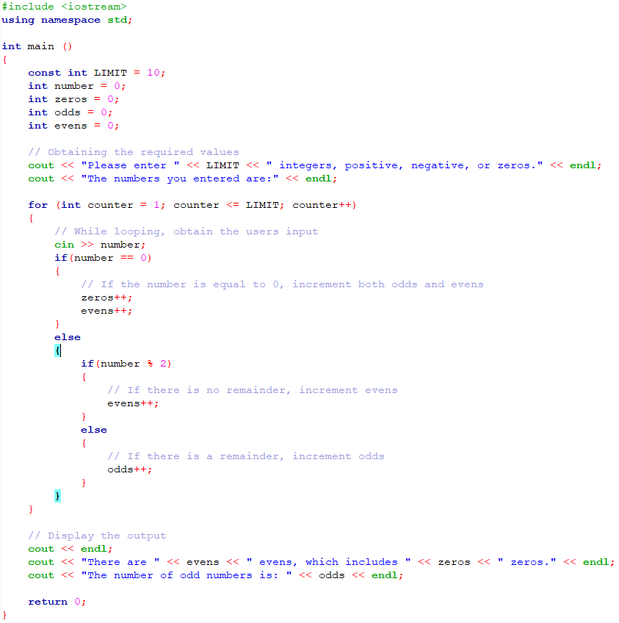

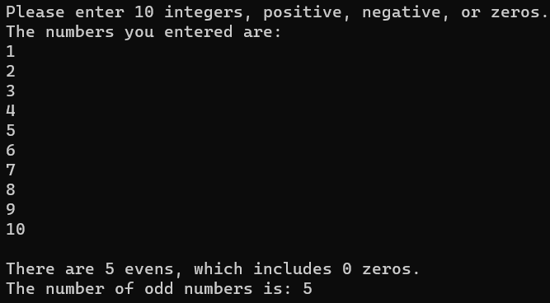

**QUESTION 2:**

In this question, we describe the problem and then you have to decide yourself how you are going to tackle it.

### Question 2a

The cost of renting a romm at a hotel is R900 per night. For special occasions, such as a wedding or conference, the hotel offers a special discount as follows:

* if the number of rooms booked is at least 10, the discount is 10%; • if the number of rooms booked is at least 20, the discount is 20%;
* if the number of rooms booked is greater or equal 30, the discount is 30%;

In addition, if rooms are booked for at leas three days, there is an additional 5% discount.

Write a program that promps the user ro enter the cost of renting one room, the number of rooms booked, the number of days the rooms are booked and theslaws tax (as a percent).

Display the output as follows:

Please enter the following: cost per room: 1000

sales tax per room: 10 the number of rooms: 35 number of days: 2

The total cost for one room is R1000

The discount per room is 30%

The number of rooms booked: 35

The total cost of the rooms are R: 70000

The sales tax paid is : 10%

The total cost per booking is R77000

### 

### 

### Question 2b

In this program, you have to make use of the switch statement.

The average life expectancy (in hours) of a lightbulb based on the bulb’s wattage is listed in the table below:

|  |  |
| --- | --- |
| **Watts** | **Life expectancy (hours)** |
| 25 | 25000 |
| 40 | 1000 |
| 60 | 1000 |
| 75 | 750 |
| 100 | 750 |

Write a program that when given a bulb’s wattage, displays the average life expectancy.



**Question 3:**

The Golden Sales Company pays it salespeople R12.50 for each item they sell. Given the number of items sold by a salesperson, your program should first print a heading, then calculate, and print the amount of pay due.

A function named printHeading (with no parameters) displays the following message:

**\*\*\*\*\*\*\*\*\*\*\*\*\*\*\*\*\*\*\*\*\*\*\*\*\*\*\*\*\*\*\*\*\*\*\*\*\*\*\*\*\*\*\*\*\*\*\*\*\*\*\* GOLDEN SALES COMPANY This program inputs the number of items sold by a**

**Salesperson and prints the amount of pay due.**

#### ***************************************************

Another function, calculatePay displays the amount pay due to a salesperson. The function multiples the numer of items sold with 12.50 to compute the pay to be payed out. The function has one value parameter items representing the number of items sold by a salesperson.

A main program inputs an integer value (items). It displays the description of the program by calling the function printHeading. The program then calls the function calculatePay to calculate and display the amount of pay due.

Sample run:

**\*\*\*\*\*\*\*\*\*\*\*\*\*\*\*\*\*\*\*\*\*\*\*\*\*\*\*\*\*\*\*\*\*\*\*\*\*\*\*\*\*\*\*\*\*\*\*\*\*\*\* GOLDEN SALES COMPANY This program inputs the number of items sold by a**

**Salesperson and prints the amount of pay due.**

**\*\*\*\*\*\*\*\*\*\*\*\*\*\*\*\*\*\*\*\*\*\*\*\*\*\*\*\*\*\*\*\*\*\*\*\*\*\*\*\*\*\*\*\*\*\*\*\*\*\*\* Please input the number of items sold 125 The amount pay due is R 1562.50**

### Question 3a

Write the functionsprintHeadingandcalculatePay as well as the main program. 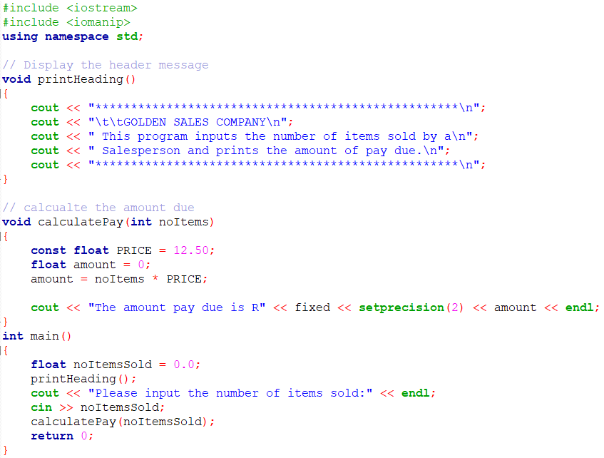

### Question 3b

Change the program so that the pay amount is displayed in the main program instead of function calculatePay. 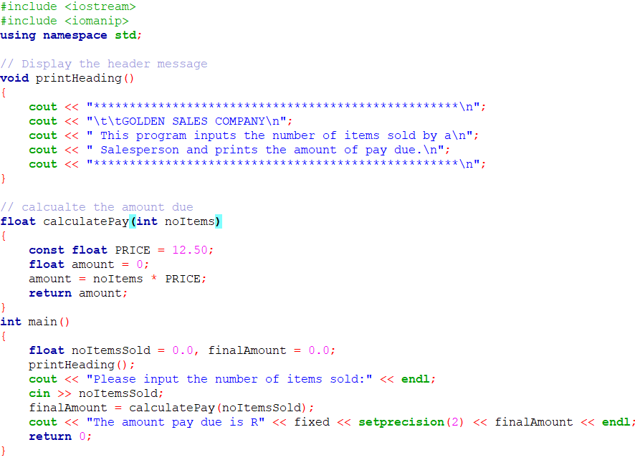

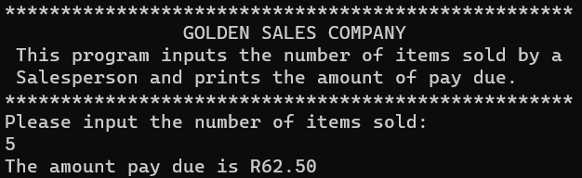

**Question 4:**

### Question 4a

Write a function named integerPower() that accepts two integer numbers (base and exponent) as formal parameters and returns the value of base exponent. For example,

integerPower(3,4) = 3 * 3 * 3 * 3 = 81

The function integerPower() should use a for or while loop to do the calculation. (Do not use any math library functions.)

Include the integerPower() function in a working program. Again, the main() function should input the values, correctly call integerPower() and display the value returned by the function, all with appropriate messages.

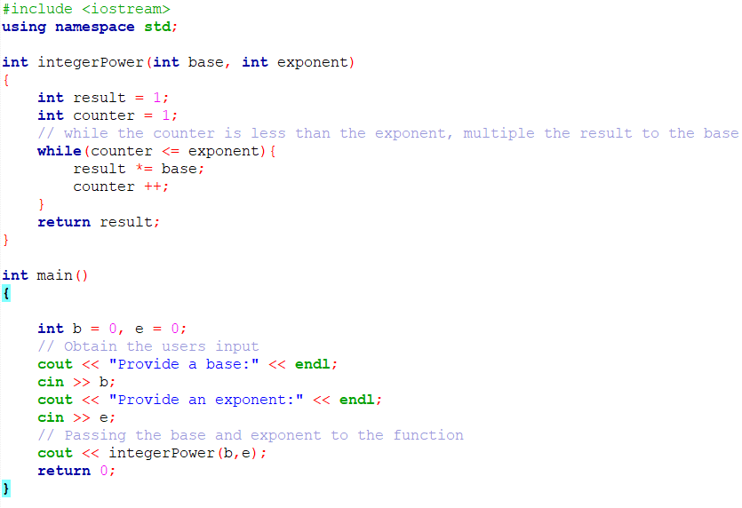

### Question 4b

Write a function named isEqual() that accepts two char values as formal parameters and returns TRUE if the characters ar the same otherwise FALSE.

Include the isEqual() function in a working program. The main() function should input the values, correctly call isEqual() and display the value returned by the function, all with appropriate messages.

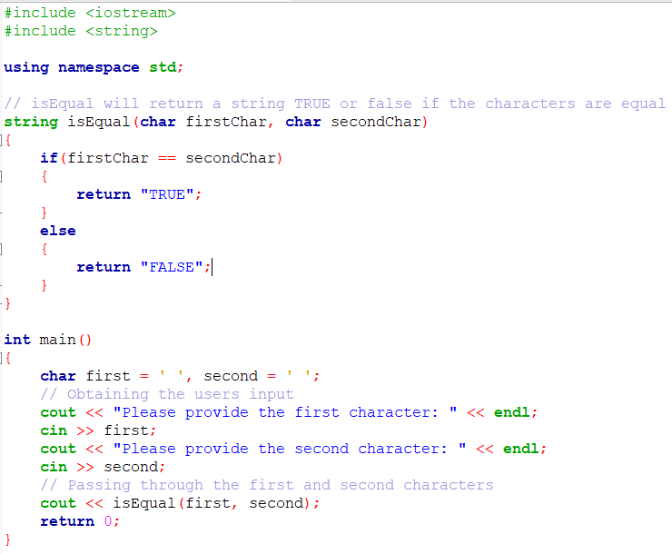

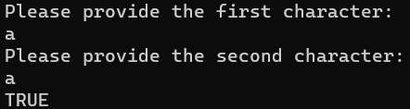

### Question 4c

Write a function named twice() that accepts two integer values as formal parameters. The function then multiplies each parameter with 2 which is returned to the calling program.

Include the twice() function in a working program. The main() function should input the values, correctly call twice() and display the values returned by the function, all with appropriate messages.

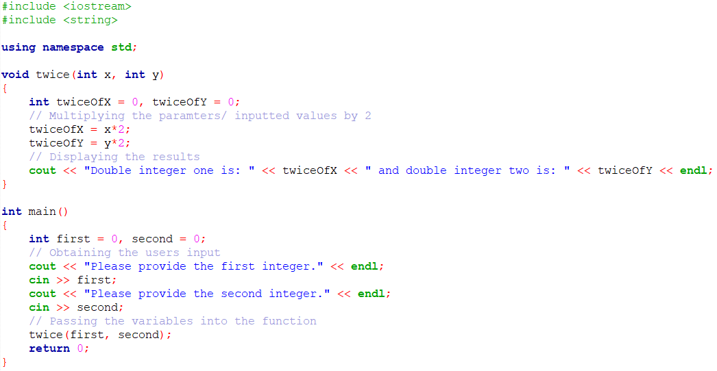

**Question 5:**

A particular talent competition has 5 judges, each of whom awards a score between 0 and 10 to each performer. Fractional scores, such as 8.3, are allowed. A performer’s final score is determined by dropping the highest and lowest score received, then averaging the 3 remaining scores. Write a program that uses this method to calculate a contestant’s score. It should include the following functions:

1. A function that asks the user for a judge’s score, store it in a reference parameter variable, and validate it. This function should be called by main once for each of the 5 judges. Do not accept judge scores lower than 0 or higher than 10.
2. A function to calculate and display the average of the 3 scores that remain after dropping the highest and lowest scores the performer received. This function should be called just once by main, and should be passed the 5 scores. The two functions, described below, should be called by this function, which uses the returned information, to determine which of the scores to drop.
3. A function to find and return the lowest of the 5 scores passed to it.
4. A function to find and return the highest of the 5 scores passed to it.
5. A function to display the output.

The main function is given below. Implement the functions you have developed and execute you’re the program using the following data:

|  |  |  |  |  |
| --- | --- | --- | --- | --- |
| 12 | 24 | 23 | 4 | 15 |
| 12 | 4 | 15 | 8 | 59 |
| y | Y | y | y | N |

#include <iostream> using namespace std;

int main()

{ double score1, score2, score3, score4, score5;

// 5 judge's scores

double finalScore;

// Call getJudgeData once for each score to be input getJudgeData(score1); getJudgeData(score2); getJudgeData(score3); getJudgeData(score4); getJudgeData(score5);

// Call calcScore to calculate the contestant's final score

finalScore = calcScore(score1, score2, score3, score4,

score5);

// Display output displayOutput(finalScore); return 0;

}// end of main function

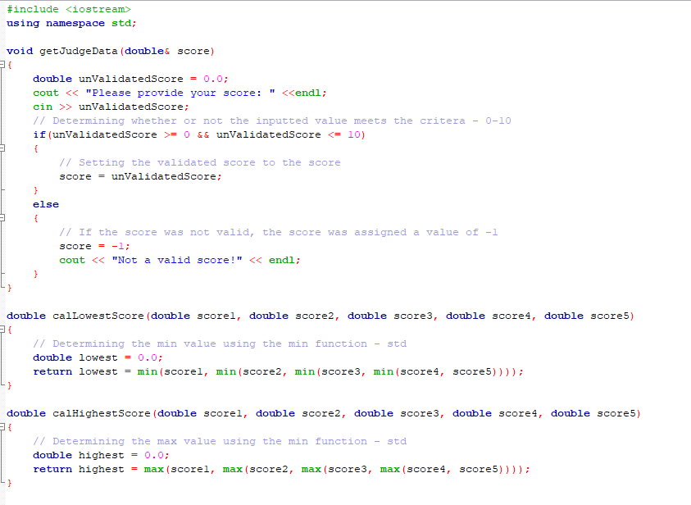 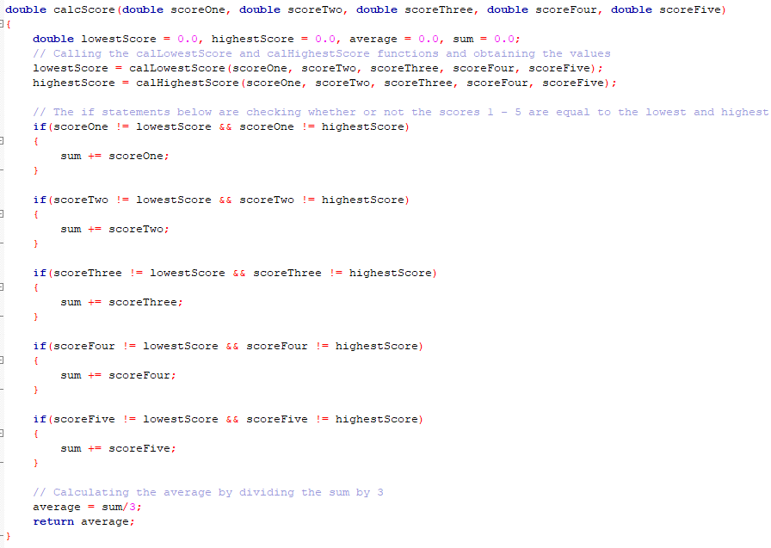

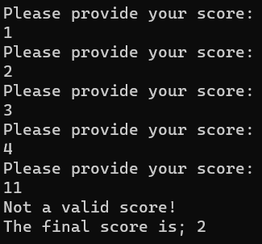

**End of Assignment 2**

©

UNISA

2023