1. In Netbeans, click Clone in Team from top bar:

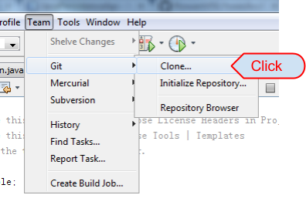

2. Copy the Java project URL in GitHub:

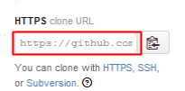

3. Paste URL in the blank, then click Next:

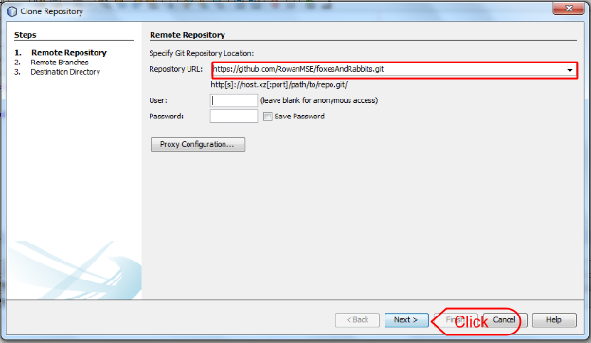

4. Select “master” and other branches if need, then click Next:

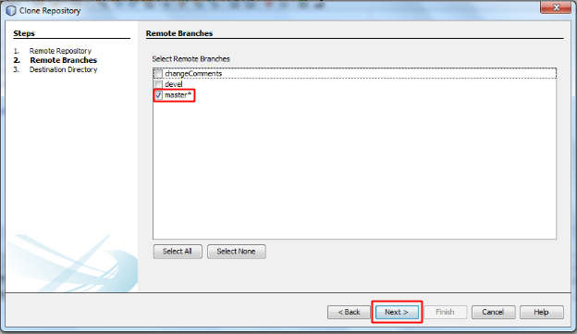

5. Choose a directory for Parent Directory and Clone Name, then click Finish:

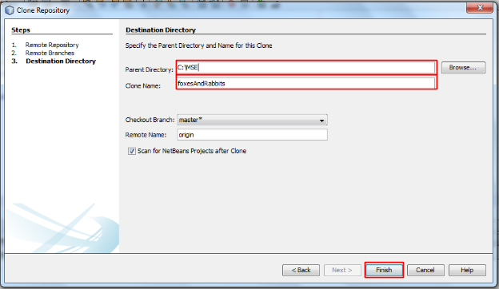

6. When Clone complete, it will pop and window. Select Create Project:

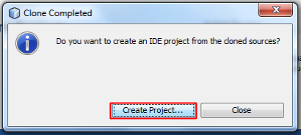

7. Select Java Project with Existing Sources in Java Categories, then click Next:

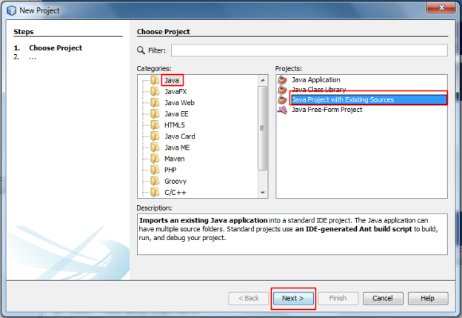

8. Type the Project Name which should be exact the same as the project inside of the clone fold, then the Project Folder will auto fix. Click Next:

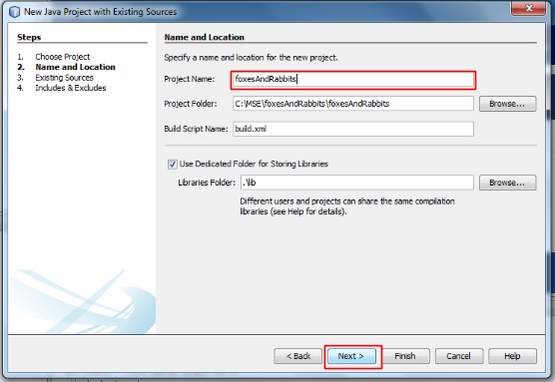

9. Click “Add Folder” for Source Package Floders:

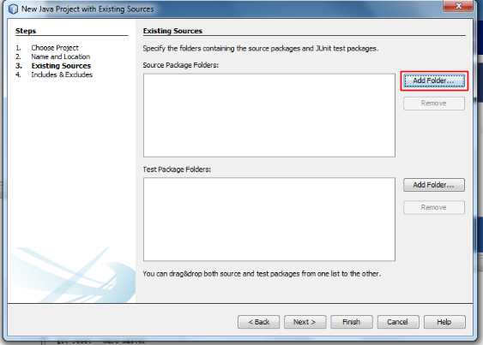

10. Select the source folder where has all the .java files, then click Open:

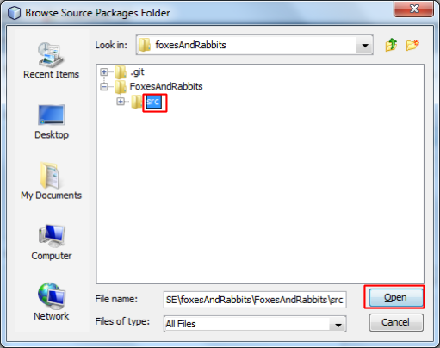

11. Click Finish.