Creating a Widget in OWF from a project in NetBeans

1. First find where you store your NetBeans Projects

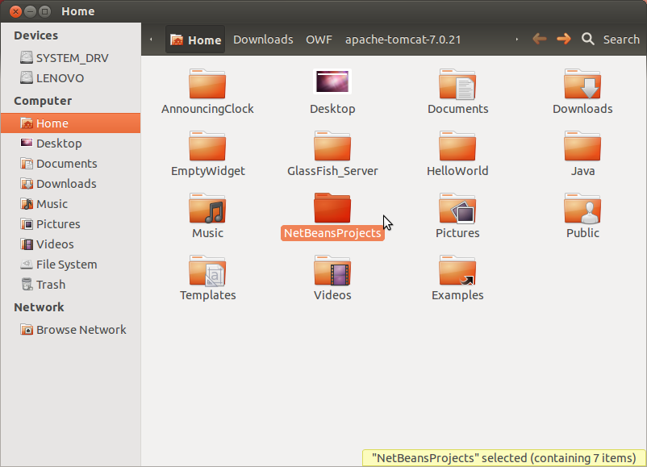

2. Now choose the project you wish to create a widget out of, in this case PersonnelSkillsDB, be sure you have cleaned and built the project beforehand.

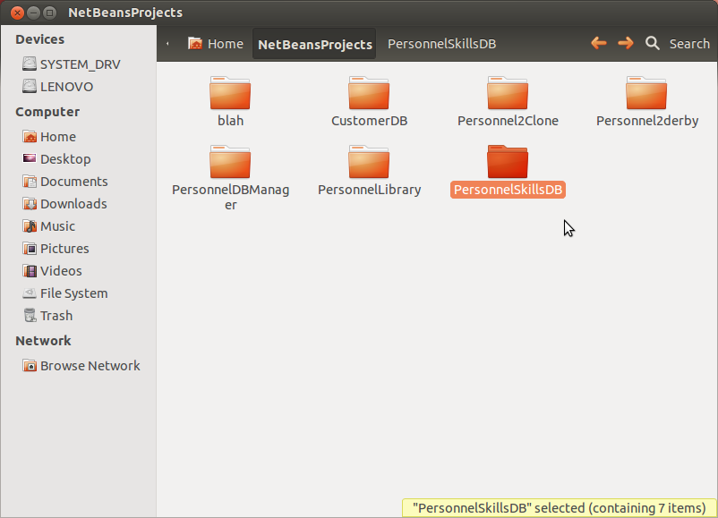

3. In the projects dist folder (that you get from cleaning and building the project) you’ll find a .war file. Copy that file. Go to OWF->Apache->webapps. In the webapps folder, paste the .war folder, it should automatically generate the folders responding to it if the apache-tomcat server is running. The server will have to be started in order to run OWF.

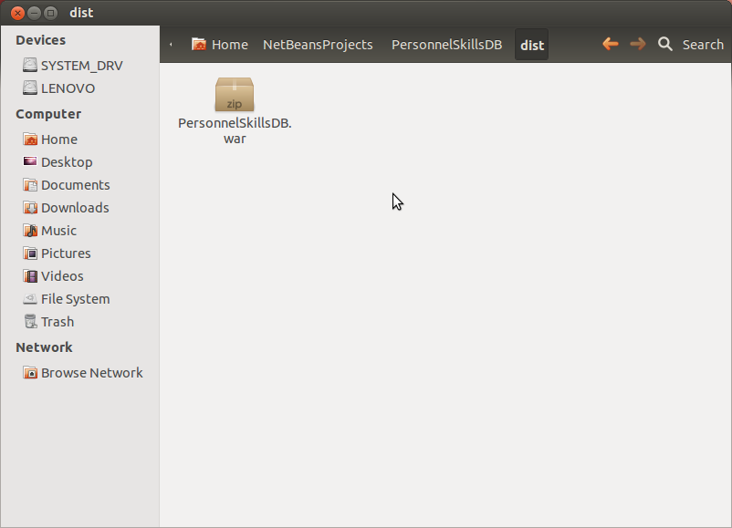

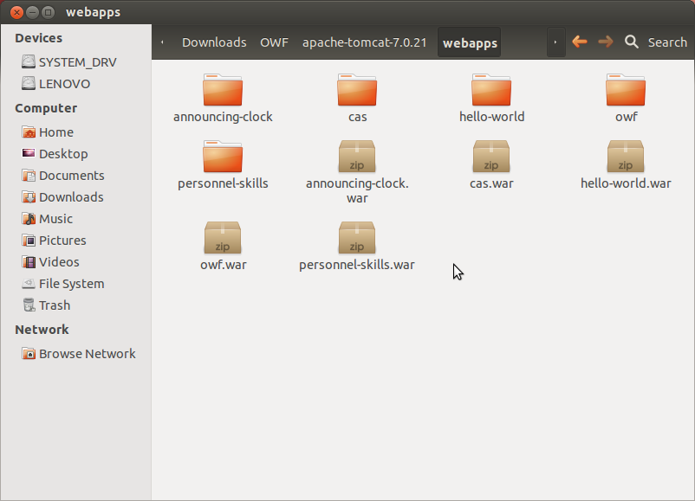

4. In OWF, log in as an administrator. Click the wrench crossed with the screwdriver icon and select widgets. On the bottom left corner of the new screen, click create widgets.

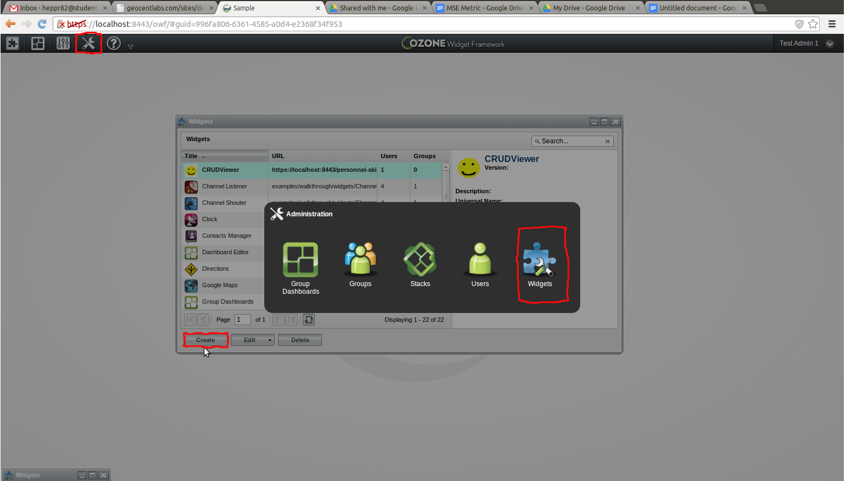

5. Give your widget a name. For the URL use <https://localhost:8443/>FOLDER_NAME

In this case the folder name is personnel-skills which is generated from the personnel-skills.war file. You then add the rest path of the path until you reach the html file you would like the widget to display. You will also need to add a Container Icon and a Launch Menu Icon. You may create your own or use the images from one of the existing widgets already.

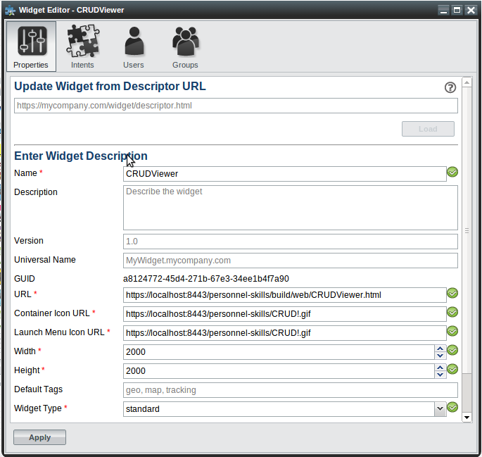

6. Lastly, you will need to add which users are allowed to use your widget. Go to the user tab, click add, and choose the user or users who are allowed access to the app. After they are added, the widget will show up in their available apps screen.

