PDF Shenanigans
1st) We craft our hidden zlib stream with this python script
import zlib
data = b"flag{this_is_a_hidden_message}" # Replace with your flag
compressed_data = zlib.compress(data)

with open("payload.zlib", "wb") as f:
f.write(compressed_data)
print("Zlib-compressed file created: payload.zlib")
2nd) Now we want the data from that compressed file so we run this script
with open("payload.zlib", "rb") as f:
compressed_hex = f.read().hex()

print(compressed_hex)

with the provided hidden message you’ll get
789c4bcb494caf2ec9c82c8e07a2c4f88ccc9494d4bcf8dcd4e2e2c4f4d45a00bef10c55
as an output
3rd) Now we make a pdf with this file with another python script
import binascii

# PDF structure before the stream
pdf_header = b"""%PDF-1.4
1 0 obj
<< /Type /Catalog /Pages 2 0 R >>
endobj
2 0 obj
<< /Type /Pages /Kids [3 0 R] /Count 1 >>
endobj
3 0 obj
<< /Type /Page /Parent 2 0 R /Contents 4 0 R >>
endobj
4 0 obj
<< /Length 20 /Filter /FlateDecode >>
stream
"""

# Convert hex stream to raw binary
hex_data = "789c4bcb494caf2ec9c82c8e07a2c4f88ccc9494d4bcf8dcd4e2e2c4f4d45a00bef10c55"
binary_data = binascii.unhexlify(hex_data)

# PDF footer after the stream
pdf_footer = b"""
endstream
endobj
xref
0 5
0000000000 65535 f
0000000010 00000 n
0000000050 00000 n
0000000100 00000 n
0000000200 00000 n
trailer
<< /Size 5 /Root 1 0 R >>
startxref
250
%%EOF
"""

# Write everything to a PDF file
with open("hidden.pdf", "wb") as f:
f.write(pdf_header)
f.write(binary_data)
f.write(pdf_footer)

print("PDF saved as hidden.pdf")
This makes our pdf with the hidden flag
4th)
To actually get the flag the intended route is for the user to download this
https://sourceforge.net/projects/malzilla/files/OldFiles/PDF_streams_inflater.zip/download?use_mirror=master&use_mirror=

Then use this to get the flag.
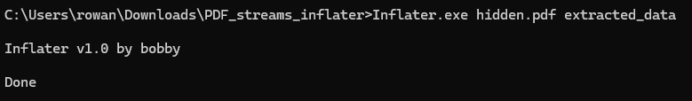
This is what extracted_data looks like
