Rowel Lim

SUMMARY
Motivated 4th-year BS Computer Science student with hands-on experience in developing websites and mobile applications through freelance projects. Able to design, build, and improve applications while meeting client expectations. Eager to apply my skills in a professional setting and continue learning new technologies.

EXPERIENCE
Freelance Web/Mobile App Developer, 06/2024 – Current
Self-employed/Freelance – Concepcion, Tarlac, Philippines
- Engaged in continuous learning to stay abreast of mobile development trends and technologies, applying insights to project work.
- Developed custom websites and mobile apps from concept to deployment, ensuring responsiveness, performance, and security.
- Created websites and mobile applications for clients as a freelance developer.
- Adjusted projects based on client feedback and completed tasks on time.

EDUCATION
Elementary Education, 2008 – 2014
Concepcion North Central Elementary School – Concepcion, Tarlac
Junior High School, 2014 – 2018
Muñoz National High School – Science City of Muñoz, Nueva Ecija
Senior High School, STEM Strand, 2022 – Current
Muñoz National High School – Science City of Muñoz, Nueva Ecija
Bachelor of Science, Computer Science, 2022 – Current
Concepcion Holy Cross College Inc. – Concepcion, Tarlac

HOBBIES AND INTERESTS
- Learning new programming languages and technologies
- Exploring UI/UX trends
- Problem-solving and coding challenges
- Building personal coding projects
- Music & creative arts

CAREER GOALS
I aim to build a successful career in technology by applying my skills to develop innovative solutions, while continuously learning, embracing emerging technologies, and contributing to impactful projects.
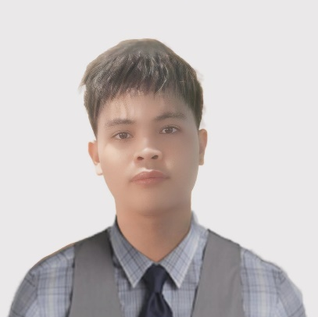

CONTACT
Address: Sta. Maria Concepcion, Tarlac, Philippines 2316
Phone: 09362041511
Email: rowellim3@gmail.com

SKILLS
• Mobile app development (Flutter)
• Java programming
• Web development
• Client engagement
• Continuous learning
• Logical thinking

