**Movie Squire**

**(Android version)**

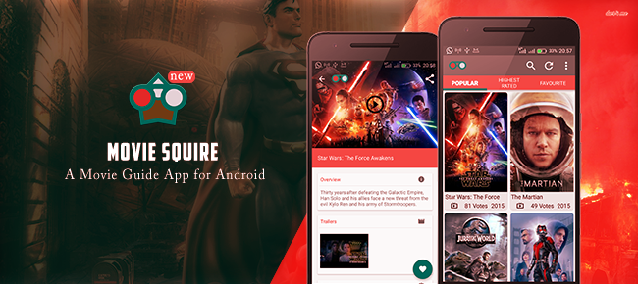

**I. Description**

Movies Squire, is an android movies app that pulls movies from imdb.com API, the world’s most renowned movies website. It brings the experience to android, by keeping users upto date with information on the latest, most popular and highest rated movies. Users can browse the movies by above categories, and save their best movies on local storage (SQLite).

It's built with latest material design techniques hence provides a beautiful and fresh layout. The material design is used in such a way that user interface is decoupled from the main logic that runs the app, hence providing the benefit of easy and quick skinning, modification and expansion.

This template is packed with many features that will turn your app idea into a reality.

APK demo link <https://www.dropbox.com/s/6hgtgog1tlwngq6/app-free-release.apk?dl=0>

Each important line in the source code is thoroughly documented through comments, hence its easy to follow.

**II.Set up**

This app is made using the Android Framework , the project is written in pure in java and easy to import to Android Studio or Eclipse (with Gradle plugin).

**1. Android version:**

a.Download the Android Studio

Android Studio (recommended): http://developer.android.com/sdk/index.html

Then open Android SDK Manager, update to the latest APIs and tools.

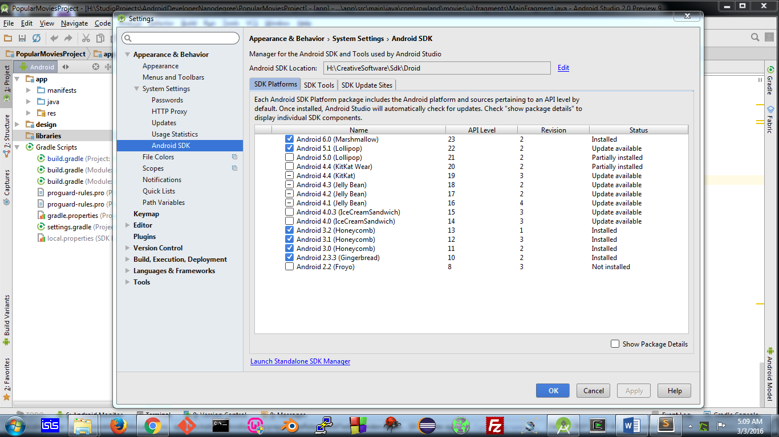

b.Import the project to Android Studio

Import project (Eclipse ADT, Gradle, etc) -> Browse to Source/Movie Squire-> OK

**3. Configure:**

**a.Rename the package name**

Using Refactor to rename all packages in the project.

*app -> src -> com*

*app -> src -> com->rowland*

*app -> src -> com->rowland->movies*

Select: Refactor -> Rename -> Rename package -> Enter the package name you want -> Refactor.

NB: The other modules can be renamed in the same manner.

In the file “Movies Squire\app\src\main\AndroidManifest.xml*”*

Change the line: *package="com.rowland.movies"* into the package name you want.

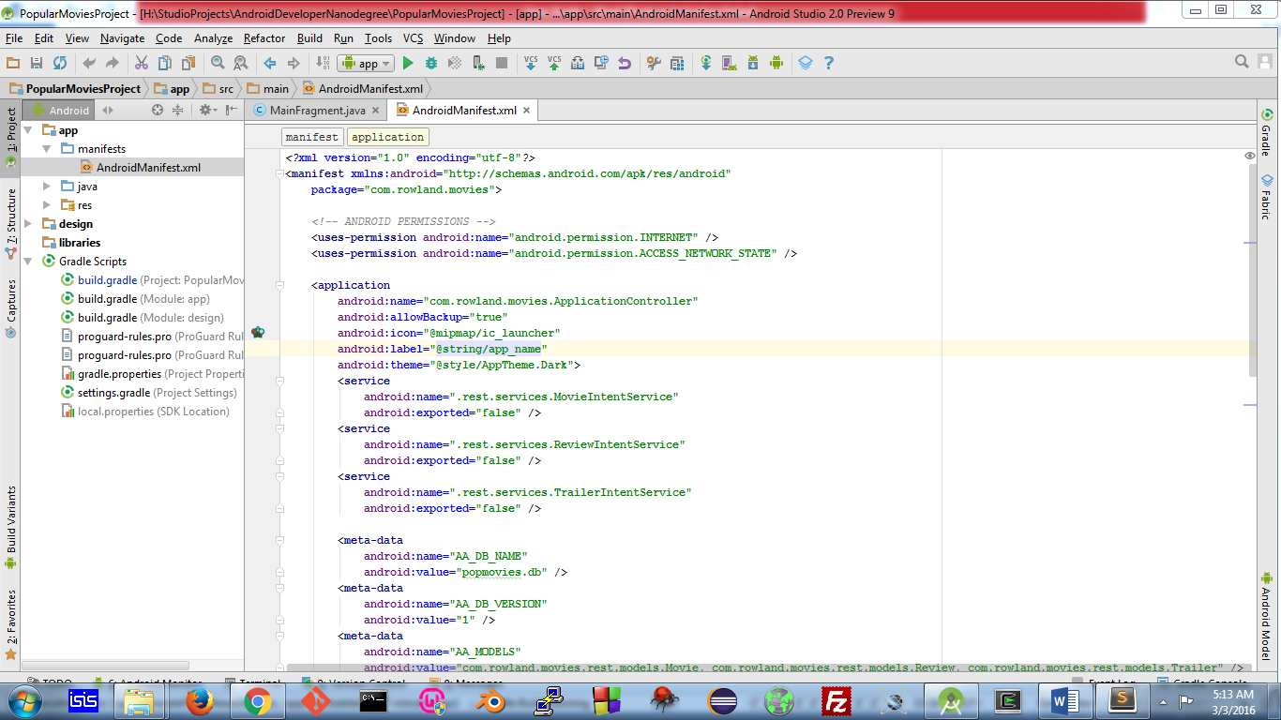

**b.Change the app name**

In the file “MoviesSquire\app\src\main\res\values\strings.xml”

*<string name="app_name">Movies Squire</string>*

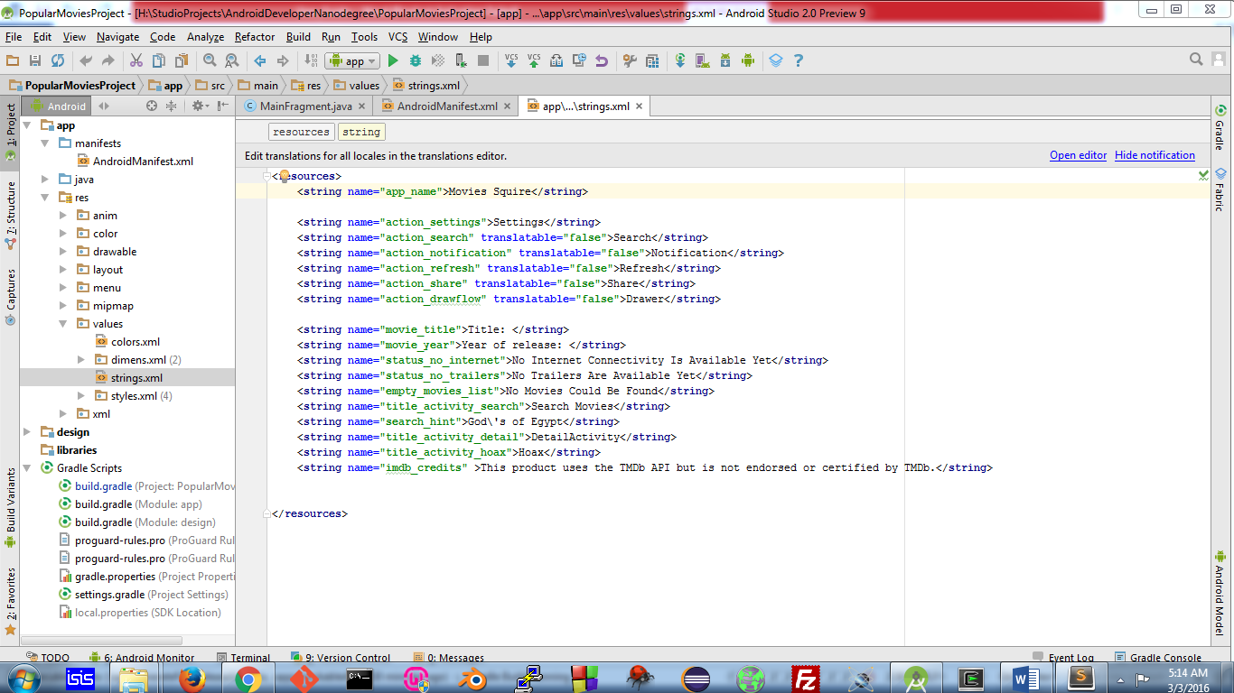

**b.Acquire API_Key from MovieDb**

Acquire an api_key from <https://www.themoviedb.org/documentation/api> and replace in this build file “Movies Squire\app”.

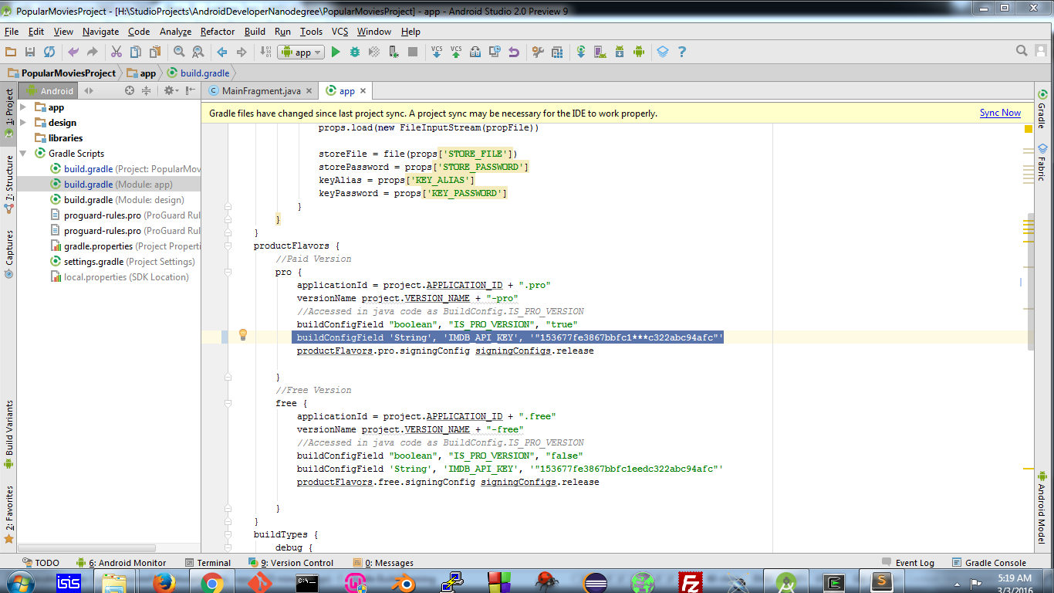

**3.Reskin**

**a.Images**

Replace the mipmaps-folders with launcher icons of your own. Similarly replace the ic_logo_48px image with the same name in the “Movies Squire\app\src\main\res\drawable-xxxhdpi” folder.

*Ideally, maintain the image sizes and aspect ratio.

**a.Material Colors**

Material design doesn't involve many images. It makes customizing apps, almost just about changing color palletes. The color palletes can be changed in the “Movies Squire\app\src\main\res\values\styles.xml” file.

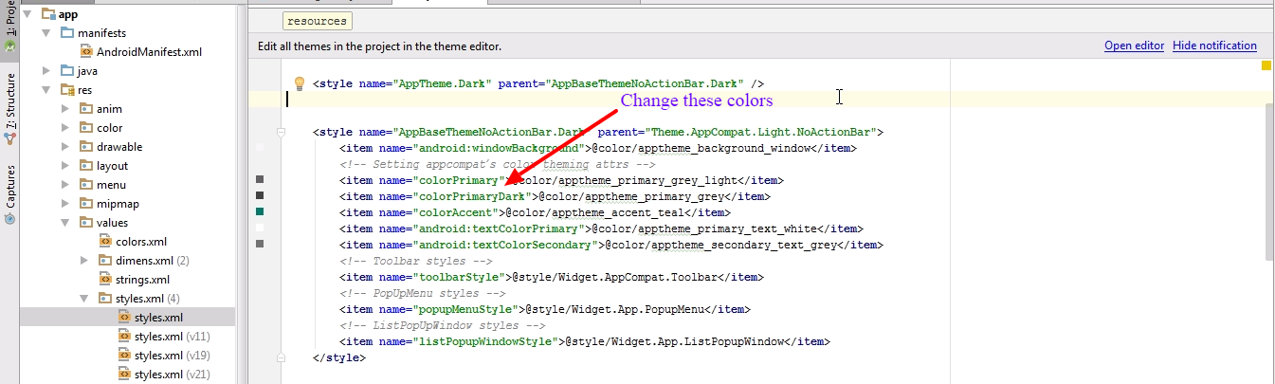

**You can also check the tutorial videos:**

Set up project with Android Studio

<https://www.youtube.com/watch?v=QHwbv3_vhH8>

Reskin the material design theme

<http://developer.android.com/training/material/theme.html>

<http://tips.androidhive.info/2015/09/android-how-to-apply-material-design-theme/>

<https://www.google.com/design/spec/style/color.html>

**Contact me if you need further information:**

Email: <rowlandmtetezi@gmail.com>

**(iOS version)**

Coming soon!!