BasList vs 1.1.0
BasList is a command-line (console) application that lists a tokenised BBC BASIC program file without needing a BBC Micro or emulator. The program can be in Acorn or R.T. Russell (Z80) format. BasList can also be used to create a text file and convert between formats. It expands on the native LIST command, offering a wide choice of styles and filters, including:
- syntax colouring and adding spaces for legibility
- listing one or a range of lines, or a sub-procedure, with or without line numbers
- indenting of loops and breaking lines at colons
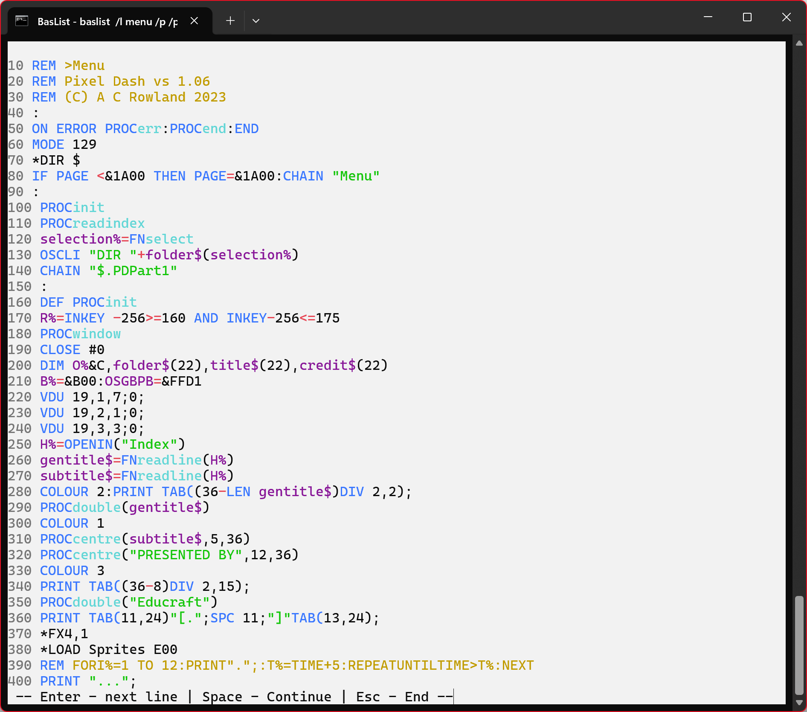
- LIST IF functionality

System requirements
- Windows 7 or later. (BasList is tested under Win10 and 11)
- .NET Runtime 8.0 or later (https://dotnet.microsoft.com/en-us/download/dotnet/8.0)

Installation
- Download the latest version (e.g. BasList_Setup_1.1.0.zip) and unzip the contents into any convenient location
- Right-click the Setup.exe (e.g. BasList_Setup1.1.0.exe) and point to Run As Administrator. Follow the prompts.
- You may wish to add the BasList folder to the system path. See https://windowsloop.com/how-to-add-to-windows-path/

Using the utility

Normal usage
- Right-c lick the program file to be converted
- Point to Send to → BasList.bat or Send to → BasListV.bat
- A text file will be generated and saved in the same folder with ‘.bas’ appended to the filename.
Example: If you right-click $.Menu and point to Send to then BasList.bat (left click), $.Menu.bas will be created. Point to BasListV.bat if the program is in Basic V format (for RiscOS).

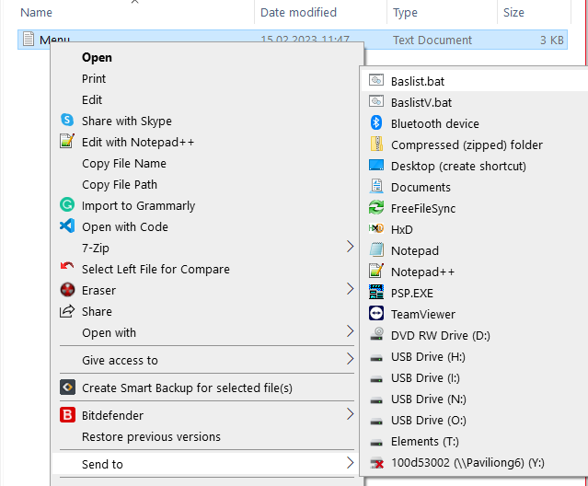
Advanced
For command line use or for greater control over options:
- Double-click the BasList shortcut on your desktop (if it exists), or open the Windows Start menu, scroll down the program list to RowlandSoftware, click it, click BasList.
- Alternatively, tap the Windows key on your keyboard (just to the left of the space bar) and without further ado, type BasList. As soon as it appears, click Open.
- A Command window appears. You should type your commands into this window. For example BasList /? will display the command syntax; BasList d:\MyProgram will display a listing of MyProgram, where ‘MyProgram’ is a BASIC program.
See over

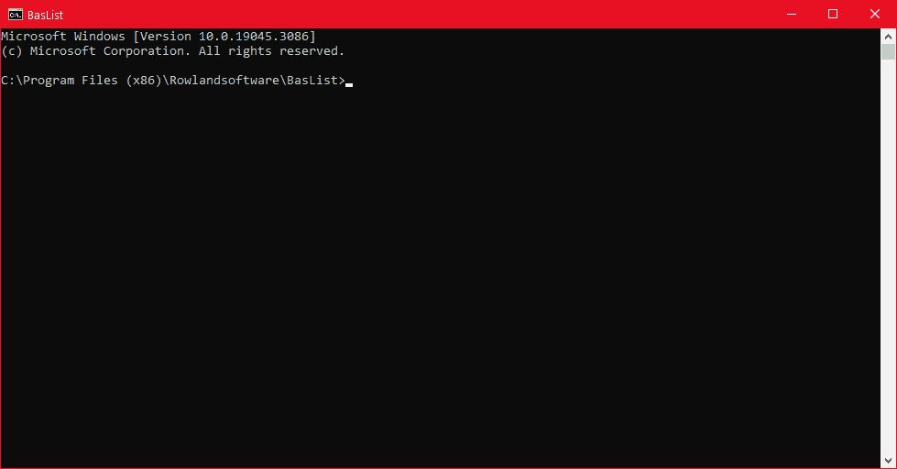
Syntax
For details of the syntax and capabilities of BasList, please see ReadMe.pdf

Customising baslist.bat
The three files, BasList.bat, BasListN.bat and BasListV.bat, are merely standard batch files. They convert using a standard set of options and save the result with the same filename as the input file with ‘.bas’ appended. You may wish to change the standard options or alter the extension, for example, to .txt instead of .bas.
BasList.bat | -bare -nonumbers -indent
BasListN.bat | -bare -indent -align
BasListV.bat | -bare -nonumbers -indent -V

- Hold the Windows Key and tap R
- The Run dialog box appears. Enter shell:sendto and press Enter or choose OK
- The SendTo folder is displayed. Right-click BasList.bat and point to Edit
- The batch file is opened in Notepad. Make your changes and save.
You might also create copies of the batch file with different sets of options.

© Andrew Rowland 2022-2026

