An Attempt at Collaboration with GitKraken

|  |
| --- |
| Akhila Nekkanti1, Kyle Reardon1, Brock Rowley1, & Jeff Gau1 |
| 1 University of Oregon |
|  |

# Author note

Correspondence concerning this article should be addressed to Akhila Nekkanti, Center for Translational Neuroscience University of Oregon 1585 E 13th Ave. Eugene, OR 97403. E-mail: [akhilan@uoregon.edu](mailto:akhilan@uoregon.edu)

Abstract

This is our abstract and it’s really something else! SO abstract! And so concise!

*Keywords:* add, some, keywords, words, keys, Yo, Key, Word

Word count:

An Attempt at Collaboration with GitKraken

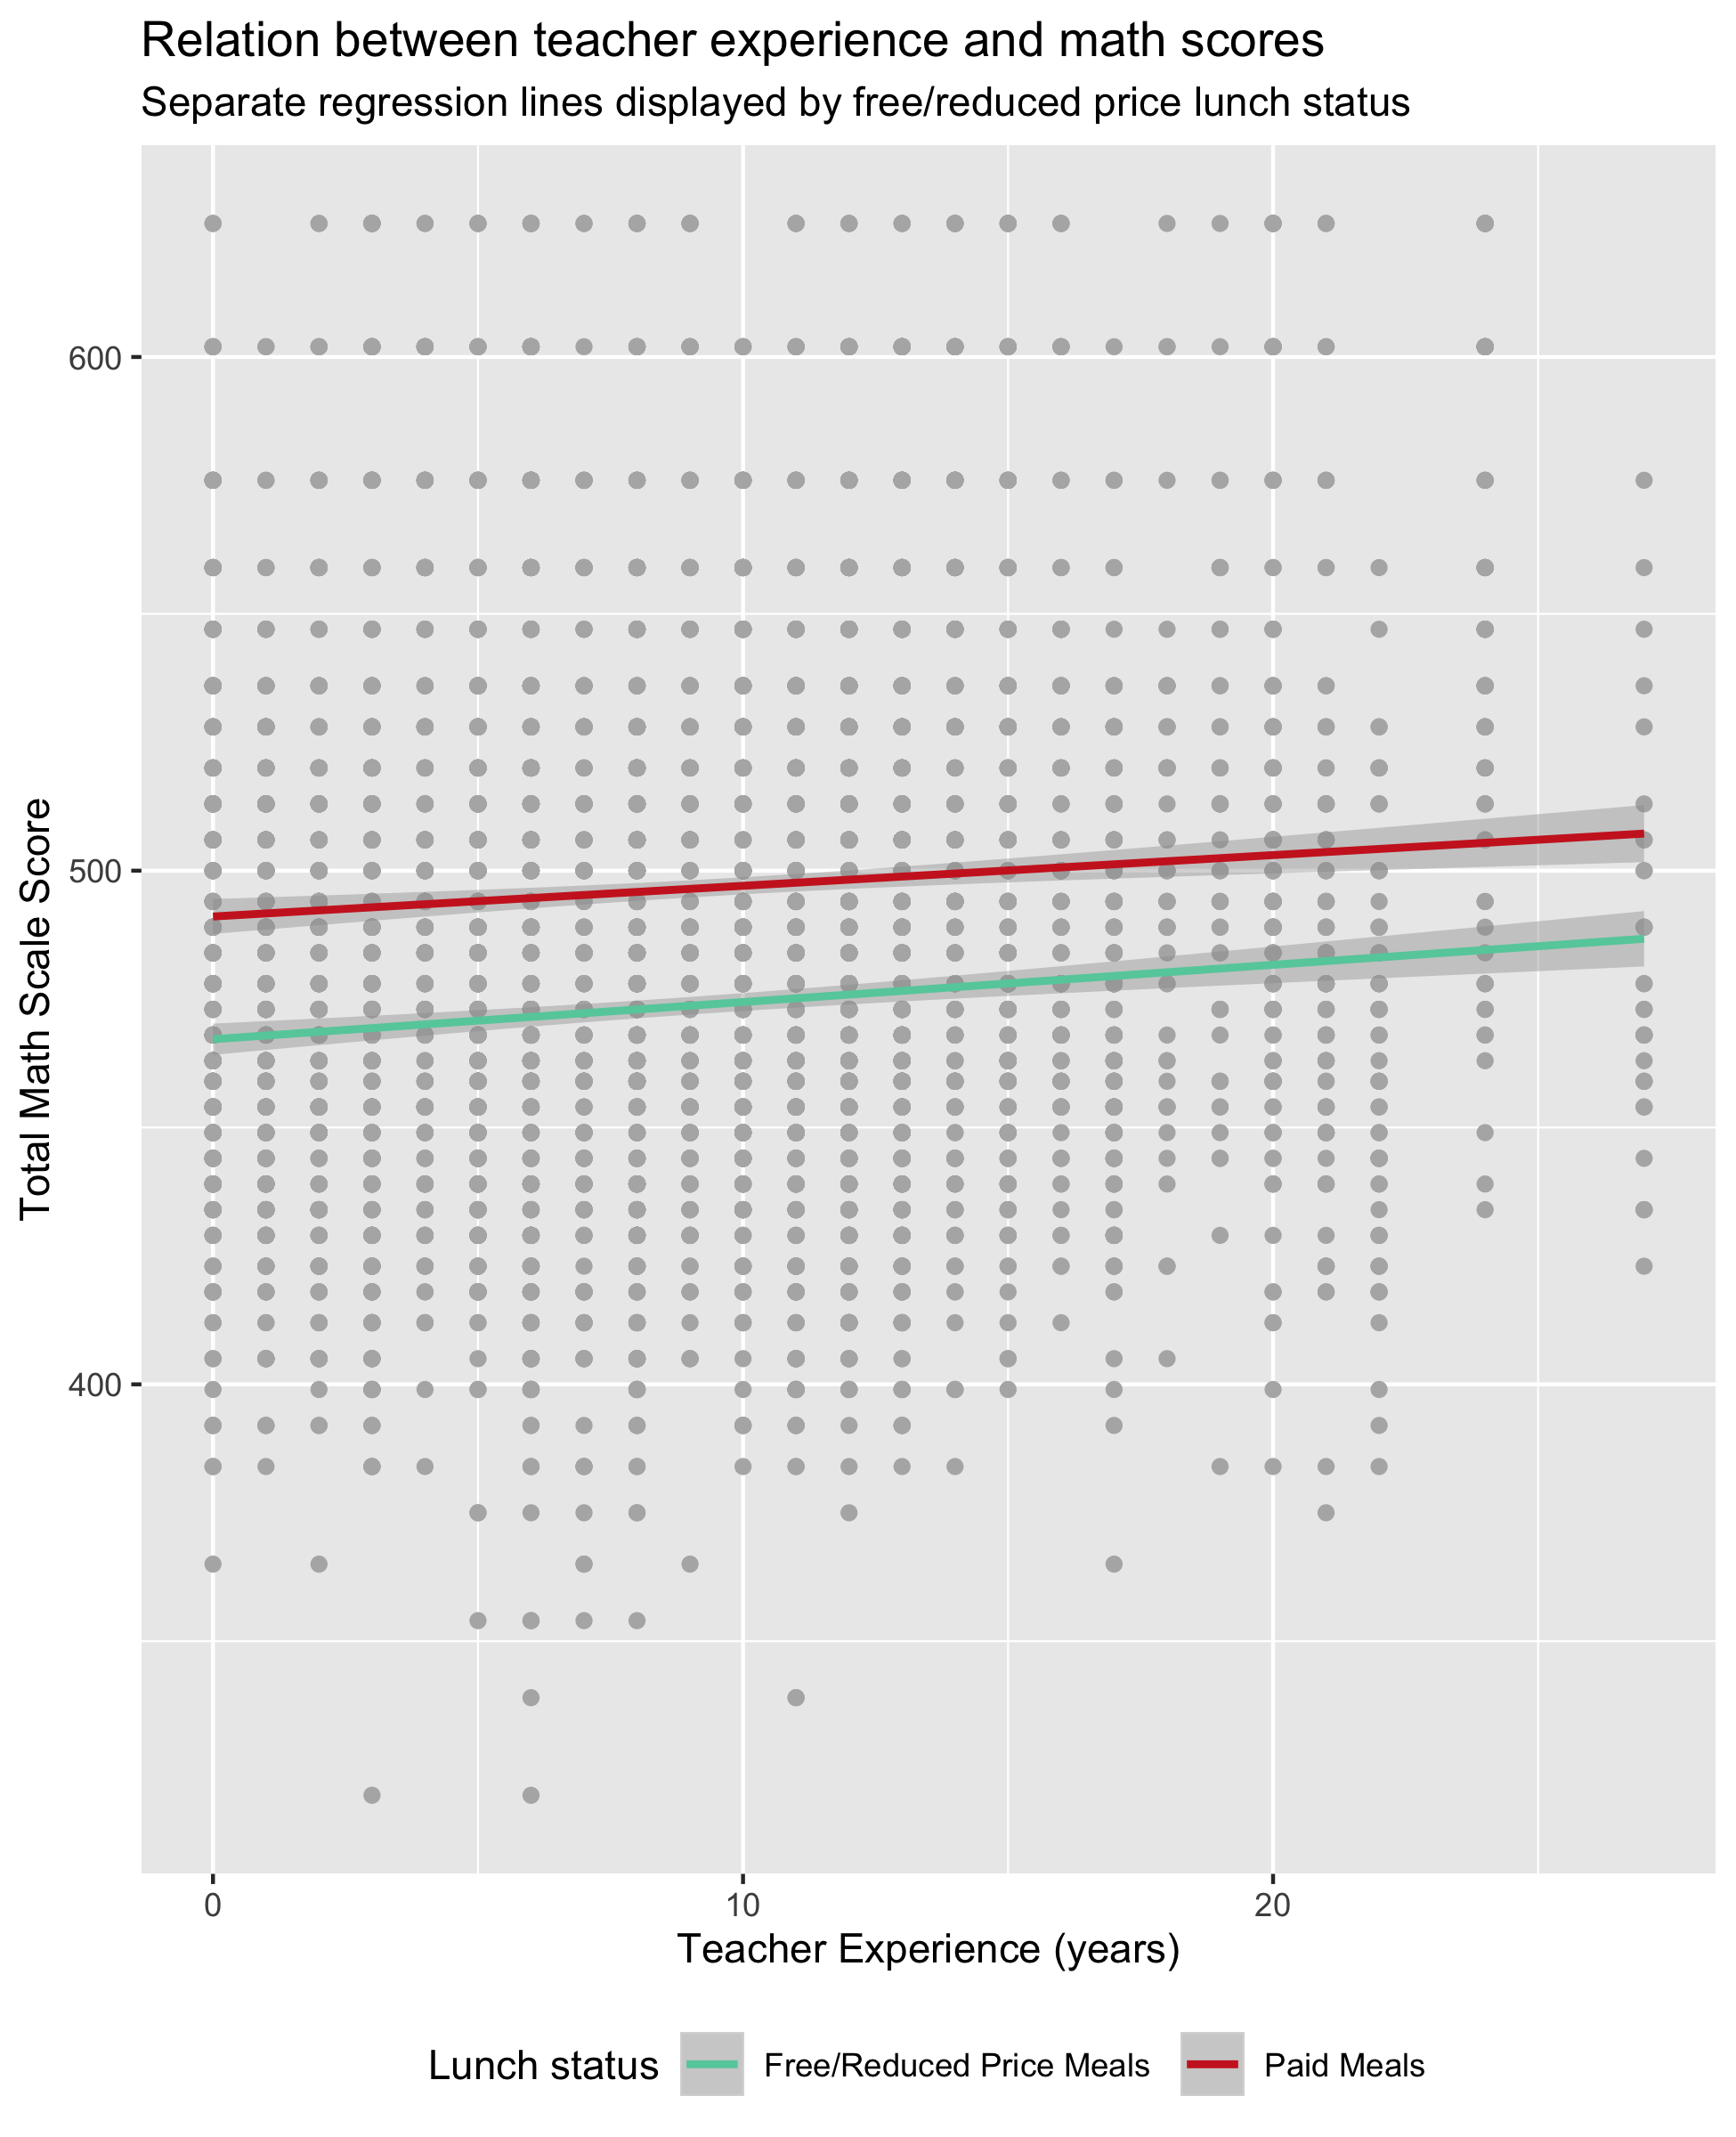

Wehman, Chan, Ditchman, and Kang (2014) conducted a case study to examine the the effect of supported employment on vocational rehabilitation outcomes of transition-age youth. Other researchers examined the exmployability skills for entry-level employees with and without disabilities (Ju, Roberts, & Zhang, 2013).

# Methods

We report how we determined our sample size, all data exclusions (if any), all manipulations, and all measures in the study.

## Participants

## Material

## Procedure

## Data analysis

We used R (Version 3.6.1; R Core Team, 2019) and the R-packages *devtools* (Version 2.2.1; Wickham et al., 2019b), *dplyr* (Version 0.8.3; Wickham et al., 2019a), *forcats* (Version 0.4.0; Wickham, 2019a), *ggplot2* (Version 3.2.1; Wickham, 2016), *here* (Version 0.1; Müller, 2017), *janitor* (Version 1.2.0; Firke, 2019), *papaja* (Version 0.1.0.9842; Aust & Barth, 2018), *purrr* (Version 0.3.2; Henry & Wickham, 2019), *readr* (Version 1.3.1; Wickham, Hester, & Francois, 2018), *rio* (Version 0.5.16; Chan, Chan, Leeper, & Becker, 2018), *stringr* (Version 1.4.0; Wickham, 2019b), *tibble* (Version 2.1.3; Müller & Wickham, 2019), *tidyr* (Version 1.0.0; Wickham & Henry, 2019), *tidyverse* (Version 1.2.1; Wickham, 2017), *tinytex* (Version 0.16; Xie, 2019), and *usethis* (Version 1.5.1; Wickham & Bryan, 2019) for all our analyses.

# Results

Figure 1 demonstrates the relationship between teacher experience and student’s math scale scores. The two regression lines demonstrate differences between free and reduced price lunch status, which students who are not eligible for free and reduced price lunch scoring, in general, higher than those who do. In general, it does not appear that teacher experience significantly impacts this difference, as math scores for students both with and without free and reduced price lunch status appears to increase at approximately the same rate.

# Discussion

# References

Aust, F., & Barth, M. (2018). *papaja: Create APA manuscripts with R Markdown*. Retrieved from <https://github.com/crsh/papaja>

Chan, C.-h., Chan, G. C., Leeper, T. J., & Becker, J. (2018). *Rio: A swiss-army knife for data file i/o*.

Firke, S. (2019). *Janitor: Simple tools for examining and cleaning dirty data*. Retrieved from <https://CRAN.R-project.org/package=janitor>

Henry, L., & Wickham, H. (2019). *Purrr: Functional programming tools*. Retrieved from <https://CRAN.R-project.org/package=purrr>

Ju, S., Roberts, E., & Zhang, D. (2013). Employer attitudes toward workers with disabilities: A review of research in the past decade. *Journal of Vocational Rehabilitation*, *38*(2), 113–123.

Müller, K. (2017). *Here: A simpler way to find your files*. Retrieved from <https://CRAN.R-project.org/package=here>

Müller, K., & Wickham, H. (2019). *Tibble: Simple data frames*. Retrieved from <https://CRAN.R-project.org/package=tibble>

R Core Team. (2019). *R: A language and environment for statistical computing*. Vienna, Austria: R Foundation for Statistical Computing. Retrieved from <https://www.R-project.org/>

Wehman, P., Chan, F., Ditchman, N., & Kang, H.-J. (2014). Effect of supported employment on vocational rehabilitation outcomes of transition-age youth with intellectual and developmental disabilities: A case control study. *Intellectual and Developmental Disabilities*.

Wickham, H. (2016). *Ggplot2: Elegant graphics for data analysis*. Springer-Verlag New York. Retrieved from <https://ggplot2.tidyverse.org>

Wickham, H. (2017). *Tidyverse: Easily install and load the ’tidyverse’*. Retrieved from <https://CRAN.R-project.org/package=tidyverse>

Wickham, H. (2019a). *Forcats: Tools for working with categorical variables (factors)*. Retrieved from <https://CRAN.R-project.org/package=forcats>

Wickham, H. (2019b). *Stringr: Simple, consistent wrappers for common string operations*. Retrieved from <https://CRAN.R-project.org/package=stringr>

Wickham, H., & Bryan, J. (2019). *Usethis: Automate package and project setup*. Retrieved from <https://CRAN.R-project.org/package=usethis>

Wickham, H., François, R., Henry, L., & Müller, K. (2019a). *Dplyr: A grammar of data manipulation*. Retrieved from <https://CRAN.R-project.org/package=dplyr>

Wickham, H., & Henry, L. (2019). *Tidyr: Easily tidy data with ’spread()’ and ’gather()’ functions*. Retrieved from <https://CRAN.R-project.org/package=tidyr>

Wickham, H., Hester, J., & Chang, W. (2019b). *Devtools: Tools to make developing r packages easier*. Retrieved from <https://CRAN.R-project.org/package=devtools>

Wickham, H., Hester, J., & Francois, R. (2018). *Readr: Read rectangular text data*. Retrieved from <https://CRAN.R-project.org/package=readr>

Xie, Y. (2019). *Tinytex: Helper functions to install and maintain ’tex live’, and compile ’latex’ documents*. Retrieved from <https://CRAN.R-project.org/package=tinytex>