**2017-18 Oregon Extended Assessment Rater Reliability**

*Observation Protocol*

The Oregon Department of Education (ODE) plans to observe a sample of Oregon’s Qualified Assessors (QAs) who administer the paper/pencil version of the Oregon Extended Assessment (ORExt) to determine reliability of administration and scoring. We do not include the tablet administration or the Oregon Observational Rating Assessment (ORora). You received this protocol because you were selected by ODE to participate as a Qualified Trainer (QT)/expert reviewer. The project will be conducted in two manners:

1. QTs in each district will observe a sample of their respective QAs using the observation protocol and enter their data online.
2. Expert reviewers from ODE and/or Behavioral Research & Teaching (BRT) will observe district-level QTs and those QAs who give the assessment in more than one school/district.

The observation protocol must be completed for the identified QA, but the student(s) and content area(s) observed will be selected by the QT or QA. BRT researchers will contact district-level QTs on day one of the test window, which runs from February 15 - April 26, 2018, to arrange multiple observations that can hopefully be completed within one school day. The observation is composed of three sections:

* **First**, you will be reviewing ORExt paper/pencil test preparation and administration using the rubric, see Page 2 for samples. Test preparation/administration domains are rated on a four-point scale from *Inappropriate (I)* to *Exemplary (E)*:
  + ***Inappropriate (I)*** denotes a level of concern that could clearly affect the accuracy of the test results gathered from the test administration. Ratings at this level require substantive retraining of the QA involved.
  + ***Somewhat Appropriate (SA)*** rating denotes a level that includes some minor aspects that could be improved, but the accuracy of the test results are likely not compromised.
  + ***Appropriate (A)*** denotes a level that is consistent with all test administration requirements,
  + ***Exemplary (E)*** level performance suggests that the QA incorporated approaches to test administration that could become models for best practice.
* **Second**, you will be scoring the student alongside the QA using the scoring sheet, see Page 3 for samples. You will compare results after this observation to ensure that the QA enters accurate data.
* **Finally**, you will observe the QA completing the data entry process to ensure that no errors are made during data entry and document the number of errors, see Page 4.

**Qualified Assessor Testing Preparation and Administration Rubric**

*(Record an “X” in the cell that corresponds to your rating)*

**Domain Definitions**

1. ***Test Security*** – The QA utilized a system to ensure that all test materials were stored in a secure location,. The QA also had a district Assurance of Test Security form on file.
2. ***Printed Materials*** – the QA had all materials required to administer the ORExt ready for test administration
3. ***Distraction-Free Environment*** – the QA arranged to provide the ORExt in a one-on-one test administration in a location that ensured that the student focused attention on the assessment.
4. ***Accessibility Supports*** – the QA provided all necessary accessibility supports for the student and ensured that all support systems were functional prior to testing.
5. ***Level of Support***– The QA provided an appropriate level of support throughout testing that did not compromise the validity of the score.
6. ***Praise***– The QA utilized praise appropriately to support student involvement without leading the student to the correct answer.
7. ***Motivation***– The QA appropriately maintained the student’s motivation during the assessment using relevant strategies, such as token systems.
8. ***Score Interpretation***– The QA demonstrated an appropriate understanding of how to use the cut scores and achievement level descriptors to interpret scores (i.e., ask the QA to describe how they interpret scores for parents).
9. ***Minimum Participation Rule*** - The QA demonstrated an appropriate understanding of the minimum participation rule (i.e., ask the QA to define the rule if it is not used).

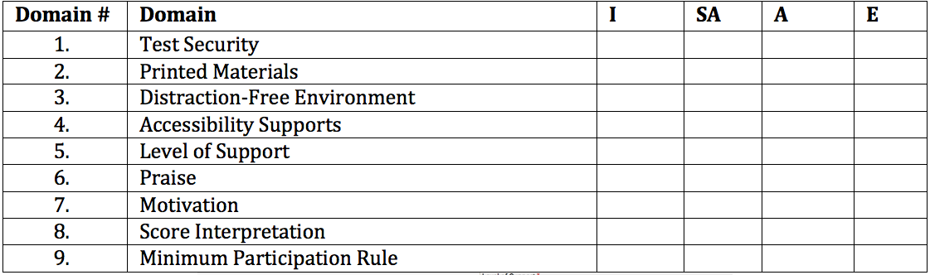

Online the form is found at the following link and will look like this: <https://docs.google.com/forms/d/e/1FAIpQLSdemN-sVqdmzNIWwanT4swSqUMM9YpncyzIt4AZ4TdeRDPSpQ/viewform?usp=form_confirm>

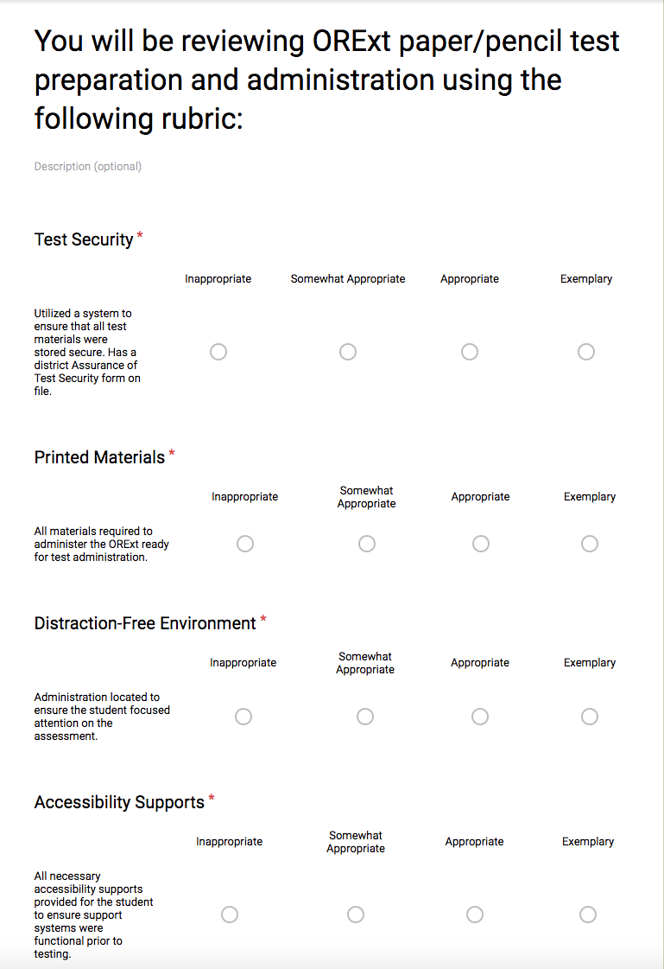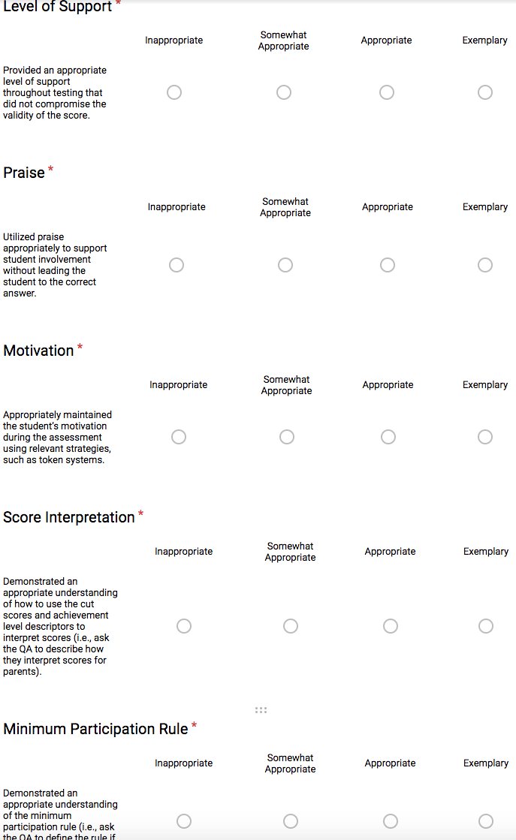

**2017-18 Oregon Extended Assessment – Rater Observation**

**Sample Scoring Sheet**

QT/Expert Reviewer Name (First – Last) _________________________________________________

Observed QA Name (First - Last):___________________________________________________________

Assessor completed required training on (date): _________________________________________

State Student ID: ______________________________

District: _______________________________________

School: _________________________________________

Student Grade: __________ Subject Area:_________________________________________________

The online scoring sheet is found at the following link with a screen capture below.

<https://docs.google.com/forms/d/e/1FAIpQLSdemN-sVqdmzNIWwanT4swSqUMM9YpncyzIt4AZ4TdeRDPSpQ/viewform?usp=form_confirm>

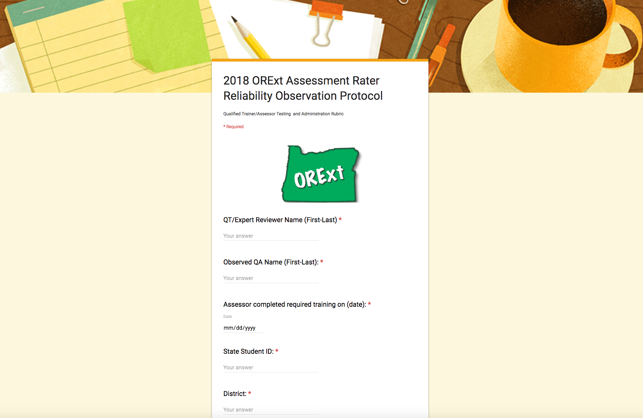

Record all student responses for inter-rater reliability comparisons below (*Please circle all responses in which there was disagreement*).

1. ☐ 0 ☐ 1
2. ☐ 0 ☐ 1
3. ☐ 0 ☐ 1
4. ☐ 0 ☐ 1
5. ☐ 0 ☐ 1
6. ☐ 0 ☐ 1
7. ☐ 0 ☐ 1
8. ☐ 0 ☐ 1
9. ☐ 0 ☐ 1
10. ☐ 0 ☐ 1
11. ☐ 0 ☐ 1
12. ☐ 0 ☐ 1
13. ☐ 0 ☐ 1
14. ☐ 0 ☐ 1
15. ☐ 0 ☐ 1
16. ☐ 0 ☐ 1
17. ☐ 0 ☐ 1
18. ☐ 0 ☐ 1
19. ☐ 0 ☐ 1
20. ☐ 0 ☐ 1
21. ☐ 0 ☐ 1
22. ☐ 0 ☐ 1
23. ☐ 0 ☐ 1
24. ☐ 0 ☐ 1
25. ☐ 0 ☐ 1
26. ☐ 0 ☐ 1
27. ☐ 0 ☐ 1
28. ☐ 0 ☐ 1
29. ☐ 0 ☐ 1
30. ☐ 0 ☐ 1
31. ☐ 0 ☐ 1
32. ☐ 0 ☐ 1
33. ☐ 0 ☐ 1
34. ☐ 0 ☐ 1
35. ☐ 0 ☐ 1
36. ☐ 0 ☐ 1
37. ☐ 0 ☐ 1
38. ☐ 0 ☐ 1
39. ☐ 0 ☐ 1
40. ☐ 0 ☐ 1
41. ☐ 0 ☐ 1
42. ☐ 0 ☐ 1
43. ☐ 0 ☐ 1
44. ☐ 0 ☐ 1
45. ☐ 0 ☐ 1
46. ☐ 0 ☐ 1
47. ☐ 0 ☐ 1
48. ☐ 0 ☐ 1

Please enter all your observations at: <https://docs.google.com/forms/d/e/1FAIpQLSdemN-sVqdmzNIWwanT4swSqUMM9YpncyzIt4AZ4TdeRDPSpQ/viewform?usp=sf_link>

for each Qualified Assessor whom you observe administering the ORExt.

**FAX** Oregon Extended Assessments

Behavioral Research & Teaching, University of Oregon

FAX: 541-346-5689

**EMAIL** orextended@gmail.com

If you want to share any anecdotal observations or explain sources of concern, please feel free to provide such on a separate email to the above email or fax. If you have any questions regarding the observation process, please contact Brock Rowley or Sevrina Tindal at the email address listed above or phone at (800) 838-3163. Thank you for your support of students with significant cognitive disabilities in Oregon.