一、项目更新

在IIS中的高级设置看项目目录，替换分组器或者分组器数据文件。

1.启动项目目录中的webhost（注意看执行后窗口标题路径和项目路径是否一致）

2.启动8899文件夹中的DRGVIEW.WEB.exe

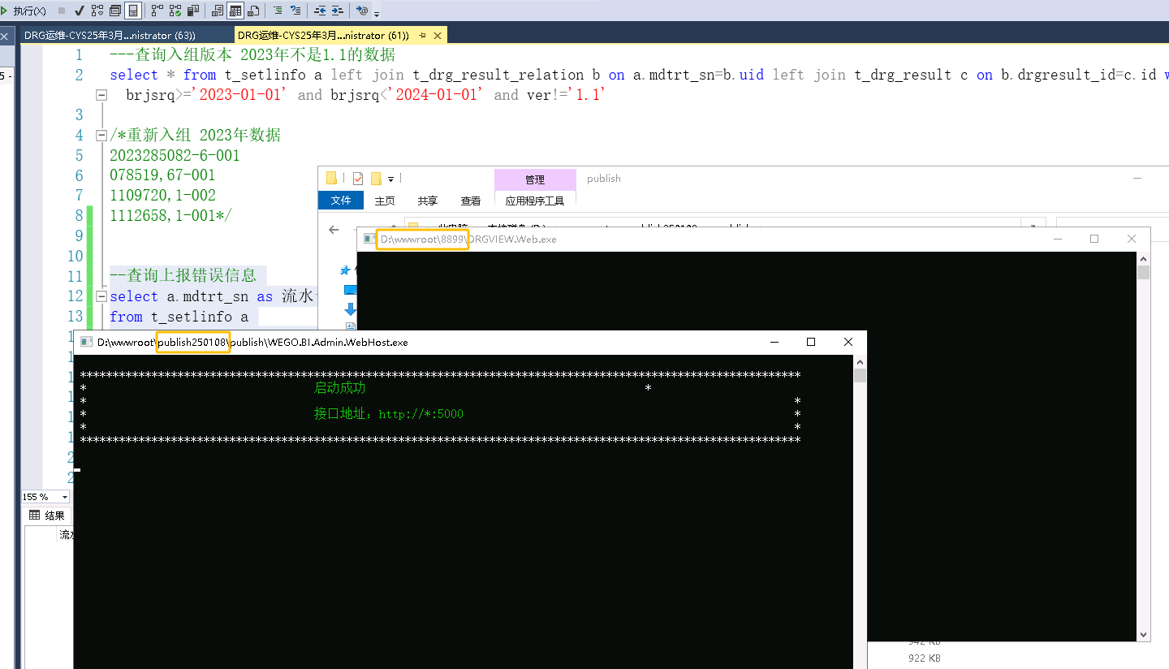

二、违反唯一约束条件(MIDR.OPERATION_UNIQUE_M)

**有修订日志**

t_setlinfo_oprninfo、t_setlinfo_diseinfo 表就不管用了

需要在修订中修改时间

1. --查询手术表和诊断表

2. declare @mdtrtsn varchar(255);

3. set @mdtrtsn='250026649-1-002';

4. select * from t_setlinfo_oprninfo

5. where mdtrt_sn=@mdtrtsn order by oprn_oprt_code,oprn_oprt_date;

6.

7. select * from t_setlinfo_diseinfo

8. where mdtrt_sn=@mdtrtsn order by diag_code;

**没有修订日志**

执行脚本 然后重新上报

1. --手术重复处理--时间重复

2. ---4

3. update t_setlinfo_oprninfo

4. set oprn_oprt_date=dateadd(MINUTE,1,oprn_oprt_date)

5. where id in (

6. ---3

7. select id

8. from (

9. ---2

10. select id,ROW_NUMBER() over(partition by mdtrt_sn,oprn_oprt_code,oprn_oprt_date order by id) rn

11. from(

12. select a.*

13. from t_setlinfo_oprninfo a,

14. (select mdtrt_sn,oprn_oprt_code,oprn_oprt_date,count(*) cont

15. from t_setlinfo_oprninfo

16. group by mdtrt_sn,oprn_oprt_code,oprn_oprt_date

17. having count(*)>1

18. ) b

19. where a.mdtrt_sn=b.mdtrt_sn

20. and a.oprn_oprt_code=b.oprn_oprt_code

21. and a.oprn_oprt_date=b.oprn_oprt_date

22. and a.mdtrt_sn in (

23. ---1

24. select mdtrt_sn

25. from t_setlinfo a

26. left join t_mihs_result_relation b on a.mdtrt_sn = b.uid

27. left join t_mihs_result c on b.resultid=c.id

28. where c.infocode=-1

29. and c.err_msg not like '%省平台%'

30. And c.err_msg like '%JSQD_OPERATION_INFO%'

31. )---1

32. ) a---2

33. ) id---3

34. where rn=1

35. )---4

**没有修订日志直接重新上报**

错误：

1. ###Errorupdatingdatabase.Cause：java.sql.SQLIntegrityConstraintViolationException：ORA-00001：uniqueconstraint(MIDR.OPERATION_UNIQUE_M)violated

###Theerrormayinvolvecom.dareway.opel.medical.tb.dao.JsqdOperationInfoMapper.insertSelective-Inline

4. ###Theerroroccurredwhilesettingparameters

5. ###SQL：insertintoMIDR.JSQD_OPERATION_INFO(IDCITY_CODEOPERATION_TIMEBITMDTRT_SNFIXMEDINS_CODE_STDFIXMEDINS_CODEOPRN_OPRT_TYPEOPRN_OPRT_NAMEOPRN_OPRT_CODEOPRN_OPRT_DATEANST_WAYOPER_DR_NAMEOPER_DR_CODEANST_DR_NAMEANST_DR_CODEMAIN_OPRN_FLAGVALI_FLAGJRSJXGSJGDBZVERSIONSYNC_FLAGYLZD1YLZD2OPRN_OPRT_BEGN_DATEOPRN_OPRT_END_DATEANST_BEGN_DATEANST_END_DATEOPER_DR_CODE_STDANST_DR_CODE_STD)values(???????????????????????????????)

6. ###Cause：java.sql.SQLIntegrityConstraintViolationException：ORA-00001：uniqueconstraint(MIDR.OPERATION_UNIQUE_M)violated

8. ；ORA-00001：uniqueconstraint(MIDR.OPERATION_UNIQUE_M)violated

9. ；nestedexceptionisjava.sql.SQLIntegrityConstraintViolationException：ORA-00001：uniqueconstraint(MIDR.OPERATION_UNIQUE_M)violated