**Project**

MS SQL SERVER 2014

Submitted By:

* Student Name: Rakesh Kumar
* Student Id : Student1009
* Session : Sess101
* Trainer : Ratnesh Dheeraj, Rahul Pathak

**Project Summary:**

Hospital Management System

The database project is to be designed for the hospital “Everest Hospital” to manage their patient and doctor availability.

**Existing Scenario:**

Everest hospital is facing issues in tracking the records of the patients and the medical assistance offered by a doctor.

**Project:**

Database Platform : MS SQL Server

Database Language : SQL (Structured Query Language)

**Minimum System Requirements:**

**OS :**

**HDD :**

**RAM :**

**CPU : X core processor**

**Programming:**

Database Name : **Hospital_Name_DB**

Table Prefix : **neo_**patient

Initial DB Size : 5MB

Size Property : Auto Increase/Shrink

**DFD- Data Flow Diagram**

*Definition*

Diagram – *draw.io*

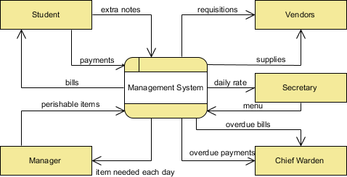

**Entity Relationship Diagram**

*Definition*

Diagram – *draw.io*

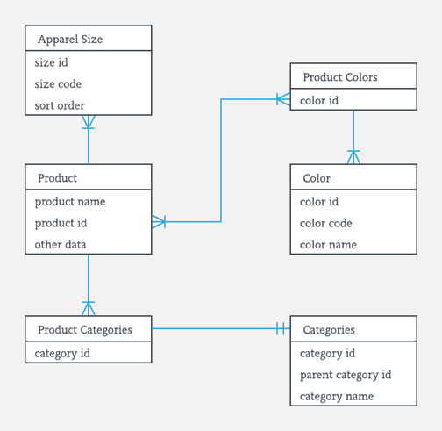

**Database Planning**

MS SQL Server properties

**Data Type**

Types of data supported by MS SQL Server

| **Exact numerics** | |
| --- | --- |
| [bigint](https://docs.microsoft.com/en-us/sql/t-sql/data-types/int-bigint-smallint-and-tinyint-transact-sql?view=sql-server-2017) | [numeric](https://docs.microsoft.com/en-us/sql/t-sql/data-types/decimal-and-numeric-transact-sql?view=sql-server-2017) |
| [bit](https://docs.microsoft.com/en-us/sql/t-sql/data-types/bit-transact-sql?view=sql-server-2017) | [smallint](https://docs.microsoft.com/en-us/sql/t-sql/data-types/int-bigint-smallint-and-tinyint-transact-sql?view=sql-server-2017) |
| [decimal](https://docs.microsoft.com/en-us/sql/t-sql/data-types/decimal-and-numeric-transact-sql?view=sql-server-2017) | [smallmoney](https://docs.microsoft.com/en-us/sql/t-sql/data-types/money-and-smallmoney-transact-sql?view=sql-server-2017) |
| [int](https://docs.microsoft.com/en-us/sql/t-sql/data-types/int-bigint-smallint-and-tinyint-transact-sql?view=sql-server-2017) | [tinyint](https://docs.microsoft.com/en-us/sql/t-sql/data-types/int-bigint-smallint-and-tinyint-transact-sql?view=sql-server-2017) |

**Table Relationship Structure:**

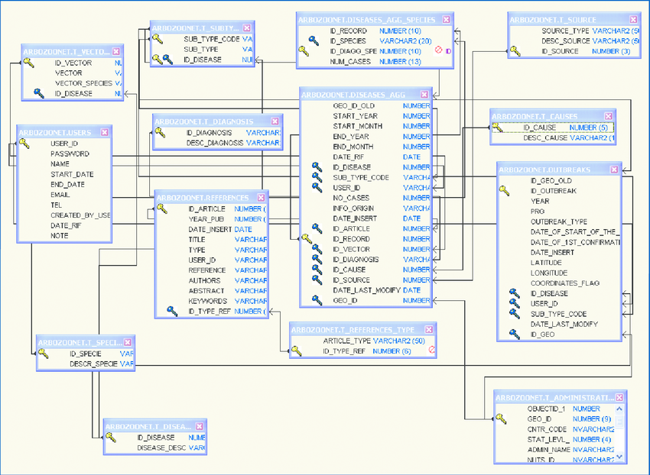

**Database Planning:**

**Database Name:** everest_hopital

**-- Comment**

**Query:**

Create database Everest_hospital

**Table Planning:**

**neo_hospital_setup**

-- This table is intended to setup the hospital and its address/properties

|  |  |  |
| --- | --- | --- |
| Col Name | Data Type | Size |
| hospital_id | Int | 2 |
| hospital_name | varchar | 200 |

Query:

create table table_name

**Screenshot:**

**Table**

**Database Backup:**

**References:**

1. [www.microsoft.com/sql-server-training](http://www.microsoft.com/sql-server-training)
2. W3schools.com