**Shahjalal University of Science and Technology**

**Department of Computer Science and Engineering**

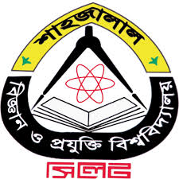

**Research & Development of Bangla OCR(Segmentation & Recognition)**

Ahnaf Farhan Rownak

2010331018

Fazle Rabby Sourav

2010331033

**Superviser:**

Dr. Muhammed Zafar Iqbal

Professor

Dept. of Computer Science and Engineering

**Co-Adviser:**

Md. Saiful Islam

Lecturer

CSE

Sabir Ismail

Assistant Professor

CSE

6th September, 2015